Wonthaggi North East
Precinct Structure Plan
Background Report
May 2022

CONTENTS
1 Executive summary 1
1.1 Introduction 1
1.2 Purpose 1
1.3 Summary of the PSP 1
2 Strategic Context 4
2.1 State context 4
2.2 Gippsland Regional Growth Plan 2014 5
2.3 Local Context & Surrounding Areas 7
2.4 Population and land supply 7
2.5 Planning Scheme Amendment & Structure Plan History 8
2.6 Wonthaggi Strategic Framework Plan 9
3 Physical Context 11
3.1 Current zone, Overlays and Land Uses 11
3.2 Lot Size & Land Ownership Pattern 12
3.3 Topography 12
3.4 Historic Heritage 12
3.5 Cultural Heritage 12
3.6 Vegetation 15
3.7 Bushfire Threat 16
3.8 Contamination 19
3.9 Public Transport 23
3.10 Active Travel 24
3.11 Road Network 25
3.12 Community Facilities 26
3.13 Open Space & Recreation 26
4 Land use, Development and Infrastructure needs 28
4.1 Servicing 28
4.2 Transmission Pressure Gas Pipeline 28
4.3 Drainage & stormwater management 30
4.4 Drainage functional designs 31
4.5 Preliminary Drainage Review 33
4.6 Transport & Movement 33
4.7 Open space 35
4.8 Community Infrastructure 35
4.9 Commercial and Industrial Land 36
4.10 Retail 37
4.11 Housing 37
5 The Vision and Principles for Wonthaggi North East 38
5.1 Vision 38
5.2 Objectives 38
6 Development Contributions 40
7 Background Reports 41
Figures
Figure 1 Regional Context Plan 3
Figure 2 Victoria’s connected cities and regions in Plan Melbourne 5
Figure 3 Wonthaggi Urban Growth Framework in the Gippsland Regional Growth Plan 6
Figure 4 Wonthaggi District area map 8
Figure 5 Wonthaggi Strategic Framework 11
Figure 6 Zone Map - Vic Plan 12
Figure 7 Areas of Aboriginal Cultural Heritage potential 15
Figure 13 Contamination - Property Assessment Plan 21
Figure 14 Contamination - Potential areas of concern 23
Figure 15 Excerpt from PPN30 showing recommended actions relating to potentially contaminated land 24
Figure 16 Municipal Bicycle Network for Wonthaggi 26
Figure 17 Excerpt of PSP Utilities Plan showing extent of pipeline and measurement length 30

Executive summary

Introduction
The Victorian Planning Authority (VPA) in consultation with Bass Coast Shire Council (Council) has prepared a draft Precinct Structure Plan (PSP) for the Wonthaggi North East precinct. The PSP sets the vision for developing new communities and is the primary plan for guiding urban development in the growth area.
The precinct was included within the Wonthaggi Strategic Framework Plan as part of Bass Coast Amendment C134.
The area will undergo a full transition of land use into a large-scale residential development, with considerable population increase.
The precinct covers approximately 632 hectares and will accommodate approximately 5,000 dwellings and approximately 12,000 local residents, with an emphasis on high quality neighbourhood design, service provision, high quality street scapes and open space and retention and protection of natural features.
Council and the VPA commissioned a number of background technical studies to inform the PSP. The purpose of this document is to provide a summary of the findings of these studies and to highlight issues and opportunities that were considered in the preparation of the PSP. Council will be responsible for implementing the PSP, the Wonthaggi Native Vegetation Precinct Plan (NVPP) and the Development Contributions Plan (DCP).

Purpose
This report summarises the key findings presented by the technical reports and analysis that informed the preparation of the PSP, NVPP and DCP and its associated documents. The report provides context and explains how this information guided the preparation of the proposed future urban structure. This report:
- Summarises the strategic context of the precinct.
- Outlines the physical context of the site including topography, vegetation, waterways and contamination.
- Identifies the land use and development needs for the precinct.
- Explains how the PSP responds to the key findings of the above.
A full list of the supporting documents that have informed the preparation of this background report and the PSP can be found in Section 7.

Summary of the PSP
The PSP provides the long-term vision for the future planning and development of the precinct. The PSP provides a broad framework that will coordinate development and assist in the transition of the area from non-urban to urban land. Future residents of the precinct will enjoy and benefit from the proposed environmental, social and economic assets proposed in the PSP.
The PSP is supported by the DCP which identifies and funds the construction of provision of land for basic and essential infrastructure projects required to ensure future residents, visitors and workers in the precinct can be provided with timely access to infrastructure and services necessary to support a quality and affordable lifestyle.
VPA has prepared the PSP, DCP and NVPP in collaboration with Council. Council and the VPA commissioned and prepared the background reports, Council will be responsible for implementing the PSP, DCP and NVPP.

The Wonthaggi North East precinct:
- Will be a predominantly residential precinct as guided by strategic planning policy with employment and in the southern portion;
- Applies to approximately 632 hectares of land located within the north eastern extent of Wonthaggi;
- Will provide a total of 515 hectares of net developable area (NDA), of this 453 hectares or 88% NDA is for residential development and 62 hectares or 12% is available for employment land;
- Will provide 1,500m² for a local village hub convenience centre and a 500m² local convenience centre that will service a local catchment;
- Will create approximately 5,000 dwellings to accommodate approximately 12,000 new local residents, based on a residential development yield average of 11 dwellings per NDA;
- Will accommodate approximately 1,650 new jobs in the centres, government primary school, economic activity located in the employment land as well as home-based businesses;
- Will comprise an urban structure that draws upon and integrates the sites existing physical features including extensive waterway and wetland system will anchor the new community, providing a natural thoroughfare through the precinct and allowing for recreation opportunities;
- Will provide an extensive open space network designed with the site's natural features;
- Will require the following infrastructure:
  - Road and path networks;
  - Drainage systems;
  - A government primary school;
  - Community facilities;
  - Sports reserve and local parks;
  - Utility services.

Figure 1 Regional Context Plan
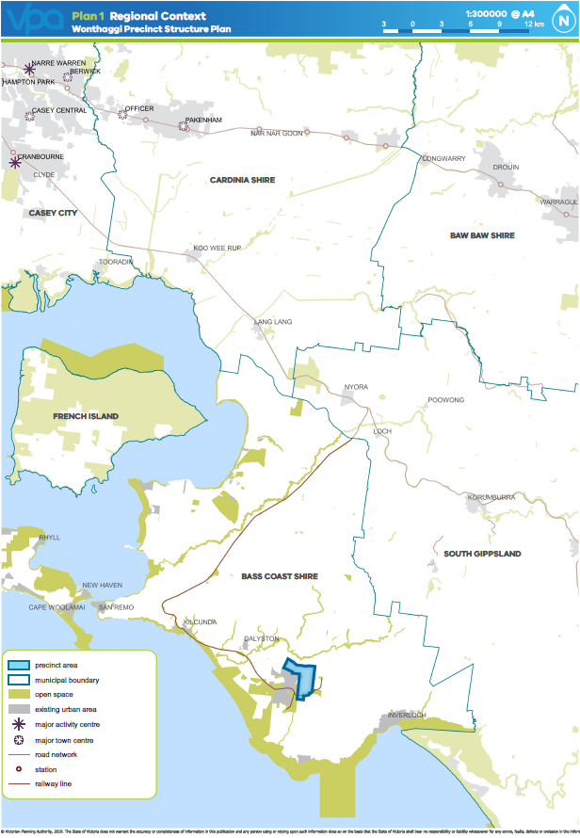

Strategic Context

State context
Wonthaggi is located in the Bass Coast Shire approximately 135 kilometres from the Melbourne CBD and currently has a population of 35,534 (2020 .id consulting). It has a mix of commercial, industrial, open space and public parks and residential areas.
Plan Melbourne sets out the State’s strategic vision for population and employment growth in the city of Melbourne and state of Victoria through to 2050. A direction of Plan Melbourne is to promote the growth of regional Victoria. It seeks to cater for future housing needs in regional Victoria by ensuring that housing change areas are defined, such as redevelopment sites and areas suitable for growth development, to support long-term housing growth, choice and diversity for a range of household types. Plan Melbourne outlines the expected population of the regions to growth from 1.5 million to 2.2 million by 2051. Bass Coast Shire is a regional centre (see Figure 2) and is located 135km from Melbourne. The development of Bass Coast should be in keeping with its existing character, balanced with the protection of the coastal environment, agricultural and horticultural land, economic resources, heritage and biodiversity assets that are critical to Victoria’s continued economic and environmental sustainability.
Policy 7.1.2 of Plan Melbourne identifies peri-urban areas that have the potential to accommodate housing and employment generating development, including Wonthaggi. The policy states:
‘Peri-urban towns can provide an affordable and attractive alternative to metropolitan living. However, strategies need to be developed for the timely delivery of state and local infrastructure to support growth and protect their significant amenity.
Most importantly, development in peri-urban areas must also be in keeping with local character, attractiveness and amenity. Growth boundaries should be established for each town to avoid urban sprawl and protect agricultural land and environmental assets’ (Plan Melbourne 2017-2050)
Wonthaggi has established itself as a regional hub providing for employment, education, health, sports and recreation. It is host to a large employment base and serves the surrounding towns including Dalyston, Kilcunda, Cape Paterson and Inverloch as well as the rural hinterland, and parts of South Gippsland through its supermarkets, hospital, schools and markets.
A direction of Plan Melbourne is to promote the growth of regional Victoria. It seeks to cater for future housing needs in regional Victoria by ensuring that housing change areas are defined, such as redevelopment sites and areas suitable for growth development, to support long-term housing growth, choice and diversity for a range of household types. Plan Melbourne outlines the expected population of the regions to growth from 1.5 million to 2.2 million by 2051. Bass Coast Shire is a regional centre (see Figure 2) and is located 135km from Melbourne. The development of Bass Coast should be in keeping with its existing character, balanced with the protection of the coastal environment, agricultural and horticultural land, economic resources, heritage and biodiversity assets that are critical to Victoria’s continued economic and environmental sustainability.
Figure 2 Victoria’s connected cities and regions in Plan Melbourne
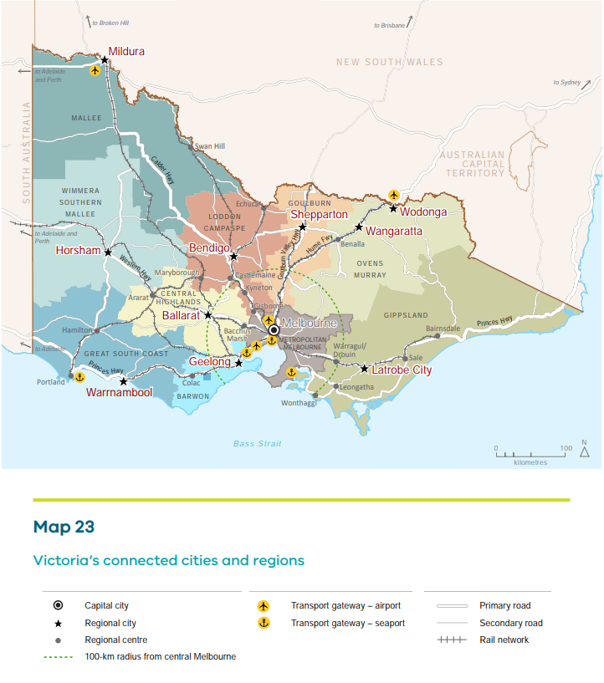

Gippsland Regional Growth Plan 2014
The Gippsland Regional Growth Plan (Department of Transport, Planning and Local Infrastructure, 2014) identifies Wonthaggi as a regional centre and part of a key sub regional network of towns to accommodate growth in regional Victoria. Significant investment in physical and social infrastructure is required to support such growth. It specifically identifies the future Precinct as a “Key residential growth front” (see Figure 3). The plan nominates future growth population within the Precinct as accommodating an additional 12,000 residents, equating to approximately 5,000 new dwellings.
Figure 3 Wonthaggi Urban Growth Framework in the Gippsland Regional Growth Plan
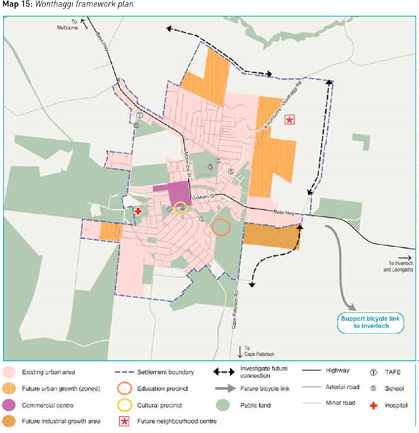

Local Context & Surrounding Areas
The Wonthaggi North East precinct is generally existing rural land. The land within the precinct is made up of properties zoned farming, general residential, low density residential, commercial 2 zone, industrial 1 zone and public use zones. The majority of the land zoned general residential and commercial 2 zone is also covered by the Development Plan Overlay Schedule 21 (Wonthaggi North East Growth Area).
The precinct sits within the north-eastern extent of Wonthaggi with views of the Strzelecki ranges and foothills. The precinct is bounded by the Heslop Road immediately north and Powlett River further north, Fuller Road to the west, Bass Highway runs in an east-west direction within the southern extent of the precinct and the Korumburra-Wonthaggi Road runs diagonally in a north south direction within the north west extent of the precinct.
Wonthaggi is historically known as a State Coal Mine town with a rich and diverse heritage. The State Coal Mine was open in Wonthaggi in 1909. By 1912, the mine employed 1,200 workers who moved to the town with their families. This led to the early construction of civic buildings like churches, the Workers Club, Wonthaggi Hospital, the Union Theatre and several other buildings across Wonthaggi which are significant at a state and local level.
Road infrastructure within the township is largely the legacy of previous land use practices such as the co-location of industrial land with an internal highway system and also the necessity for highways to traverse the town centres for convenience purposes.
Wonthaggi is the largest town within the Bass Coast Shire and is the municipality’s regional centre (see Figure 4). The town has the employment, shopping and business environment of a Regional Centre, having multiple supermarkets, national chain store retail and independent traders.
It also provides for a new State Secondary School and many primary schools as well as early learning services. Wonthaggi also has major sporting and recreational facilities including the Rail Trail which acts as a connection from Wonthaggi to Phillip Island and into South Gippsland.

Population and land supply
A land supply analysis of Wonthaggi has indicated that the Wonthaggi North East Growth Area combined with existing vacant lots (zoned as GRZ or LDRZ) is adequate to meet the demand for residential land for the next 30-50 years.
The area will undergo a full transition of land use as part of large-scale residential development with considerable population increase and demographic change, with commercial areas and community facilities to support it. Wonthaggi North East will be home to 12,000 residents in the next 20-30 years, contributing to the projected population increase to 46,429 within the Bass Coast Shire by 2036 (.id consulting). The 2020 population for the ‘Wonthaggi District’ which includes Wonthaggi North, Wonthaggi, South Dudley and Cape Paterson, is 6,958 and is forecast to grow to 9,269 by 2036. The population growth in ‘Wonthaggi District’, is significantly higher than overall population growth for Bass Coast Shire. (.id consulting)
Wonthaggi is an established regional hub that services areas both within and beyond the municipal boundary. It provides for employment, education, health, sports and recreation. The PSP is envisaged to be a multi-functional regional employment area that provides a greater mix of jobs. A significant industrial and commercial employment area is identified on the Bass Highway to the south east of the development area. Providing an addition to the existing employment land in this part of the Shire. Village hubs and a convenience centre will also provide opportunities for employment within the centre of the growth area. The delivery of community infrastructure such as a school, community centre also provides employment opportunities.
Figure 4 Wonthaggi District area map
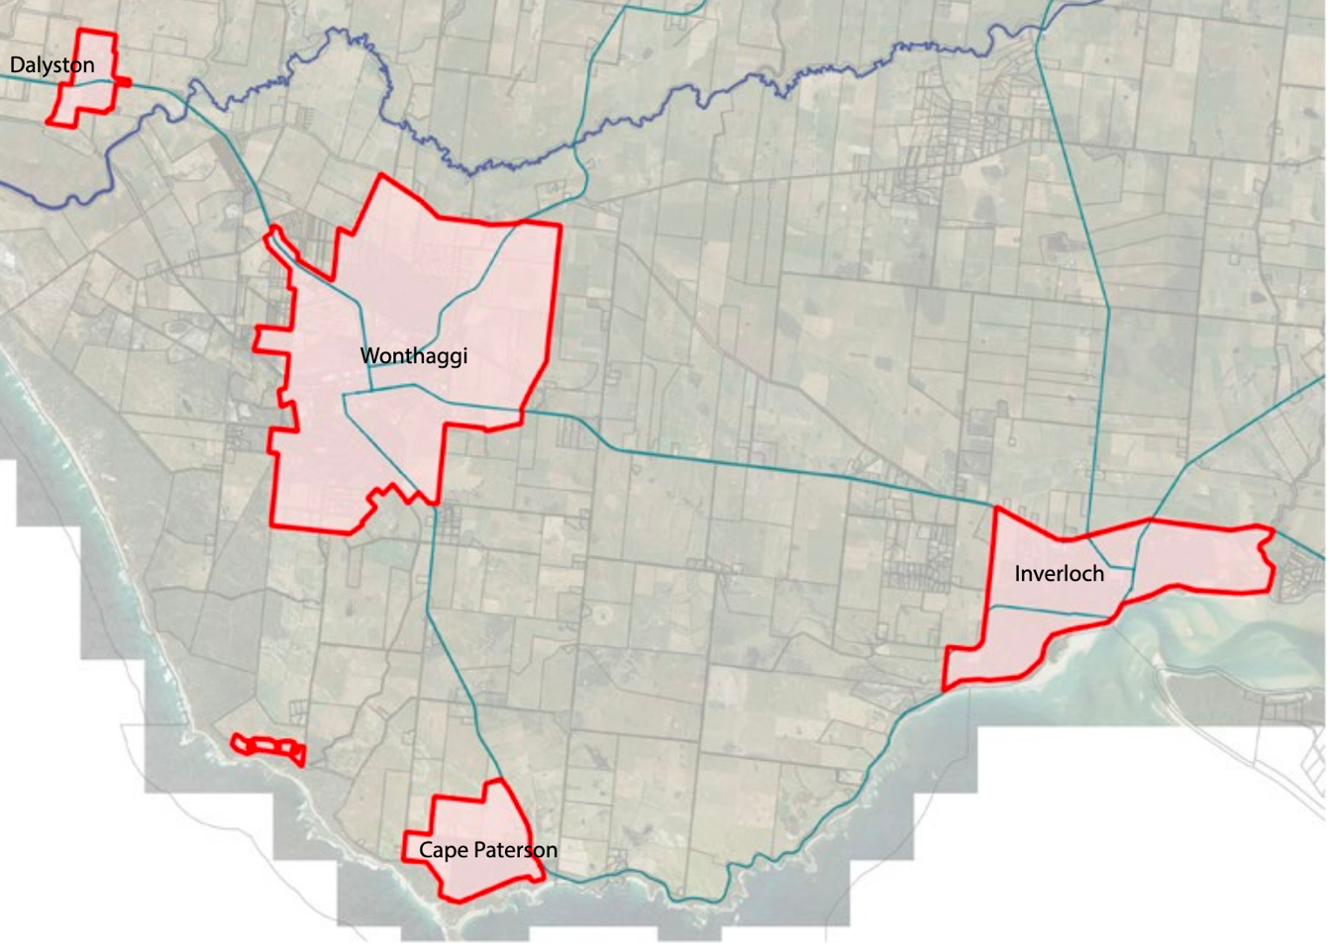

Planning Scheme Amendment & Structure Plan History
Wonthaggi is identified as a ‘high growth’ regional centre through the state and local policy and has been identified as having high spatial growth capacity and encourages large scale residential growth within the township boundary, particularly within the north east growth area.
The area currently included in the Wonthaggi Strategic Framework Plan (which includes the PSP) is adequate to meet land supply needs. Therefore, implementing the PSP is critical in meeting the land supply and housing needs.
Table 1 Amendment History
Amendment No & Year | Amendment Area
C113 (2010) | Introduces new policies into the MSS for the Wonthaggi and Dalyston townships, introduces Development Plan Overlay 21. Clause 21.10 Local Areas - Clause 21.10.11 Wonthaggi – references the Wonthaggi Strategic Framework Plan and the plan. Introduces the Wonthaggi - Dalyston Structure Plan September 2008 and the Wonthaggi North East Growth Area Development Plan November 2009 into the planning scheme as a reference document.  Rezoned land within the Wonthaggi North East Growth Area from Farming Zone to General Residential Zone.
C116 (2011) | Rezoned land at Bass Highway, Wonthaggi from Farming Zone to Business 4 Zone and Industrial 1 Zone.
C133 (2013) | Implemented the findings of the Bass Coast Planning Scheme Review (2011).
Structure Plans
2008 | Wonthaggi-Dalyston Structure Plan May 2008 – was prepared by Coomes Consulting and was adopted by Council in 2008. The structure plan is a combined document for the townships which identifies the preferred direction for future growth and how it will be managed for the long term. The structure plan became the central strategic document which identified the study area and outlines development for the area which includes an implementation plan and the application of a Development Plan Overlay.  The structure plan was prepared in response to a review of the MSS in 2003 which recommended that a structure plan be prepared for the townships. The structure plan acknowledged that the wider Wonthaggi - Dalyston area was experiencing significant growth and change in addition to Wonthaggi emerging as a major centre within the West Gippsland region.  The structure plan was informed by the Coastal Spaces Recommendations Report 2006 which recommended that the settlements of Wonthaggi and Dalyston apply a coastal settlement boundary to contain urban growth.  There have been significant changes to the SPPF and LPPF since this structure plan was prepared, such as the inclusion of Plan Melbourne 2017 and the Gippsland Regional Growth Plan in 2014 which identified Wonthaggi as a regional centre and encouraged growth.
2009 | Wonthaggi North East Growth Area Development Plan (WNEGA) 2009 - The need for the Development Plan was triggered by the Wonthaggi – Dalyston Structure Plan, which established a strategic direction for future use and development in Wonthaggi and Dalyston. The Wonthaggi North East Growth Area (WNEGA) Development Plan was prepared by CPG Australia for Council in 2009. It created the Development Plan and concept plan for an area within the north east to inform how it would be developed. The Development Plan has been informed by the significant base of technical information that has been prepared by consultants.
2018 | Wonthaggi Structure Plan 2018 – The structure plan supersedes the Wonthaggi - Dalyston Structure Plan 2008. The Wonthaggi Structure Plan sets out a 20-year strategic framework to consider the potential growth options for Wonthaggi. A range of State Government and Bass Coast Shire Council policies informed the development of the structure plan.  The Wonthaggi North East Precinct Structure Plan (WNEPSP) was adopted by Council in June 2017.  The vision from the Wonthaggi - Dalyston Structure Plan 2008 (Coomes Consulting 2008), remains relevant to the 2018 Structure Plan as it supports the ongoing development of Wonthaggi as a regional centre for South and West Gippsland, encourages physical activity, facilitates community interaction and respects the environment.

Wonthaggi Strategic Framework Plan
The Wonthaggi Strategic Framework Plan, is included as a reference document to the Bass Coast Planning Scheme and also within Development Plan Overlay Schedule 21 and the Municipal Strategic Statement related to the town.
The Wonthaggi Strategic Framework Plan establishes a direction for the future physical form of Wonthaggi in that it identifies the preferred location for the various forms of land uses within the township. Wonthaggi consists of a wide mix of land uses including retail, business, residential, community, recreational and environmental uses. Economic and population growth has seen Wonthaggi evolve into the primary service centre for the municipality.

The commercial land to the south of the Bass Highway has been refined to industrial land to cater for a shortfall of provision in that area, and an oversupply of commercially zoned land.
Figure 5 Wonthaggi Strategic Framework
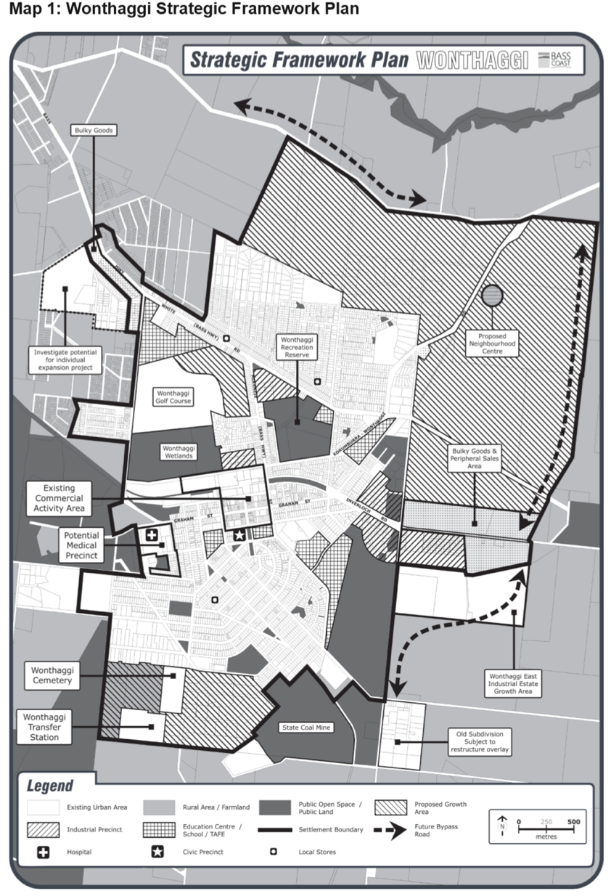

Physical Context

Current zone, Overlays and Land Uses
A number of multi lot residential subdivisions are currently under construction within the General Residential Zone within the precinct boundary. The majority of residential land within Wonthaggi is zoned General Residential Zone (GRZ) with some lots zoned Low Density Residential Zone (LDRZ) towards the outskirts of Wonthaggi. The precinct has significant land zoned as Farming Zone (FZ) whilst other zones include the Public Use Zone (PUZ1), Industrial 1 Zone (IN1Z) and Commercial 2 Zone (C2Z) within the southern portion of the precinct, (Figure 6).
The following overlays apply within the precinct; Development Plan Overlay 21 (DPO21) applies to the land within the precinct shown as GRZ1, parts of the precinct are within the Environmental Significance Overlay 4 (ESO4) and Land Subject to Inundation Overlay (LISO) to the far most northern extent of the precinct boundary.
The surrounding area within the precinct is characterised as generally rural land with dwellings used for a variety of farming purposes to the north, east and south. A small area of industrial land exists to the south and farming land beyond the southern extent. Land immediately to the west is the existing area of Wonthaggi which consists of residential housing immediately abutting the precinct boundary.
Figure 6 - Zone Map - Vic Plan
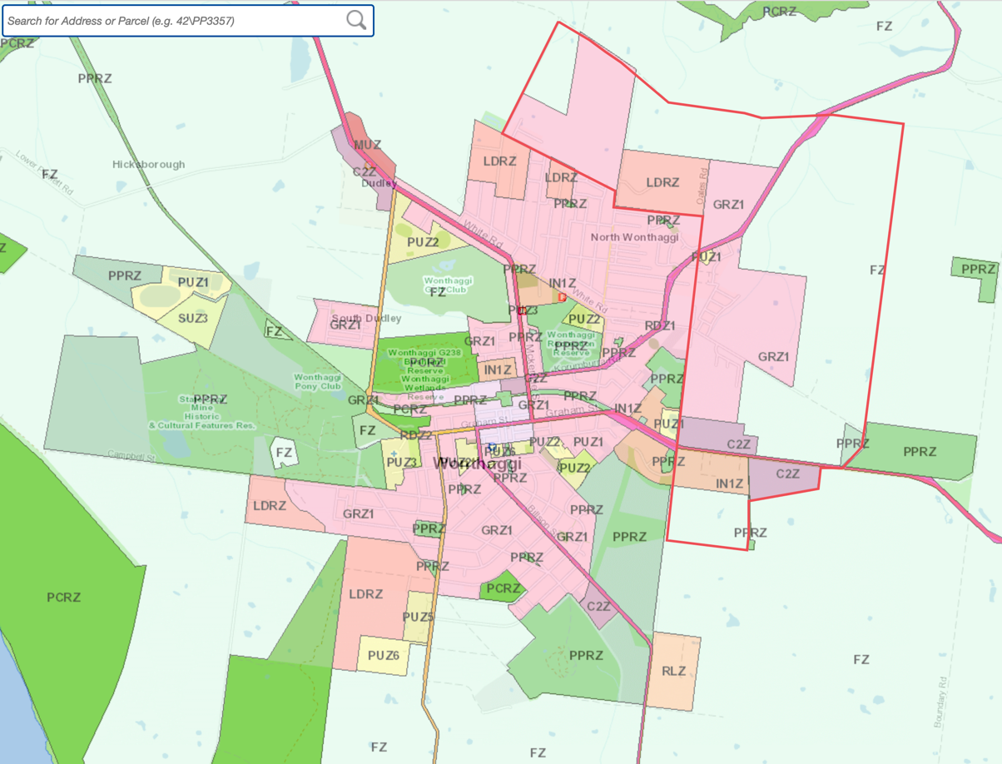

Lot Size & Land Ownership Pattern
Lot sizes and land ownership patterns within the precinct are variable. Lot sizes within the north, east and southern parts of the precinct consist of larger parcels of land, ranging from 20 hectares to 104 hectares. There is an area of Low Density Residential Zone land within the northern area of the precinct with lifestyle properties with lot sizes that range from 0.7 hectares to 2.16 hectares.
The typical lot sizes within Wonthaggi are low-density in nature with significant variation in the built form typologies ranging from old heritage style homes to contemporary styles. Wonthaggi has an inconsistent built form and typology with significant variation. Building height is predominantly single storey. New development is emerging which is typical of the current trends with regard to the lot size and dwelling type.
The land within the precinct generally accessed by Regency Drive is zoned Low Density Residential. The Planning Scheme Amendment will facilitate development of the low-density zoned land for residential use with a greater intensity. The PSP will ensure development is integrated into the wider structure plan and will ensure an appropriate interface with the existing township.

Topography
Wonthaggi is located on the Bunurong Coastal and Powlett River lowlands. The Powlett River system is located approximately 650 metres from the northern extent of the precinct (Heslops Road). Powlett River traverses around the north eastern edge of Wonthaggi, through Dalyston, eventually flowing out into the ocean.
The areas surrounding Wonthaggi north can be characterised as having many points of interface with the wider natural landscape with pastoral uses dominating the landscape area across the open rural hinterland. Low rolling topography provides opportunities for open rural views in the hinterland. The northern edge of the pastoral plains is defined by the Strzelecki foothills, which rise steeply from the surrounding coastal plains provides a topographic backdrop to viewing. There is some scattered remnant vegetation, riparian reserves and exotic shelterbelts within the farmland areas. The landscape has been cleared for grazing and is characterised as open pastures.
The Environmental Significance Overlay 4 (ESO4) applies to land within the south east area of the precinct. The overlay refers to ‘Land Subsidence’ specifically the former coal mining activities which have made the land susceptible to land subsidence.

Historic Heritage
Wonthaggi’s history as a State Coal Mine town has resulted in existence of civic heritage buildings and houses. Wonthaggi hosts several buildings and places which feature heritage significance and contribute to the township character.
Wonthaggi has a low-density feel with significant variation in the built form typologies, ranging from old heritage houses and buildings to contemporary buildings.
Dwellings tend to be sited towards the front of allotments to provide for secluded area of private open space to the rear. Several notable heritage buildings are located in the town centre and occupy prominent corner sites. Street trees feature in some streets however their contribution overall is limited.
The character of Wonthaggi is influenced by landscaping, public spaces of the settlement, including its streetscapes, and buildings on private land. In addition, at a finer grain, building height, form and material contributes to influencing the character of the street and the precinct.
Bass Coast Shire is currently preparing a Heritage Gaps Assessment (2020) to assist with managing local heritage. At the time of writing this report no listed high or very high priority areas are found within the PSP area.

Cultural Heritage
Bass Coast Shire commissioned Triskel Heritage Consultants to prepare an Aboriginal cultural heritage survey report, the Wonthaggi North East Growth Area: Aboriginal Cultural Heritage Survey (May 2017) for the Wonthaggi North East PSP. The analysis required prediction of likelihood of cultural heritage occurring within the area, mapping potential cultural heritage, first person and visual surveys of parcels with the greatest potential of cultural heritage, intensive site assessments based on background research and a provision of findings and recommendations.
Areas of archaeological potential, including crests, rises and slopes, were found across the area, but no artefacts or archaeological features were identified. Consultation with Bunurong Land Council indicated that little is known of the broader region, so anything could be found across the area. One burial is known, and stone axes have been found. Consultation highlighted the landscape as important and sensitive to the Bunurong community, and further detailed cultural heritage work has been requested in collaboration with the land’s Traditional Owners.
No artefacts or archaeological features were identified during the survey, however the only area where archaeological potential can be ruled out is the electricity substation at corner of Benetti Road and Korumburra Road. Prior to European contact, this landscape likely contained wetlands, and it remains technically possible that archaeological deposits associated with resource acquisition from these environments may have survived.
It was recommended that a voluntary CHMP be carried out for developments in areas assessed as having moderate or high Aboriginal archaeological potential. It is strongly recommended that Council and developers continue to consult and engage with relevant Traditional Owners through the current PSP process as well as any more focused studies in the future, including CHMPs. An additional area to the south also contains landforms of high archaeological potential. In order to refine the Aboriginal Cultural Heritage potential of this area, further assessment in the form of an archaeological survey with the participation of Traditional Owners is recommended.
Where conservation of areas of Aboriginal cultural heritage is not possible due to conflict with future development, and disturbance has been approved through a CHMP, the process of disturbance should be managed through a program mitigation involving research, analysis and interpretation of the cultural heritage that is disturbed. A research design and methodology should aim to identify the character of Aboriginal occupation of the area, mitigate disturbance in the form of archaeological salvage, and interpret the heritage.
Figure 7 - Areas of Aboriginal Cultural Heritage potential
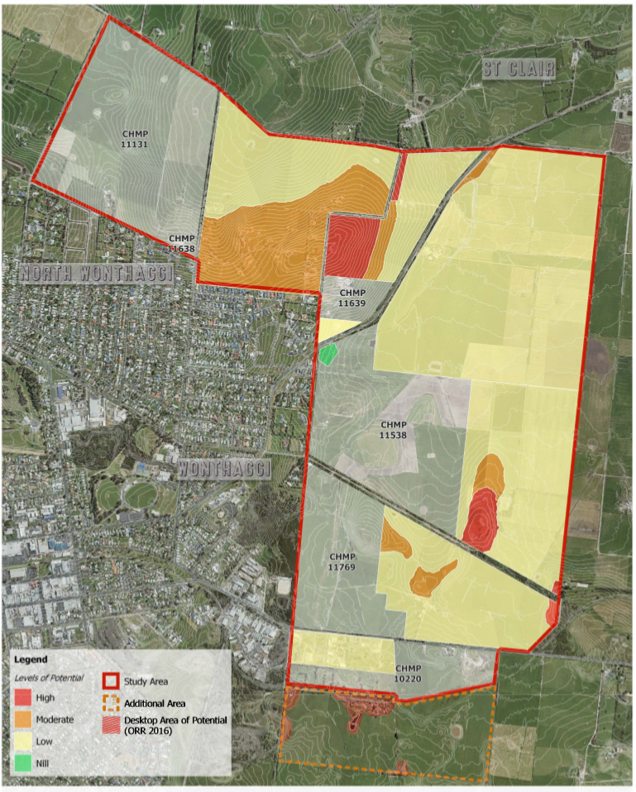

Vegetation
Council commissioned Nature Advisory to prepare the Wonthaggi North East Precinct Structure Plan Flora and Fauna Assessment (May 2020). The scope of the investigation included; reviewing existing information on the flora, fauna and native vegetation of the study area and surrounds, an initial site survey (which was undertaken in February 2016), and additional site surveys which were conducted in February 2018.
Native vegetation recorded throughout the PSP area predominantly comprised Swamp Scrub, which is primarily situated along roadsides. Vegetation from the following Ecological Vegetation Classes (EVCs) were also present across the site:
- Damp Sands Herb-rich Woodland (EVC 3)
- Lowland Forest (EVC 16)
- Grassy Woodland (EVC 175)
- Tall Marsh (EVC 821)
- Swampy Woodland (EVC 937)
A total of 61 remnant patches of native vegetation comprising the above listed EVCs were recorded in the PSP area (or adjacent to). A total of 14 large trees were recorded within patches. In addition, 122 scattered indigenous canopy trees occurred throughout the site, of which 24 were large and 98 small scattered trees.
Fauna habitat included agricultural, treed and aquatic habitats. Roadside vegetation provided the main habitat corridors throughout the site, connecting with other adjoining treed habitats. Aquatic habitats were largely limited to farm dams, however, one large wetland existed amidst the scrub north west of the intersection of Bass Hwy and Carneys Road. One area of aquatic habitat (north west of the proposed roundabout at Carneys Road) has the potential to support Growling Grass Frog.
The Native Vegetation Precinct Plan will:
- Ensure there is no net loss to biodiversity as a result of the approved removal, destruction or lopping of native vegetation. This is achieved by applying the three-step approach in accordance with Clause 12.01-2S Native vegetation management, Clause 52.16 and the Guidelines;
- Apply a landscape approach to the management of native vegetation within the NVPP area, in accordance with Clause 12.01-1S Protection of biodiversity and Clause 21.04-3 Biodiversity Conservation and Protection.
- Manage native vegetation to be retained in accordance with obligations under the Catchment and Land Protection Act 1994.
- Ensure that areas set aside to protect native vegetation are managed to conserve biodiversity and other values in accordance with the PSP;
- Ensure that the Tree Protection Zones of trees within patches and scattered trees are protected in accordance with the Australian Standard AS4790-2009;
- Provide for the long-term preservation of the flora and fauna and associated habitat of environmentally significant areas;
- Protect and enhance remnant native vegetation and associated habitats along Korumburra – Wonthaggi Road, McGibbonys Road and the tree reserve within the employment area.
- Manage impacts on protected native vegetation from recreational facilities and infrastructure.
One listed migratory bird species, Latham’s Snipe, was recorded in the study area, and additional fauna species that have the potential to occur in the area include:
- Eastern Great Egret (Flora and Fauna Guarantee (FFG) Act listed)
- Fork-tailed Swift (Environment Protection and Biodiversity Conservation (EPBC) Act listed Migratory)
- Growling Grass Frog (EPBC Act listed vulnerable)
- White-throated Needletail (EPBC Act listed Migratory)
It is believed that there will be no impacts to Matters of National Environmental Significance protected by the EPBC Act and species protected by the FFG Act from the current development. This will be confirmed through targeted spring surveys to confirm whether there are any of the above species present and to confirm that the development will not create any significant impact.
Overall 14 large trees are prepositioned to be removed in the North East PSP, including 10 large scattered trees and 4 large trees in patches of native vegetation. As the proposed removal of native vegetation is less than 10 hectares, a Referral to the state Minister for Planning would not be required under the Environment Effects Act 1978. Such removal of native vegetation would be assessed under the Detailed assessment pathway, trigger a referral to DELWP and result in the following offset requirement:
- 1,744 general habitat units, with a minimum strategic biodiversity value score (SBV) of 0.338 and be located within the West Gippsland Catchment Management Authority (CMA) area or the Bass Coast Shire Council.
- The protection of 14 large trees.
No threatened ecological communities, flora or fauna species are likely to be impacted, though a Protected Flora Permit would be required from DELWP to remove any of the following flora, which may be present in the area:
- Acacia
- Senecio
- Xanthorrhoea
In addition to the utilisation of the NVPP, the Plan 3 – Future Urban Structure of the PSP has also responded to existing native vegetation where relevant. This has primarily been conducted through the identification of tree reserves on the plan, in areas where large patches of significant native vegetation have been identified for retention. Subdivisions throughout the Wonthaggi North East area will have the ability to incorporate established trees into subdivision layouts to enhance the residential landscape character of new subdivisions. The Native Vegetation Precinct Plan provides guidance to prospective developers around which native trees and vegetation patches are recommended for retention.
Nature Advisory’s Vegetation Assessment was undertaken by senior botanists who are qualified through DELWP in native vegetation quality assessments (habitat hectare assessment). The botanists are highly trained to distinguish between native vegetation and non-native vegetation as defined by DELWP’s Guidelines. It is noted that all vegetation that is not mapped and included in report figures is either planted or non-native vegetation.

Bushfire Threat
Terramatrix were commissioned to undertake a Bushfire Development Report and a bushfire hazard site and landscape assessment in accordance with the Bushfire Management Overlay (BMO) application requirements for the Wonthaggi North East PSP.
Following consultation with the CFA and Bass Coast Shire Council, Terramatrix were commissioned to prepare an Addendum to the Bushfire Development Report to revise assumptions about the BAL 12.5 setbacks required for waterways and wetlands within the PSP.
The entire precinct area is currently a designated Bushfire Prone Area (BPA). Land within approximately 150m of the Woodland and Scrub in the Wonthaggi Bushland Reserve adjacent to the western boundary of the PSP area, comprising approximately 3.6% of the precinct, is also covered by the BMO.
The WNEPSP area is in a low bushfire risk landscape. There are low risk urban-residential and township areas immediately adjacent to the precinct that are not in the BPA and which offer protection from any bushfire that may occur.
Overall, the topography on and around the precinct is benign, with no significant changes in elevation or slopes that would significantly exacerbate the bushfire attack. For the purpose of determining BALs and commensurate setbacks from classified vegetation, the applicable slope class is 'All slopes and flat land'.

If parts of the PSP become eligible for excision from the BPA as urban development permanently removes the bushfire hazard, BAL-LOW would apply, i.e. no specific construction requirements for bushfire protection.

Bushfire hazard identification and assessment strategies
Schedule 1 to the BMO (BMO1) is appropriate to part of the small area of the WNEPSP affected by the BMO. The BMO1 bushfire protection measures include a BAL-12.5 construction standard for a dwelling, with defendable space for 30m or to the property boundary, whichever is the lesser distance.
Good access and egress for emergency management vehicles and residents, in the event of a bushfire, can be achieved via a conventional residential road network. The proposed perimeter roads shown in the future urban structure plan are incorporated to achieve the BAL-12.5 separation distances for future development from any potentially hazardous vegetation, and to facilitate property protection and firefighting. Access standards for driveways are applicable in BMO areas.
A reliable water supply for firefighting can be provided via a conventional reticulated hydrant system in accordance with the hydrant objective for residential subdivision at Clause 56.09-3.
The risk to existing residents will be reduced by the development of additional low threat or non-vegetated land.
Neither the existing or future zones or overlays (apart from the BMO) have any significant bushfire safety implications, and the existing bushfire controls in the planning and building system can be deemed adequate to address bushfire risk.

Planning and Design response

Building setbacks
Future dwellings, and other buildings requiring a BAL, will be sufficiently setback from classified vegetation to enable a BAL-12.5 construction standard. The setbacks required for Grassland, Woodland and Scrub, based on the hazard assessment in Bushfire Development Report are shown in Table 3 in the Bushfire Development Report and on Map 7, Map 8 and Map 9 in the Addendum to the Bushfire Development Report.
The future form of vegetation in the north-western and north-eastern drainage reserves and waterways previously assumed as ‘scrub’ in the Bushfire Development Report will be maintained in a low-threat state by Council, no longer requiring development to have a setback distance of 27m from these areas to achieve a 12.5 BAL rating.
If future buildings are setback sufficiently (see Table 2 - Building Setbacks for BAL 12.5) from any hazardous vegetation such that they achieve a construction standard of BAL-12.5 or lower, then the bushfire risk can be deemed to be acceptably mitigated.
Applicable setbacks for BAL-12.5 construction in BPA and BMO parts of the precinct are shown in the following table.
Table 2 Building Setbacks for BAL-12.5

No setbacks are needed from areas of unmanaged vegetation that meet one or more of the exclusion criteria for low threat vegetation (see Section 5.1.4), including:
- Single areas of vegetation less than 1ha in area and at least 100m from other areas of classified vegetation;
- Multiple areas less than 0.25ha (2,500m2) in area that are at least 20m from a building or each other; and
- Strips of vegetation less than 20m wide that are at least 20m from a building, other strips or any other area of classified vegetation.
In parts of the PSP area covered by the BMO, the setbacks comprise defendable space that would need to be managed to the standards stipulated in Table 6 to Clause 53.02-5.

Vegetation beyond the PSP boundary
Development adjacent to the perimeter of the PSP will respond to classified vegetation beyond the PSP boundary, including providing the requisite setbacks to achieve BAL-12.5 .
Most of the PSP is bounded by Grassland, including to the northwest beyond Fuller Road, to the north beyond Heslop Road, and beyond most of the eastern and southern boundaries.
Exceptions are to the west, where the Wonthaggi Bushland Reserve comprises Scrub and a small area of Woodland; to the southeast where Scrub is adjacent to Sharrock Road; and to the southwest where Scrub borders the existing industrial area.
It has been proposed that land within the PSP area adjacent to the Wonthaggi Bushland Reserve be used as sports grounds for a school outside the PSP. This use is supported as the large low threat area of the sports grounds will buffer residential development to the east from the bushfire hazard.

Excision of areas from the BPA
It is likely that as development progresses, much of the land within the PSP will become eligible to be excised from the BPA. DELWP review and excise areas from the BPA approximately every 6 months, particularly in growth areas where the hazard is removed as urban development occurs.
Reliably low threat urban areas become eligible for excision if they satisfy state-wide hazard mapping criteria, including that they would need to be:
- At least 300m from areas of classified vegetation (except grassland) larger than 4ha in size; and
- At least 150m from areas of classified vegetation (except grassland) 2 to 4ha in size; and
- At least 60m from areas of unmanaged grassland more than 2ha in size.
For isolated areas of vegetation greater than 1ha but less than 2ha, the shape of the area and connectivity to any other hazardous vegetation will be a consideration.
Areas of the PSP that may be eligible for excision as urban development progresses are:
- Land more than 60m from classified Grassland, i.e. from the pasture outside the WNEPSP area; and
- Land more than 300m from classified Woodland or Scrub in the Wonthaggi Bushland Reserve, along the McGibbonys shared trail and in the waterway and drainage reserves.
Excision from the BPA would enable BAL-LOW construction in these areas.

BMO schedule
The BMO affects a small area of the PSP, within approximately 150m of the Woodland and Scrub of the Wonthaggi Bushland Reserve adjacent to the western boundary of the PSP area.
As future dwellings and other buildings are to be located where a BAL-12.5 construction standard (or BAL-LOW) can be achieved (i.e. providing setbacks for future buildings from unmanaged vegetation, such that radiant heat impacting upon the buildings can be expected to be below 12.5kW/m2), it is considered that the small area of future residential development that would be affected by the BMO will be suitable for application of the existing BMO1 schedule in the Bass Coast Planning Scheme.
This potential BMO1 area in the PSP is shown in Map 10 of the Addendum to the Bushfire Development Report. It is considered appropriate for BMO1 coverage as:
- The bushfire hazard in the Wonthaggi Bushland Reserve will remain, and require a planning response, following development of the precinct;
- The simplified application requirements of the BMO1 apply to applications to construct or extend one dwelling on a lot, which is therefore applicable to the proposed residential area in the WNEPSP; and
- Future dwellings and other buildings are to be located where a BAL-12.5 construction standard applies, hence the BMO1 requirements, which include a BAL-12.5 construction standard, are appropriate.
.

Contamination

Soil contamination
A Contaminated Land Investigation and a Phase 1 Preliminary Site Investigation (PSI) was undertaken by GHD. The Contaminated Land Investigation sought to identify potential contaminants within the soil that may constrain the development of the land. The assessment stated that the prior use of the land for farming purposes may lead to the potential for accumulation and/or concentration of contaminants (associated with agricultural land use) in drainage channels.
GHD conducted an inspection of the study area on 2 December 2015 to identify possible contaminating activities and to confirm land use identified as potentially contaminating. The inspection included only visual inspections from publicly accessible property boundaries and roadways. Potential areas of concern, as identified in Figure 13 below, and detailed in Table 8 and Appendix G of the Contamination Study, include dams (areas of disturbed land and fill), water / storage tanks, general storage of waster or scrap materials, light industrial areas (predominantly to the south of the precinct) and a possible former abattoir and possible former auto motive repair facility.
The assessment recommended that further studies, in particular the sampling of sediments within drainage channels to assess the potential for accumulation of contaminants, be undertaken before subdivision.
The Assessment of potentially contaminated land, completed in accordance with the DSE 2005, Potentially Contaminated Land Practice Note, identified the following
- 16 properties – High PFC Rating
- 70 Properties – Medium PFC Rating
- 27 Properties – Low PFC Rating
In the November 2020 version of the exhibited amendment, the following planning controls were proposed, consistent with the DSE 2005, Potentially Contaminated Land Practice Note.
- Assessment Level A properties: An Environmental Overlay Audit should be applied to these properties to ensure and environmental audit is carried out at the site prior to redevelopment to sensitive residential or associated land use
- Assessment Level B properties: A Phase 1 environmental site assessment will be completed on these properties, specifically in those areas identified as containing specific potential areas of contamination. A phase 2 ESA will be carried out depending on the size and identified potential contamination issues
- Assessment Level C properties: No further works will be carried out unless evidence of a potentially contaminating activities or sources of contamination are identified at a later date.
The Property Assessment Plan is shown in Figure 13.
Figure 13 Contamination - Property Assessment Plan
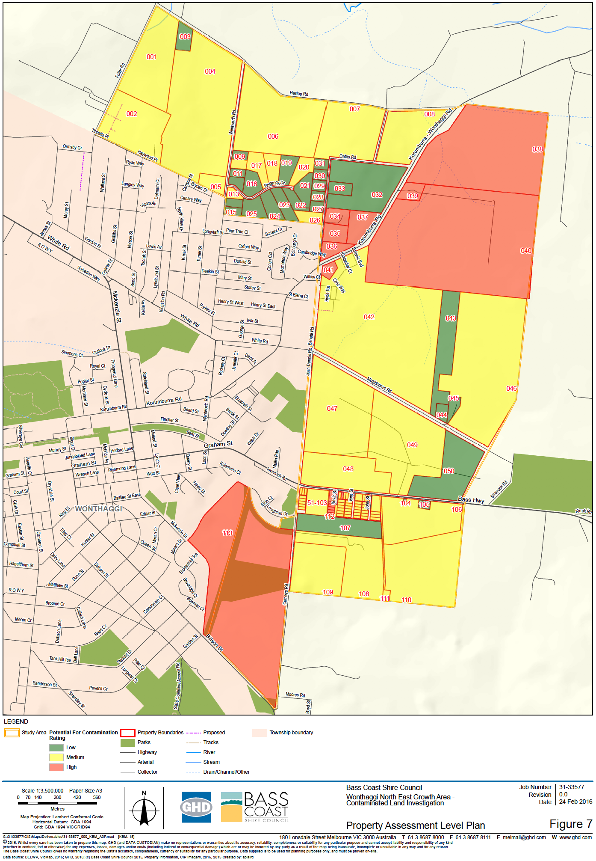

The Phase 1 PSI was conducted for properties identified as having ‘high’ potential for contamination through the initial Contaminated Land Investigation. The PSI identified 2 of the 16 properties with a ‘high’ potential for contamination were not required for further assessment, noting the below property numbers taken from GHD’s reporting do not align with the PSP Parcel Numbers nominated in the Wonthaggi North East PSP and DCP:
- Property 41 is a current Ausnet electricity substation which will remain as such.
- Property 113, which has been excised from the PSP.
Additionally, details of the owner of property 67 were not provided and therefore property 67 was not included as part of this assessment.
Based on the further targeted intrusive investigations the properties with ‘high’ potential for contamination were revised as follows:
Table 3 PFC Rating Table
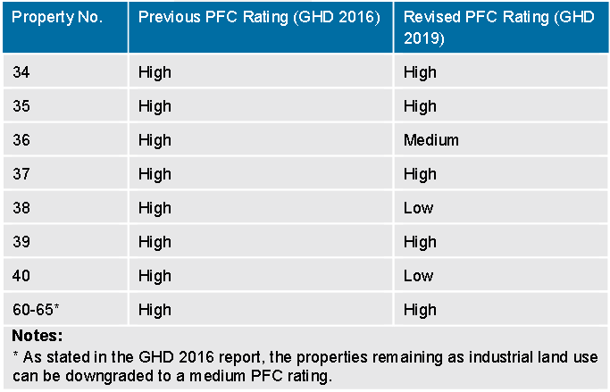
It was recommended that detailed Environmental Site Assessments (ESA) be undertaken at properties 34, 35, 37, 39 and 60 to 65 prior to development of the properties to evaluate the areas of potential contamination through the collection of further information such as soil and groundwater quality. It is noted that targeted ESAs to evaluate the identified areas of concern may either increase or reduce the PFC ratings and consequently the requirement for additional intrusive investigations or an EAO. No further works were considered necessary for properties 38 and 40, unless evidence of potentially contaminating activities or sources of contamination are identified at a later date.

Figure 14 Contamination - Potential areas of concern

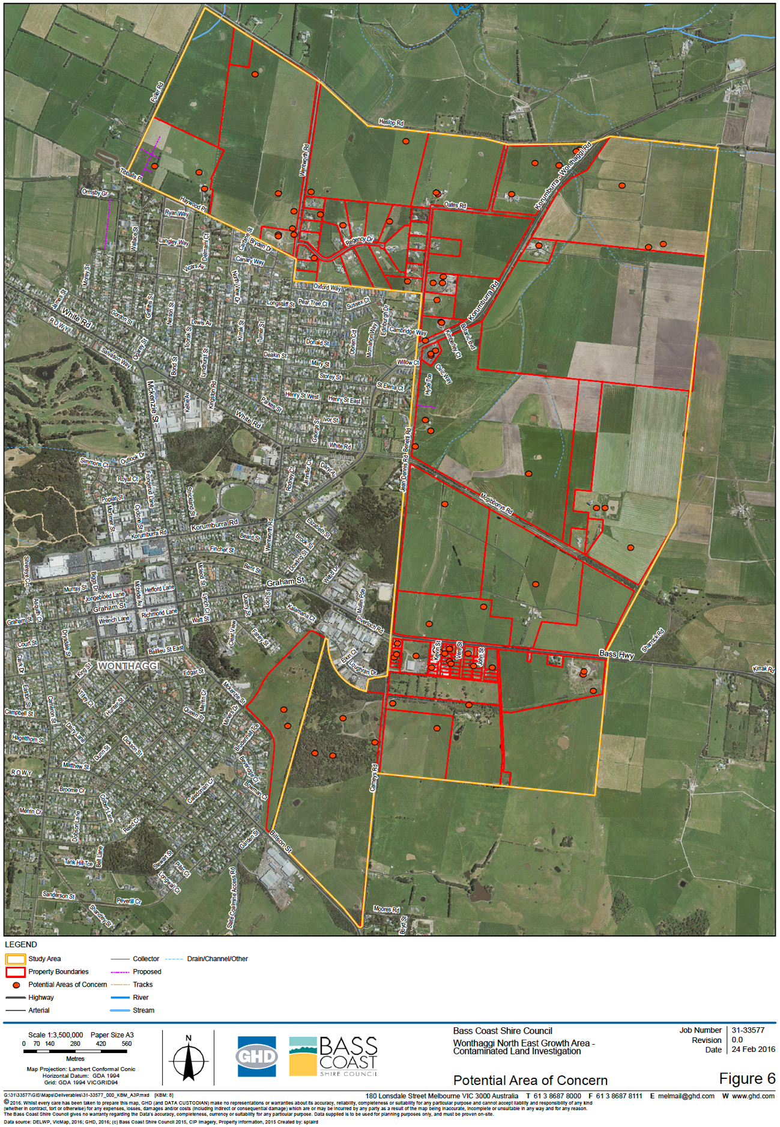

On 1 July 2021, the new Environment Protection Act 2017 came into effect, with an updated Ministerial Direction 1 (Potentially Contaminated Land) and an updated Planning Practice Note 30 – Potentially Contaminated Land (PPN30) accompanying the commencement of the new legislation. The new legislation and accompanying material provided updated guidance to planning authorities on how to ensure the risks presented by potentially contaminated land are appropriately considered and managed in planning scheme amendments involving the rezoning of land to sensitive uses.
The Environment Protection Authority provided written advice to the VPA on how the amendment documentation could be updated to ensure consistency with the new legislative framework. The new Act introduced two revised tools used to assess contaminated land risk, being a Preliminary Risk Screen Assessment (PRSA) and an Environmental Audit. As shown in Figure 15 below, PPN30 recommends a PRSA or Environmental Audit be undertaken for planning scheme amendments involving the rezoning of land that may facilitate sensitive uses.
PPN30 further states that the application of the Environmental Audit Overlay is the appropriate tool to defer conducting an Environmental Audit or PRSA as part of a planning scheme amendment to re-zone land. Accordingly, the Environmental Audit Overlay Map includes properties both:
- Identified in the GHD reporting as having a high or medium risk of contamination; and
- Identified for residential development in PSP Plan 3 – Future Urban Structure.
Medium-risk properties identified for future industrial development in PSP Plan 3 – Future Urban Structure have retained their requirement to undertake a PSI within the IPO Schedule as recommended by PPN30.
Figure 15 Excerpt from PPN30 showing recommended actions relating to potentially contaminated land
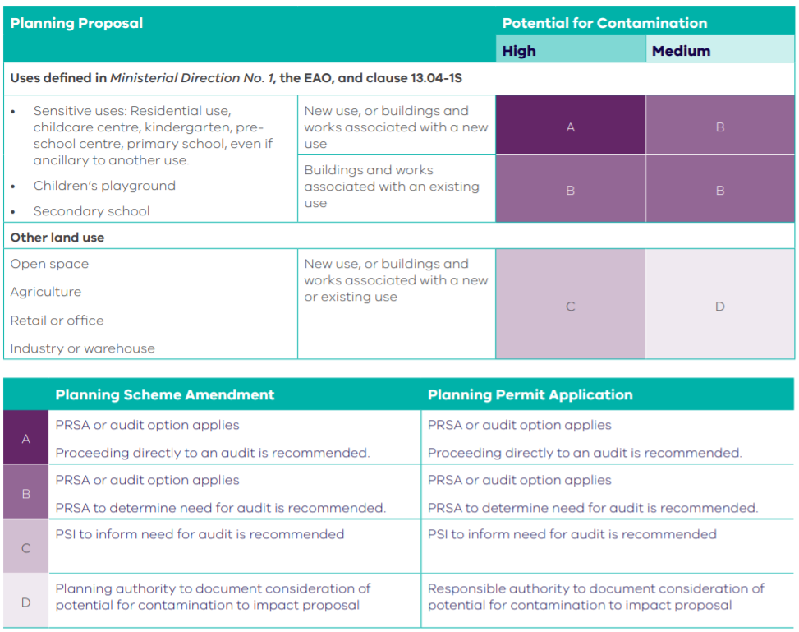

Adverse amenity impacts
The study area is currently used for mixed agricultural uses with predominating grazing paddocks and farm buildings / homesteads, with areas of low density residential and commercial/ Industrial land use in the northwest and south respectively. The area is currently zoned General Residential and Farming Zone with existing Mixed Use and Industrial 1 Areas to the south of the precinct which are to be retained in the PSP.
No existing noise or odour buffers impact the precinct. As of 9 December 2015, no properties within the precinct or within a 1km radius of the precinct have been issues with a Certificate or Statement of Environment Audit.

Public Transport
Wonthaggi is serviced by several regional buses, as summarised in Table 1.
The Wonthaggi town service is aligned in a circuit around the town. Travel times on the bus are greater than typical driving times. This is reflected in the relatively low mode share to bus presented later in this section.
Wonthaggi is also serviced by the Vline coach service (Cowes/Inverloch to Melbourne via Koo Wee Rup and Dandenong). The Vline coach services run an approximately 2 hour frequency service and off peak times.
Table 4 – Bus Services in Wonthaggi

Active Travel

Pedestrian Facilities
Pedestrian footpaths are generally provided on both sides of roads within the Wonthaggi town centre and on major roads accessing the town (such as Bass Highway and Korumburra- Wonthaggi Road). Pedestrian paths are provided on one side of Wentworth Road and Fuller Road accessing the PSP Area. In general, pedestrian footpaths are currently not provided on the lower order streets within residential areas of Wonthaggi.

Bass Coast Rail Trail
The Bass Coast Rail Trail is a 17km off-road trail that connects Wonthaggi with the townships of Kilcunda and Anderson to the west. The trail follows the former rail line that previously serviced the precinct. The trail is suitable for pedestrians, cyclists and horse riders. The trail terminates at the Billson Street (south of the McKenzie Street unused road reserve) after passing through the town.

Municipal Bicycle Network (MBN)
The Municipal Bicycle Networks (MBN) represent the core bicycle networks in regional Victorian cities and include existing and proposed on-road and off-road facilities and are managed by the responsible local Council. The MBN for Wonthaggi is shown in Figure 16. The Rail Trail and Cape Patterson Road bike lanes do not form part of the MBN.
Figure 16 - Municipal Bicycle Network for Wonthaggi

Road Network
Three arterial roads converge in the Wonthaggi township, These roads are managed by the Department of Transport.

Bass Highway
Bass Highway (M420/460) connects the South Gippsland Highway near Lang Lang to the north with Leongatha to the east of Wonthaggi. Bass Highway provides the primary connection between the Bass Coast Local Government Area and metropolitan Melbourne. It also provides the most convenient link between Wonthaggi and Inverloch to the east, further extending to the South Gippsland Highway and Strzelecki Highway via Leongatha. In the vicinity of Wonthaggi, it is configured with a single traffic lane in each direction, with parking lanes on both sides of the road. Bass Highway forms a key freight route servicing the needs of the broader Gippsland region. Direct vehicle access is provided to the properties fronting the Bass Highway within the Wonthaggi township.

Korumburra-Wonthaggi Road
Korumburra-Wonthaggi Road (C437) connects Wonthaggi to Korumburra approximately 30km to the northeast. It is configured with a single traffic lane in each direction. Direct vehicle access is provided to the properties between Bass Highway and Wentworth Road (i.e. older part of town), with direct vehicle access generally restricted or facilitated via a service road east of Wentworth Road (i.e. newer part of town).

Cape Paterson Road
Cape Paterson Road (C435) connects Wonthaggi to Cape Paterson approximately 8km to the south. It also forms a secondary tourist link between Wonthaggi and Inverloch, although is less convenient than the Bass Highway. It is configured with a single traffic lane in each direction. Occasional direct vehicle access is provided to the properties abutting Cape Paterson Road in the Wonthaggi township.

Municipal roads
Wentworth Road, Fuller Road and Oates Road are municipal roads managed by Council that service the study area, and are generally aligned in a north-south direction. These roads primarily service existing residential properties at their southern ends. Loch-Wonthaggi Road and Heslop Road are rural roads to the north and west boundaries of the study area.

Heslop Road
The PSP road network also includes the upgrade of Heslop Road between Korumburra Road and Fuller Road. This link could form part of a future ring road around Wonthaggi. In this respect, it is noted that it is not proposed to specifically deliver a ring road as part of the PSP.

Community Facilities
The precinct is within proximity to several community facilities including the Wonthaggi Neighbourhood Centre at Mitchell House, and Wonthaggi Hospital, as well as several kindergartens, childcare centres and schools.
The following kindergartens and childcare centres are in close proximity to the precinct:
- Wonthaggi North Kindergarten
- Wonthaggi Drysdale Street Kindergarten
- Wonthaggi Child Care Centre,
- Nurture One McKenzie Street Children's Centre
- Bass Coast Family Day Care
The following schools are in close proximity to the precinct:
- Wonthaggi Primary School
- Wonthaggi North Primary School
- Wonthaggi Secondary College
  - Dudley Junior Campus (Year 7 to 9)
  - McKenzie Senior Campus (Year 10 to 12)
- St Joseph's (Primary) School Wonthaggi

Open Space & Recreation
Wonthaggi is well served by a variety of areas of useable, passive and active open space. The key parks and public open space in Wonthaggi area:
- Apex Park (Local playspace - Community gathering space, events, playspace)
- Bass Coast Rail Trail (Links to the George Bass Coastal Walk, 21km trail from old Wonthaggi Railway Station in Murray St, Wonthaggi and runs to Woolamai Racecourse and ends in Nyora).
- Causen Reserve – Gordon St (Local playspace - basic playground facilities)
- Guide Park (Local playspace – play ground, car parking, toilet facilities, BBQ areas)
- McMahon Reserve (Local playspace – open reserve and facilities)
- Rodney Court Reserve (Local playspace – play equipment and parkland)
- Strongs Reserve (Local playspace - play equipment and open parkland, part of a larger open ground
- South Dudley Reserve (Local playspace – playground, shelter, BBQ and toilet facilities)
- Sussex Court – Jacobs Park (Local playspace – basic playground facilities)
- Wonthaggi Recreational Reserve (Regional recreation reserve. Approximately 700m west of the PSP precinct boundary)
- Wonthaggi Wetlands – Graham Street (Wetland reserve, sand gravel walking trails amongst bushland)
During consultation of the 2018 Wonthaggi Structure Plan, the community included playspace for all ages, shaded spaces, public amenities, accessible playspaces with variety of features. The current provision of playspaces across Bass Coast is generally limited to in catering across the 0-12 age group, in particular for children under 10 years old. (Source: Playspace Strategy 2017)
The key issue identified in the structure plan, was the inequitable distribution of open spaces in Wonthaggi North. This is expected to the partly addressed by the provision of open spaces under the PSP.

Land use, Development and Infrastructure needs

Servicing
Correspondence between Council and the relevant service providers from January 2020 confirm that electricity, gas, sewer, telecommunications and water can be provided to the precinct. Electricity can be supplied to the area from existing assets to the west of the precinct. In relation to sewer assets, there is sufficient capacity in the existing sewer to accommodate the initial stages of development of the precinct. Water distribution mains exist along Oates Road and Korumburra – Wonthaggi Road. New water and sewer mains, and three new sewer pump stations will be provided throughout the precinct.
The final design of constructed waterways (including widths), drainage corridors, retarding basins, wetlands, and associated paths, boardwalks, bridges and planting, will be developed to the satisfaction of the catchment management authority and the responsible authority.

Transmission Pressure Gas Pipeline
The Multinet Gas South Gippsland Pipeline is proximate to the north-eastern boundary of the PSP area, sitting just outside the precinct boundary (refer Figure 17 below). A Safety Management Study (SMS) was prepared by Project Delivery Assurance in consultation with the pipeline operator Multinet Gas (MG), which included an AS2885 Pipeline Impact Assessment and facilitation of a SMS workshop.
The SMS Report captures all actions undertaken as a result of the SMS, most notably the re-design of the retarding basin at the north-eastern PSP boundary to overlap entirely with the pipeline measurement length (143m), and the inclusion of provisions within the PSP and ordinance that addresses the safety risks presented by the pipeline. Service proving and survey work was undertaken to resolve potential conflict between the pipeline and proposed drainage and transport infrastructure.

Figure 17 – Excerpt of PSP Utilities Plan showing extent of pipeline and measurement length
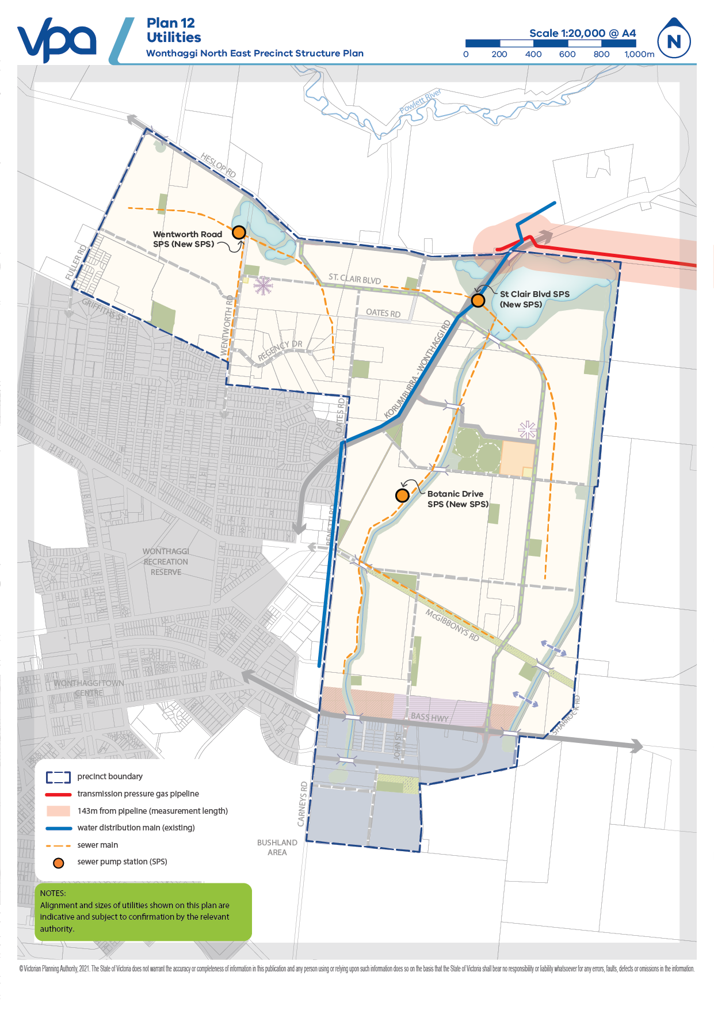

Drainage & stormwater management

Drainage Strategy (Engeny)
Engeny Water Management Pty Ltd (Engeny) prepared a drainage strategy for the precinct area in October 2019. The drainage strategy was updated in 2021 following the Tranche 1 SAC Hearing and associated conclave of drainage experts, with key changes relating to:
- Updated hydrology to be compliant with Australian Rainfall and Runoff 2019.
- Updated strategy to account for existing gas transmission and water supply pipelines.
- Further work on the outfall channel from Wetlands 1 and 2 to the Powlett River.
While the same general drainage design layout as the 2019 strategy has been adopted for the updated strategy, some asset sizes have been adjusted as necessary in response to the above changes. The drainage strategy details both the modelling work and subsequent conceptual drainage layout proposed for the precinct. The drainage strategy has heavily influenced the final layout of land uses identified in the PSP.

The drainage strategy recommended the following stormwater treatment infrastructure to achieve the best practice management targets for pollutant removal for the precinct area:
- Two constructed waterways through the development area to provide drainage outfalls.

- 11 sediment basins located adjacent to the constructed waterways and upstream of the wetlands for primary treatment to protect constructed waterways and/or wetland assets from high sediment loads.
- Four
- wetland assets along the northern boundary of the PSP to provide the final form of treatment prior to discharging into 435 and 465 Heslop Road and Powlett River. Wetland RB1 has been configured to account for the measurement length of the adjacent transmission pressure gas pipeline.
- 12 culverts, including waterway crossings and major crossings under Heslop and Korumburra-Wonthaggi Road.
- Widened existing channel on 435 and 465 Heslop Road, downstream of the PSP area, to convey flows from the development area in the 50% AEP event.
- A series of external catchment conveyance pipes sized to convey the 20% AEP flows through the PSP’s residential area and 10% AEP flows for pipes located within the PSP’s industrial area.
- Continuous Deflection Separation (CDS) unit recommended to treat stormwater upstream of Bass Highway. This is a proprietary product and is not included as an item in the DCP.
- Rainwater tanks recommended for all new dwellings within the development area, reduce the total annual volume of runoff entering the drainage system and requiring treatment, and provide a valuable alternative water source and opportunity to offset future potable water demands.

The recommendations and costings from the 2019 drainage strategy were reflected in the 2020 exhibited PSP and DCP. All subsequent changes in the 2021 update to the strategy are reflected in the 2021 exhibited versions of the PSP and DCP.

April 2022 Changes
Engeny Water Management Pty Ltd has updated the 50% AEP and 1% AEP TUFLOW modelling of the Wonthaggi North East Revised Drainage Strategy to adopt the recommendations resulting from the Preliminary Drainage Review. Key modelling changes related to:
- Update the developed conditions TUFLOW model created by Engeny (November 2021) to represent the functional design of the stormwater infrastructure provided by Alluvium.
- Run the updated TUFLOW developed conditions model forthe50% and 1 % AEP storm events to validate the function of key stormwater infrastructure assets provided by Alluvium.
- Run the TUFLOW model with coincident flooding from Powlett River for the 1 % AEP storm event to understand the impact on regional flood patterns downstream of the Wonthaggi NE PSP development area.
- Prepare relevant outputs including flood depth and flood extent layout plans5.Prepare flood difference (afflux) plots comparing the predeveloped and developed conditions flood depths

These updates to the revised drainage strategy have informed the revision of the Functional Design Report prepared by Alluvium in April 2022.

Drainage functional designs
Alluvium Consulting Australia Pty Ltd (Alluvium) prepared functional designs and costs for the stormwater drainage assets proposed in Engeny’s 2021 stormwater drainage strategy. The purpose of the functional design work was to proof the stormwater management concept and provide more detailed designs and construction cost estimates for each drainage asset. The functional design work provides Council, landowners and the community a greater level of confidence that the proposed assets are robust, sustainable and maximise community benefits. The functional designs were informed by past drainage investigations and modelling, background and site investigations, and discussions with VPA and Council.
During the functional design process, the following broad modifications were made to Engeny’s strategy:
- Naming convention for all four wetlands amended from WL (wetland) to WLRB (wetland retarding basin), because they all have a retarding function.
- WLRB1 has been ‘split’ into WLRB-1A and WLRB-1B to improve overall treatment performance and asset integrity, while ensuring land take is confined to land subject to inundation.
- Increased sinuosity of both waterways to reduce instream flow velocities, thereby protecting the waterway bed/banks and promoting the ecological health of waterways and associated riparian zones.
- Reduced number of independent sediment basins by integrating them into WLRB assets or removing redundant assets. This has reduced the number of proposed assets from 31 to 23.
The functional design assets supersede the concept design proposed by Engeny. The functional design report recommends the following assets for the precinct area:
- Two constructed waterways for flow conveyance and improved ecological outcomes for the broader area. No change in the quantity of constructed waterways from Engeny’s strategy.
- Five independent sediment basins. The quantity sediment basins has decreased from Engeny’s strategy. Two sediment basins proposed by Engeny are recommended to be replaced by Gross Pollutant Traps.
- Nine culverts. The quantity of culverts has decreased from Engeny’s strategy.
- Main outfall to the Powlett River (MOP), designed to carry the 50% AEP flow from WLRB-1A, WLRB-1B and WLRB2. This builds on the concept design proposed by Engeny.
Cardno Victoria Pty Ltd (Cardno) have prepared concept design and high-level costing for three crossings spanning east-west across the main outfall channels. The crossings are required for the landowner to be able to access the other paddocks within property once the channels are upgraded to accommodate drainage outfalls from the PSP. Cardno have designed the crossings to accommodate the clearance height for smaller flooding events (i.e. 1 in 50 year events, or 50% AEP), as overflows from the Powlett River will be contained within the proposed channel upgrades in these events, therefore minimising impact on surrounding paddocks. Vertical clearances are designed in accordance with requirements for minor bridges in AS5100.1. Cardno have used the Alluvium HECRAS model and CAD set to determine the crossing width and associated flood levels for Crossing B and Crossing C. The cross-sectional dimensions of Crossing A over the channel is based on the survey file provided by Engeny. Cardno’s concept design drawing set and cost estimates will be included as drainage construction items in the DCP.
A summary of the three crossings is as follows:
- Crossing A (CU-15): Overall bridge length (span) of approximately 3.8m and soffit of the structure set 200mm above the 50% AEP level. Estimated cost is $92,618 (2021/22$).
- Crossing B (CU-14): Overall bridge length (span) of approximately 8.89m and soffit of the structure set 900mm above the 50% AEP level. Estimated cost is $183,233 (2021/22$).
- Crossing C (CU-16): Overall bridge length (span) of approximately 18.8m and soffit of the structure set 430mm above the 50% AEP level. The existing pipes are designed to remain within the channel therefore a clear span structure will not apply any load to these pipes and ensure the current integrity is maintained. Estimated cost is $452,090 (2021/22$).

April 2022 Changes
The original outfall connection (Engeny) and subsequent functional designs (Alluvium) connected the precinct outfall to an existing open farm channel that provided the ultimate outfall connection to the Powlett River. Further investigation by Alluvium determined that the existing farm channel is undersized with respect to conveying the 50% AEP flow for the precinct.
Alluvium have prepared concept design and high-level costing of upsizing the existing farm channel to convey the 50% AEP flow to the Powlett River (as per the Wonthaggi NE recommendations, Alluvium 2021) and ensure no further flooding to the subject property from the PSP as an Addendum to the Main Outfall Functional Design (December, 2021). As a result of implementation of findings from the Preliminary Drainage Review (Section 4.5), the Addendum to the Main Outfall Functional Design (December 2021) has been superseded. The Main Outfall solution is outlined in the Functional Design Report (April, 2022) as outlined below.

In response to the recommendations of the Preliminary Drainage Review undertaken by Neil M Craigie Pty Ltd, VPA instructed Alluvium to adopt the following changes as updates to the Functional Design Report (April, 2022):
- Wetland sizes and designs updated to align with revised TUFLOW modelling prepared by Engeny. These changes are primarily to WLRB1a and WLRB1b, and the east and west constructed waterways.
- Reduction of the macrophyte zones of all wetlands.
  - WLRB4 footprint has been approved by Council so no changes have been made to this wetland.
- Raised the normal water level of WLRB1a and WLRB1b to revude overall excavation costs, without compromising flood storage requirements and water quality treatment compliance.
- Raised the invert of the two constructed waterways to reduce overall excavation quantities associated with the development of the PSP and DCP without losing flood conveyance and capacity.
- Updated items and costing rates using region-specific costing estimates.
- Reduced the excavation rate from $38/m3 to $25/m3.
- Revised cost estimates using the following volumes and reuse estimates:
  - An excavated volume of 5% assumed for offsite disposal.
  - An excavated volume of 95% assumed to be reused on site for filling.
  - An allowance of 5% assumed for some rock excavation / potential reuse in waterways.
  - Excavated topsoil has assumed 5% for removal and 95% for stockpiling on site for later reuse on site
  - An allowance of 5% assumed to import clean topsoil to cover for topsoil losses (shortfall due to above).
- SB4 and SB6 relocated into the respective waterway corridors. These Sedimentation Basins have been integrated into the waterway 'floodplains' to reduce overall land take.
- Updated box culverts design comprising 3 x 900mm (W) x 300mm (H) measurements, which would transition to a single 1200mm (W) x 600mm (H) box culvert midway through the road crossing, once the existing services requiring appropriate cover was passed.
  - The proposed outfall arrangement is considered a more feasible and effective approach in comparison to a 10 x 300mm HDPE pipe arrangement (Engeny, 2021) given the propensity to blockages.
- Shifted the eastern waterway as close to the eastern boundary of the PSP as possible while maintaining a total 19m minimum offset for bushfire protection through the waterway corridor.
- An analysis of volume data from external catchments.

Preliminary Drainage Review
Neil M Craigie Pty Ltd (Waterway Management Consultants) were engaged by the VPA to undertake an independent review of the Functional Design Report (Alluvium, April 2022), going back to first principles, of the appropriateness of assumptions and conclusions in the Functional Design Report. The findings of the Preliminary Drainage Review recommend:
- Strict adherence to MWC DTC guidelines be tempered with practical considerations given the significant burden caused by maintenance costs on limited Council budgets.
- New design approach and modelling to incorporate the retarding effects of the wetland inlet ponds resulting in a reduction to the macrophyte zones, subsequently reducing the overall footprint of the wetlands.
- Excavation rate of $25/m3 to be applied, consistent with excavation rates currently used in south eastern Melbourne.
- Changes to the assumption of topsoil importation for all earthworks projects.
- Changes to the Supervision & Project Management and Council Fees delivery allowances.
- Normal Water Level (NWL) raised from 13.6m to 14.2m.
- Offline basins SB4 and SB6 to be integrated as online to reduce land take, earthworks, plantings and to improve aesthetics.
- Changes to low flow outlet design for WLRB1a and WLRB1b to adopt the suggested design detailed in the Preliminary Drainage Review, due to expected operation and maintenance problems and likelihood of blockages occurring with the Engeny design.
- Flexibility be retained in the PSP/DCP to allow for adjustment of drainage asset location/alignment/shape at detailed design stage, subject to best practice.
- Contribution from external existing areas be considered due to the size of the catchment draining through the PSP.

This review informed revision of the Functional Design Report and Engeny modelling as outlined in Section 4.3.1 and 4.4.1 of this report.

Transport & Movement
The exhibited PSP and DCP were informed by the Wonthaggi North East Precinct Structure Plan Transport Impact Assessment (GTA, 2020), which has been superseded by an updated report of the same title (Stantec, 2021). The 2021 report has not fundamentally changed its recommendations, although several changes have been made following the Tranche 1 SAC hearing. The changes between the exhibited 2020 version of the report (Issue I) and current 2021 version (Issue K) are summarised:
- All intersection concept layout plans (IN-01 to IN-08) and costings have been updated to account for further consideration regarding utility services protection and/or relocation.
- Fuller Road carriageway in IN-01 design realigned to the centre of existing road reserve to avoid relocating the existing South Gippsland Water asset within the Fuller Road reserve.
- Estimated cost for IN-07 removed from report as the intersection is constructed at the time of report update.
- Additional road upgrade (RD-02) included in report. The existing McGibbonys Road carriageway between Korumburra-Wonthaggi Road and the PSP Area is not constructed to a suitable standard to cater for the forecasted PSP generated traffic demands. The inclusion of this upgrade is considered appropriate for inclusion in the DCP.
- The St Clair Boulevard / Korumburra Road intersection (IN-04) design has been updated to include an 80km/h design speed on the northeast approach (i.e. to slow vehicles travelling into Wonthaggi on Korumburra Road) as per the requirements of Regional Roads Victoria. The associated costing for the intersection has been updated accordingly.
- The Bass Highway / St Clair Boulevard intersection (IN-06) concept layout has been revised to annotate the land take requirement. There has been no physical change to the proposed intersection layout.
The proposed transport network for the precinct includes a, network of connector and local access streets. Key features of the proposed PSP transport projects include:
- A future boulevard connector road (known as St Clair Boulevard) connecting Heslop Road to Korumburra-Wonthaggi Road and Bass Highway
- Two new connections to Bass Highway east of the town centre (at St Clair Boulevard and Carneys Road)
- Continuation of Oates Road, Wentworth Road and Fuller Road into the PSP area
- A new major intersection to Korumburra-Wonthaggi Road at St Clair Boulevard (IN-02)
- Upgraded Heslop Road (to rural connector standard) between Fuller Road and Korumburra-Wonthaggi Road
The Transport Impact Assessment includes strategic transport modelling and SIDRA intersection modelling, which was used to determine a future road network and any necessary road and intersection upgrades. The proposed road network and intersection layouts are considered to represent an appropriate and functional transport outcome for the PSP area and broader Wonthaggi township. It is noted that the Bass Highway / McKenzie Street / Graham Street and Bass Highway / Korumburra-Wonthaggi Road intersections (IN-10 and IN-11 respectively) are anticipated to be operating near capacity following the full development of the PSP area. These two intersections are located externally to the PSP area and have not been included as DCP items.

It is noted that any future bypass road is not proposed to be delivered as part of the PSP.

The cost sheets for all road and intersection projects in the DCP included in the 2021 Stantec report.

April 2022 Changes
Through the finalisation of the revised transport designs and costs in November 2021, the need for a new DCP intersection project was identified. This project is identified as IN-09 in the DCP. With feedback from the Department of Transport, Stantec have prepared designs and cost estimates for IN-09 as a 3-exit roundabout. A 4th exit is able to be delivered as developer works to provide local access but the construction cost of this exit is not included in the cost of IN-09 as a DCP item.
IN-04 was proposed to move further south along Korumburra-Wonthaggi Road to accommodate the increased footprint of Wetland 1 in the November 2021 Drainage Functional Design Report. As the footprint of Wetland 1 has been reduced in the April 2022 Drainage Functional Design Report, the design and cost of IN-04 will be taken from the Transport Impact Assessment (Stantec, November 2021).

Open space

Active Open Space
A community infrastructure needs assessment was prepared by the VPA and Council. The approach to identification, supply and operation of active and passive recreational facilities and services was established through a range of local policy including the Bass Coast Open Space Plan, 2008, the Bass Coast Public Open Space Policy 2017 and the Bass Coast Open Space Asset Management Plan 2018-2022.
Existing facilities from regional to local in nature and function are available in Wonthaggi and surrounding areas. The PSP establishes a new active open space reserve for active recreation and could cater for any of the following sports (netball, Australian rules football, soccer, cricket, tennis, hockey, netball, baseball, softball etc) depending on the communities need at the time of delivery. Actual sports reserve provision proposed within the precinct is one 6ha sports reserve to be co located with the government primary school and local convenience centre within the precinct. The sports reserve is within 800m of approximately xx% of residents within the precinct.

Passive Open Space
Generally, local parks have been equitably distributed across the precinct, maximising access by the local community and generating high amenity. Most local parks are proposed in sizes approximately one hectare, to cater for a diverse range of functions (i.e. gathering spaces, walking pets, linear connections, community focal points), and be located within convenient walking distance (400m) of 95% of all dwellings. 11.12ha (2.14% of the precinct NDA) of land has been provided for local network parks within the residential component of the PSP, and 0.90ha (0.17% of the precinct NDA) of land has been provided for local network parks within the employment component of the PSP. A number of open space reserves are proposed to abut significant remnant vegetation, drainage reserves and historical features to maximise the benefit of the open space.

Other Open Space
Precinct residents will also have access to other uncredited open space including network of waterways, tree reserves, and existing road reserves. These aspects of the precinct will, with incorporated bike and pedestrian trails will serve a key role in linking the community and promoting active transport options.

Community Infrastructure
The VPA in conjunction with Council undertook a Community Infrastructure Needs Assessment to understand the demand and type of community infrastructure and open space required to support the future residential population and workforce of the Precinct. The assessment is based on adopted benchmarks and provision models, iterative discussions with Council and State Government departments, relevant external stakeholders and a review of technical reports as they relate to the planning for the Precinct.
The configuration and locations of centres within the precinct areas take into account the local topography and the barriers to movement or access to community infrastructure.
The Precinct will have sufficient population to warrant two local convenience centres and a range of community infrastructure. The projected population of around 12,000 people accommodated in 5,000 dwellings will be serviced by new Level 1 & 2 community facilities within the precinct, and the established community facilities and services within the Wonthaggi Township.
The Level 2 facility will be co located with the future government primary school and sports reserve. The smaller Level 1 Facility will be co locates with the Northern Local Convenience Centre.
The demographic profile of the Precinct is likely to be made up of young families, people who have young children or are likely to be starting families in the coming years and in the shorter to medium term, household occupancy is likely to be closer to 3.1 persons per household, being reflective of current trends. The Assessment identified that one multi-purpose community centre along with a combined neighbourhood house would be required for the precinct and that it would ideally be co-located with a government primary school as part of an integrated community hub.
These centres will be suitable to accommodate the following services
- maternal and child health
- Multipurpose space
- kindergartens
- childcare

Education
The Precinct will make provision for a 3.5 hectare government primary school adjacent to the Village Hub and active open space based on the dwelling and population projections for the precinct. However there is not sufficient demand within the precinct to warrant provision of higher order education facilities (such as government secondary schools, non-government primary school and secondary school, and library) and these are instead provided within the existing Wonthaggi Township, which will also service Precinct residents.

Commercial and Industrial Land
The Commercial and Industrial Land Assessment (2017, Updated 2019) undertaken by Urban Enterprise presented the following findings with regards to land requirements and characteristics in Wonthaggi:
- Projected demand to support 11,000sqm of Commercial 2 Zoned (C2Z) floorspace over next 20 years. This floorspace demand requires a minimum of 8 ha of land.
- The proposed C2Z site (to the north of the Bass Highway) provides excellent exposure and accessibility, including highway frontage. This presents a characteristic that would make the site an attractive location for a future bulky goods development, including potential for a homemaker centre, once sufficient demand accumulates.
- Short-term, demand will likely be taken by Cranbourne and Pakenham Homemakers Centres.
- The C2Z bulky goods area will cater for demand generated by long-term growth in Wonthaggi, including North-East Growth Area.
- Land south of the Bass Highway will be maintained for industrial uses, with the existing C2Z being rezoned for further industrial uses. Land south of the existing industrial area should be kept for long-term employment growth and industrial expansion (IN3Z).
- Land demand projections identify a requirement for 15-17 ha of industrial land over the next 20 years (population generated demand of 8-10 ha, plus an additional 7 ha to cater for strategic sites).
The relevant elements of the Future Urban Structure include:
- Council have proposed a mixed-use precinct (7 ha), to be zoned Mixed Use Zone (MUZ), at the corner of Carneys Road and Bass Highway after consideration of submission to the exhibited WNEPSP.
- Council has advised that the landowner of the proposed precinct is interested in a small service station, supermarket, medical facility and retirement living within the precinct.
- A proposed business precinct (7 ha) is to be zoned Commercial 2 Zone (C2Z), east of the mixed-use precinct.
- Proposed industrial expansion to the east and south of the existing industrial precinct.
- Village hub shown along the connect street boulevard, near the proposed primary school, and a local convenience centre shown towards the north-west corner of the PSP area.

Retail
The local convenience centre hierarchy features:
- A Village Hub Convenience Centre (1,500m2), which comprises a local convenience centre, co-located with the future sporting reserves, proposed government primary school and community facility. The Village Hub will act as the heart of the precinct providing residents with a central location for daily needs and community facilities.
- A local convenience centre (500m2) in the north of the precinct will provide residents with day to day needs and will provide opportunities for some small local enterprises to develop. A smaller community facility will underpin this convenience centre and provide residents at the northern edge of the precinct access to these services.

Housing
At full development, the precinct will accommodate in excess of 5,000 dwellings based upon an average density of 11 lots per hectare of NDA. A broad range of lot sizes will be encouraged, capable of accommodating a variety of housing types. The lot mix will also cater for a range of life cycle stages and age groups. Higher density housing will be encouraged around the proposed convenient centres and open space.

The Vision and Principles for Wonthaggi North East

Vision
Wonthaggi’s natural character is defined by its location between rural South Gippsland and the coastal landscapes of the Bass Coast. The landscape surrounding the Wonthaggi North East Precinct features coastal scrub vegetation, the Powlett River, bushland reserves and views to the northern rural hills.
The Wonthaggi North East PSP will create an attractive extension to the existing Wonthaggi township, providing long term residential and employment growth for Bass Coast Shire. The PSP will enable a significant expansion to Wonthaggi delivering community facilities, local parks, linear trails and a new sports reserve for its residents. The PSP will also provide for employment opportunities by allowing for commercial and industrial businesses to establish in close proximity to the Bass Highway.
The PSP will ensure that new communities are integrated within the existing town through road connections with tree lined streets connecting to St Clair Boulevard. The extensive pathway network will connect residents to local parks, sporting and community facilities, bushland, the existing township and the Bass Coast broader regional rail trail.
Protection and enhancement of Wonthaggi’s natural elements will be a crucial component of the PSP, through the retention and rehabilitation of native vegetation, protection of view lines and improvement of existing waterways.
The introduction of an extensive waterway and wetland system will anchor the new community, providing a natural thoroughfare through the precinct and allowing for recreation opportunities. The significant wetland and waterways areas for stormwater management, encompassing 66ha, and will include landscaping and pathways.
The urban structure concept supports an engaged community with development opportunities that encourage access to local employment, participation in community and recreation activities, and contribute positively to the physical and social health and wellbeing of all members of the community.

Objectives
The development of the Wonthaggi North East Precinct is guided by a set of key objectives:
TOWNSHIP IMAGE, CHARACTER, HERITAGE & HOUSING
Integrate Wonthaggi North East growth area with the existing urban area (township).
Develop a strong identity for Wonthaggi North East by incorporating elements of the nearby coastal and rural character into landscaping and streetscapes.
Ensure subdivision design, developments and public spaces are aesthetically pleasing, respond to the natural context and incorporate environmentally sustainable design.
Promote greater housing diversity and affordability with lots capable of accommodating a variety of dwelling types and sizes that encourage a variety of tenure and household types in appropriate locations.
Provide a sensitive interface to existing and adjoining development, natural features, open space and waterways.
Protect, conserve and celebrate places of Aboriginal cultural heritage and post-contact cultural heritage significance.
OPEN SPACE, COMMUNITY FACILITIES AND EDUCATION
Deliver an accessible and integrated network of local parks, sports reserves and community facilities that meet the needs and aspirations of the new community with adaptable, flexible and multi-use designs.
Facilitate active and healthy living by creating an urban environment that encourages cycling and walking.
Encourage the retention and establishment of trees through responsive layout of lots, streets and open spaces.
VILLAGE HUB AND EMPLOYMENT
Strengthen the local economy by creating opportunities for new businesses and a variety of local jobs.
Provide for local retail, civic and community opportunities through village hubs while maintaining and enhancing the service centre role of Wonthaggi.
Deliver highly accessible, functional and vibrant local convenience centres with a sense of place that encourages social interaction and community engagement.
INTEGRATED WATER MANAGEMENT AND UTILITIES
Deliver an integrated water management system that encourages reduced reliance on reticulated potable water, encourages the re-use of alternative water, minimises flood risk, ensures waterway health, and contributes toward a sustainable and green urban environment.
Ensure sensitive land uses are minimised within the area subject to planning controls responding to the transmission pressure gas pipeline and that construction is managed to minimise risk of any adverse impacts.
BUSHFIRE, BIODIVERSITY AND NATIVE VEGETATION
Ensure that bushfire risk is considered in the layout, staging and design of development and the local street network.
Ensure that bushfire hazards are identified and that protection measures are considered in the layout and design of the local street network, subdivisions and buildings and works.
Ensure development responds to flora and fauna species and habitats in accordance with the Wonthaggi North East Native Vegetation Precinct Plan.
TRANSPORT AND MOVEMENT
Provide a high-amenity, low speed and permeable local road network that prioritises community access and safety.
Establish an integrated and permeable transport network to encourage public transport, walking and cycling, reduced car dependency.
PRECINCT INFRASTRUCTURE PLAN AND STAGING
Encourage development staging to be co-ordinated with the delivery of key infrastructure.

Development Contributions
The PSP and DCP were prepared by the VPA in collaboration with council, service authorities and major stakeholders. The DCP was developed to support the provision of works, services and facilities that will be used by the future residents - of the precinct.
The DCP establishes a framework for development proponents to contribute a fair proportion of the cost of works and services required to support the future development of the precinct. It ensures that the cost of providing new infrastructure and services is shared equitably between developers and the wider community. Fairness requires costs to be apportioned according to the projected share of use, and the required works, services and facilities items.
The key projects that are funded wholly or in part by development are listed in the DCP.

Background Reports
The PSP and DCP are supported by several background reports:
Victorian and local government policy
- Victorian and Local Government Policy, including the Bass Coast Planning Scheme
- Wonthaggi/Dalyston Structure Plan (Coomes Consulting, April 2006)
- Coastal Spaces Recommendations (Department of Sustainability and Environment, 2006)
- Wonthaggi Structure Plan (Bass Coast Council, April 2018)
- Wonthaggi North East Growth Area Development Plan Final (CPG Australia, November 2009)
Environmental
- Wonthaggi North East Precinct Structure Plan Flora and Fauna Assessment (Nature Advisory. 2020)
- Wonthaggi North East Growth Area Planning Studies Contaminated Land Investigations (GHD April 2016)
- Wonthaggi Precinct Structure Plan- North East Growth Area Phase 1 Preliminary Site Investigation (GHD May 2019)
- Bushfire Development Report for the Wonthaggi North East Precinct Structure Plan (Terramatrix October 2018)
- Addendum to the Bushfire Development Report for the Wonthaggi North East Precinct Structure Plan (Terramatrix, August 2021)
Heritage
- Wonthaggi North East Growth Area: Aboriginal Cultural Heritage Survey (May 2017)
Stormwater management

- Drainage Strategy for Wonthaggi North East PSP - Stormwater Management Plan (Engeny, November 2021)

- Wonthaggi North East – Proof of Concept Report (Alluvium, September 2021)

- Wonthaggi North East Preliminary Drainage Review (Waterway Management Consultants, 24 December 2021)
- Wonthaggi North East PSP – Functional Design Report (Alluvium, April 2022)

- Bridge Concept and High-level Cost Estimate (Cardno, November 2021)
Traffic

- Wonthaggi North East Precinct Structure Plan Transport Impact Assessment (Stantec, November 2021)
- IN-09 Broad Level Concept Design and Cost Estimate (Stantec, 11 March 2022)

Infrastructure
- Wonthaggi North East Precinct Structure Plan- Community Infrastructure Needs Assessment (Bass Coast Council, VPA, October 2020)
- Estimates of Value Report Wonthaggi North East PSP- Public Land Equalisation Estimated Land Valuations (Westernport Property Consultants, September 2020)
- AS 2885 Pipeline Impact Assessment of Wonthaggi North East Precinct Structure Plan re‐zoning proposal adjacent to existing Multinet gas transmission pipeline (Project Delivery Assurance, September 2021)
Economic and retail
- Wonthaggi Commercial and Industrial Land Assessment (June 2017 (Urban Enterprise, Updated 2019)
Open space
- Wonthaggi North East Precinct Structure Plan- Community Infrastructure Needs Assessment (Bass Coast Council, VPA, October 2020)

Previously known as GTA.

