SCHEDULE 1 TO CLAUSE 37.07 URBAN GROWTH ZONE
--/--/20—
C152
Shown on the planning scheme map as UGZ1.
WONTHAGGI NORTH EAST PRECINCT STRUCTURE PLAN
1.0 The Plan
--/--/20—
C152

Map 1 below shows the future urban structure proposed in the Wonthaggi North East Precinct Structure Plan, May 2022. It is a reproduction of Plan 3 in the Wonthaggi North East Precinct Structure Plan, May 2022.

Map 1 to Schedule 1 to Clause 37.07
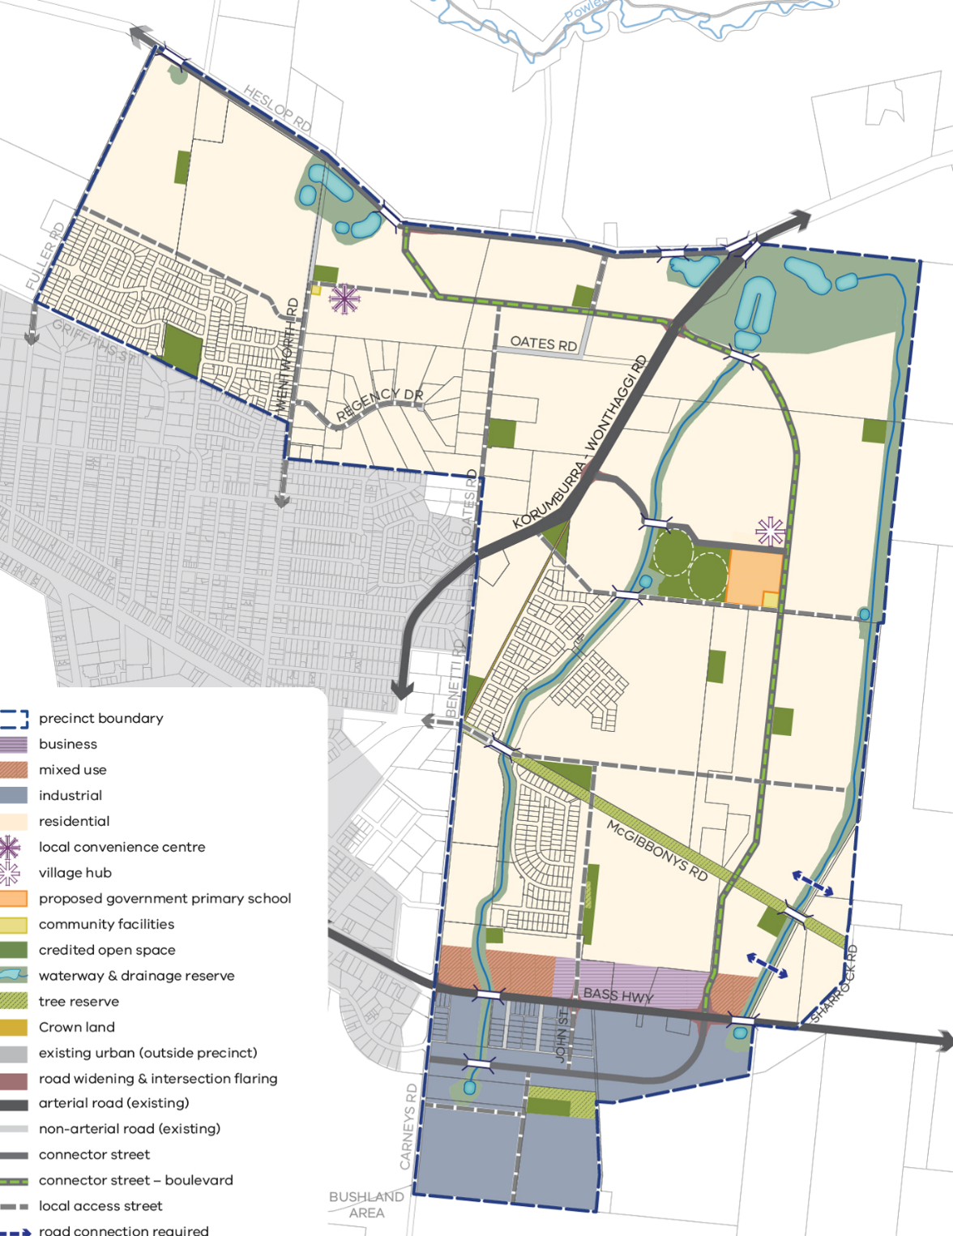
N
area not zoned UGZ1

2.0 Use and development
--/--/20—
C152

2.1 The Land
--/--/20—
C152
The land use and development provisions specified in this schedule apply to the land as shown within the ‘precinct boundary’ on Map 1 to Schedule 1 to Clause 37.07 and shown as UGZ1 on the planning maps.
Note: If land shown on this map is not zoned UGZ the provisions of this zone do not apply.
2.2 Applied zone provisions
--/--/20—
C152
Table 1 allocates the land use/development shown on Map 1 of this Schedule with a corresponding zone from this scheme.
Where the use/development in the left column is carried out or proposed generally in accordance with the incorporated Wonthaggi North East Precinct Structure Plan, the use, subdivision, construction of a building and construction and carrying out of works provisions of the corresponding zone in the right column apply.
A reference to a planning scheme zone in an applied zone must be read as if it were a reference to an applied zone under this schedule.
Note: e.g. The Commercial 2 Zone specifies ‘Shop’ as a Section 1 Use with the condition, ‘The site must adjoin, or have access to, a road in a Road Zone.’ In this instance the condition should be read as, ‘The site must adjoin, or have access to, a road in a Road Zone or an applied Road Zone in the Urban Growth Zone schedule applying to the land’
Table 1: Applied zone provisions
Land shown on map 1 of this schedule | Applied zone provisions
Local convenience centre  Village hub | Clause 34.01 – Commercial 1 Zone
Business | Clause 34.02 – Commercial 2 Zone
Mixed use | Clause 32.04 – Mixed Use Zone
All other land | Clause 32.08 – General Residential Zone
2.3 Specific provisions – Use of land

--/--/20—
C152

Section 1 – Permit not required
Use | Condition
Accommodation (other than Corrective institution) where the applied zone is General Residential Zone | Must not be on land shown within ‘143m from pipeline (measurement length)’ depicted on Plan 12 of the incorporated Wonthaggi North East Precinct Structure Plan
Place of worship where the applied zone is General Residential Zone | Must not be on land shown within ‘143m from pipeline (measurement length)’ depicted on Plan 12 of the incorporated Wonthaggi North East Precinct Structure Plan  The gross floor area of all buildings must not exceed 250 square metres.  The site must adjoin, or have access to, a road in a Road Zone.
Residential aged care facility where the applied zone is General Residential Zone | Must not be on land shown within ‘143m from pipeline (measurement length)’ depicted on Plan 12 of the incorporated Wonthaggi North East Precinct Structure Plan

Section 2 – Permit required
Any other use not in Section 1 or 3 in the Table of uses in the applicable applied zone

Section 3 - Prohibited
Any use listed in Section 3 in the Table of uses of the applicable applied zone

2.4 Specific provisions - Subdivision
--/--/20—
C152
None specified.
2.5 Specific provisions - Buildings and works
--/--/20—
C152
None specified.

3.0 Application requirements
--/--/20—
C152
The following application requirements apply to an application for a permit under Clause 37.07, in addition to those specified in Clause 37.07 and elsewhere in the scheme and must accompany an application, as appropriate, to the satisfaction of the responsible authority:
For an application to use land, or construct a building, or construct or carry out works, the application requirements in the zone applied to the land at Sub-section 2.2 of Schedule 1 to Clause 37.07 (see above).
For an application to subdivide land:
  - a site and context description as described in Clause 56.01;
  - a scaled and dimensioned subdivision design response in the context of the area that derives from and responds to: the site and context description; the precinct structure plan; and, any relevant objective, policy, strategy or plan in the planning scheme;
  - Subdivision and Housing Design Guidelines, prepared to the satisfaction of the responsible authority, in accordance with the incorporated Wonthaggi North East Precinct Structure Plan;
  - A table setting out the amount of land allocated to the proposed uses and expected population, dwelling and employment yields;
  - A Traffic Impact Assessment Report to the satisfaction of the relevant road management authority;
  - A hydrogeological assessment of the groundwater conditions on the site and the potential impacts on the proposed development including any measures required to mitigate the impacts of groundwater on the development and the impact of the development on groundwater.
- An application to subdivide land adjacent to a Bushfire Hazard Area shown on Plan 8 must be accompanied by a Bushfire Management Plan that demonstrates how the application will address bushfire risk at the site. The plan must be prepared in accordance with Section 3.4.2 Bushfire Resilience of the PSP, unless otherwise agreed in writing by the Responsible Authority and CFA. The plan must include:
  - The design and layout of the subdivision, including lot layout, road design and access points, both vehicular and pedestrian;
  - The location of any bushfire hazard areas;
  - The details of any bushfire protection measures required for individual lots;
  - The identification of any areas to form the setback between a bushfire hazard and built form.
  - The details of any vegetation management in any area of defendable space including, information on how vegetation will be managed and when the vegetation management will occur i.e. annually, quarterly, during the fire danger period.
  - Notations that indicate what authority is responsible for managing vegetation within open space areas.
  - Notations that ensure that the areas of classified vegetation in the nominated bushfire hazard areas must be managed to a level that will ensure the vegetation classification under AS3959-2019 will not be altered.

The responsible authority and fire authority may waive this requirement if a plan has been previously approved for the land.

4.0 Conditions and requirements for permits
--/--/20—
C152
Condition – Gas pipeline construction management plan

Prior to the construction of a building or the carrying out of works, including demolition, on land within 53.5m of the transmission pressure gas pipeline shown on Plan 12 – Utilities in the incorporated Wonthaggi North East Precinct Structure Plan, a construction management plan must be submitted to and approved by the responsible authority. The plan must:
- Prohibit the use of rippers or horizontal directional drills unless otherwise agreed by the owner/operator of the high pressure gas pipeline; and
- Be endorsed by the owner/operator of the high pressure gas transmission pipeline prior to being submitted to the responsible authority.
- Include any other relevant matter to the satisfaction of the responsible authority.
The responsible authority must be satisfied that the transmission pressure pipeline licensee has reviewed and approved the Construction Management Plan.
The construction management plan must be implemented to the satisfaction of the responsible authority.
The construction management plan may be amended to the satisfaction of the responsible authority.

Conditions – Management of bushfire risk during subdivision works
A permit for subdivision of land must include the following condition:
Prior to the commencement of works, a Site Management Plan that addresses bushfire risk during, and where necessary, after construction must be approved by the CFA. The plan must specify the following:
  - The staging of development and the likely bushfire risks at each stage;
  - An area of land between the development edge and non-urban areas consistent with the separation distances specified in AS3959-2009, where bushfire risk is managed;
  - The land management measures to be undertaken by the developer to reduce the risk from fire within any surrounding rural or undeveloped landscape to protect residents and property from threat of fire; and
  - How adequate opportunities for access and egress will be provided for early residents, construction workers and emergency vehicles.
.
5.0 Exemption from notice and review
--/--/20—
C152
An application to use or develop land for a use other than accommodation on land where Sub-section 2.2 of Schedule 1 to Clause 37.07 (see above) applies the provisions of Clause 32.08 (GRZ) is not exempt from the notice requirements of section 52(1)(a), (b) and (d).
6.0 Decision guidelines
--/--/20—
C152
The following decision guidelines apply to an application for a permit under Clause 37.07, in addition to those specified in Clause 37.07 and elsewhere in the scheme which must be considered, as appropriate, by the responsible authority:
For an application to use land, or construct a building, or construct or carry out works, the decision guidelines in the zone applied to the land at Sub-section 2.2 of Schedule 1 to Clause 37.07 (see above).
For an application to subdivide land the objectives of Clause 56.
7.0 Signs
--/--/20—
C152

The advertising sign category for the land is the category specified in the zone applied to the land at Schedule sub-section 2.2 of Schedule 1 to Clause 37.07 (see above).

