21.07
07/04/2016
C134

21.07-1
07/04/2016
C134

HIGH GROWTH REGIONAL CENTRE

Contents
Wonthaggi

21.07-2
07/04/2016

Proposed C152

Wonthaggi
The Wonthaggi Strategic Framework Plan establishes a clear direction for the future physical form of Wonthaggi in that it identifies the preferred location for the various forms of land uses within the township.
Wonthaggi consists of a wide mix of land uses including retail, business, residential, community, recreational and environmental uses. Economic and population growth has seen Wonthaggi evolve into the primary service centre for the municipality. The locations of particular land uses in Wonthaggi are no longer compatible with the type of urban growth that is occurring.
Local Planning Policy and strategic planning documents identify Wonthaggi as a regional centre for the Gippsland area. Wonthaggi should be planned to accommodate a diverse range of housing options, employment opportunities, medical and educational facilities and services that can meet the needs of Bass Coast Shire and surrounding regions.
Local Area Implementation Settlement
Plan for urban growth within the settlement boundary shown in the Wonthaggi Strategic Framework Plan.
Reinforce Wonthaggi’s role as the major service centre for Bass Coast Shire and the township where major development should occur:
Encourage a consolidated industrial precinct located to the south of Inverloch Road and bounded by the proposed bypass road.
Encourage residential growth to the north and east of Wonthaggi.
Encourage the consolidation of the Commercial 1 Zone and relocate non-commercial use into more appropriate areas.
Land uses Existing area
Encourage infill residential development in close proximity to the Wonthaggi CBD. Encourage industrial and associated uses to locate away from residential and recreational areas. Encourage medium density development of under-utilised sites within core areas of the town.
Encourage the mixed use area at the western entrance of Wonthaggi, north of White Road, to accommodate both residential uses and commercial uses that are not appropriate for the town centre.
Encourage consolidation of all residential areas incorporated within the General Residential Zone.
Incorporate a mix of infill development and residential expansion to meet the future housing needs of the population.
Encourage the consolidation of existing areas within the Low Density Residential Zone in Wonthaggi north.
Encourage the relocation of the Wonthaggi Secondary School from the CBD. Encourage the establishment of a university campus within the township.

Encourage medical and specialist services to locate in close proximity to the Wonthaggi Hospital. Encourage higher residential development on the periphery of the CBD.
Discourage development in environmentally sensitive locations.

Wonthaggi North East Growth Area
Encourage urban development.
Establish new neighbourhood nodes in emerging urban growth areas.
Facilitate growth in accordance with the Wonthaggi North East Precinct Structure Plan and development plans approved for this locality.
Encourage the majority of residential expansion to locate in the north east of Wonthaggi. Ensure future residential development provides a sustainable mix of infill development. Discourage low density residential land to the north and east of Wonthaggi.
Providing new open spaces, sports, and recreational facilities in emerging urban growth areas.

Landscape and built form
Encouraging future development in Wonthaggi to incorporate design elements that:
- Encourage physical activity;
- Provide neighbourhood nodes located at the centre of walkable catchments;
- Facilitate community interaction;
- Respect the environment; and
- Support the ongoing development of Wonthaggi as the Regional Centre for south west Gippsland.
Applying the recommendations of the Bass Coast Open Space Strategy (2008) including:
- Providing pedestrian/bicycle links between open space nodes.
- Providing pedestrian/bicycle linkages between open space nodes and the Wonthaggi commercial area.
- Providing pedestrian/bicycle linkages between the Wonthaggi commercial centre and the educational precinct.
Encouraging linkages between all significant areas of open space, particularly areas of passive open space, and those managed as flora and fauna reserves as identified by map titled Parks and Trails Wonthaggi.
Providing support for the implementation of the Wonthaggi Centenary Environmental Project a project initiated by the Wonthaggi Urban Landcare Group to revegetate and restore wetland areas surrounding Wonthaggi.
Within the mixed use area at the western entrance of Wonthaggi north of White Road;
- Encourage the consolidation of lots to facilitate development that fronts White Road, not Murray Road .Where possible service access to these lots should be from Murray Street.
Within the Wonthaggi commercial area:
- Maintaining the compact nature of the Wonthaggi Commercial Activity Centre.
- Investigating an open space link between from Murray Street to Korumburra Road to provide a continuous north – south pedestrian space through Wonthaggi.

Commercial Development
Encouraging the consolidation and intensification of retail and commercial uses within the existing Commercial 1 Zoned land.
Encouraging the relocation of car dealerships, auto parts and repair outlets to less centralised areas within Wonthaggi.
Encouraging co-location of bulky goods and peripheral sales along highway frontages identified in the Wonthaggi Framework Plan below.
Rezoning the Cyclone Industrial Factory site from the Commercial 2 Zone to the Commercial 1 Zone.
Developing a new Commercial 2 Zoned precinct along the frontage of Inverloch Road, between the existing Industrial 1 Zone and the proposed alignment of the bypass road.
Support an increase in commercial zoned land in Wonthaggi to provide for a variety of new and existing businesses consistent with the Wonthaggi Structure Plan.

Industrial
Supporting a consolidated industrial precinct located south of Inverloch Road, as shown in the Wonthaggi Strategic Framework Plan.
Encouraging the relocation of existing industrial uses to appropriate areas as shown in the Wonthaggi Strategic Framework Plan.

Infrastructure
Planning for a bypass road generally in the location shown in the Wonthaggi Strategic Framework Plan.
Encouraging the location of a transport interchange within or immediately adjacent to the Wonthaggi CBD.

Map 1: Wonthaggi Strategic Framework Plan
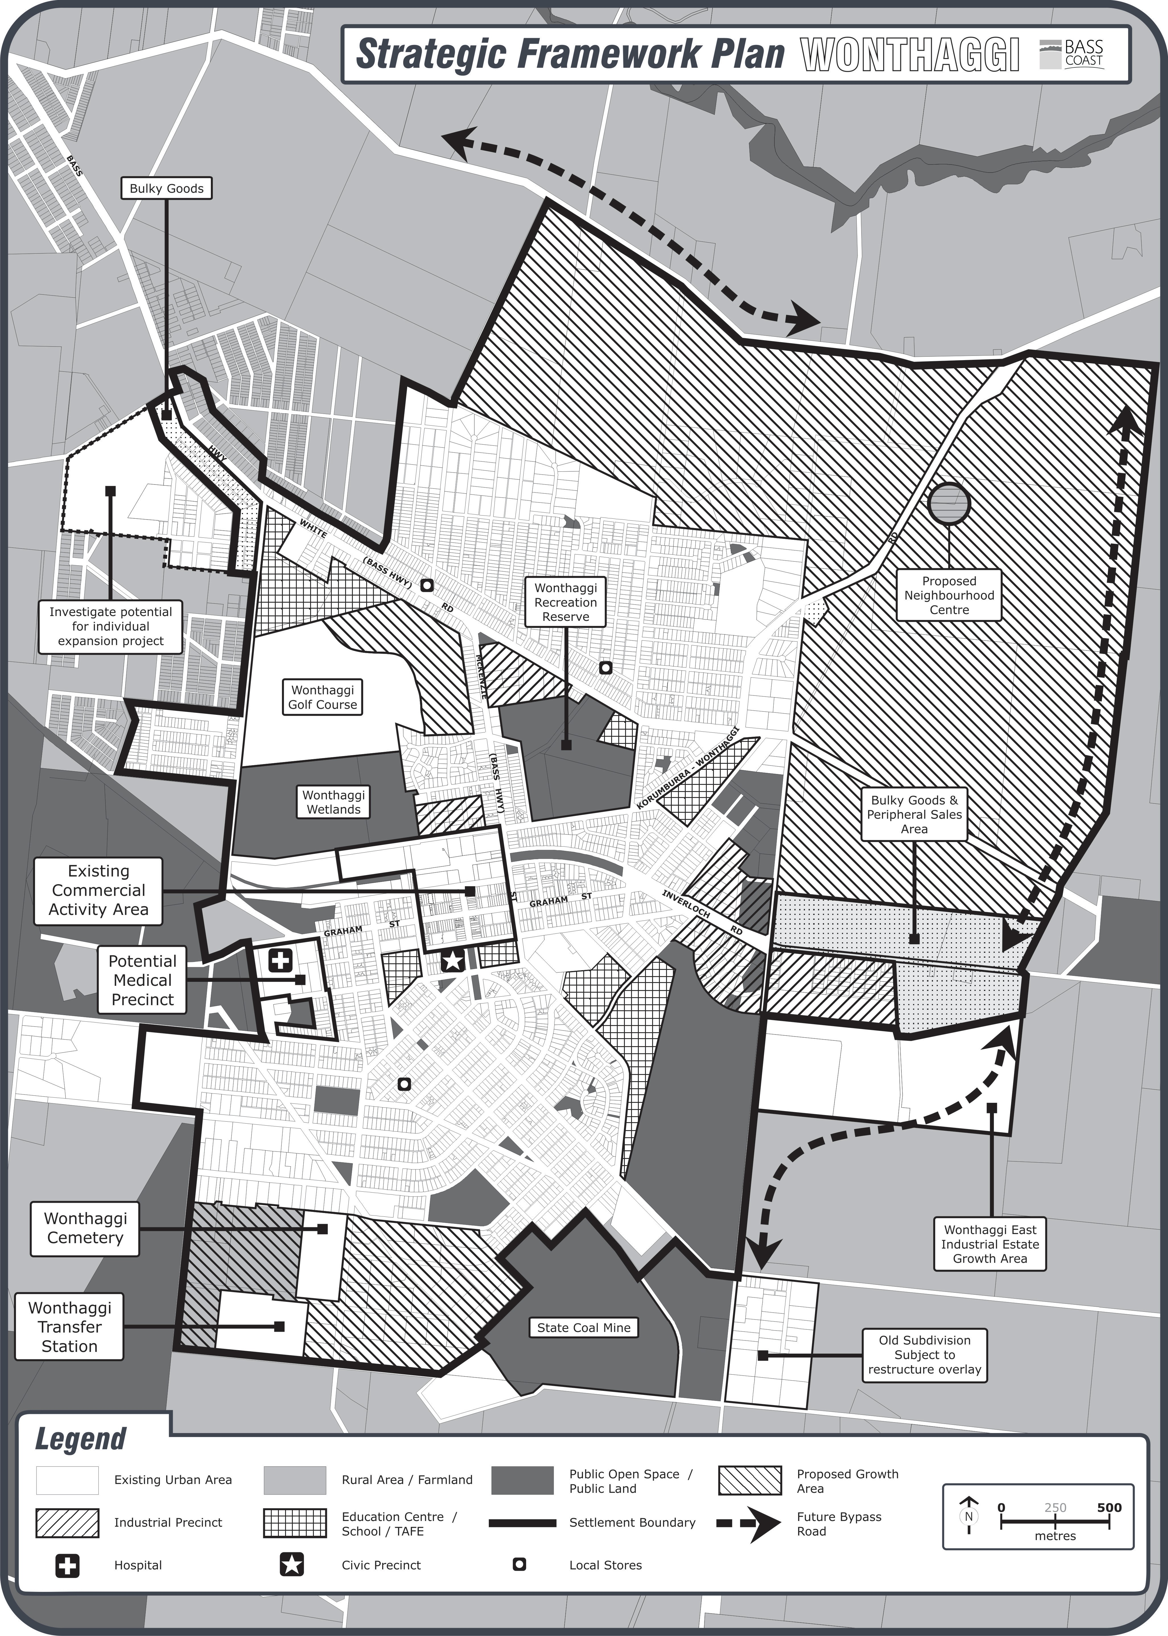

Map 2: Wonthaggi Parks and Trails
