Wonthaggi North East
Native Vegetation Precinct Plan
November 2021

CONTENTS
1 Introduction 1
1.1 Purpose of the NVPP 1
1.2 Vegetation protection objectives 1
2 Area to which the NVPP applies 3
3 Native vegetation to be removed 4
3.1 Assessment pathway 4
3.2 Description of native vegetation to be removed 4
4 Native vegetation offsets 13
4.1 Offset requirements for native vegetation to be removed 13
4.2 Offset statement 13
5 Native vegetation to be retained 14
5.1 Description of native vegetation to be retained 14
5.2 Management responsibilities and actions 20
6 Conditions for removal of native vegetation 21
7 Plans 23
8 Appendix A – NVPP Property Addresses 29
PLANS
Plan 1 NVPP Precinct Area 23
Plan 2 Existing Conditions 24
Plan 3 NVRR Reference Plan 25
Plan 4 Native Vegetation Retention and Removal 26
Plan 5 Native Vegetation Retention and Removal 27
Plan 6 Native Vegetation Retention and Removal 28
Tables
Table 1 Assessment pathway and reason for the assessment pathway 4
Table 2 Native vegetation to be removed 5
Table 3 Information about trees to be removed 10
Table 4 Total offset requirements for NVPP area 13
Table 5 Native vegetation to be retained 14
Table 6 Information about trees to be retained 17
Table 7 Land included within the area to which this NVPP applies 29

Introduction
This is the Wonthaggi North East Native Vegetation Precinct Plan (NVPP) listed under the Schedule to Clause 52.16 of the Bass Coast Planning Scheme (the Planning Scheme). This NVPP includes the information required under section 10 of the Guidelines for the removal, destruction or lopping of native vegetation (Department of Environment, Land, Water and Planning, 2017a) (the Guidelines). The Guidelines state that an NVPP prepared for incorporation into the planning scheme must:
- specify the purpose and objectives of the plan;
- specify the area to which the NVPP applies;
- map and describe the native vegetation that can be removed, destroyed or lopped;
- map and describe the native vegetation to be retained;
- set out the offset requirement, determined in accordance with the Guidelines;
- specify management responsibilities and actions for native vegetation to be retained, and;
- provide an offset statement that includes evidence that an offset that meets offset requirements for the removal of native vegetation is available and explains how it will be secured in accordance with the Guidelines. This statement must also include procedures regarding how the offset will be secured should the offsets be divided amongst multiple properties or parties.
The Guidelines also state that an NVPP must include mechanisms for tracking the removal of native vegetation and corresponding securing of offsets, to ensure that this occurs in accordance with the NVPP.
The removal, destruction or lopping of native vegetation in accordance with this NVPP does not require a planning permit provided conditions and requirements specified in this NVPP are met.
If native vegetation is proposed to be removed, destroyed or lopped not in accordance with this NVPP, a planning permit to remove native vegetation is required under Clause 52.16 of the Planning Scheme. In this circumstance, an application for a permit must comply with the application requirements specified in the Guidelines. An application to remove native vegetation not in accordance with the incorporated NVPP must be supported by current site information, as per Assessor’s handbook – applications to remove, destroy or lop native vegetation (Assessor’s handbook) (DELWP 2017a). In this plan the term ‘remove native vegetation’ includes to destroy and/or to lop native vegetation.

Purpose of the NVPP
The purpose of the NVPP is to:
- Summarise the biodiversity values across the precinct;
- Apply a holistic, landscape wide approach to retention and removal of native vegetation across the precinct;
- Ensure that areas retained for the protection of native vegetation are managed to conserve ecological values in accordance with the Wonthaggi North East Precinct Structure Plan (PSP);
- Ensure that the removal, destruction or lopping of native vegetation and the management of the native vegetation specified to be retained is consistent with conserving the ecological values of these areas and is in accordance with the no net loss objective of the Guidelines;
- Describe the offset requirements for any permitted removal, destruction or lopping of native vegetation as identified in this plan; and
- Streamline the planning approvals process through a landscape approach to native vegetation protection and management.

Vegetation protection objectives
The objectives of the NVPP are to:
- Ensure there is no net loss to biodiversity as a result of the approved removal, destruction or lopping of native vegetation. This is achieved by applying the three-step approach in accordance with Clause 12.01-2S Native vegetation management, Clause 52.16 and the Guidelines;
- Apply a landscape approach to the management of native vegetation within the NVPP area, in accordance with Clause 12.01-1S Protection of biodiversity and Clause 21.04-3 Biodiversity Conservation and Protection.
- Manage native vegetation to be retained in accordance with obligations under the Catchment and Land Protection Act 1994.
- Ensure that areas set aside to protect native vegetation are managed to conserve biodiversity and other values in accordance with the PSP;
- Ensure that the Tree Protection Zones of trees within patches and scattered trees are protected in accordance with the Australian Standard AS4790-2009;
- Provide for the long-term preservation of the flora and fauna and associated habitat of environmentally significant areas;
- Protect and enhance remnant native vegetation and associated habitats along Korumburra – Wonthaggi Road, McGibbonys Road, and the tree reserve within the employment area.
- Manage impacts on protected native vegetation from recreational facilities and infrastructure.

Area to which the NVPP applies
The Wonthaggi North East NVPP applies to land within the NVPP Area shown on Plan 1.
The properties included in the area to which this NVPP applies are provided in Table 5 in Appendix A – NVPP Property Addresses. Property ID numbers in Table 5 correspond to those listed in Plan 1.
The NVPP applies to approximately 632 hectares of future residential and employment land located in Bass Coast Shire, approximately 130 kilometres south east of Melbourne.
It is located in the West Gippsland Catchment Management Authority area and the land in the NVPP is predominately used for agricultural purposes.

Native vegetation to be removed

Assessment pathway
The assessment pathway for native vegetation that can be removed (including the reason for the assessment pathway) is described in the Flora and Fauna Assessment (Nature Advisory, May 2020) and Table 1.
Table 1 Assessment pathway and reason for the assessment pathway
Assessment pathway | Detailed Assessment Pathway
Extent included past and proposed | N/A
Extent of past removal | N/A
Extent of proposed removal (ha) | 7.146
No. large trees proposed to be removed | 14
Location category | Location 3

Description of native vegetation to be removed
The following native vegetation can be removed, destroyed or lopped without a planning permit, subject to the requirements and conditions set out in this NVPP:
- Native vegetation described in Table 2 and Table 3 and shown in Plan 4 to Plan 6 in this NVPP.
- Native vegetation that does not qualify as a patch of native vegetation or a scattered tree.
For native vegetation that regenerates following approval of this NVPP, and all other native vegetation in the NVPP area that is not identified as ‘to be retained’, advice should be sought from the relevant Responsible Authority as to whether a permit is required for its removal, destruction or lopping.
Habitat zone and tree labels in the tables correspond to those in the plans.

Table 2 Native vegetation to be removed
Habitat zone | Type | BioEVC code | BioEVC conservation status | Large tree(s) | Partial removal | Condition score | Extent | SBV score | Habitat units | Offset type
1-AB1 | Patch | gipp0053 | Endangered | 0 | no | 0.23 | 0.506 | 0.405 | 0.123 | General
1-AA | Patch | gipp0053 | Endangered | 0 | no | 0.25 | 0.047 | 0.416 | 0.013 | General
1-AD | Patch | gipp0053 | Endangered | 0 | no | 0.24 | 0.053 | 0.429 | 0.014 | General
1-AE | Patch | gipp0053 | Endangered | 0 | no | 0.24 | 0.23 | 0.418 | 0.059 | General
1-AF | Patch | gipp0053 | Endangered | 0 | no | 0.25 | 0.458 | 0.331 | 0.114 | General
1-AG1 | Patch | gipp0053 | Endangered | 0 | no | 0.25 | 0.247 | 0.346 | 0.062 | General
1-AG2 | Patch | gipp0053 | Endangered | 0 | no | 0.25 | 0.146 | 0.305 | 0.036 | General
1-AJ1 | Patch | gipp0053 | Endangered | 0 | no | 0.22 | 0.519 | 0.317 | 0.113 | General
1-AJ2 | Patch | gipp0053 | Endangered | 0 | no | 0.22 | 0.19 | 0.312 | 0.041 | General
1-AJ3 | Patch | gipp0053 | Endangered | 0 | no | 0.22 | 0.01 | 0.397 | 0.002 | General
1-AJ4 | Patch | gipp0053 | Endangered | 0 | no | 0.22 | 0.103 | 0.26 | 0.021 | General
1-AJ5 | Patch | gipp0053 | Endangered | 0 | no | 0.22 | 0.193 | 0.365 | 0.043 | General
1-AK | Patch | gipp0053 | Endangered | 0 | no | 0.24 | 0.02 | 0.39 | 0.005 | General
1-AP1 | Patch | gipp0053 | Endangered | 0 | no | 0.25 | 0.036 | 0.38 | 0.009 | General
1-AP2 | Patch | gipp0053 | Endangered | 0 | no | 0.25 | 0.006 | 0.38 | 0.002 | General
1-AM | Patch | gipp0053 | Endangered | 0 | no | 0.23 | 0.17 | 0.383 | 0.04 | General
1-AL1 | Patch | gipp0053 | Endangered | 0 | no | 0.24 | 0.27 | 0.67 | 0.081 | General
1-AL2 | Patch | gipp0053 | Endangered | 0 | no | 0.24 | 0.006 | 0.35 | 0.001 | General
1-AL3 | Patch | gipp0053 | Endangered | 0 | no | 0.24 | 0.003 | 0.375 | 0.001 | General
1-AL4 | Patch | gipp0053 | Endangered | 0 | no | 0.24 | 0.205 | 0.358 | 0.05 | General
1-AO | Patch | gipp0053 | Endangered | 0 | no | 0.17 | 0.019 | 0.355 | 0.003 | General
1-AN1 | Patch | gipp0053 | Endangered | 0 | no | 0.23 | 0.15 | 0.383 | 0.036 | General
1-AN2 | Patch | gipp0053 | Endangered | 0 | no | 0.23 | 0.072 | 0.381 | 0.017 | General
1-AV | Patch | gipp0053 | Endangered | 0 | no | 0.16 | 0.595 | 0.91 | 0.136 | General
1-AU3a | Patch | gipp0053 | Endangered | 0 | no | 0.25 | 0.4462 | 0.414 | 0.013 | General
1-AU4 | Patch | gipp0053 | Endangered | 0 | no | 0.25 | 0.0288 | 0.380 | 0.029 | General
AW1 | Patch | gipp0053 | Endangered | 0 | no | 0.19 | 1.3322 | 0.745 | 0.002 | General
AX | Patch | gipp0175 | Endangered | 0 | no | 0.23 | 0.1282 | 0.384 | 0.059 | General
1-BC | Patch | gipp0003 | Vulnerable | 0 | no | 0.13 | 0.009 | 0.42 | 0.001 | General
1-BD1a | Patch | gipp0053 | Endangered | 0 | no | 0.2 | 0.181 | 0.38 | 0.038 | General
D4a | Patch | gipp0053 | Endangered | 0 | no | 0.2 | 0.015 | 0.392 | 0.003 | General
1-BT1 | Patch | gipp0053 | Endangered | 0 | no | 0.25 | 0.031 | 0.41 | 0.008 | General
1-BT2 | Patch | gipp0053 | Endangered | 0 | no | 0.25 | 0.039 | 0.41 | 0.01 | General
1-BS1 | Patch | gipp0053 | Endangered | 0 | no | 0.25 | 0.13 | 0.332 | 0.033 | General
1-BS2 | Patch | gipp0053 | Endangered | 0 | no | 0.25 | 0.247 | 0.369 | 0.063 | General
1-BM1 | Patch | gipp0053 | Endangered | 0 | no | 0.25 | 0.0204 | 0.360 | 0.006 | General
1-BM2 | Patch | gipp0053 | Endangered | 0 | no | 0.25 | 0.0158 | 0.360 | 0.001 | General
1-BP | Patch | gipp0053 | Endangered | 0 | no | 0.25 | 0.2104 | 0.470 | 0.033 | General
1-BU1 | Patch | gipp0053 | Endangered | 0 | no | 0.25 | 0.027 | 0.2 | 0.006 | General
1-BU2 | Patch | gipp0053 | Endangered | 0 | no | 0.25 | 0.013 | 0.2 | 0.003 | General
1-BU3 | Patch | gipp0053 | Endangered | 0 | no | 0.25 | 0.004 | 0.2 | 0.001 | General
1-BU4 | Patch | gipp0053 | Endangered | 0 | no | 0.25 | 0.018 | 0.2 | 0.004 | General
1-BR1 | Patch | gipp0053 | Endangered | 0 | no | 0.25 | 0.043 | 0.352 | 0.011 | General
1-BR2 | Patch | gipp0053 | Endangered | 0 | no | 0.25 | 0.067 | 0.297 | 0.016 | General
1-CC | Patch | gipp0003 | Vulnerable | 3 | no | 0.24 | 0.098 | 0.72 | 0.03 | General
1-BQ1 | Patch | gipp0053 | Endangered | 0 | no | 0.25 | 0.017 | 0.54 | 0.005 | General
1-BQ2 | Patch | gipp0053 | Endangered | 0 | no | 0.25 | 0.007 | 0.54 | 0.002 | General
1-BEa | Patch | gipp0053 | Endangered | 0 | no | 0.16 | 0.008 | 0.42 | 0.001 | General
BJa | Patch | gipp0053 | Endangered | 0 | no | 0.16 | 0.03 | 0.399 | 0.005 | General
1-CE1 | Patch | gipp0003 | Vulnerable | 0 | no | 0.1 | 0.022 | 0.2 | 0.002 | General
1-CE2 | Patch | gipp0003 | Vulnerable | 0 | no | 0.1 | 0.031 | 0.2 | 0.003 | General
1-BV3a | Patch | gipp0003 | Vulnerable | 0 | no | 0.18 | 0.033 | 0.2 | 0.005 | General
1-BV3b | Patch | gipp0003 | Vulnerable | 0 | no | 0.18 | 0.019 | 0.207 | 0.003 | General
1-BV3c | Patch | gipp0003 | Vulnerable | 0 | no | 0.18 | 0.017 | 0.2 | 0.003 | General
1-BV3d | Patch | gipp0003 | Vulnerable | 1 | no | 0.18 | 0.159 | 0.2 | 0.026 | General
1-CD | Patch | gipp0003 | Vulnerable | 0 | no | 0.1 | 0.015 | 0.471 | 0.002 | General
1-BT1 | Patch | gipp0053 | Endangered | 0 | no | 0.25 | 0.025 | 0.291 | 0.006 | General
1-BT2 | Patch | gipp0053 | Endangered | 0 | no | 0.25 | 0.016 | 0.342 | 0.004 | General
1-CG | Patch | gipp0053 | Endangered | 0 | no | 0.33 | 0.102 | 0.21 | 0.031 | General
1-CH | Patch | gipp0937 | Endangered | 0 | no | 0.29 | 0.01 | 0.21 | 0.003 | General
1-96 | Scattered Tree | gipp0003 | Vulnerable | 0 | no | 0.2 | 0.031 |  | 0
1-97 | Scattered Tree | gipp0003 | Vulnerable | 0 | no | 0.2 | 0.031 |  | 0
1-98 | Scattered Tree | gipp0003 | Vulnerable | 1 | no | 0.2 | 0.07 | 0.397 | 0.015 | General
1-99 | Scattered Tree | gipp0003 | Vulnerable | 0 | no | 0.2 | 0.031 | 0.677 | 0 | General
1-100 | Scattered Tree | gipp0003 | Vulnerable | 0 | no | 0.2 | 0.031 | 0.383 | 0 | General
1-101 | Scattered Tree | gipp0003 | Vulnerable | 0 | no | 0.2 | 0.031 | 0.341 | 0.003 | General
1-102 | Scattered Tree | gipp0003 | Vulnerable | 0 | no | 0.2 | 0.031 | 0.72 | 0.004 | General
1-103 | Scattered Tree | gipp0003 | Vulnerable | 1 | no | 0.2 | 0.07 | 0.72 | 0.007 | General
1-104 | Scattered Tree | gipp0003 | Vulnerable | 1 | no | 0.2 | 0.07 | 0.72 | 0.011 | General
1-105 | Scattered Tree | gipp0003 | Vulnerable | 1 | no | 0.2 | 0.07 | 0.72 | 0.014 | General
1-106 | Scattered Tree | gipp0003 | Vulnerable | 0 | no | 0.2 | 0.031 | 0.72 | 0 | General
1-107 | Scattered Tree | gipp0003 | Vulnerable | 0 | no | 0.2 | 0.031 | 0.72 | 0.004 | General
1-108 | Scattered Tree | gipp0003 | Vulnerable | 0 | no | 0.2 | 0.031 | 0.72 | 0.002 | General
1-109 | Scattered Tree | gipp0003 | Vulnerable | 0 | no | 0.2 | 0.031 | 0.72 | 0.004 | General
1-110 | Scattered Tree | gipp0003 | Vulnerable | 0 | no | 0.2 | 0.031 | 0.72 | 0.008 | General
1-86 | Scattered Tree | gipp0003 | Vulnerable | 0 | no | 0.2 | 0.031 | 0.24 | 0.006 | General
1-87 | Scattered Tree | gipp0003 | Vulnerable | 0 | no | 0.2 | 0.031 | 0.24 | 0.003 | General
1-88 | Scattered Tree | gipp0003 | Vulnerable | 0 | no | 0.2 | 0.031 | 0.24 | 0.001 | General
1-89 | Scattered Tree | gipp0003 | Vulnerable | 0 | no | 0.2 | 0.031 | 0.24 | 0.002 | General
1-90 | Scattered Tree | gipp0003 | Vulnerable | 0 | no | 0.2 | 0.031 | 0.24 | 0.003 | General
1-91 | Scattered Tree | gipp0003 | Vulnerable | 0 | no | 0.2 | 0.031 | 0.24 | 0.001 | General
1-92 | Scattered Tree | gipp0003 | Vulnerable | 0 | no | 0.2 | 0.031 | 0.24 | 0.004 | General
1-93 | Scattered Tree | gipp0003 | Vulnerable | 0 | no | 0.2 | 0.031 | 0.24 | 0.001 | General
1-94 | Scattered Tree | gipp0003 | Vulnerable | 1 | no | 0.2 | 0.07 | 0.772 | 0.019 | General
1-95 | Scattered Tree | gipp0003 | Vulnerable | 0 | no | 0.2 | 0.031 | 0.88 | 0.009 | General
1-116 | Scattered Tree | gipp0003 | Vulnerable | 0 | no | 0.2 | 0.031 | 0.2 | 0.003 | General
1-118 | Scattered Tree | gipp0003 | Vulnerable | 0 | no | 0.2 | 0.031 | 0.2 | 0 | General
1-117 | Scattered Tree | gipp0003 | Vulnerable | 0 | no | 0.2 | 0.031 | 0.2 | 0.003 | General
1-119 | Scattered Tree | gipp0003 | Vulnerable | 0 | no | 0.2 | 0.031 | 0.2 | 0.003 | General
1-120 | Scattered Tree | gipp0003 | Vulnerable | 0 | no | 0.2 | 0.031 | 0.2 | 0.003 | General
1-121 | Scattered Tree | gipp0003 | Vulnerable | 1 | no | 0.2 | 0.07 | 0.2 | 0.01 | General
1-122 | Scattered Tree | gipp0003 | Vulnerable | 1 | no | 0.2 | 0.07 | 0.2 | 0.01 | General
1-5 | Scattered Tree | gipp0937 | Endangered | 0 | no | 0.2 | 0.031 | 0.21 | 0.006 | General
1-58 | Scattered Tree | gipp0937 | Endangered | 0 | no | 0.2 | 0.031 | 0.35 | 0.006 | General
1-52 | Scattered Tree | gipp0053 | Endangered | 0 | no | 0.2 | 0.031 | 0.33 | 0.006 | General
1-53 | Scattered Tree | gipp0053 | Endangered | 0 | no | 0.2 | 0.031 | 0.33 | 0.006 | General
1-114 | Scattered Tree | gipp0003 | Vulnerable | 0 | no | 0.2 | 0.031 | 0.24 | 0.004 | General
1-115 | Scattered Tree | gipp0003 | Vulnerable | 0 | no | 0.2 | 0.031 | 0.24 | 0.004 | General
1-6 | Scattered Tree | gipp0053 | Endangered | 0 | no | 0.2 | 0.031 | 0.38 | 0.005 | General
1-7 | Scattered Tree | gipp0053 | Endangered | 0 | no | 0.2 | 0.031 | 0.38 | 0.006 | General
1-8 | Scattered Tree | gipp0053 | Endangered | 0 | no | 0.2 | 0.031 | 0.38 | 0.003 | General
1-10 | Scattered Tree | gipp0053 | Endangered | 0 | no | 0.2 | 0.031 | 0.38 | 0.002 | General
1-9 | Scattered Tree | gipp0053 | Endangered | 0 | no | 0.2 | 0.031 | 0.38 | 0.001 | General
1-11 | Scattered Tree | gipp0053 | Endangered | 0 | no | 0.2 | 0.031 | 0.38 | 0.004 | General
1-12 | Scattered Tree | gipp0053 | Endangered | 0 | no | 0.2 | 0.031 | 0.38 | 0.006 | General
1-13 | Scattered Tree | gipp0053 | Endangered | 0 | no | 0.2 | 0.031 | 0.38 | 0.006 | General
1-14 | Scattered Tree | gipp0053 | Endangered | 0 | no | 0.2 | 0.031 | 0.38 | 0.006 | General
1-15 | Scattered Tree | gipp0053 | Endangered | 0 | no | 0.2 | 0.031 | 0.38 | 0.006 | General
1-16 | Scattered Tree | gipp0053 | Endangered | 0 | no | 0.2 | 0.031 | 0.38 | 0.006 | General
1-17 | Scattered Tree | gipp0053 | Endangered | 0 | no | 0.2 | 0.031 | 0.395 | 0.006 | General
1-1 | Scattered Tree | gipp0175 | Endangered | 0 | no | 0.2 | 0.031 | 0.38 | 0.006 | General
1-2 | Scattered Tree | gipp0175 | Endangered | 0 | no | 0.2 | 0.031 | 0.371 | 0.006 | General
1-56 | Scattered Tree | gipp0937 | Endangered | 0 | no | 0.2 | 0.031 | 0.36 | 0.006 | General
1-55 | Scattered Tree | gipp0937 | Endangered | 1 | no | 0.2 | 0.07 | 0.42 | 0.015 | General
1-59 | Scattered Tree | gipp0937 | Endangered | 0 | no | 0.2 | 0.031 | 0.4 | 0.007 | General
1-60 | Scattered Tree | gipp0937 | Endangered | 0 | no | 0.2 | 0.031 | 0.4 | 0.007 | General
1-61 | Scattered Tree | gipp0937 | Endangered | 0 | no | 0.2 | 0.031 | 0.4 | 0.007 | General
1-23 | Scattered Tree | gipp0937 | Endangered | 1 | no | 0.2 | 0.07 | 0.45 | 0.015 | General
1-19 | Scattered Tree | gipp0053 | Endangered | 0 | no | 0.2 | 0.031 | 0.38 | 0.006 | General
1-3 | Scattered Tree | gipp0053 | Endangered | 0 | no | 0.2 | 0.031 | 0.36 | 0.006 | General
1-21 | Scattered Tree | gipp0053 | Endangered | 0 | no | 0.2 | 0.031 | 0.38 | 0.006 | General
1-20 | Scattered Tree | gipp0937 | Endangered | 1 | no | 0.2 | 0.07 | 0.38 | 0.015 | General
1-4 | Scattered Tree | gipp0937 | Endangered | 0 | no | 0.2 | 0.031 | 0.33 | 0.006 | General
1-18 | Scattered Tree | gipp0937 | Endangered | 0 | no | 0.2 | 0.031 | 0.42 | 0.007 | General
1-46 | Scattered Tree | gipp0937 | Endangered | 0 | no | 0.2 | 0.031 | 0.39 | 0.004 | General
1-47 | Scattered Tree | gipp0937 | Endangered | 0 | no | 0.2 | 0.031 | 0.39 | 0.004 | General
1-48 | Scattered Tree | gipp0003 | Vulnerable | 0 | no | 0.2 | 0.031 | 0.42 | 0.004 | General
1-49 | Scattered Tree | gipp0003 | Vulnerable | 0 | no | 0.2 | 0.031 | 0.42 | 0.004 | General
1-51 | Scattered Tree | gipp0053 | Endangered | 0 | no | 0.2 | 0.031 | 0.391 | 0.007 | General
1-54 | Scattered Tree | gipp0937 | Endangered | 0 | no | 0.2 | 0.031 | 0.36 | 0.006 | General
1-50 | Scattered Tree | gipp0053 | Endangered | 0 | no | 0.2 | 0.031 | 0.37 | 0.006 | General
Note: SBV Score = Strategic Biodiversity Score
Table 3 Information about trees to be removed
Tree ID | Type and size | Scientific name | Common name | DBH (cm)
1 | SST | Eucalyptus ovata | Swamp Gum | 65
2 | SST | Eucalyptus ovata | Swamp Gum | 66
3 | SST | Melaleauca ericifolia | Swamp Paperbark | 17
4 | SST | Eucalyptus ovata | Swamp Gum | 38
5 | SST | Eucalyptus viminalis subsp. pryoriana | Coast Manna-gum | 45
6 | SST | Melaleauca ericifolia | Swamp Paperbark | 21
7 | SST | Melaleauca ericifolia | Swamp Paperbark | 24
8 | SST | Melaleauca ericifolia | Swamp Paperbark | 12
9 | SST | Melaleauca ericifolia | Swamp Paperbark | 15
10 | SST | Melaleauca ericifolia | Swamp Paperbark | 15
11 | SST | Melaleauca ericifolia | Swamp Paperbark | 14
12 | SST | Melaleauca ericifolia | Swamp Paperbark | 22
13 | SST | Melaleauca ericifolia | Swamp Paperbark | 17
14 | SST | Melaleauca ericifolia | Swamp Paperbark | 21
15 | SST | Melaleauca ericifolia | Swamp Paperbark | 21
16 | SST | Melaleauca ericifolia | Swamp Paperbark | 18
17 | SST | Melaleauca ericifolia | Swamp Paperbark | 22
18 | SST | Eucalyptus radiata | Narrow-leaf Peppermint | 33
19 | SST | Melaleauca ericifolia | Swamp Paperbark | 15
20 | LST | Eucalyptus ovata | Swamp Gum | 112
21 | SST | Melaleauca ericifolia | Swamp Paperbark | 35
22 | SST | Melaleauca ericifolia | Swamp Paperbark | 18
23 | LST | Eucalyptus ovata | Swamp Gum | 70
40 | SST | Eucalyptus ovata | Swamp Gum | 20
46 | SST | Eucalyptus ovata | Swamp Gum | 25
47 | SST | Eucalyptus ovata | Swamp Gum | 15
48 | SST | Eucalyptus viminalis subsp. pryoriana | Coast Manna-gum | 46
49 | SST | Eucalyptus viminalis subsp. pryoriana | Coast Manna-gum | 36
50 | SST | Melaleauca ericifolia | Swamp Paperbark | 10
51 | SST | Melaleauca ericifolia | Swamp Paperbark | 10
52 | SST | Eucalyptus ovata | Swamp Gum | 35
53 | SST | Eucalyptus ovata | Swamp Gum | 40
54 | SST | Eucalyptus ovata | Swamp Gum | 38
55 | LST | Eucalyptus ovata | Swamp Gum | 100
56 | SST | Eucalyptus ovata | Swamp Gum | 50
58 | SST | Eucalyptus ovata | Swamp Gum | 30
59 | SST | Eucalyptus ovata | Swamp Gum | 27
60 | SST | Eucalyptus ovata | Swamp Gum | 23
61 | SST | Eucalyptus ovata | Swamp Gum | 35
86 | SST | Eucalyptus ovata | Swamp Gum | 53
87 | SST | Eucalyptus viminalis subsp. pryoriana | Coast Manna-gum | 16
88 | SST | Eucalyptus ovata | Swamp Gum | 44
89 | SST | Eucalyptus viminalis subsp. pryoriana | Coast Manna-gum | 15
90 | SST | Eucalyptus viminalis subsp. pryoriana | Coast Manna-gum | 59
91 | SST | Eucalyptus viminalis subsp. pryoriana | Coast Manna-gum | 35
92 | SST | Eucalyptus viminalis subsp. pryoriana | Coast Manna-gum | 39
93 | SST | Eucalyptus viminalis subsp. pryoriana | Coast Manna-gum | 45
94 | LST | Eucalyptus viminalis subsp. pryoriana | Coast Manna-gum | 126
95 | SST | Eucalyptus ovata | Swamp Gum | 42
96 | SST | Eucalyptus viminalis subsp. pryoriana | Coast Manna-gum | 61
97 | SST | Eucalyptus viminalis subsp. pryoriana | Coast Manna-gum | 51
98 | LST | Eucalyptus viminalis subsp. pryoriana | Coast Manna-gum | 77
99 | SST | Eucalyptus viminalis subsp. pryoriana | Coast Manna-gum | 20
100 | SST | Eucalyptus viminalis subsp. pryoriana | Coast Manna-gum | 29
101 | SST | Eucalyptus viminalis subsp. pryoriana | Coast Manna-gum | 30
102 | SST | Eucalyptus viminalis subsp. pryoriana | Coast Manna-gum | 22
103 | LST | Eucalyptus viminalis subsp. pryoriana | Coast Manna-gum | 73
104 | LST | Eucalyptus viminalis subsp. pryoriana | Coast Manna-gum | 94
105 | LST | Eucalyptus viminalis subsp. pryoriana | Coast Manna-gum | 70
106 | SST | Eucalyptus viminalis subsp. pryoriana | Coast Manna-gum | 62
107 | SST | Eucalyptus viminalis subsp. pryoriana | Coast Manna-gum | 30
108 | SST | Eucalyptus viminalis subsp. pryoriana | Coast Manna-gum | 44
109 | SST | Eucalyptus viminalis subsp. pryoriana | Coast Manna-gum | 27
110 | SST | Eucalyptus viminalis subsp. pryoriana | Coast Manna-gum | 58
114 | SST | Eucalyptus viminalis subsp. pryoriana | Coast Manna-gum | 60
115 | SST | Eucalyptus viminalis subsp. pryoriana | Coast Manna-gum | 25
116 | SST | Eucalyptus viminalis subsp. pryoriana | Coast Manna-gum | 42
117 | SST | Eucalyptus viminalis subsp. pryoriana | Coast Manna-gum | 33
118 | SST | Eucalyptus viminalis subsp. pryoriana | Coast Manna-gum | 44
119 | SST | Eucalyptus ovata | Swamp Gum | 65
120 | SST | Eucalyptus ovata | Swamp Gum | 32
121 | LST | Eucalyptus viminalis subsp. pryoriana | Coast Manna-gum | 94
125 | LPT | Eucalyptus viminalis subsp. pryoriana | Coast Manna-gum | 72
130 | LPT | Eucalyptus viminalis subsp. pryoriana | Coast Manna-gum | 82
131 | LPT | Eucalyptus viminalis subsp. pryoriana | Coast Manna-gum | 80
132 | LPT | Eucalyptus viminalis subsp. pryoriana | Coast Manna-gum | 86
Note: LPT = Large tree within a patch of native vegetation, LST = Large scattered tree, SST = Small scattered tree.

Native vegetation offsets

Offset requirements for native vegetation to be removed
The offset requirements for native vegetation that can be removed are described in the Flora and Fauna Assessment (Nature Advisory, May 2020) and Table 4.
Table 4 Total offset requirements for NVPP area
General offset amount (general habitat units) | 1.744
Vicinity | West Gippsland Catchment Management Authority (CMA) or Bass Coast Shire Council
Minimum strategic biodiversity score | 0.338
Large trees | 14
Species offset amount | N/A
Large trees | N/A

Offset statement
The offset target for the current proposal is unlikely to be achievable within the study area given the offset requirements and the area of native vegetation to be retained.
Appropriate third party (offsite) offsets would need to be identified through a native vegetation broker. Offsets must be protected using an appropriate on-title security agreement and managed for the first ten years of establishment to meet specific targets set out in an offset plan and maintained in perpetuity.

Native vegetation to be retained

Description of native vegetation to be retained
The native vegetation to be retained is described in Table 5 and Table 6 and shown in Plan 4 and Plan 6.
The habitat zone and tree labels in in the tables correspond to those in the plans.
Native vegetation identified in this NVPP as ‘to be retained’ has been identified following a strategic approach to retaining native vegetation with greater biodiversity, arboricultural landscape or other value. Any future removal of native vegetation which has been identified as ‘to be retained’ may undermine the strategic approach adopted for the preparation of this NVPP.
Table 5 Native vegetation to be retained
Habitat zone | Type | BioEVC code | BioEVC conservation status | Large tree(s) | Condition score | Extent | SBV score
AB2 | Patch | GipP0053 | Endangered | 0 | 0.23 | 0.2794 | 0.414
AB3 | Patch | GipP0053 | Endangered | 0 | 0.23 | 0.0039 | 0.330
AC1 | Patch | GipP0175 | Endangered | 0 | 0.24 | 0.074 | 0.373
AC2 | Patch | GipP0175 | Endangered | 0 | 0.24 | 0.0056 | 0.379
AH1 | Patch | GipP0175 | Endangered | 0 | 0.16 | 0.0184 | 0.420
AH2 | Patch | GipP0175 | Endangered | 0 | 0.16 | 0.0143 | 0.420
AI1 | Patch | GipP0053 | Endangered | 0 | 0.25 | 0.0172 | 0.428
AI2 | Patch | GipP0053 | Endangered | 0 | 0.25 | 0.0146 | 0.427
AQ | Patch | GipP0053 | Endangered | 0 | 0.25 | 0.0251 | 0.388
AR | Patch | GipP0053 | Endangered | 0 | 0.25 | 0.0181 | 0.450
AS1 | Patch | GipP0053 | Endangered | 0 | 0.25 | 0.0051 | 0.430
AS2 | Patch | GipP0053 | Endangered | 0 | 0.25 | 0.0132 | 0.430
AT1 | Patch | GipP0053 | Endangered | 0 | 0.25 | 0.0908 | 0.430
AT2 | Patch | GipP0053 | Endangered | 0 | 0.25 | 0.0768 | 0.430
AU1a | Patch | GipP0053 | Endangered | 0 | 0.25 | 0.1738 | 0.450
AU1b | Patch | GipP0053 | Endangered | 0 | 0.25 | 0.051 | 0.450
AU2a | Patch | GipP0053 | Endangered | 0 | 0.25 | 0.0869 | 0.450
AU2b | Patch | GipP0053 | Endangered | 0 | 0.25 | 0.01 | 0.450
AU2c | Patch | GipP0053 | Endangered | 0 | 0.25 | 0.0052 | 0.450
AU3a | Patch | GipP0053 | Endangered | 0 | 0.25 | 0.4328 | 0.414
AU3b | Patch | GipP0053 | Endangered | 0 | 0.25 | 0.0457 | 0.417
AU5 | Patch | GipP0053 | Endangered | 0 | 0.25 | 0.0572 | 0.380
AU6 | Patch | GipP0053 | Endangered | 0 | 0.25 | 0.3177 | 0.795
AW1 | Patch | GipP0053 | Endangered | 0 | 0.19 | 1.3291 | 0.745
AW2 | Patch | GipP0053 | Endangered | 0 | 0.19 | 0.0461 | 0.740
AX | Patch | GipP0175 | Endangered | 0 | 0.23 | 0.0693 | 0.384
AY1a | Patch | GipP0053 | Endangered | 0 | 0.24 | 0.0403 | 0.450
AY1b | Patch | GipP0053 | Endangered | 0 | 0.24 | 0.0237 | 0.450
AY2a | Patch | GipP0053 | Endangered | 0 | 0.24 | 0.1506 | 0.412
AY2b | Patch | GipP0053 | Endangered | 0 | 0.24 | 0.0035 | 0.380
AY2c | Patch | GipP0053 | Endangered | 0 | 0.24 | 0.0147 | 0.433
AZ | Patch | GipP0053 | Endangered | 0 | 0.25 | 0.8103 | 0.445
BA1 | Patch | GipP0053 | Endangered | 0 | 0.25 | 0.0038 | 0.200
BA2 | Patch | GipP0053 | Endangered | 0 | 0.25 | 0.0168 | 0.200
BB | Patch | GipP0053 | Endangered | 0 | 0.23 | 0.0137 | 0.450
BD1b | Patch | GipP0053 | Endangered | 0 | 0.2 | 1.8128 | 0.451
BD2 | Patch | GipP0053 | Endangered | 0 | 0.2 | 0.0165 | 0.434
BD3 | Patch | GipP0053 | Endangered | 0 | 0.2 | 0.0031 | 0.450
BD4b | Patch | GipP0053 | Endangered | 0 | 0.2 | 0.0909 | 0.435
BEb | Patch | GipP0053 | Endangered | 0 | 0.16 | 0.014 | 0.420
BF1a | Patch | GipP0053 | Endangered | 0 | 0.25 | 0.3894 | 0.450
BF1b | Patch | GipP0053 | Endangered | 0 | 0.25 | 0.0488 | 0.450
BF2a | Patch | GipP0053 | Endangered | 0 | 0.25 | 0.7927 | 0.368
BF2b | Patch | GipP0053 | Endangered | 0 | 0.25 | 0.0487 | 0.355
BG1a | Patch | GipP0053 | Endangered | 0 | 0.25 | 0.2153 | 0.450
BG2b | Patch | GipP0053 | Endangered | 0 | 0.25 | 0.3792 | 0.450
BH | Patch | GipP0053 | Endangered | 0 | 0.25 | 0.1079 | 0.380
BI | Patch | GipP0053 | Endangered | 0 | 0.25 | 0.0231 | 0.350
BJb | Patch | GipP0053 | Endangered | 0 | 0.16 | 0.1495 | 0.367
BK | Patch | GipP0053 | Endangered | 0 | 0.25 | 0.1876 | 0.330
BM1 | Patch | GipP0053 | Endangered | 0 | 0.25 | 0.0145 | 0.360
BM2 | Patch | GipP0053 | Endangered | 0 | 0.25 | 0.0143 | 0.360
BN1 | Patch | GipP0053 | Endangered | 0 | 0.25 | 0.1387 | 0.628
BN2 | Patch | GipP0053 | Endangered | 0 | 0.25 | 0.0109 | 0.440
BN3 | Patch | GipP0053 | Endangered | 0 | 0.25 | 0.0052 | 0.350
BN4 | Patch | GipP0053 | Endangered | 0 | 0.25 | 0.0504 | 0.350
BN5 | Patch | GipP0053 | Endangered | 0 | 0.25 | 0.0886 | 0.439
BN6 | Patch | GipP0053 | Endangered | 0 | 0.25 | 0.0848 | 0.399
BO1 | Patch | GipP0053 | Endangered | 0 | 0.39 | 0.1146 | 0.643
BO2 | Patch | GipP0053 | Endangered | 0 | 0.39 | 0.7275 | 0.693
BO3 | Patch | GipP0053 | Endangered | 0 | 0.39 | 0.0411 | 0.652
BP | Patch | GipP0053 | Endangered | 0 | 0.25 | 0.1774 | 0.470
BV1a | Patch | GipP0003 | Vulnerable | 0 | 0.18 | 0.1775 | 0.508
BV1b | Patch | GipP0003 | Vulnerable | 0 | 0.18 | 0.0302 | 0.535
BV2a | Patch | GipP0003 | Vulnerable | 0 | 0.18 | 0.1652 | 0.209
BV2b | Patch | GipP0003 | Vulnerable | 0 | 0.18 | 0.0481 | 0.200
BV2c | Patch | GipP0003 | Vulnerable | 0 | 0.18 | 0.1487 | 0.200
BV2d | Patch | GipP0003 | Vulnerable | 0 | 0.18 | 0.0254 | 0.233
BW1 | Patch | GipP0053 | Endangered | 0 | 0.25 | 0.0133 | 0.880
BW2 | Patch | GipP0053 | Endangered | 0 | 0.25 | 0.0072 | 0.597
BX1 | Patch | GipP0053 | Endangered | 0 | 0.2 | 0.0034 | 0.880
BX2 | Patch | GipP0053 | Endangered | 0 | 0.2 | 0.3086 | 0.391
BX3 | Patch | GipP0053 | Endangered | 0 | 0.2 | 0.0788 | 0.414
BY | Patch | GipP0053 | Endangered | 0 | 0.25 | 0.1146 | 0.240
BZ1 | Patch | GipP0003 | Vulnerable | 4 | 0.36 | 0.348 | 0.651
BZ2 | Patch | GipP0003 | Vulnerable | 0 | 0.36 | 0.1323 | 0.670
CA1 | Patch | GipP0053 | Endangered | 0 | 0.23 | 0.0248 | 0.400
CA2 | Patch | GipP0053 | Endangered | 0 | 0.23 | 0.2114 | 0.400
CA3 | Patch | GipP0053 | Endangered | 0 | 0.23 | 0.0568 | 0.400
CA4 | Patch | GipP0053 | Endangered | 0 | 0.23 | 0.0042 | 0.400
CB | Patch | GipP0003 | Vulnerable | 4 | 0.19 | 0.4204 | 0.679
CF | Patch | GipP0016 | Vulnerable | 2 | 0.28 | 0.5074 | 0.239
CG | Patch | GipP0053 | Endangered | 0 | 0.33 | 1.5338 | 0.215
CH | Patch | GipP0937 | Endangered | 0 | 0.29 | 0.0959 | 0.210
CI | Patch | GipP0821 | Endangered | 0 | 0.4 | 0.1885 | 0.210

Table 6 Information about trees to be retained
Tree ID | Type and size | Scientific name | Common name | DBH (cm) | Circumference (cm)
24 | SST | Melaleauca ericifolia | Swamp Paperbark | 5 | 16
25 | SST | Eucalyptus ovata | Swamp Gum | 40 | 126
26 | SST | Eucalyptus ovata | Swamp Gum | 24 | 75
27 | SST | Eucalyptus ovata | Swamp Gum | 14 | 44
28 | SST | Eucalyptus ovata | Swamp Gum | 29 | 91
29 | SST | Eucalyptus ovata | Swamp Gum | 33 | 104
30 | SST | Eucalyptus ovata | Swamp Gum | 27 | 85
31 | SST | Eucalyptus ovata | Swamp Gum | 15 | 47
32 | SST | Eucalyptus ovata | Swamp Gum | 20 | 63
33 | SST | Eucalyptus ovata | Swamp Gum | 20 | 63
34 | SST | Eucalyptus ovata | Swamp Gum | 25 | 79
35 | SST | Eucalyptus ovata | Swamp Gum | 25 | 79
36 | SST | Eucalyptus ovata | Swamp Gum | 25 | 79
37 | SST | Eucalyptus ovata | Swamp Gum | 20 | 63
38 | SST | Eucalyptus ovata | Swamp Gum | 10 | 31
39 | SST | Eucalyptus ovata | Swamp Gum | 10 | 31
41 | SST | Eucalyptus ovata | Swamp Gum | 20 | 63
42 | SST | Eucalyptus ovata | Swamp Gum | 20 | 63
43 | SST | Eucalyptus ovata | Swamp Gum | 20 | 63
44 | SST | Eucalyptus ovata | Swamp Gum | 20 | 63
45 | SST | Eucalyptus ovata | Swamp Gum | 25 | 79
57 | SST | Eucalyptus viminalis subsp. pryoriana | Coast Manna-gum | 55 | 173
62 | SST | Eucalyptus radiata | Narrow-leaf Peppermint | 63 | 198
63 | LST | Eucalyptus viminalis subsp. pryoriana | Coast Manna-gum | 76 | 239
64 | SST | Eucalyptus viminalis subsp. pryoriana | Coast Manna-gum | 10 | 31
65 | SST | Eucalyptus viminalis subsp. pryoriana | Coast Manna-gum | 64 | 201
66 | SST | Eucalyptus viminalis subsp. pryoriana | Coast Manna-gum | 34 | 107
67 | LST | Eucalyptus viminalis subsp. pryoriana | Coast Manna-gum | 70 | 220
68 | LST | Eucalyptus viminalis subsp. pryoriana | Coast Manna-gum | 71 | 223
69 | LST | Eucalyptus viminalis subsp. pryoriana | Coast Manna-gum | 73 | 229
70 | LST | Eucalyptus viminalis subsp. pryoriana | Coast Manna-gum | 74 | 232
71 | SST | Eucalyptus viminalis subsp. pryoriana | Coast Manna-gum | 66 | 207
72 | SST | Eucalyptus viminalis subsp. pryoriana | Coast Manna-gum | 64 | 201
73 | SST | Eucalyptus viminalis subsp. pryoriana | Coast Manna-gum | 40 | 126
74 | LST | Eucalyptus viminalis subsp. pryoriana | Coast Manna-gum | 79 | 248
75 | LST | Eucalyptus viminalis subsp. pryoriana | Coast Manna-gum | 92 | 289
76 | LST | Eucalyptus viminalis subsp. pryoriana | Coast Manna-gum | 75 | 236
77 | LST | Eucalyptus viminalis subsp. pryoriana | Coast Manna-gum | 89 | 280
78 | LST | Eucalyptus viminalis subsp. pryoriana | Coast Manna-gum | 99 | 311
79 | LST | Eucalyptus viminalis subsp. pryoriana | Coast Manna-gum | 71 | 223
80 | LST | Eucalyptus viminalis subsp. pryoriana | Coast Manna-gum | 70 | 220
81 | SST | Eucalyptus viminalis subsp. pryoriana | Coast Manna-gum | 57 | 179
82 | SST | Eucalyptus viminalis subsp. pryoriana | Coast Manna-gum | 63 | 198
83 | SST | Eucalyptus viminalis subsp. pryoriana | Coast Manna-gum | 68 | 214
84 | LST | Eucalyptus viminalis subsp. pryoriana | Coast Manna-gum | 80 | 251
85 | SST | Eucalyptus viminalis subsp. pryoriana | Coast Manna-gum | 49 | 154
111 | SST | Eucalyptus viminalis subsp. pryoriana | Coast Manna-gum | 30 | 94
112 | LST | Eucalyptus ovata | Swamp Gum | 77 | 242
113 | SST | Eucalyptus ovata | Swamp Gum | 55 | 173
122 | LST | Eucalyptus viminalis subsp. pryoriana | Coast Manna-gum | 114 | 358
123 | LPT | Eucalyptus obliqua | Messmate Stringybark | 76 | 239
124 | LPT | Eucalyptus obliqua | Messmate Stringybark | 90 | 283
126 | LPT | Eucalyptus viminalis subsp. pryoriana | Coast Manna-gum | 79 | 248
127 | LPT | Eucalyptus viminalis subsp. pryoriana | Coast Manna-gum | 78 | 245
128 | LPT | Eucalyptus viminalis subsp. pryoriana | Coast Manna-gum | 71 | 223
129 | LPT | Eucalyptus viminalis subsp. pryoriana | Coast Manna-gum | 75 | 236
133 | LPT | Eucalyptus viminalis subsp. pryoriana | Coast Manna-gum | 85 | 267
134 | LPT | Eucalyptus viminalis subsp. pryoriana | Coast Manna-gum | 70 | 220
135 | LPT | Eucalyptus viminalis subsp. pryoriana | Coast Manna-gum | 70 | 220
136 | LPT | Eucalyptus viminalis subsp. pryoriana | Coast Manna-gum | 90 | 283

Note: LPT = Large tree within a patch of native vegetation, LST = Large scattered tree, SST = Small scattered tree.

Management responsibilities and actions

Native vegetation to be retained
Protection (of a tree) refers to an area with twice the canopy diameter of the tree(s) fenced and protected from adverse impacts including grazing, burning and soil disturbance. Fallen timber should be retained, any noxious weeds controlled and any other management steps necessary to ensure adequate natural regeneration or planting can occur in the area.
The owner of the land must continue to meet any existing legal obligations to manage the land, for example the management of noxious weeds and pest animals under the Catchment and Land Protection Act 1994.
The native vegetation shown in Table 5 and Table 6 or elsewhere that are to be retained, should not be removed. A landscape-wide approach to the retention and removal of native vegetation has been adopted in the preparation of this Native Vegetation Precinct Plan rather than as a site by site approach.
Decisions relating to the removal of individual trees or patches of native vegetation have been made in a holistic manner taking into account scattered trees and areas of native vegetation which are proposed to be protected. The ad-hoc removal of native vegetation which is identified as to be protected may undermine the holistic and landscape-wide approach adopted in the preparation of this Native Vegetation Precinct Plan.
Native vegetation to be protected as an offset must meet the eligibility requirements and management standards specified in the Guidelines and the Native Vegetation Gain Scoring Manual Version 2, or as updated from time to time.
Where possible, final detailed design at the subdivisional level should aim to further avoid and minimise the loss of the native vegetation that has been previously identified for removal.
Offsetting the Removal or Destruction of Native Vegetation
The following requirements must be met:

- Only the native vegetation which is identified for removal in this incorporated NVPP applying to the land may be removed, lopped or destroyed without a permit.
- Prior to the removal, destruction or lopping of any native vegetation including dead native vegetation within a property (identified by the PSP Property Number in Plan 4, 5 or 6) the owner of the land from which the native vegetation is being removed must provide an Offset Plan in accordance with the incorporated Wonthaggi North East NVPP to the satisfaction of the Responsible Authority and have the Offset Plan approved by the responsible authority.
- Applicants removing native vegetation must provide Council with evidence they have secured their offset. This may be on new or existing third party offset areas. Evidence that the required offset has been secured must be provided to the Responsible Authority prior to the removal of the native vegetation.
- Should the landowner choose to offset native vegetation removal on site, prior to subdivision, building and works or the removal, destruction or lopping of any native vegetation they must enter into a legal, on title agreement that provides for the management and ongoing protection of the offset in accordance with the approved Offset Plan. and must include, as appropriate:
- The on-going land use commitments to manage the offset primarily for protection of the native vegetation values in perpetuity;
- Specification of the identity of the responsible monitoring authority and the reporting responsibilities of the land owner;
- Specification of the terms in which the responsible authority can visit and monitor the site; and
- Pay the reasonable costs of the preparation, execution and registration of any on-title agreement.
- Offset management prescriptions shall be detailed in a specific Offset Management Plan that must be approved by the DELWP.
- Offsets must commence before the removal of the native vegetation and implementation must be completed according to the schedule of works in the Offset Plan, to the satisfaction of the Responsible Authority.
Refer to DELWP’s First Party Offset Guide (July 2018) for further information.

Conditions for removal of native vegetation
The native vegetation identified in Table 2 and Table 3 and shown in Plan 4 to Plan 6 can be removed, destroyed or lopped without a planning permit as allowed under Clause 52.16, subject to the following conditions:
- The removal, destruction or lopping of native vegetation must be in accordance with this NVPP. Only the native vegetation which is identified for removal in this NVPP may be removed, destroyed or lopped. Native vegetation which is identified for removal in this NVPP can only be removed if the purpose of its removal is in accordance with the purpose of this NVPP.
- Prior to the removal of any native vegetation, a statement of intention to remove native vegetation must be provided to the satisfaction of the Responsible Authority. The statement must include:
- The purpose of the native vegetation removal.
- Evidence that an offset has been secured. The offset must meet the offset requirements set out in this NVPP and delivered in accordance with the requirements of Guidelines for the removal, destruction or lopping of native vegetation. Offset evidence can be:
- A security agreement (signed by both parties) to the required standard for the offset site or sites, including a 10 year offset management plan.
- An allocated credit extract from the Native Vegetation Credit Register.
- Other evidence that meets the requirements described in Section 4 of this NVPP.
- Prior to the removal of any native vegetation, or prior to the commencement of works, all native vegetation identified in this NVPP as to be retained must be protected by high visibility fencing, as follows:
      - Fencing around scattered trees and trees within patches of native vegetation must meet the minimum standards for a tree protection zone described in AS 4970-2009 Protection of trees on development sites or succeeding Australian Standard.
      - Fencing around patches of native vegetation must be erected at a minimum distance of 2 metres from the retained native vegetation.
      - The area within the tree protection zone must be mulched for the duration of construction works. Mulch must be laid to a minimum depth of 2.5cm.
      - Fencing shall not be removed until such works are completed.
- Except with the written consent of the Responsible Authority, within the native vegetation protection areas:
      - No vehicular or pedestrian access, trenching or soil excavation is to occur;
      - No storage or dumping of tools, equipment or waste is to occur; and
      - No entry and exit pits for underground services are to be constructed.
- Prior to felling of any tree which may be removed, the tree must be examined by a suitably qualified zoologist for the presence of fauna in hollows or external nests. Whenever possible tree removal should not occur during spring and early summer to avoid disturbing active nests. If native fauna species are located, they must be salvaged and relocated to the closest suitable vegetation, in consultation with DELWP and the Responsible Authority.
- All indigenous trees permitted to be removed must be relocated into protected conservation areas within the NVPP or a nearby conservation reserve for inclusion as large logs, in consultation with DELWP and the Responsible Authority. These logs must be cut into a minimum of 1.5 metre lengths and placed into the conservation areas under the direction of a suitably qualified ecologist or Council environment officer, with the written consent of the Responsible Authority.
- Any construction stockpiles, fill and machinery associated with construction must be placed at least 30 metres away from areas supporting native vegetation and drainage lines, or to the satisfaction of the responsible authority.
- Prior to the removal of vegetation the Responsible Authority and/or DELWP must be given an opportunity to salvage genetic material from flora species for use in nearby Public Reserves.
- All earthworks must be undertaken in a manner that will minimise soil erosion and adhere to Construction Techniques for Sediment Pollution Control, (EPA, 1991).
- Water run-off must be designed to ensure that native vegetation to be retained is not compromised.
The following condition must be included on any subdivision permit:
- Prior the beginning of any works authorised by a permit a statement of intention must be provided to the satisfaction of the responsible authority. The statement must include:
- The purpose of the subdivision.
- Evidence that an offset has been secured. The offset must meet the offset requirements set out in this NVPP and delivered in accordance with the requirements of Guidelines for the removal, destruction or lopping of native vegetation. Offset evidence can be:
- A security agreement (signed by both parties) to the required standard for the offset site or sites, including a 10 year offset management plan.
- An allocated credit extract from the Native Vegetation Credit Register.

Plans
Plan 1 NVPP Precinct Area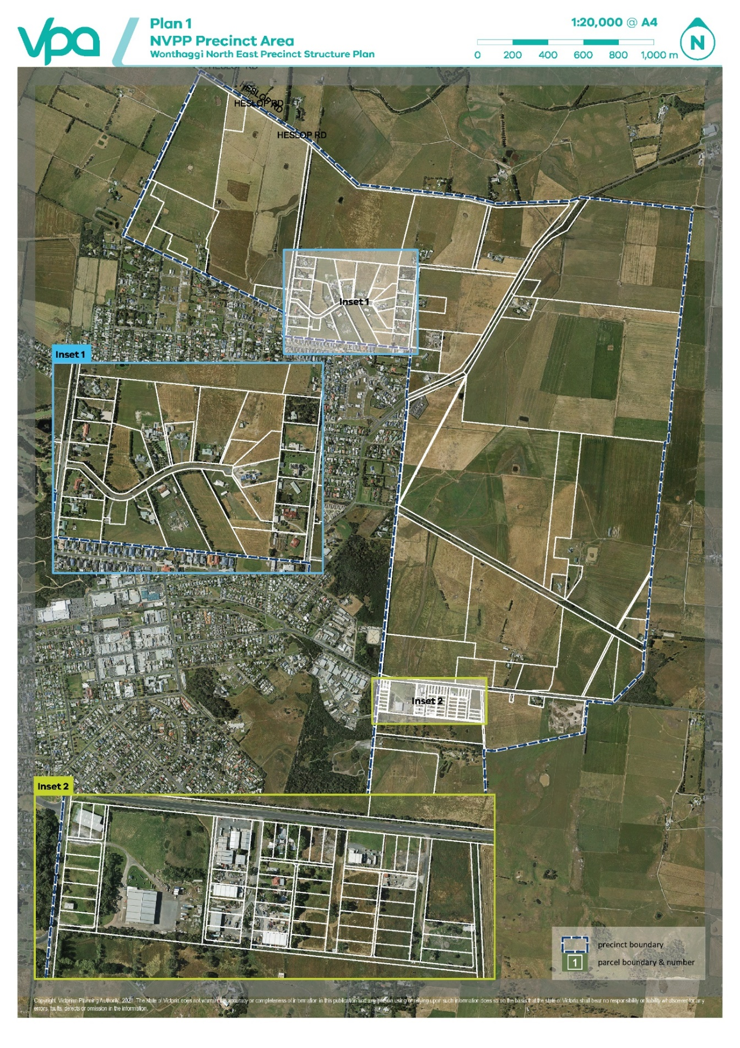

Plan 2 Existing Conditions
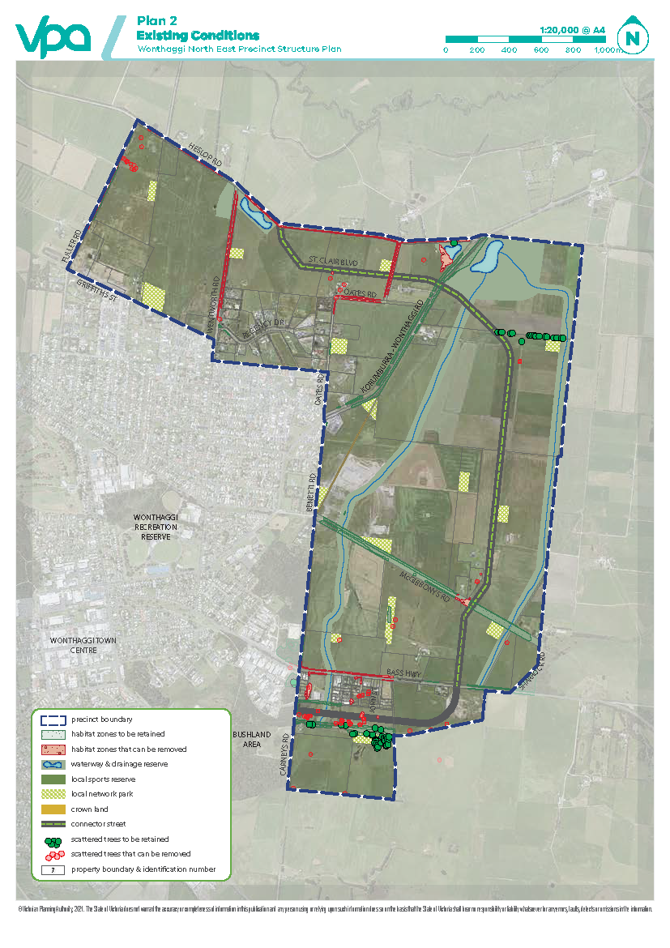
Plan 3 NVRR Reference Plan
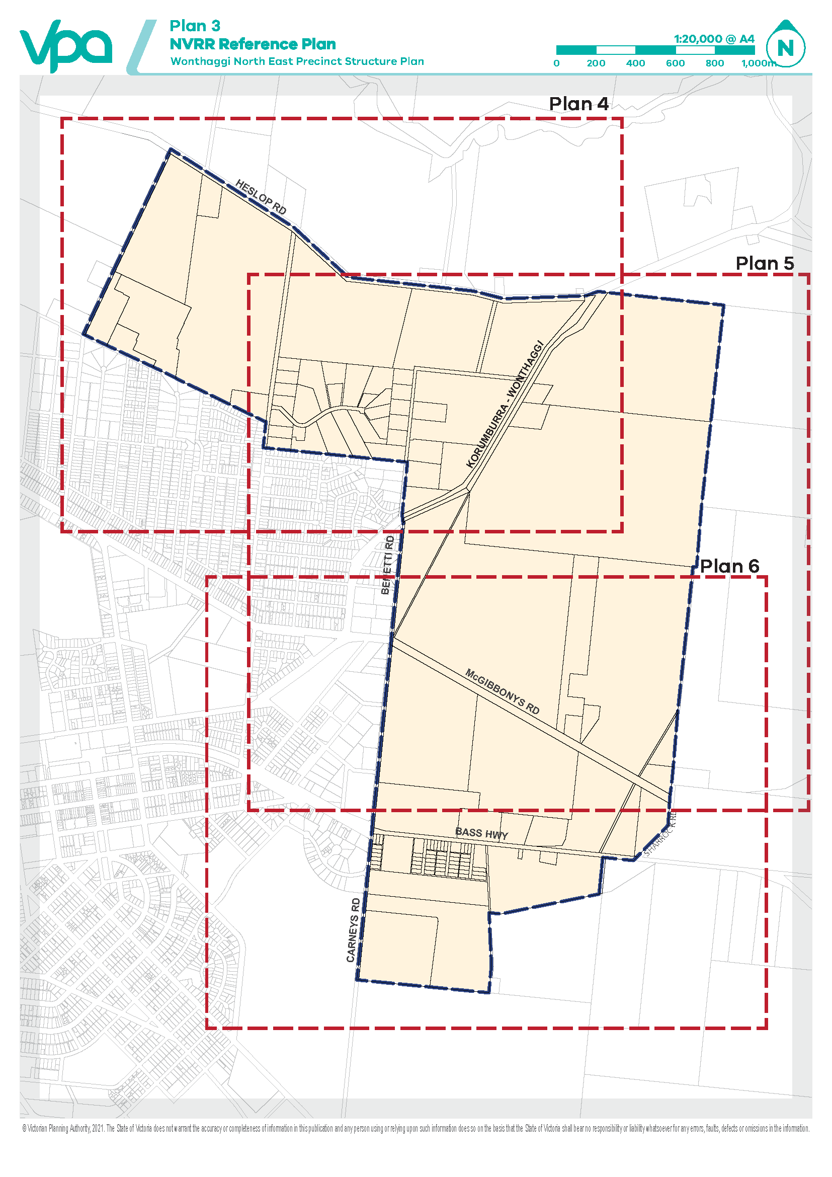

Plan 4 Native Vegetation Retention and Removal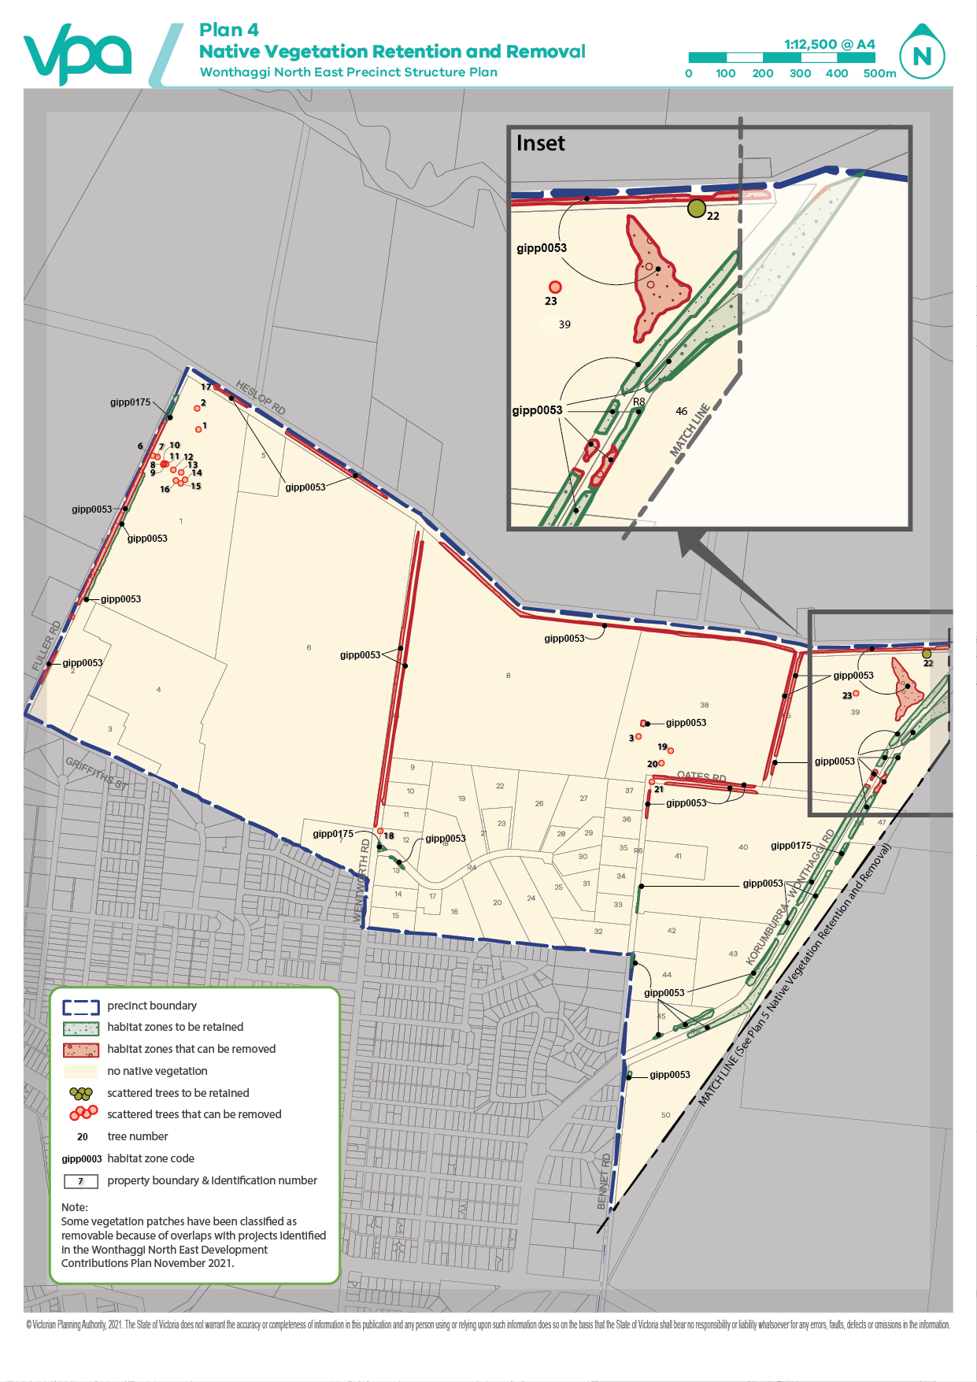

Plan 5 Native Vegetation Retention and Removal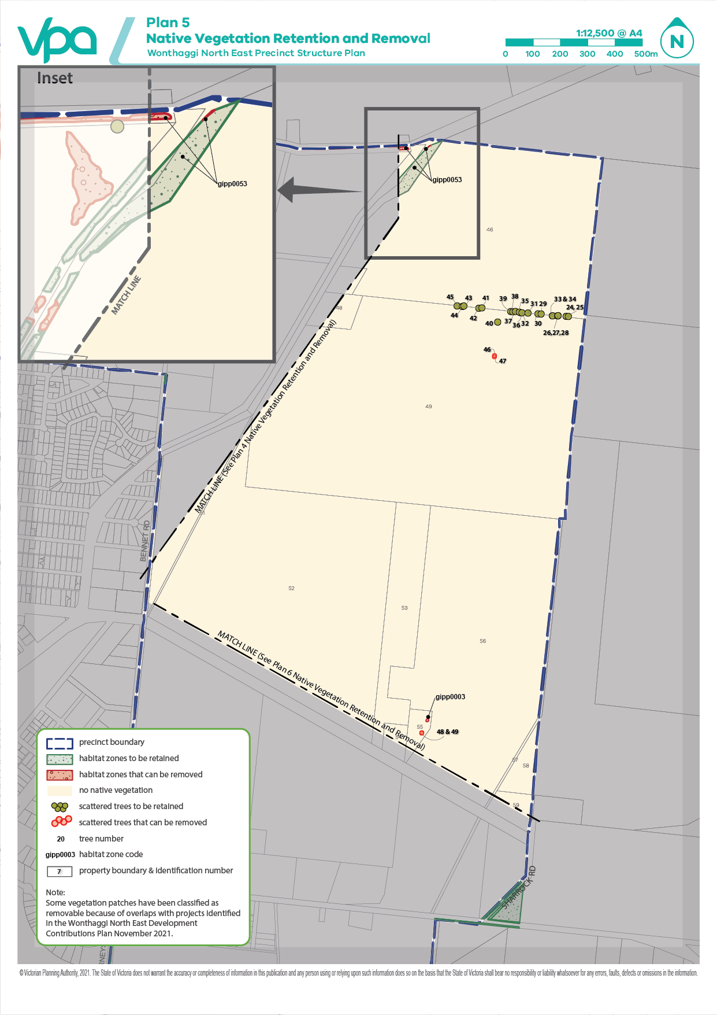

Plan 6 Native Vegetation Retention and Removal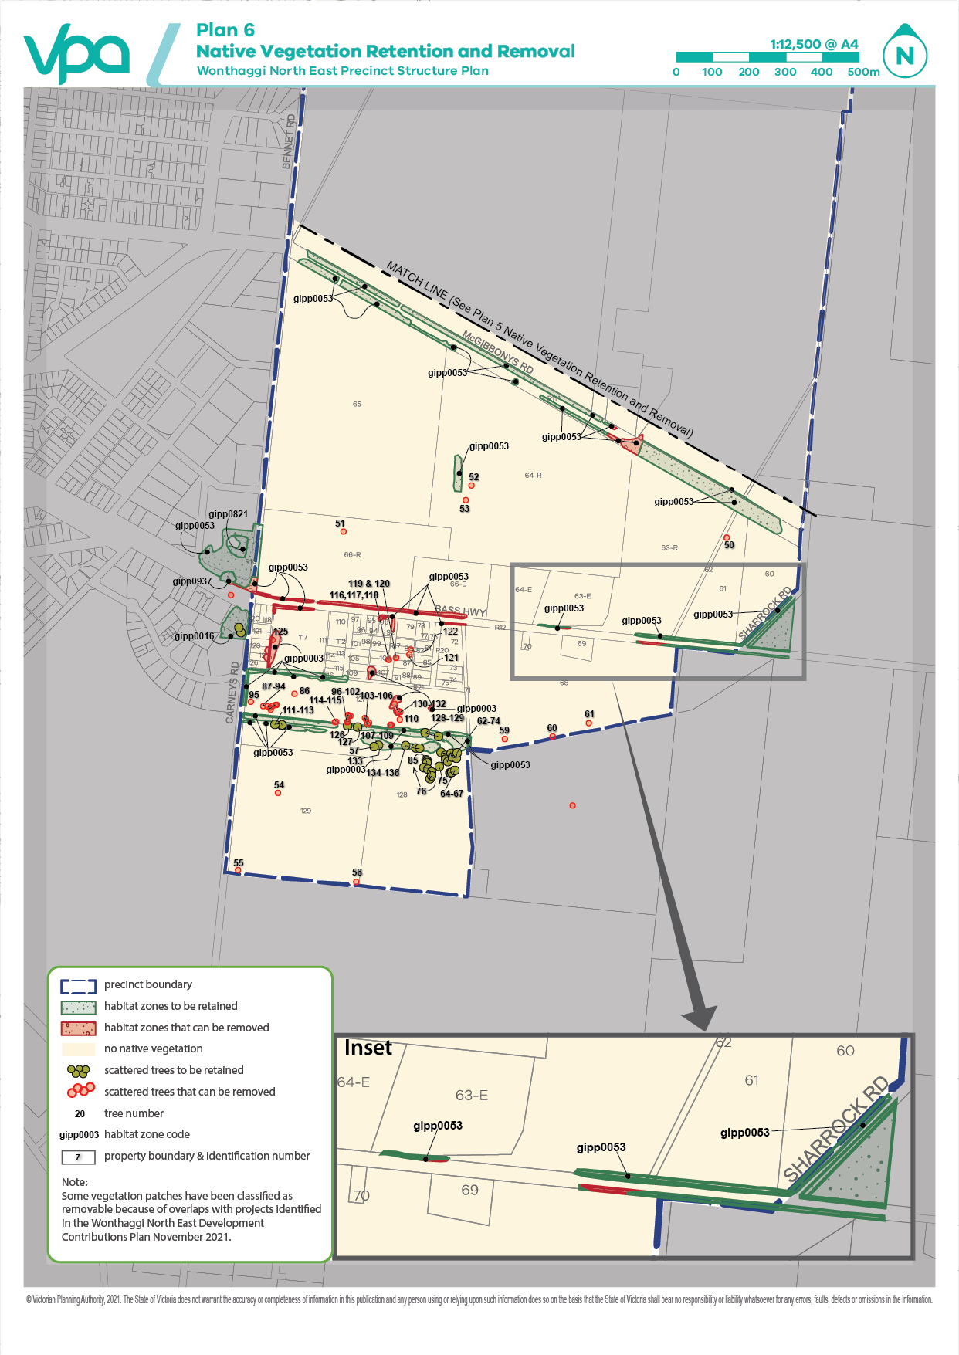l

Appendix A – NVPP Property Addresses
Table 7 Land included within the area to which this NVPP applies
Property ID no. | Property Address | Property SPI no.
1 | 90 FULLER ROAD NORTH WONTHAGGI 3995 | 1\TP232027
2 | GRIFFITHS STREET NORTH WONTHAGGI 3995 | 31\PS706365
3 | HAYWOOD PLACE NORTH WONTHAGGI 3995 | B\PS728714
4 | HAYWOOD PLACE NORTH WONTHAGGI 3995 | C\PS728714
5 | HESLOP ROAD NORTH WONTHAGGI 3995 | 2\PS302494
6 | 90 FULLER ROAD NORTH WONTHAGGI 3995 | 2\PS700899
7 | 173 WENTWORTH ROAD NORTH WONTHAGGI 3995 | 1\PS302494
8 | OATES ROAD NORTH WONTHAGGI 3995 | 1\TP862367
9 | 154 WENTWORTH ROAD NORTH WONTHAGGI 3995 | 13\PS323085
10 | 152 WENTWORTH ROAD NORTH WONTHAGGI 3995 | 12\PS323085
11 | 150 WENTWORTH ROAD NORTH WONTHAGGI 3995 | 11\PS323085
12 | 148 WENTWORTH ROAD NORTH WONTHAGGI 3995 | 10\PS323085
13 | 146 WENTWORTH ROAD NORTH WONTHAGGI 3995 | 9\PS323085
14 | 144 WENTWORTH ROAD NORTH WONTHAGGI 3995 | 8\PS323085
15 | 142 WENTWORTH ROAD NORTH WONTHAGGI 3995 | 7\PS323085
16 | 8 REGENCY DRIVE NORTH WONTHAGGI 3995 | 2\PS749270
17 | 2 REGENCY DRIVE NORTH WONTHAGGI 3995 | 1\PS749270
18 | 1-11 REGENCY DRIVE NORTH WONTHAGGI 3995 | 14\PS434235
19 | 13-15 REGENCY DRIVE NORTH WONTHAGGI 3995 | 15\PS434235
20 | 14-20 REGENCY DRIVE NORTH WONTHAGGI 3995 | 22\PS434235
21 | REGENCY DRIVE NORTH WONTHAGGI 3995 | CM1\PS739973
22 | REGENCY DRIVE NORTH WONTHAGGI 3995 | 2\PS739973
23 | REGENCY DRIVE NORTH WONTHAGGI 3995 | 1\PS739973
24 | 22-28 REGENCY DRIVE NORTH WONTHAGGI 3995 | 21\PS434235
25 | 30-36 REGENCY DRIVE NORTH WONTHAGGI 3995 | 2\PS443068
26 | 23-27 REGENCY DRIVE NORTH WONTHAGGI 3995 | 17\PS434235
27 | 29 REGENCY DRIVE NORTH WONTHAGGI 3995 | 2\PS739974
28 | 31 REGENCY DRIVE NORTH WONTHAGGI 3995 | 1\PS739974
29 | 33 REGENCY DRIVE NORTH WONTHAGGI 3995 | 1\PS735470
30 | 35 REGENCY DRIVE NORTH WONTHAGGI 3995 | 2\PS735470
31 | 38 REGENCY DRIVE NORTH WONTHAGGI 3995 | 3\PS735470
32 | 33 OATES ROAD NORTH WONTHAGGI 3995 | 1\PS443068
33 | 39 OATES ROAD NORTH WONTHAGGI 3995 | 2\PS313181
34 | 45 OATES ROAD NORTH WONTHAGGI 3995 | 3\PS313181
35 | 51 OATES ROAD NORTH WONTHAGGI 3995 | 4\PS313181
36 | 57 OATES ROAD NORTH WONTHAGGI 3995 | 5\PS313181
37 | 63 OATES ROAD NORTH WONTHAGGI 3995 | 6\PS313181
38 | 75 OATES ROAD NORTH WONTHAGGI 3995 | 1\TP861100
39 | 2928 KORUMBURRA ROAD NORTH WONTHAGGI 3995 | 33B\PP3866
40 | OATES ROAD NORTH WONTHAGGI 3995 | 2\PS648351
41 | 60 OATES ROAD NORTH WONTHAGGI 3995 | 1\PS506140
42 | 30 OATES ROAD NORTH WONTHAGGI 3995 | 1\LP211687
43 | KORUMBURRA-WONTHAGGI ROAD NORTH WONTHAGGI 3995 | 1\PS648351
44 | 26 OATES ROAD NORTH WONTHAGGI 3995 | 2\LP211687
45 | 3028 KORUMBURRA-WONTHAGGI ROAD NORTH WONTHAGGI 3995 | 1\TP129892
46 | KORUMBURRA-WONTHAGGI ROAD ST CLAIR 3995 | 1\LP74840
47 | KORUMBURRA-WONTHAGGI ROAD ST CLAIR 3995 | 1\PS728726
48 | 2965 KORUMBURRA-WONTHAGGI ROAD ST CLAIR 3995 | 1\PS531086
49 | KORUMBURRA-WONTHAGGI ROAD ST CLAIR 3995 | 2\PS531086
50 | KORUMBURRA-WONTHAGGI ROAD WONTHAGGI 3995 | RES1\PS646625
51 | BENETTI ROAD WONTHAGGI 3995 | 34F1\PP3866
52 | BENETTI ROAD WONTHAGGI 3995 | A\PS646625
53 | MCGIBBONYS ROAD WONTHAGGI 3995 | 1\PS644463
54 | 129 MCGIBBONYS ROAD WONTHAGGI 3995 | 1\PS525119
55 | 135A MCGIBBONYS ROAD WONTHAGGI 3995 | 1\PS629443
56 | 135B MCGIBBONYS ROAD WONTHAGGI 3995 | 2\PS644463
57 | MCGIBBONYS ROAD WONTHAGGI 3995 | 34E1\PP3866
58 | SHARROCK ROAD WONTHAGGI 3995 | 3\PS305402
59 | 39 SHARROCK ROAD WONTHAGGI 3995 | 1\PS305402
60 | SHARROCK ROAD WONTHAGGI 3995 | 34D3\PP3866
61 | BASS HIGHWAY WONTHAGGI 3995 | 4\PS628069
62 | 5261 BASS HIGHWAY WONTHAGGI 3995 | 34D2\PP3866
63 | BASS HIGHWAY WONTHAGGI 3995 | 4\PS628069
64 | 5261 BASS HIGHWAY WONTHAGGI 3995 | 3\PS628069
65 | MCGIBBONYS ROAD WONTHAGGI 3995 | 1\PS628069
66-E | 5261 BASS HIGHWAY WONTHAGGI 3995 | 2\PS628069
68 | BASS HIGHWAY WONTHAGGI 3995 | 2\PS500715
69 | 5266 BASS HIGHWAY WONTHAGGI 3995 | 1\PS500715
70 | 5262 BASS HIGHWAY WONTHAGGI 3995 | 1\TP127267
71 | WHITE ROAD WONTHAGGI 3995 | 2004\PP3866
72 | BASS HIGHWAY WONTHAGGI 3995 | PC371263
73 | JOHN STREET WONTHAGGI 3995 | 3\TP90427
74 | JOHN STREET WONTHAGGI 3995 | 2\TP90427
75 | JOHN STREET WONTHAGGI 3995 | 1\TP90427
76 | BASS HIGHWAY WONTHAGGI 3995 | 3\TP85819
77 | BASS HIGHWAY WONTHAGGI 3995 | 2\TP85819
78 | BASS HIGHWAY WONTHAGGI 3995 | 1\TP85819
79 | 5256 BASS HIGHWAY WONTHAGGI 3995 | PC367141
80 | VERE STREET WONTHAGGI 3995 | 42\LP11690
81 | JOHN STREET WONTHAGGI 3995 | 1\TP120994
82 | JOHN STREET WONTHAGGI 3995 | 1\TP106470
83 | VERE STREET WONTHAGGI 3995 | 41\LP11690
84 | VERE STREET WONTHAGGI 3995 | 40\LP11690
85 | JOHN STREET WONTHAGGI 3995 | 1\TP108217
86 | JOHN STREET WONTHAGGI 3995 | 1\TP106471
87 | VERE STREET WONTHAGGI 3995 | 39\LP11690
88 | VERE STREET WONTHAGGI 3995 | 38\LP11690
89 | JOHN STREET WONTHAGGI 3995 | 1\TP106472
90 | JOHN STREET WONTHAGGI 3995 | 1\TP108218
91 | VERE STREET WONTHAGGI 3995 | 37\LP11690
92 | 5248 BASS HIGHWAY WONTHAGGI 3995 | 5\TP949763
93 | 5248 BASS HIGHWAY WONTHAGGI 3995 | 4\TP949763
94 | 5248 BASS HIGHWAY WONTHAGGI 3995 | 3\TP949763
95 | 5248 BASS HIGHWAY WONTHAGGI 3995 | 2\TP949763
96 | 5248 BASS HIGHWAY WONTHAGGI 3995 | 26\LP11690
97 | 5248 BASS HIGHWAY WONTHAGGI 3995 | 1\TP949763
98 | 7 KEVIN STREET WONTHAGGI 3995 | 1\TP102555
99 | VERE STREET WONTHAGGI 3995 | 1\TP102187
100 | VERE STREET WONTHAGGI 3995 | 1\TP102189
101 | 9 KEVIN STREET WONTHAGGI 3995 | 1\TP86342
102 | 9 KEVIN STREET WONTHAGGI 3995 | 1\TP86302
103 | VERE STREET WONTHAGGI 3995 | 1\TP102556
104 | VERE STREET WONTHAGGI 3995 | 1\TP102190
105 | 9 KEVIN STREET WONTHAGGI 3995 | 1\TP87456
106 | 9 KEVIN STREET WONTHAGGI 3995 | 1\TP86304
107 | VERE STREET WONTHAGGI 3995 | 1\TP111325
108 | VERE STREET WONTHAGGI 3995 | 1\TP102188
109 | 9 KEVIN STREET WONTHAGGI 3995 | 1\TP86311
110 | BASS HIGHWAY WONTHAGGI 3995 | CP172891
111 | 10 KEVIN STREET WONTHAGGI 3995 | 1\TP7801
112 | 10 KEVIN STREET WONTHAGGI 3995 | 14\LP11690
113 | 10 KEVIN STREET WONTHAGGI 3995 | 15\LP11690
114 | 10 KEVIN STREET WONTHAGGI 3995 | 16\LP11690
115 | 10 KEVIN STREET WONTHAGGI 3995 | 17\LP11690
116 | 10 KEVIN STREET WONTHAGGI 3995 | 18\LP11690
117 | 19 CARNEYS ROAD WONTHAGGI 3995 | PC363587
118 | 5 CARNEYS ROAD WONTHAGGI 3995 | 3\TP100022
119 | 5 CARNEYS ROAD WONTHAGGI 3995 | 2\TP100022
120 | 5 CARNEYS ROAD WONTHAGGI 3995 | 1\TP100022
121 | 19 CARNEYS ROAD WONTHAGGI 3995 | 4\TP100022
122 | 19 CARNEYS ROAD WONTHAGGI 3995 | 5\TP100022
123 | 11 CARNEYS ROAD WONTHAGGI 3995 | 6\LP11690
124 | 13 CARNEYS ROAD WONTHAGGI 3995 | 7\LP11690
125 | 13 CARNEYS ROAD WONTHAGGI 3995 | 8\LP11690
126 | 19 CARNEYS ROAD WONTHAGGI 3995 | PC363587
127 | 35 CARNEYS ROAD WONTHAGGI 3995 | 1\TP167690
128 | 37 CARNEYS ROAD WONTHAGGI 3995 | 2\PS428092
129 | CARNEYS ROAD WONTHAGGI 3995 | 1\PS428092

