Craigieburn West Precinct Structure Plan
Public consultation report
Final
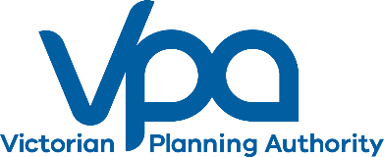
February 2021

Prepared by | Naomi Oosting
Date | 22/01/2021
Reviewed by | James Paull
Date | 22/01/2020
Reviewed by | Marco Bass
Date | 27/01/2020
Authorised by | Tony Marks
Date | 04/02/2020

CONTENTS
1 Executive Summary 4
2 Overview 5
2.1 Project background 5
2.2 The VPA’s Fast Track Program 5
2.3 Public consultation overview 6
2.4 Previous community consultation 7
2.5 Government agency and service provider consultation 7
2.6 Local council consultation 7
2.7 Landowner consultation 7
3 Consultation Methodology 8
3.1 Consultation program 8
4 Summary of Feedback 9
4.1 Road Improvements 9
4.2 Active and Public Transport 9
4.3 Preservation of native flora and fauna 9
4.4 Drainage and Stormwater Management 9
4.5 Suburb Naming 9
4.6 Written submissions 10
5 Post Consultation & Next Steps 11
5.1 Resolution of submissions 11
5.2 Pathway to approval 11
6 Appendices 12
6.1 Mail out boundary map 12
6.2 Project brochure 12

Executive Summary
The Craigieburn West PSP will set out a planning roadmap for the precinct to 2040 and beyond. The PSP will identify where and when future housing, infrastructure and associated community facilities may be developed. It will also identify what infrastructure is needed to support the growing community, such as roads and community facilities, and land for employment and retail.
The Victorian Planning Authority (VPA) has worked with Hume City Council to prepare a draft planning scheme amendment (amendment) to the Hume Planning Scheme. The draft amendment will enable future decisions about Craigieburn’s growth to be guided by the PSP.
This consultation report summarises the public consultation process for the Craigieburn West PSP and supporting draft amendment to the Hume Planning Scheme. The consultation ran for four weeks from Tuesday 17 November until Friday 18 December 2020. The report also provides a thematic overview of feedback heard during this time.

The VPA’s approach to community consultation for this project mirrored the key elements of the planning scheme amendment notice and submission process required under Section 19 of the Planning and Environment Act. It ensured that the Craigieburn community, local businesses, key stakeholders, government agencies and site landowners had ample opportunity to understand the proposed planning changes; discuss the planning concepts with the VPA planning team and make a written submission to the plan and associated draft amendment.
The VPA collected 35 comments and/or questions across its public events, with 24 people contacting the team over the phone and a further 14 people attending the online session. Hume City Council also received calls from interested parties in the engagement period. The key topics of interest were;
- Road connections and transport and active transport
- Protection of native vegetation and wildlife
- Provision of schools and services
- Drainage and stormwater management
42 written submissions were received to the draft amendment, which the VPA has acknowledged and is working to resolve where possible in the time available.
A detailed outline of the consultation process is contained in this report including council, landowner and agency consultation ensuring that all views are known.

Overview

Project background
The Craigieburn West Precinct Structure Plan (PSP) proposes a long-term plan for the development of a new neighbourhood in Melbourne’s north. It describes how Craigieburn West is expected to develop and provides plans for services and infrastructure to support the new community. The Craigieburn West Precinct Structure Plan is the final Precinct Structure Plan in the Craigieburn residential area.
The precinct will create a series of walkable neighbourhoods arranged along a north–south spine including open space links and key road connections. The precinct will also enhance the heritage and landscape features of the area and maximize the retention of established native vegetation.
The precinct will feature schools, community hubs, and different types of housing to support a diverse community, as well as a range of open spaces, including conservation reserves, active open spaces, and a network of local parks.
The Precinct Structure Plan anticipates the completion of the network of green links across the greater Craigieburn area. It also plans for a sensitive transition between the residential neighbourhood and the green wedge land west of Mickleham Road.
Members of the new Craigieburn West community will have easy access to nearby Craigieburn Central, Aston Village and Highlands Village, as well as new local facilities including a new local town centre with open space and community facilities and a series of potential government and non-government schools.

The VPA’s Fast Track Program
The Craigieburn West PSP is part of the VPA – Fast-Track Program, an element of the Victorian Government’s response to support a post-COVID economic recovery. This accelerated work program will provide certainty for communities and a pipeline of development that will assist in delivering future jobs and homes for Victorians as the economy recovers from the impact of the pandemic.
As part of the VPA – Fast-Track Program, if required, the Craigieburn West PSP project will be subject to the VPA Projects Standing Advisory Committee (VPA SAC). The VPA SAC has been established to provide independent advice on draft planning scheme amendments to the VPA and the Minister for Planning. More information on this process is available in Section 5.

Public consultation overview
The Craigieburn West PSP and associated draft planning scheme amendment were released for public comment on Tuesday 17 November until Friday 18 December 2020. The identified stakeholders include the Craigieburn community, local council, state government agencies and services providers, landowners and the general public. The consultation consisted of a project letter, project brochure, telephone conversations, a virtual-drop-in session and a live ‘Question and Answer’ forum, as well as virtual meetings with local and state government authorities. VPA promoted the project through its social media channels.
These engagement activities were designed to reflect the relevant public health restrictions at the time of consultation and closely followed the elements of the planning scheme amendment notice and submission process under section 19 of the Planning and Environment Act 1987.
A complete suite of the planning documentation was made accessible on the VPA’s Have your Say platform as well as the Engage Victoria project page. Hardcopy versions were offered to any person with limited access to the website. Formal feedback was collected in the form of written submissions.

Purpose
The key purpose of this consultation process was to provide an opportunity for the local community and key stakeholders to write a submission to the draft PSP and planning scheme amendment before it is progressed through the planning system.

Promotion and reach
The opportunity to get involved was promoted through direct mail to 5326 all addresses within 500 metres of the precinct. A map showing the boundary of the mailout area is shown in Appendix 6.1 to this report.
The mailout included a letter and project brochure which outlined the key features of the plan and planning process. It included background information on the VPA’s Fast Track program; details for making a submission and information about upcoming community events.
A further 59 community subscribers on the Craigieburn West PSP digital database received a project update regarding the consultation opportunity. The Craigieburn West webpage on the VPA site was visited 882 times during the consultation period. The Engage Victoria page on the Craigieburn West PSP received 1889 views during the same period.

Previous community consultation
No previous community consultation has been conducted for the Craigieburn West PSP.

Government agency and service provider consultation
Throughout the planning process for Craigieburn West PSP, the VPA project manager and planning team met with the necessary government and delivery agencies to ensure a coordinated whole-of-government approach was being applied.
Government agencies were offered the opportunity to review and provide informal comments on the proposed plan and planning scheme amendment documentation prior to the broader public consultation in November 2020. As a result, several improvements were made to the planning documentation before it was made publicly available.
A further eight government agency and service provider submissions were received during the public consultation period.

Local council consultation
The VPA worked closely with Hume City Council to prepare the plan and associated planning materials for the Craigieburn West PSP to ensure the project aligns with local planning policy. Hume City Council was invited to make a submission to the draft amendment during public consultation and did so.

Landowner consultation
As the land covered by the Craigieburn West PSP is privately owned, the VPA consulted with those landowners while preparing the plan to ensure the views of this stakeholder group were known. The landowners were also invited to prepare a written submission during this final public consultation process. The VPA received 12 submissions from landowners within the proposed precinct.

Consultation Methodology

Consultation program
The consultation period of the draft amendment to the Hume City Planning Scheme ran from Tuesday 17 December until Friday 18 December 2020. The activities and responses are summarised below.
Frequency and date | Public consultation activity | Audience | Outcomes
17 November 2020 | Letters and project brochure sent to owners and occupiers within 500m of the precinct. | Community & landowners | 5326 delivered
17 November 2020 | Update to project webpage | Community, landowners & agencies | 882 unique page views
17 November 2020 | Consultation page open on Engage Victoria | Community | 1889 unique page views
Various times | Hardcopy documents delivered on request | Community | 2 set delivered
Throughout consultation within business hours. | Telephone calls | Community, landowners and agencies | 9 calls
30 November 2020 (evening) | Virtual drop-in | Community & landowners | 14 participants
Offered on an as-needed basis | Additional community meetings | Community only | 6 meetings
17 November to 18 December 2020 | Written submissions | All | 42 submissions in total  - Government agency and service providers (8)  - Local council (1)  - Landowners within proposed PSP area (12)  - Local community, local organisations or community group (6)

Summary of Feedback
A total of 42 written submissions and an additional 32 questions/comments through phone/ email/ Zoom were made to the Craigieburn project during the consultation period.
An overview of the key themes raised through feedback heard over the phone, at the virtual drop-in session and via written submissions is outlined below.

Road Improvements
There were several comments relating to the current condition of roads in and around the precinct. Concerns were raised about the timing of the upgrade, or duplication of key arterial roads, including Mickleham Road, and stated that road upgrades should be aligned with the timing of development.
People were keen to know when the planned road improvements would take place and ensuring roads had sufficient capacity to accommodate the increased population planned for the area.

Active and Public Transport
There were comments in support of active and public transport within and around this precinct, suggesting that there should be more bike lanes and other concessions to encourage people to use alternative forms of transport.

Preservation of native flora and fauna
Some comments related to the preservation and management of native flora and fauna, particularly the Biodiversity Conservation Area, Mickleham Road Avenue of Honour and the retention of remnant vegetation within the precinct.

Drainage and Stormwater Management
There were some comments relating to drainage and stormwater management, particularly how this may affect some properties within the precinct.

Suburb Naming
There was some concern that the approval of the precinct would result in the area being renamed Craigieburn West, which was not supported by some members of the community. It is important to note that name of the suburb will not be affected by this planning process.

Written submissions
42 pieces of written feedback
The VPA received 42 submissions during this consultation process. All submitters received an immediate acknowledgement of receipt and the submissions are available (with personal details redacted) on the VPA’s website.
The VPA will continue to respond to and resolve the key issues raised in the written feedback where possible. Any unresolved submissions will be reported to the Minister for Planning, who will consider whether to refer matters to the VPA SAC for independent advice and the manner in which they may be heard.
The key issues raised by submitters have been grouped into the following categories:
- Duplication/upgrade of Mickleham Road
- Drainage and Water, including Drainage Services Scheme (Yuroke & Aitken Creek)
- Integrated Water Management matters
- Local Town Centre, including location and concept plan
- Open Space/Green links/Local Parks
- Bushfire Management
- Biodiversity and Ecosystems including tree retention/native vegetation
- Biodiversity Conservation Area 29- Realignment
- Kangaroo Management
- Transport & Movement, including traffic impact assessment, street network, public transport matters
- Requirements & Guidelines (inclusions/proposed changes)
- Precinct Infrastructure, including Infrastructure Contributions Plan
- Utilities
- Education and Community Facilities, including location of assets et al
- Planning Ordinance (inclusions/proposed changes)
- Heritage
- Land Capability, including sodic and dispersive soils matters
- CWPSP Vision and Objectives
- Housing, including density targets and affordable housing

Post Consultation & Next Steps

Resolution of submissions
As part of the VPA – Fast-Track Program, the Craigieburn West project will be assessed by the VPA Projects Standing Advisory Committee (VPA SAC). The VPA SAC has been established to provide independent advice on draft planning scheme amendments to the VPA and the Minister for Planning.
While the VPA will seek to resolve issues raised by submitters within the time available, unresolved issues requiring further consideration may be referred to the VPA SAC. Should the Minister for Planning seek to refer these matters to the VPA SAC, Planning Panels Victoria will contact affected submitters regarding next steps, process and timings.
The VPA will provide a written response to submitters whose submissions are not referred to the VPA SAC to ensure they are aware of the outcome of their submission.

Pathway to approval
The VPA SAC will provide advice on the draft amendment to the VPA and the Minister for Planning. The VPA will then make recommendations to the Minister for Planning, who will consider the appropriate approval pathway for an amendment to the Hume Planning Scheme.

Appendices

Mail out boundary map

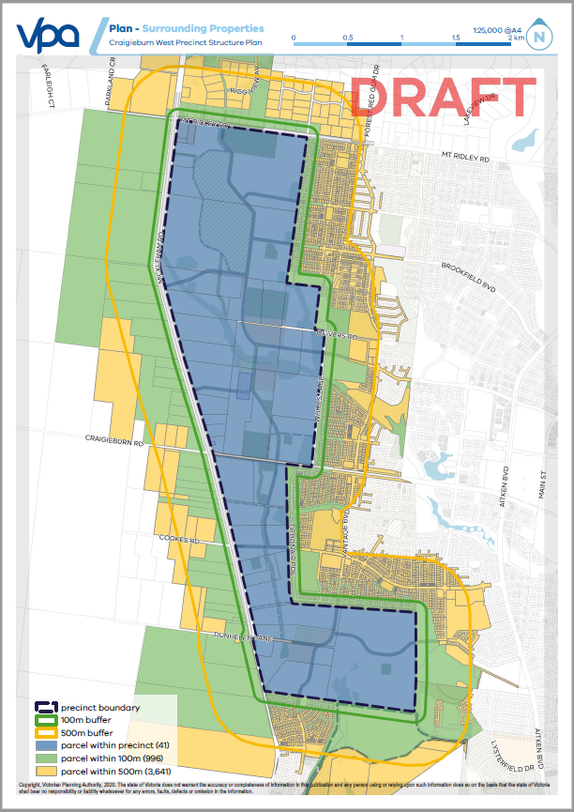
Project brochure

- Craigieburn West Project Brochure (November 2020)

