**Wonthaggi North East**

**Precinct Structure Plan**

 

November 2020

CONTENTS

1 INTRODUCTION 4

1.1 How to read this document 6

1.2 Land to which this Precinct Structure Plan applies 6

1.3 Wonthaggi North East Development Contributions Plan 6

1.4 Background Information 6

**2** OUTCOMES 8

2.1 Vision 8

2.2 Objectives 9

2.3 Summary land Use budget 12

**3** IMPLEMENTATION 14

3.1 Township image and character, heritage and housing 14

3.2 Village Hub and Employment 19

3.3 Open Space, Community Facilities and Education 22

3.4 Bushfire resilience, Biodiversity, Threatened Species and Native Vegetation Retention 25

3.5 Transport and Movement 27

3.6 Integrated Water Management and Utilities 32

3.7 Sequencing, staging and infrastructure delivery 36

APPENDICES 38

Parcel Specific Land Budget 38

Service Placement Guidelines 42

Village Hub and Local Convenience Centre Design Guidelines 44

Street Cross sections 47

PLANS

Plan 1 Regional Context 1

Plan 2 Precinct Features 3

Plan 3 Future Urban Structure 7

Plan 4 Land Use Budget 11

Plan 5 Image and Character 13

Plan 6 Open Space 21

Plan 7 Road Network 26

Plan 8 Public Transport and Path Network 29

Plan 9 Integrated Water Management 31

Plan 10 Utilities 34

Tables

Table 1 Project History 5

Table 2 Summary Land Use Budget 12

Table 3 Housing types by lot size 17

Table 4 Local Convenience Centre Hierarchy 19

Table 5 Anticipated Employment Creation 20

Table 6 Open Space Delivery Guide 23

Table 7 Drainage and Stormwater Management 33

fIGURES

Figure 1 McGibbonys Road Interface Concept Plan 15

Figure 2 Village Hub Concept Plan 18

Plan 1 Regional Context

FOREWORD

The Wonthaggi North East Growth area has been identified for some time as a key growth area for Bass Coast Shire Council, and the peri-urban area of Melbourne. The PSP is a framework that will facilitate the orderly growth and delivery of infrastructure and services in the growth area.

As a regional centre it is important that Council plans for growth in Wonthaggi and ensures that the municipality is ready to take advantage of the opportunities presented in proximity to the metropolitan area, tourism, improved infrastructure and the surrounding Gippsland region.

Planning for growth in the right locations protects the assets that we value, such as coastal settlements, coastal reserves and rural hinterland.

This PSP presents an exciting opportunity for the town of Wonthaggi to grow and realise its potential. Future growth will provide greater investment opportunities, build on existing and deliver new infrastructure as well as provide new services and create more local jobs.

The Wonthaggi North East Precinct Structure Plan (PSP) will capture the benefits of growth while maintaining the town as a strong rural service centre, with attractive new communities and surrounding farmland. It creates a strategic framework that will guide the town’s growth from 8,000 to 20,000 residents through the construction of approximately 5000 new homes over the next 30 to 50 years.

The PSP contains plans, objectives, requirements, and guidelines to govern development and ultimately lead to the realisation of the future vision of Wonthaggi. It provides certainty for the development industry, Bass Coast Shire Council, and the community.

The PSP also plans for an expansion of the town’s existing infrastructure to service an increased population, including:

* A new road network that provides alternative routes through and around the town.
* An expanded business and industry precinct to increase the number of local jobs in Wonthaggi.
* New pedestrian and cycle paths, linking to and building on the significant Bass Coast trail network.
* 98 hectares of new open space, including significant areas of waterways and wetlands.
* Provision for a new community and village hub.

The plan will also assist council in seeking continued State investment in service provision and facilities, such as health and education services.

Overall, the PSP embraces the opportunity for population growth to create a vision for a bigger and better Wonthaggi.

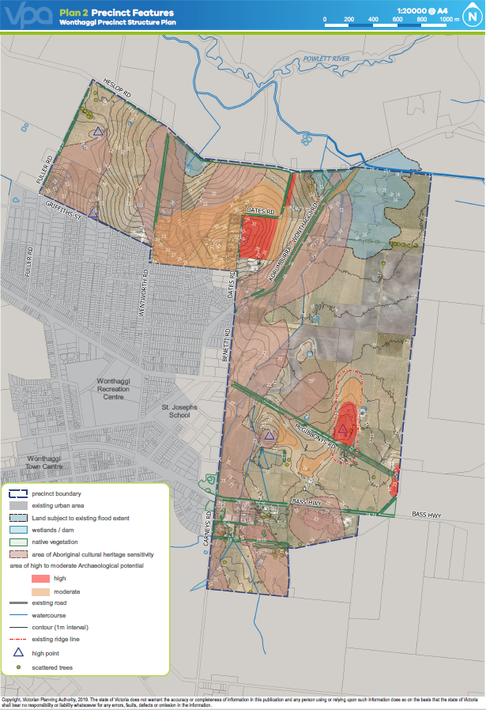

Plan 2 Precinct Features

1 INTRODUCTION

The Wonthaggi North East Precinct Structure Plan (the PSP) has been prepared by Bass Coast Shire Council and the Victorian Planning Authority in consultation with Government agencies, service authorities, existing landowners and major stakeholders.

The PSP is a long-term plan for urban development. It describes how the land is expected to be developed and how and where services are planned to support development.

The PSP:

* Provides Government agencies, the Council, developers, investors and local communities with certainty about future development.
* Sets out plans to guide the delivery of quality urban environments in accordance with the Victorian Government policies and guidelines (listed below) and local policy.
* Enables the transition from non-urban land to urban land.
* Sets the vision for how land should be developed, illustrates the future urban structure and describes the outcomes to be achieved by future development.
* Outlines projects required to ensure that the future community, visitors and workers within the area are provided with timely access to services and transport infrastructure necessary to support a quality, affordable lifestyle.
* Sets out objectives, requirements and guidelines for land use, development and subdivision.

The PSP is informed by the following policies and guidelines:

* The Planning Policy Framework as set out in the Bass Coast Planning Scheme;
* The Precinct Structure Planning Guidelines (Victorian Planning Authority);
* Plan Melbourne Refresh 2017-2050, (Department of Environment, Land, Water and Planning 2017);
* Gippsland Regional Growth Plan (Department of Transport, Planning & Local Infrastructure, 2013);
* Wonthaggi North East Growth Area Development Plan: Final (Prepared by CPG Australia, November 2009.

The following planning documents have been developed in parallel with the PSP to inform and direct the future planning and development of the precinct:

* The Wonthaggi North East Development Contributions Plan (the DCP) that applies the requirements for development proponents to make a contribution toward infrastructure required to support the development of the precinct.
* The Wonthaggi North East Native Vegetation Precinct Plan (NVPP) which identifies the native vegetation that is to be retained and permitted for removal.

The Wonthaggi North East precinct area has been identified within a number of previous documents. The project history can be summarised below:

|  |  |  |
| --- | --- | --- |
| **DOCUMENT** | **WHEN** | **RESULT / PURPOSE** |
| Wonthaggi Dalyston Structure Plan | 2008 | The Plan indicated strong residential growth projections for the town and a lack of future residential land supply. The plan also identified a shortage of industrial and commercial land. The Wonthaggi Dalyston Structure Plan recommended that future growth be directed to the Wonthaggi North East Growth Area. |
| Wonthaggi North East Growth Area Concept Plan (CPG Consultants) | 2009 | The Concept Plan was produced to implement the recommendations of the Wonthaggi Dalyston Structure Plan.  The Concept Plan provided residential, commercial and industrial land for development and was implemented into Development Plan Overlay Schedule 21 (DPO21) of the Bass Coast Planning Scheme. |
| Amendment C113 | 2010 | Rezoned 190 hectares of the broader Wonthaggi North East Growth Area from Farming Zone to Residential Zones to accommodate up to 1700 new dwellings. |
| Amendment C116 | 2011 | Rezoned 29 hectares of land adjacent to the Bass Highway to Business 4 Zone (now Commercial 2  Zone) and 18 hectares to the south of the Bass Highway to Industrial 1 Zone. |
| Wonthaggi Structure Plan | 2018 | The Wonthaggi Structure Plan was a policy neutral update which produced a separate Structure Plan for the Wonthaggi and Dalyston Townships. As a policy neutral update the 2018 Wonthaggi Structure Plan indicated strong residential growth projections for the town and a lack of future residential land supply. There was also a shortage of industrial and commercial land availability. The Wonthaggi Structure Plan recommended that future growth be directed to the Wonthaggi North East Growth Area. |

Table 1 Project History

## How to read this document

A planning application and a planning permit implement the outcomes of the Precinct Structure Plan. The outcomes are expressed as the **Vision** and **Objectives**.

Each element of the precinct structure plan contains Requirements and Guidelines as relevant. Meeting these **Requirements** and **Guidelines** will implement the outcomes of the precinct structure plan.

**Requirements** must be adhered to in developing the land. Where they are not demonstrated in a permit application, requirements will usually be included as a condition on a planning permit whether or not they take the same wording as in this precinct structure plan. A requirement may include or reference a plan, table or figure in this precinct structure plan.

**Guidelines** express how discretion will be exercised by the Responsible Authority in certain matters that require a planning permit. If the Responsible Authority is satisfied that an application for an alternative to a guideline implements the outcomes the Responsible Authority may consider the alternative. A guideline may include or reference a plan, table or figure in the precinct structure plan.

Not every aspect of the land’s use and development is addressed in this structure plan and a responsible authority may manage development and issue permits under its general discretion. Native vegetation is in the precinct is management the **Wonthaggi North East Native Vegetation Precinct Plan**. Development must also comply with other Acts and approvals where relevant e.g. the *Environmental Protection and Biodiversity Act 1999* (Cth) in the case of biodiversity or the *Aboriginal Heritage Act 2006* in the case of cultural heritage amongst others.

## Land to which this Precinct Structure Plan applies

This PSP applies to land within the ‘precinct boundary’ on Plan 3 and marked UGZ1, IPO2 and DPO21 on the Bass Coast Planning Scheme maps. The Urban Growth Zone, Incorporated Plan Overlay and Development Plan Overlay implement the plan in different ways – read those provisions and the zone for the land first to understand how and when the PSP applies in each situation.

## Wonthaggi North East Development Contributions Plan

The *Wonthaggi North East Development Contributions Plan* (DCP) has been developed in parallel with the PSP to inform and direct the future planning and development of the precinct. The DCP:

* is a separate document incorporated into the Bass Coast Planning Scheme and implemented through the Development Contributions Plan Overlay;
* requires development proponents to contribute to infrastructure required to support the future community;
* sets out the requirements for infrastructure funding across the precinct;
* will be a separate document incorporated into the Bass Coast Planning Scheme and is implemented through the Development Contributions Plan Overlay.

The DCP identifies projects that are paid for in full or partially from existing Section 173 agreements. In circumstances where an infrastructure item has been nominated in both the DCP and in a Section 173 agreement, no additional payment as part of the DCP will be required from the contributing developer if the payment of the item is satisfied under the Section 173 agreement.

## Background Information

See the background documents marked C152 in the Schedule to Clause 72.08 in the Bass Coast Planning Scheme for a list of specialist report and documents informing this PSP.

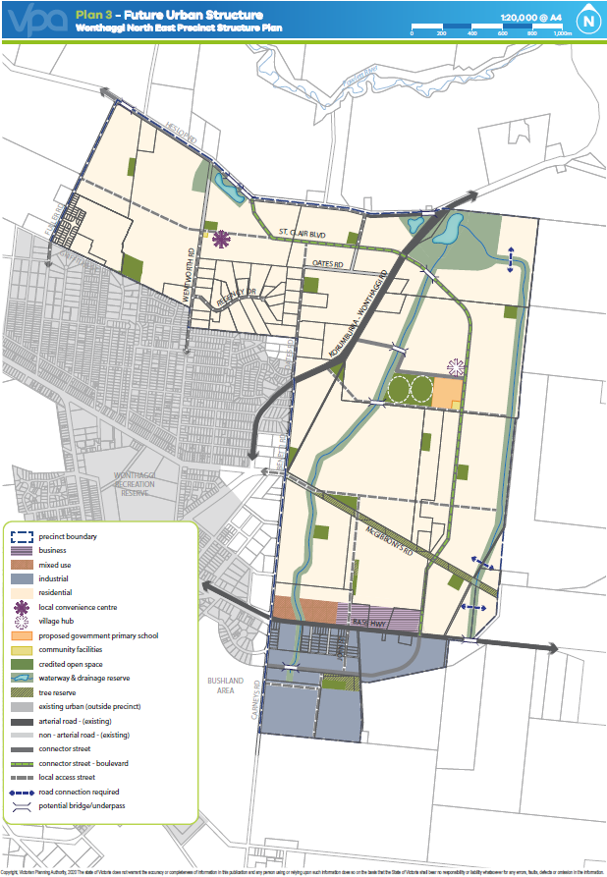

Plan 3 Future Urban Structure

# OUTCOMES

## Vision

Wonthaggi’s natural character is defined by its location between rural South Gippsland and the coastal landscapes of the Bass Coast. The landscape surrounding the Wonthaggi North East Precinct features coastal scrub vegetation, the Powlett River, bushland reserves and views to the northern rural hills.

The Wonthaggi North East PSP will create an attractive extension to the existing Wonthaggi township, providing long term residential and employment growth for Bass Coast Shire. The PSP will enable a significant expansion to Wonthaggi delivering community facilities, local parks, linear trails and a new sports reserve for its residents. The PSP will also provide for employment opportunities by allowing for commercial and industrial businesses to establish in close proximity to the Bass Highway.

The PSP will ensure that new communities are integrated within the existing town through road connections with tree lined streets connecting to St Clair Boulevard. The extensive pathway network will connect residents to local parks, sporting and community facilities, bushland, the existing township and the Bass Coast broader regional rail trail.

Protection and enhancement of Wonthaggi’s natural elements will be a crucial component of the PSP, through the retention and rehabilitation of native vegetation, protection of view lines and improvement of existing waterways.

The introduction of an extensive waterway and wetland system will anchor the new community, providing a natural thoroughfare through the precinct and allowing for recreation opportunities. The significant wetland and waterways areas for stormwater management, encompassing 66ha, and will include landscaping and pathways.

The urban structure concept supports an engaged community with development opportunities that encourage access to local employment, participation in community and recreation activities, and contribute positively to the physical and social health and wellbeing of all members of the community.

## Objectives

|  |  |
| --- | --- |
| **TOWNSHIP IMAGE, CHARACTER, HERITAGE & HOUSING** | |
|  | Integrate Wonthaggi North East growth area with the existing urban area (township). |
|  | Develop a strong identity for Wonthaggi North East by incorporating elements of the nearby coastal and rural character into landscaping and streetscapes. |
|  | Ensure subdivision design, developments and public spaces are aesthetically pleasing, respond to the natural context and incorporate environmentally sustainable design. |
|  | Promote greater housing diversity and affordability with lots capable of accommodating a variety of dwelling types and sizes that encourage a variety of tenure and household types in appropriate locations. |
|  | Provide a sensitive interface to existing and adjoining development, natural features, open space and waterways. |
|  | Protect, conserve and celebrate places of Aboriginal cultural heritage and post-contact cultural heritage significance. |
| **OPEN SPACE, COMMUNITY FACILITIES AND EDUCATION** | |
|  | Deliver an accessible and integrated network of local parks, sports reserves and community facilities that meet the needs and aspirations of the new community with adaptable, flexible and multi-use designs. |
|  | Facilitate active and healthy living by creating an urban environment that encourages cycling and walking. |
|  | Encourage the retention and establishment of trees through responsive layout of lots, streets and open spaces. |
| **VILLAGE HUB AND EMPLOYMENT** | |
|  | Strengthen the local economy by creating opportunities for new businesses and a variety of local jobs. |
|  | Provide for local retail, civic and community opportunities through village hubs while maintaining and enhancing the service centre role of Wonthaggi. |
|  | Deliver highly accessible, functional and vibrant local convenience centres with a sense of place that encourages social interaction and community engagement. |
| **INTEGRATED WATER MANAGEMENT** | |
|  | Deliver an integrated water management system that encourages reduced reliance on reticulated potable water, encourages the re-use of alternative water, minimises flood risk, ensures waterway health, and contributes toward a sustainable and green urban environment. |
| **BUSHFIRE, BIODIVERSITY AND NATIVE VEGETATION** | |
|  | Ensure that bushfire risk is considered in the layout, staging and design of development and the local street network. |
|  | Ensure that bushfire hazards are identified and that protection measures are considered in the layout and design of the local street network, subdivisions and buildings and works. |
|  | Ensure development responds to flora and fauna species and habitats in accordance with the Wonthaggi North East Native Vegetation Precinct Plan. |
| **TRANSPORT AND MOVEMENT** | |
|  | Provide a high-amenity, low speed and permeable local road network that prioritises community access and safety. |
|  | Establish an integrated and permeable transport network to encourage public transport, walking and cycling, reduced car dependency. |
| **PRECINCT INFRASTRUCTURE PLAN AND STAGING** | |
|  | Encourage development staging to be co-ordinated with the delivery of key infrastructure. |

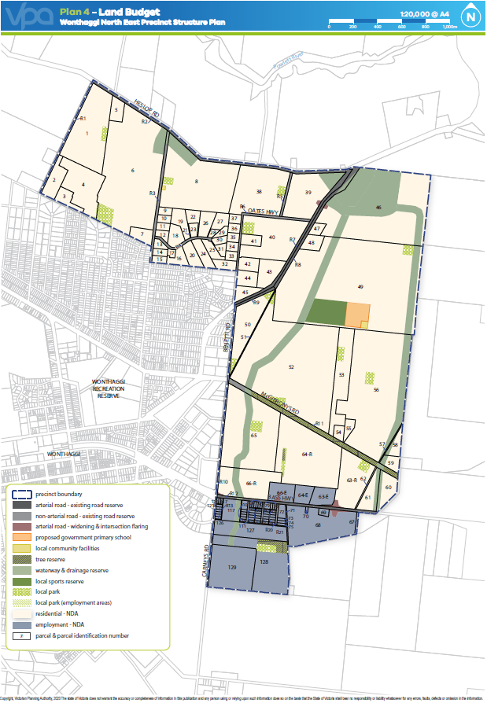

Plan 4 Land Use Budget

## Summary land Use budget

The land budget in Table 2 provides a summary of the land required for transport, community facilities, government education facilities, open space and identifies the total amount of land available for development. The land required for transport projects only applies to Precinct wide transport infrastructure and not local roads.

The Net Developable Area (NDA) is established by deducting the land requirement for transport, community facilities, public and private education facilities, open space (sports reserves and local parks), and other encumbered land from the Gross Developable Area (GDA). The GDA for Wonthaggi North East is 633 hectares of which 519 hectares, or 82%, is NDA. 455 hectares are available for residential development and 64 hectares for employment development. Based on a residential development yield average of 11 dwellings per NDA, the Wonthaggi North East precinct will generate approximately 5,000 dwellings to accommodate approximately 12,000 new local residents.

Table 2 Summary Land Use Budget



*\* A parcel specific land budget is included at Appendix 4.1. INSERT SUMARY LAND USE BUDGET*

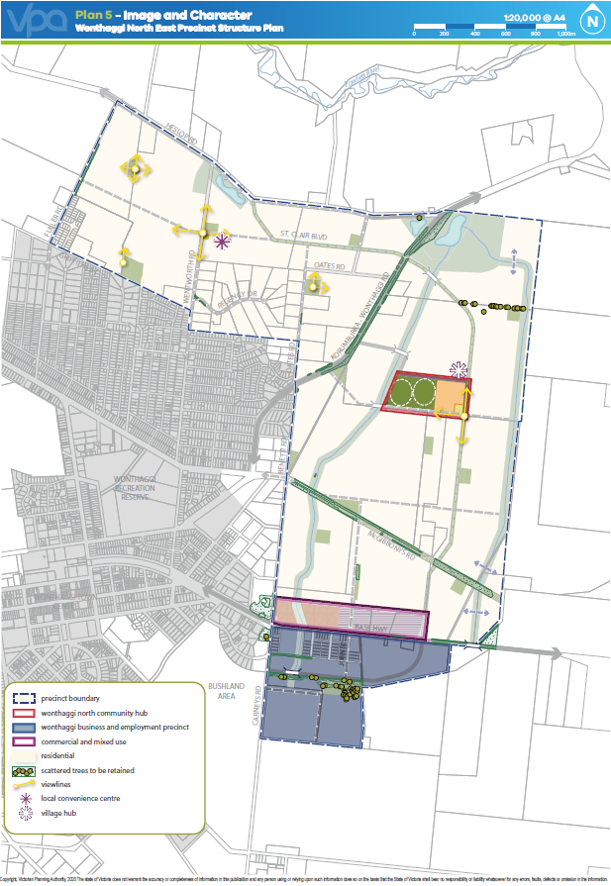

Plan 5 Image and Character

# IMPLEMENTATION

## Township image and character, heritage and housing

### Image and character

|  |  |
| --- | --- |
| requirements | |
|  | Street trees must be provided on both sides of all roads/streets (excluding laneways) in accordance with the cross-sections at Appendix 4.4, and at regular intervals appropriate to tree size at maturity and not exceeding the average intervals below unless otherwise agreed by the responsible authority:   |  |  | | --- | --- | | **AVERAGE INTERVAL** | **TREE SIZE** | | 8 – 10 metres | Small trees (less than 10 metre canopy) | | 10 – 12 metres | Medium trees (10 – 15 metre canopy) | | 12 – 15 metres | Large trees (Canopy larger than 15 metres) | |
|  | Trees in parks and streets must be suitable for local conditions and planted in modified and improved soil, as required, to support tree longevity. |
|  | Street tree planting must use locally appropriate species and be consistent with any guidance provided within the *Bass Coast Indigenous Plant Brochure* or on the relevant cross section within this Precinct Structure Plan unless otherwise approved by the responsible authority. |
|  | Development must address prominent sections of the township, as illustrated on Plan 3, with public streets or direct building frontages with pedestrian access. |
|  | Where lots directly adjoin adjacent non-urban land, lot and street layout must not prejudice the ability for that boundary to be extended and to effectively integrate any future development. |
| GUIDELINES | |
|  | Street networks should be designed to maximise the number of connections and direct views to waterways, open space and the surrounding Gippsland landscape. |
|  | A diversity of active frontages should be provided along the McGibbonys Road shared path reserve in order to maximise access and create visual interest, in accordance with the McGibbonys Road concept plan (Concept 1) and relevant cross - section in Appendix 4.5. |
|  | Significant elements of the landscape and built form should be used as focal points for view lines along streets. Elements may include items such as hill tops, ridge lines, prominent vegetation and other landmarks. |
|  | A frontage road should be provided along the township boundary, where appropriate. In areas where the lots directly adjoining the township boundary, road reserves and open spaces terminating on the boundary should be provided at regular intervals to provide open views of and access to the rural landscape. |
|  | Where lots directly adjoin the township boundary, the interface should be softened through increased length of rear yards, low fences, and vegetation to create a positive visual connection with the rural landscape. |
|  | Existing windrows and significant vegetation should be retained within the public domain, including parks and road reserves, where practical. |
|  | Consistent provision of street lighting and furniture should be provided across neighbourhoods, appropriate to the type and role of the street or public space, unless otherwise approved by the responsible authority. |
|  | Trees in streets and parks should be larger species wherever space allows to facilitate increased canopy cover. |

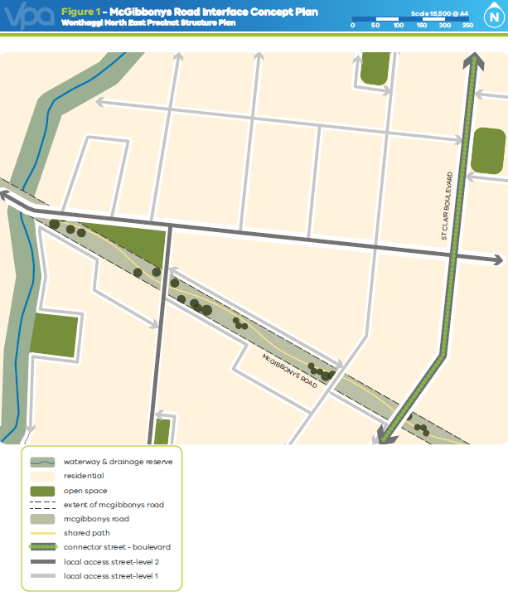

Figure 1 McGibbonys Road Interface Concept Plan

### Heritage and Land Contamination

|  |  |
| --- | --- |
| requirements | |
|  | Any subdivision and/or development of land adjoining an identified heritage place subject to the Heritage Overlay in the Bass Coast Planning Scheme must have regard to the heritage significance of the place and propose planning measures to ensure that the subdivision and/ or development provides a sensitive interface. |
|  | A mandatory Cultural Heritage Management Plan must be prepared if development designs are on land identified in Plan 2 as “area of Aboriginal cultural heritage sensitivity”. |
| GUIDELINES | |
|  | The Wonthaggi North East PSP seeks to encourage development of land close to areas of Aboriginal Cultural Heritage sensitivity to incorporate prominent interpretation features. The design of any local parks in proximity to these areas should incorporate interpretation mediums. |
|  | A voluntary Cultural Heritage Management Plan is recommended on land identified in Plan 2 as “area of high to moderate archaeological potential”. |

### Housing

|  |  |
| --- | --- |
| requirements | |
|  | Residential subdivisions must deliver a broad range of lot sizes capable of accommodating a variety of housing types. |
|  | Lots must front or side (in order of priority, where a lot fronts multiple elements):   * All public open space, including waterways, parks and tree reserves. * Utility easements that form part of the open space network. * Neighbourhood centres, schools and community facilities * Connector roads. * Arterial roads. |
|  | Residential subdivision applications must demonstrate how lots intended for medium-density, high-density, or integrated housing can be practically developed by providing indicative layouts that suitably demonstrate:   * Connections to and active interfaces with adjacent streets, open space and waterways. * Safe and effective internal vehicle and pedestrian circulation.   Unless otherwise agreed by the responsible authority. |
| GUIDELINES | |
|  | Residential subdivision should provide across each neighbourhood a broad range of lot sizes capable of accommodating a variety of housing types as described in Table 3. |
|  | Subdivision of land within a walkable distance of neighbourhood centres, public transport or areas of high amenity should create a range of lot sizes suitable for the delivery of medium-density housing. |
|  | Specialised housing forms such as retirement living or aged care should be:   * Integrated into the wider urban structure. * Located in close proximity to neighbourhood centres and community hubs. * Accessible by public transport. |
|  | The design of residential subdivisions abutting existing low-density areas should provide for a sensitive interface by   * Minimising the number of new lots abutting an existing low-density lot; and * providing sufficient space within new lots to allow screen planting along the interface. |

|  |  |  |  |  |  |
| --- | --- | --- | --- | --- | --- |
| **HOUSING TYPES THAT MAY BE SUPPORTED** | **LOT SIZE CATEGORY (M2)** | | | | |
| **LESS THAN 300M2** | **400M2-600M2** | **600M2-800M2** | **800M2-1,000M2** | **MORE THAN 1,000M2** |
| Rural style detached housing |  |  |  |  |  |
| Large-lot detached housing |  |  |  |  |  |
| Standard detached housing |  |  |  |  |  |
| Small detached housing |  |  |  |  |  |
| Semi-detached, duplexes |  |  |  |  |  |
| Attached housing, terraces |  |  |  |  |  |
| Integrated, multi-unit housing |  |  |  |  |  |

Table 3 Housing types by lot size

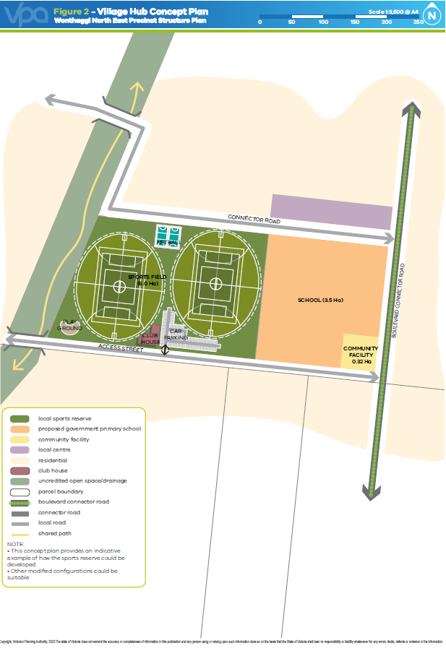

Figure 2 Village Hub Concept Plan

## Village Hub and Employment

The Village Hub will comprise a local convenience centre, co-located with the future sporting reserves, proposed government primary school and community facility. The Village Hub will act as the heart of the precinct providing residents with a central location for daily needs and community facilities.

The local convenience centre in the north of the precinct will provide residents with day to day needs and will provide opportunities for some small local enterprises to develop. A smaller community facility will underpin this local convenience centre and provide residents at the northern edge of the precinct access to these services.

Table 4 Local Convenience Centre Hierarchy

|  |  |  |
| --- | --- | --- |
| **LOCAL CONVENIENCE CENTRE** | **RETAIL FLOOR SPACE** | **LOCATION AND ANCILLARY USES** |
| Village Hub local convenience centre | 1,500m2 | Located central to the precinct co-located with the future sporting reserves, community facility and proposed government primary school. |
| Northern local convenience centre | 500m2 | Located in the northern edge of the precinct. Location is flexible but should be on a connector or local access road. The convenience centre is co-located with a smaller community facility than the Village Hub. |

### Village hub and Local Convenience Centres

|  |  |
| --- | --- |
| requirements | |
|  | Land use and development within the Wonthaggi North East Village Hub must respond to the Village Hub concept plan (Concept 2) and the Convenience Centre guidelines at Appendix 4.3 of this PSP. |
|  | Provision of retail floor space within the village hub must not exceed 1,500m2 without a planning permit. |
|  | A Local Convenience Centre must be developed on a connector or local access road at or near the location shown on Plan 3 and must be consistent with the guidance provided in relation to the hierarchy of centres in Table 4. |
|  | Buildings as part of a Local Convenience Centre must:   * Provide primary access to tenancies from the main access street; * Provide active and articulated frontages to the connector roads and local access streets; * Have active frontages and must be designed in a way that contributes to the public domain; and * Incorporate sensitively designed loading areas that do not detract from the design of the centre. |
|  | Allocation of land uses, building design and interface treatments in designated Local Convenience Centres shown on Plan 3 must create a positive address to streets and minimise negative impacts on the amenity of adjacent residential areas. |
| GUIDELINES | |
|  | The design of the Village Hub and any Local Convenience Centre should:   * Provide for a mix of tenancies. * Incorporate landscaping and design treatments which reflect local character, this may include distinct, coastal, rural town or Wonthaggi township elements. * Site built form in order to maximise access to winter sunlight and provide shelter and shade for pedestrians and visitors in summer. * Locate any servicing infrastructure or car parking to the rear or centre of the allotment in a manner that protects the amenity of the surrounding neighbourhood. |

### Employment

The role of the Business/Mixed Use area is to provide a precinct of concentrated employment and services with an element of residential living.

In the business area the range and size of lots will provide opportunities for existing businesses in the town to relocate and expand as well as attracting new employers to Wonthaggi. The mixed-use area provides an interface between the core business and residential uses and caters for a broad range of employment and higher residential densities.

|  |  |
| --- | --- |
| requirements | |
|  | Allocation of land uses, building design, and interface treatments must minimise negative impacts on the amenity of adjacent sensitive uses. |
|  | Development must integrate with surrounding neighbourhoods including the provision of convenient connections to the shared path network. |
|  | Buildings must create a positive address to all public streets, public open space, and waterways. |
| GUIDELINES | |
|  | Subdivision should provide for the creation of a range of lot sizes to cater for a range of commercial uses. |
|  | Ancillary offices should be located at the front of buildings and include a façade that addresses the street and allows for suitable pedestrian access and interaction to the public domain. |
|  | Service infrastructure, plant material, water tanks and other structures should be located behind the building line; or, where this is not possible, behind constructed screening using durable and attractive materials to the satisfaction of the responsible authority. |
|  | Fencing forward of building lines and along public streets should have a maximum height of 1.5 metres and be largely transparent, unless otherwise agreed with the responsible authority. |
|  | Buildings in employment areas that have an interface with residential uses should be set back a minimum of 6.0 metres from the footpath with the frontage landscaped, unless otherwise approved by the responsible authority. |
|  | Buildings should maintain a minimal setback to Bass Highway and the adjoining commercial/community buildings. |
|  | Delivery and loading facilities should be located to the side and rear of any buildings with appropriate landscaping to screen these facilities from adjoining residential streets. |
|  | Goods/material storage and refuse areas should not be visible from public streets. |
|  | Expanses of continuous wall visible to the street should be painted in muted tones or suitably articulated through the use of windows and landscaping (i.e. vegetation) to create visual interest and relief. |

Table 5 Anticipated Employment Creation



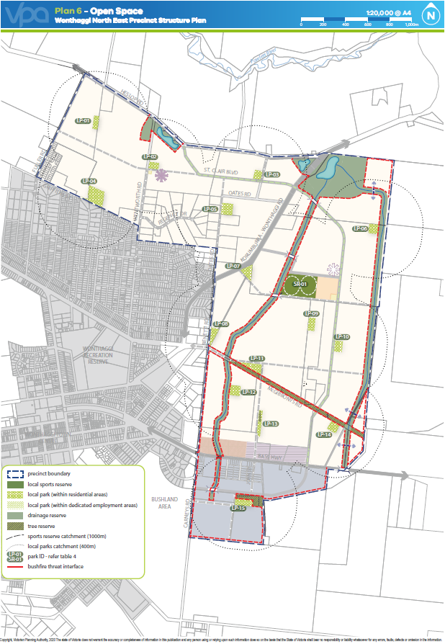

Plan 6 Open Space

## Open Space, Community Facilities and Education

### Open Space

|  |  |
| --- | --- |
| requirements | |
|  | All local parks must be located, designed and developed to the satisfaction of the responsible authority generally in accordance with Plan 6 and Table 6 of this PSP. |
|  | All public landscaped areas must be designed and constructed to enable practical maintenance and planted suitable to the local climate and soil conditions, to the satisfaction of the responsible authority. |
|  | Lots directly fronting a local park or sports reserve must provide for a primary point of access from the footpath or shared path proximate the lot boundary. |
|  | Any fencing of open space, whether encumbered or unencumbered, must be low scale (less than 1.2 metres in height) and visually permeable to facilitate public safety and surveillance. |
|  | The sporting reserve must be developed in accordance with a master plan adopted by or prepared to the satisfaction of the responsible authority, unless otherwise agreed by the responsible authority. |
|  | Where a local park as shown on Plan 6 spans across multiple properties, the first development proponent to lodge a permit application must undertake a master plan for the entire park to the satisfaction of the responsible authority. The proponent delivering the master plan for a local park that traverses multiple property ownerships should consult with the landowners of parcels covered by the park to ensure an integrated design. |
|  | Where a street frontage to a park is not provided, lots must provide for a 4 metre “Paper Road”. Lots directly fronting open space must provide for a primary point of access from a footpath or shared path proximate to the lot boundary to the satisfaction of the responsible authority. |
|  | In exceptional circumstances where lots back onto open space, whether encumbered or unencumbered, fencing must be low scale and visually permeable to facilitate public safety and surveillance. |
|  | Land designated for local parks must be finished and maintained to a suitable standard, prior to the transfer of land, to the satisfaction of the responsible authority. |
|  | Appropriately scaled energy efficient/ smart lighting must be installed along all major pedestrian thoroughfares traversing public open space and the cycling network to the satisfaction of the responsible authority. |
|  | Water sensitive urban design principles must be used so that excess runoff water from within, or where appropriate, external to the park, is directed to support park planning and / or rain gardens, rather than being diverted to drains, to the satisfaction of the responsible authority. |
| Guidelines | |
|  | Subject to being compatible with Table 6, local parks should contain extensive tree planting. |
|  | Local Parks should cater for a broad range of users by providing a mix of spaces and planting to support both structured and unstructured recreational activities and play opportunities for all ages and abilities. |

Table 6 Open Space Delivery Guide



### Community facilities and education

|  |  |
| --- | --- |
| requirements | |
|  | Schools and community centres must be designed to front and be directly accessed from a public street with off-street car parks located away from the main building entry. Site design must ensure that any other adjoining streets or public spaces are positively addressed and the use of fencing is minimised. |
|  | Where the responsible authority is satisfied that land shown as a non-government school site is unlikely to be used for a non-government school, that land may be used for an alternative purpose which is generally consistent with the surrounding land uses and the provisions of the applied zone. In order to satisfy the responsible authority that a site is unlikely to be used for a non-government school, it is necessary to demonstrate that:   * The application for an alternative use is not premature having regard to the extent of development in the surrounding residential area * The school site is no longer strategically justified having regard to the provision of schools in the locality, including land not within the PSP, as appropriate   The landowner provides the responsible authority with evidence that:   * Genuine negotiations have been had with a range of education providers including the lead agency nominated in the PSP, regarding the use of the site as a school and the sale of site to the education provider/s; and * The educational provider(s), including the lead agency nominated in the PSP, do not intend to purchase and use the site as a school. |
| guidelines | |
|  | Any education or community infrastructure not shown on Plan 3 should be located within or proximate to a local convenience centre or the village hub, as appropriate. |
|  | Any private childcare, medical, or similar facility should be located proximate to a local convenience centre or the village hub, as appropriate. |
|  | Community facilities, schools, and sporting reserves which are co-located should be designed to maximise efficiencies through the sharing of car parking and other complementary infrastructure. |
|  | School sites should be provided with three street frontages, where practical. |
|  | The design and layout of schools, community facilities and sports reserves should be integrated where possible with neighbouring facilities, and fencing minimised, to enable community use of facilities out of hours; to deliver continuous pedestrian paths of travel; and to achieve efficiencies such as sharing and overall reduction of car parking spaces. |

## Bushfire resilience, Biodiversity, Threatened Species and Native Vegetation Retention

### Biodiversity, Threatened species and Native Vegetation Retention

|  |  |
| --- | --- |
| requirements | |
|  | All development must be in accordance with the incorporated Wonthaggi North East Native Vegetation Precinct Plan. |
|  | Drainage from storm water treatment infrastructure must be designed to minimise impacts on biodiversity values. |
|  | Where trees are retained, applications for subdivision and/ or development must apply Tree Protection Zones. |
|  | Any development or public infrastructure to be located abutting or adjacent to retained biodiversity must be designed and located in a manner that avoids or minimises the potential for future biodiversity degradation. |
| guidelines | |
|  | Development should aim to improve the long-term health and habitat value of retained native vegetation. Information on restoration and rehabilitation techniques can be obtained from the responsible authority. |
|  | Public open space landscaping should contribute to habitat for indigenous fauna species including tree dwelling animals and birds. |
|  | Constructed/modified wetlands and waterways should be revegetated with indigenous native vegetation based on the species composition of the relevant Ecological Vegetation Class and should be complementary to any specific biodiversity management objectives.  Note: The Bass Coast Shire “Indigenous plants of Bass Coast Shire” should be used to guide revegetation activities, unless otherwise agreed to by the catchment management authority and responsible authority. |
|  | Landscaping adjacent to retained native vegetation should be complementary to conservation objectives and should use indigenous planting where appropriate. |
|  | Strategic revegetation or restoration should link and develop retained native vegetation or habitat areas with emphasis on enhancing corridors along and around constructed waterways and wetlands. |
|  | Planting in the open space networks including conservation areas, constructed waterways, streets, parks and utilities easements should maximise the use of indigenous species to the satisfaction of the responsible authority and the relevant land manager. |
|  | The layout and design of constructed waterways, wetlands and retarding basins (including the design of paths, bridges and boardwalks and the stormwater drainage system) should integrate with biodiversity and natural systems to the satisfaction of the responsible authority and the catchment management authority as relevant. |
|  | Where appropriate, parks should be located abutting conservation areas to provide a buffer. |
|  | Where practical, natural or pre development hydrological patterns must be maintained in any conservation areas. |

### Bushfire Resilience

|  |  |
| --- | --- |
| requirements | |
|  | Where residential land adjoins a bushfire threat interface as shown on Plan 6, the required separation distances specified in AS3959-2009 must be achieved by:   * Widening the identified road cross section in the PSP to provide for defendable space strips in accordance with cross section 12 and/or * Incorporating larger front or side setbacks   To the satisfaction of the responsible authority. |

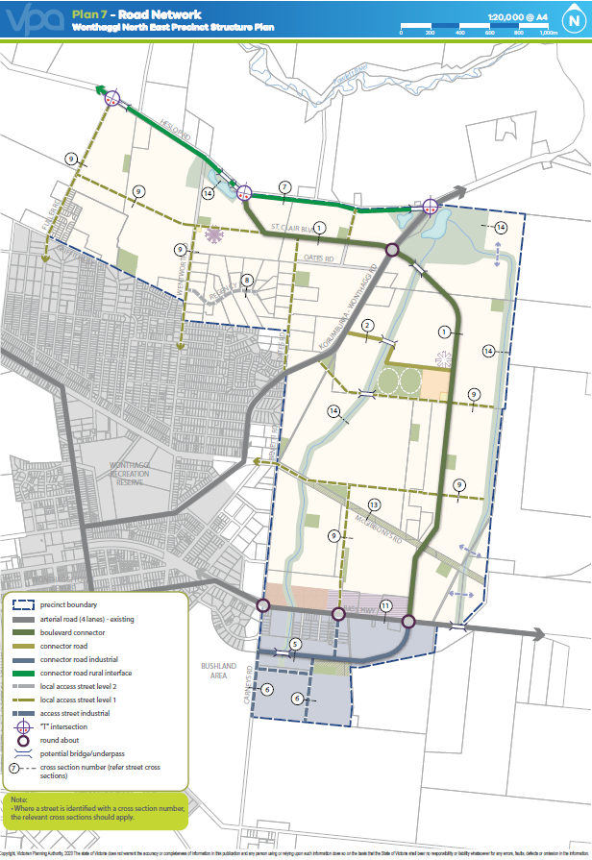

Plan 7 Road Network

## Transport and Movement

### Street Network

|  |  |
| --- | --- |
| requirements | |
|  | Subdivision layouts must provide:   * A permeable, direct and safe street network that encourages walking and cycling; and * Convenient access to local points of interest and destinations for effective integration with neighbouring properties. |
|  | Approximately 30% of local streets (including connector streets) within a subdivision must apply an alternative cross section to the ‘standard’ cross section for these streets outlined in Appendix 4.4.  Examples of potential variations are provided in Appendix 4.4, which include but are not limited to:   * Varied street tree placement * Varied footpath or carriageway placement * Introduction of elements to create a boulevard effect * Differing tree outstand treatments * For the purposes of this requirement, changes to street tree species between or within streets does not constitute a variation.   Alternative cross section must ensure that:   * Minimum required carriageway dimensions are maintained to ensure safe and efficient operation of emergency vehicles on all streets as well as buses on connector streets. * The performance characteristics of standard cross sections as they relate to pedestrian and cycle use are maintained. * Relevant minimum road reserve widths for the type of street (illustrated in Appendix 4.4) are maintained. |
|  | Where a single street spans across multiple properties that street may consist of multiple cross sections so long as a suitable transition has been allowed for between each. Where that street has already been constructed or approved for construction to a property boundary, the onus is on the development connecting into that street to adopt a consistent cross-section until that suitable transition can be made. |
|  | Vehicle access to lots must be provided from a service road, local road or rear lane only where fronting:   * Heslop Road * Korumburra-Wonthaggi Road * Bass Highway   All to the satisfaction of the coordinating roads authority. |
|  | Vehicle access to a lot that is six metres or less in width must be via rear laneway unless otherwise agreed by the responsible authority. Configuration of vehicle access to all other lots must ensure that there is sufficient separation between crossovers to allow for:   * A minimum of one on-street car park for every two residential lots. * The planting of street trees in accordance with the objectives and requirements of this document. |
|  | Any connector road or access street abutting a school, neighbourhood centre, village convenience centre, or sporting reserve must be designed to achieve slow vehicle speeds and provide designated pedestrian crossing points as required by the responsible authority. |
|  | The width of streets within subdivisions must be consistent with at least the minimum dimensions provided on the relevant cross section included within this document (Appendix 4.4), unless otherwise agreed by the responsible authority. Where existing vegetation is to be retained in a street, reserve widths may need to be widened to ensure that the provision of footpaths, services, and drainage does not compromise the health of that vegetation. |
|  | Subdivision applications must be accompanied by a Transport Impact Assessment that considers the current and future speed environment of any existing roads interfacing with the development. |
| guidelines | |
|  | Subdivisions adjacent to existing low-density residential areas should consider how additional street or pedestrian connections can be delivered in the long-term to improve permeability and integration should those low density residential areas redevelop. |
|  | Street block lengths should not exceed 240 metres to ensure a permeable and low speed environment for pedestrians, cyclists and vehicles is achieved. |
|  | Cul-de-sacs where allowable, should provide convenient pedestrian and vehicular connections. |
|  | Slip lanes for local roads should be avoided in areas of high pedestrian activity and only be provided where they are necessitated by high traffic volumes to the satisfaction of the road management authority. |
|  | The use of roundabouts on arterial or connector roads should not detract from the safe and convenient crossing of those roads by pedestrians and cyclists. |
|  | The frequency of vehicular crossovers on widened verges (a verge in excess of six metres) or verges where existing vegetation is to be retained should be minimised through a combination of:   * Rear loaded lots with laneway access. * Vehicular access from the side of a lot. * Vehicular access via a service lane. * Combined or grouped crossovers. * Increased lot widths. |
|  | The alignment and layout of streets as illustrated in Plan 7 may be adjusted so long as connectivity and function are maintained, to the satisfaction of the responsible authority. |

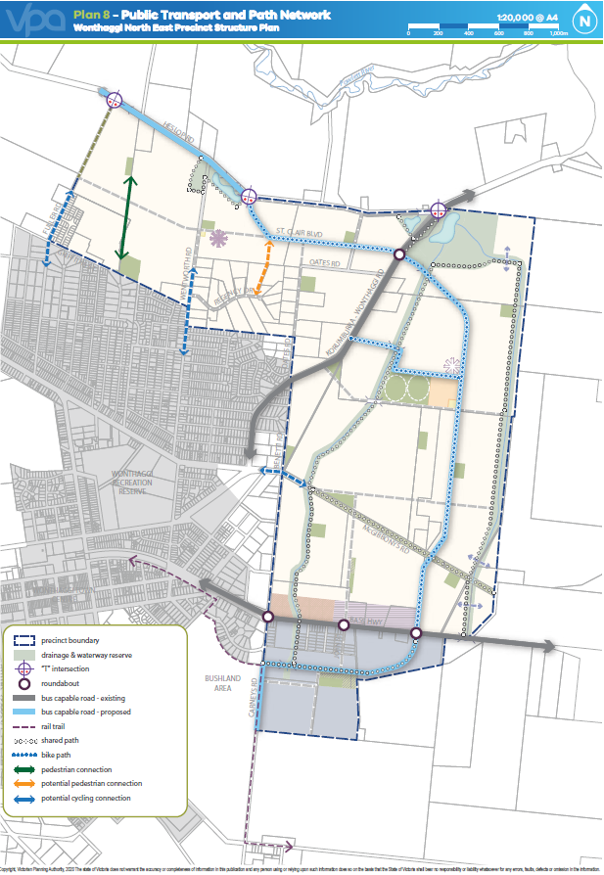

Plan 8 Public Transport and Path Network

### Walking and Cycling

|  |  |
| --- | --- |
| requirements | |
|  | Design of all streets and arterial roads must give priority to the requirements of pedestrians and cyclists by providing:   * Footpaths of at least 1.5 metres on both sides of all streets and roads unless otherwise specified by the PSP. * Shared paths or bicycle paths where shown on Plan 8, included in the relevant cross section (Appendix 4.4), or specified by another requirement in the PSP (Shared or bicycle paths must be a minimum of 2.5 metres in width unless otherwise specified). * Safe and convenient crossing points of connector roads and local streets at all intersections and on key desire lines. * Pedestrian priority crossings on all slip lanes. * Safe and convenient transition between on and off-road bicycle networks.   All to the satisfaction of the responsible authority. |
|  | Shared and pedestrian paths along waterways must:   * Be delivered by development proponents consistent with the network shown on Plan 8. * Be above the 1% AEP flood level with any crossing of the waterway designed to maintain hydraulic function of the waterway. * Be constructed to a standard that satisfies the requirements of the responsible authority and the catchment management authority. * Where a shared path is to be delivered on one side of a minor waterway as outlined in Plan 8, a path is also to be delivered on the other side of the waterway but may be constructed to a lesser width (min. 1.8 metres) and standard (such as granitic gravel) where it does not form part of the wider shared-path network.   All to the satisfaction of the responsible authority and catchment management authority. |
|  | Bicycle parking facilities are to be provided by development proponents in convenient locations at key destinations such as local parks and convenience centres. |
| guidelines | |
|  | Lighting should be installed along shared, pedestrian, and cycle paths linking areas of high pedestrian activity, unless otherwise approved by the responsible authority. |
|  | In addition to the crossing locations shown on Plan 8, development proponents should provide formal pedestrian crossings of creeks and minor waterways at regular intervals of no greater than 400 metres where this level of connectivity is not already satisfied by the street network. |

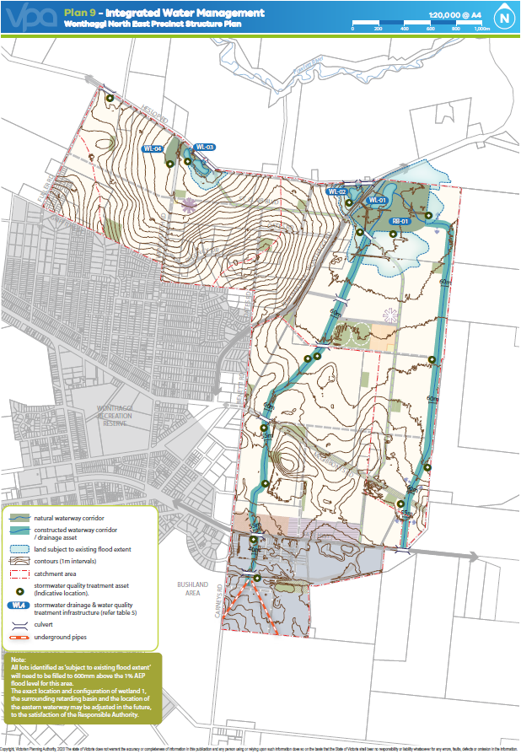

Plan 9 Integrated Water Management

## Integrated Water Management and Utilities

### Integrated Water Management

|  |  |
| --- | --- |
| requirements | |
|  | Final design of constructed waterways (including widths), drainage corridors, retarding basins, wetlands, and associated paths, boardwalks, bridges and planting, must be to the satisfaction of the catchment management authority and the responsible authority. |
|  | Development must meet or exceed best practice stormwater quality treatment standards (Urban Stormwater Best Management Practice, 2005), prior to discharge to receiving waterways as outlined on Plan 9, unless otherwise approved by the catchment management authority and the responsible authority. |
|  | For waterways shown on Plan 9, development works must ensure:   * Waterways and integrated water management design maximise land available to be used for multiple recreation and environmental purposes. * Overland flow paths and piping within road reserves will be connected and integrated across property/parcel boundaries. * Any freeboard requirements for overland flow paths will be adequately contained within road reserves.   All to the satisfaction of the catchment management authority and the responsible authority. |
|  | Development staging must provide for the delivery of ultimate waterway and drainage infrastructure, including stormwater quality treatment. Where this is not possible, development proposals must demonstrate how any interim solution adequately manages and treats stormwater prior to discharge from the development and how this will enable delivery of an ultimate drainage solution, to the satisfaction of the catchment management authority and the responsible authority. |
|  | Development must positively address all waterways through the use of frontage roads or lots with a direct frontage, to the satisfaction of catchment management authority and the responsible authority. |
|  | All lots identified as “subject to existing flood extent” on Plan 9 must be filled to 600mm above the 1% AEP flood level for this area. |
| guidelines | |
|  | The design and layout of roads, road reserves and public open space should optimise water use efficiency and long-term viability of public landscaped areas through the use of Water Sensitive Urban Design (WSUD) initiatives. |
|  | Streets should be the primary interface between development and waterways. Public open space and lots with a direct frontage may be provided as a minor component of the waterway interface. Where lots with direct frontage are provided, they should be sufficiently set back from the waterway corridor to allow for the provision of pedestrian and service vehicle access to the front of those lots, to the satisfaction the responsible authority. |
|  | Development should demonstrate a reduced reliance on potable water through the use of alternative design features that increases the utilisation of fit-for-purpose alternative water sources such as storm water, rain water and recycled water. |
|  | Development should have regard to relevant policies and strategies being implemented by the Responsible Authority and retail water authority, including any approved Integrated Water Management Plan. |
|  | Integrated water management systems should be designed to:   * Support and enhance habitat values for local flora and fauna species * Enable future harvesting and/or treatment and re-use of stormwater |
|  | Where primary waterway, conservation or recreation functions are not adversely affected, land required for integrated water management initiatives (such as stormwater harvesting, aquifer storage and recovery, sewer mining) should be incorporated within the precinct open space system as depicted on Plan 6. |

Table 7 Drainage and Stormwater Management



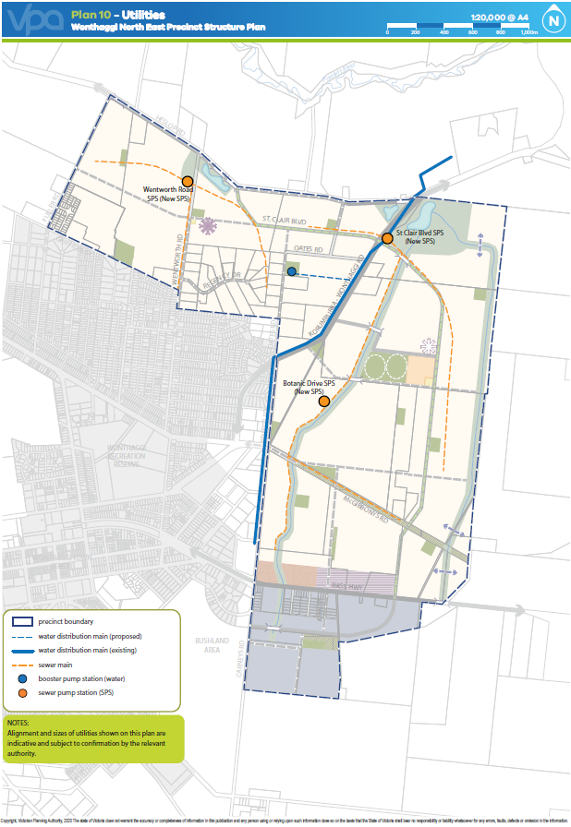

Plan 10 Utilities

### Utilities

|  |  |
| --- | --- |
| requirements | |
|  | Above-ground utilities (such as electricity substations and sewer pump stations) must be identified at the subdivision design stage to enable their appropriate integration into the subdivision layout and minimisation of adverse amenity impacts. |
|  | A Sewer Catchment plan shall be submitted to South Gippsland Water for approval. Sewer Catchment Boundaries are shown on Plan 9 – Integrated Water Management. The plan will include the whole of catchment area for the sewer pump station. The catchment plan shall define how significant assets will enable a whole of catchment solution. |
|  | Water reticulation infrastructure plans must show consideration for future surrounding developments. |
|  | Before development commences on a property, functional layout plans are to be submitted of the road network showing the location of all:   * Underground services * Driveways/crossovers * Street lights * Street trees   A typical cross section of each street is also to be submitted showing above and below ground placement of services, street lights and trees.  The plans and cross sections must demonstrate how services, driveways and street lights will be placed so as to achieve the road reserve width (consistent with the road cross sections outlined in this PSP, Appendix 4.4) and accommodate the minimum level of street tree plants (as outlined in R1 - section 3.1.1 of this PSP). If required, the plan and cross sections will nominate which services will be placed under footpaths or road pavement. The plans and cross sections are to be approved by the responsible authority and all relevant authorities. |
|  | Residential subdivision proposing any un-sewered low-density lots must:   * Obtain the consent of both the catchment management authority and the responsible authority. * Demonstrate how groundwater and surface water will be protected from contamination. * Demonstrate how the design of the subdivision allows for the efficient future re-subdivision should sewer become available. * Demonstrate how the development complies with the development sequencing requirements in this PSP (Section 3.7). |
| guidelines | |
|  | Above-ground utilities should be located outside of prominent view lines and screened with vegetation, as appropriate. |
|  | Design and placement of underground services in new or upgraded streets should have regard to the service placement guidelines outlined in Appendix 4.2. |
|  | Utility easements to the rear of lots should only be provided where there is no practical alternative. |

## Sequencing, staging and infrastructure delivery

### Development Sequencing and staging

|  |  |
| --- | --- |
| requirements | |
|  | Development sequencing will largely be determined by the ability to appropriately access and service land. Within this context, the following must be achieved:   * Development staging must provide for the early delivery of neighbourhood parks or other local amenity for new residents where parks are not otherwise easily accessible. * Access to each new lot must be via a sealed road constructed to an appropriate standard. * Each new lot must be sewered unless the area of the lot exceeds 2,000m2 and is approved by the catchment management authority and the responsible authority. * Each new lot must be connected to a potable water supply. * Where not directly adjoining existing development, new development should provide for onward connections to existing walking and cycling paths to facilitate access to the town and nearby facilities.   Where there is a need for works to satisfy this requirement, those works must be undertaken at the full cost of the development proponent. Works may constitute Works In Kind for projects included in the DCP, however Council will not be obliged to satisfy any liability until contributions sufficient to cover the cost of that liability have been received and projects deemed to be of a higher priority in the DCP have been fully funded or constructed. |
|  | Streets must be constructed to property boundaries where a local road is intended or indicated in the structure plan, by any date or stage of development required or approved by the responsible authority. |
| guidelines | |
|  | Development staging should provide for the timely connection of:   * Road links between properties. * Road links to the wider connector and arterial network. * Pedestrian and cyclist links to the off-road pedestrian and bicycle network.   All to the satisfaction of the responsible authority. |
|  | Each stage of development, where at the edge of the urban area, should comply with any relevant interface objectives, requirements or guidelines contained in this PSP. |

### Subdivision works by Developers

|  |  |
| --- | --- |
| requirements | |
|  | Subdivision of land within the precinct must provide and meet the total cost of delivering the following infrastructure where not included in the DCP, funded through an alternative mechanism:   * Connector streets and local streets. * Tree planting and landscaping in all streets. * Intersection works and traffic management measures along arterial roads, connector streets, and local streets. * Council approved fencing and landscaping (where required) along arterial roads. * Local bus stop infrastructure (where locations have been agreed in writing by Public Transport Victoria). * Shared, pedestrian and bicycle paths along streets, and waterways and within parks including bridges and other waterway crossings. * Appropriately scaled lighting along all roads and bicycle, shared, or pedestrian paths as required by this PSP. * Bicycle parking as required in this PSP. * Basic improvements to local parks and open space (refer open space delivery below). * Local drainage system. * Infrastructure as required by utility service providers including water, sewerage, electricity, gas, and telecommunications. |

### Provisions of Open Space

|  |  |
| --- | --- |
| requirements | |
|  | All local level neighbourhood parks must be free from contamination and finished to a standard that satisfies the requirements of the responsible authority prior to the transfer of the public open space, including:   * Removal of all existing and disused structures, foundations, pipelines, and stockpiles. * Clearing of rubbish and weeds, levelled, topsoiled and grassed with warm climate grass (unless conservation reserve requirements dictate otherwise). * Provision of water tapping, potable and recycled water connection points. Sewer and gas connection points must also be provided to land identified as a sporting reserve. * Planting of trees and shrubs. * Provision of vehicular exclusion devices (fence, bollards, or other suitable method) and maintenance access points. * Installation of park furniture including barbeques, shelters, furniture, rubbish bins, local scale playground equipment, local scale play areas, and appropriate paving to support these facilities, consistent with the type of public open space listed in the open space delivery guide (Table 6). |
|  | Land for sporting reserves or district level neighbourhood parks must be vested in the relevant authority in the following condition:   * Free from surface / protruding rocks and structures. * Free from contamination. * Reasonably graded and topsoiled to create a safe and regular surface (with a maximum 1:6 gradient for all grassed areas). * Bare, patchy and newly graded areas seeded, top-dressed with drought resistant grass. * Where works are required to satisfy the above requirement those works may be undertaken through the Works In Kind provisions of the DCP and the costs offset against any DCP liability. |
|  | With respect to the public open space contribution required by Clause 53.01 of the Bass Coast Planning Scheme, this provision sets out the amount of land to be contributed by each property in the precinct and consequently where a cash contribution is required in lieu of land.  All land owners within a residential or low-density residential area must provide a public open space contribution equal to 2.44% of the Net Developable Area Residential (NDAR) upon subdivision of land in accordance with the following:   * Where land is required for unencumbered open space (local park) purposes as shown on Plan 3 and specified in Appendix 4.1 and is equal to 2.44% of NDA that land is to be transferred to Council at no cost. * Where no land or less than 2.44% of NDA is shown on Plan 3 and specified in Appendix 4.1, as required for unencumbered open space (local park) purposes a cash contribution is to be made to Council to bring the total open space contribution to a value equal to 2.44% of NDA of that site. * Where land required for unencumbered open space (local park) purpose as shown on Plan 3 and specified in Appendix 4.1 is more than 2.44% of NDA, Council will pay an amount equivalent to the value of the additional land being provided by that proposed development.   All land owners within a business & industry area must provide a public open space contribution equal to 1.41% of the Net Developable Area Employment (NDAE) upon subdivision of land in accordance with the following:   * Where land is required for unencumbered open space (neighbourhood park) purposes as shown on Plan 3 and specified in Appendix 4.1 and is equal to 1.41% of NDA that land is to be transferred to Council at no cost. * Where no land or less than 1.41% of NDA is shown on Plan 2 and specified in Appendix 4.1 as required for unencumbered open space (neighbourhood park) purposes a cash contribution is to be made to Council to bring the total open space contribution to a value equal to 1.41% of NDA of that site. * Where land required for unencumbered open space (neighbourhood park) purpose as shown on Plan 3 and specified in Appendix 4.1 is more than 1.41% of NDA, Council will pay an amount equivalent to the value of the additional land being provided by that proposed development.   The value of land for equalisation purposes is to be assessed as an equivalent proportion of the value of the whole of the land, in accordance with Section 18 of the Subdivision Act 1988. |

# APPENDICES

## Parcel Specific Land Budget

| **PSP PROPERTY ID** | **TOTAL AREA (HECTARES)** | **Transport** | | **Community & Education** | | **Open Space** | | | | | **Total Net Developable Area (Hectares)** | **Net Developable Area % of Property** |
| --- | --- | --- | --- | --- | --- | --- | --- | --- | --- | --- | --- | --- |
| **Arterial Road** | **Other Transport** |  |  | **Uncredited Open Space** | | **Credited Open Space** | | |
| **Arterial Road - New / Widening / Intersection Flaring (DCP land)** | **Non-Arterial Road - Retained Existing Road Reserve** | **Future Government School (DCP land)** | **Local Community Facility (DCP land)** | **Waterway and Drainage Reserve (DCP land)** | **Tree Reserve** | **Local Sports Reserve (DCP land)** | **Local Network Park (via Cl 53.01) (employment areas)** | **Local Network Park (via Cl 53.01) (residential areas)** |
|  |  |  |  |  |  |  |  |  |  |  |  |  |
| 1 | 18.52 | - | - | - | - | - | - | - | - | 0.53 | 18.00 | 97.16% |
| 2 | 3.57 | - | - | - | - | - | - | - | - | - | 3.57 | 100.00% |
| 3 | 2.00 | - | - | - | - | - | - | - | - | - | 2.00 | 100.00% |
| 4 | 10.36 | - | - | - | - | - | - | - | - | 0.15 | 10.21 | 98.55% |
| 5 | 2.00 | - | - | - | - | - | - | - | - | - | 2.00 | 100.00% |
| 6 | 44.46 | - | - | - | - | 1.70 | - | - | - | 1.93 | 40.83 | 91.83% |
| 7 | 2.01 | - | - | - | - | - | - | - | - | - | 2.01 | 100.00% |
| 8 | 27.68 | - | - | - | 0.10 | 2.52 | - | - | - | 0.50 | 24.55 | 88.72% |
| 9 | 0.72 | - | - | - | - | - | - | - | - | - | 0.72 | 100.00% |
| 10 | 0.72 | - | - | - | - | - | - | - | - | - | 0.72 | 100.00% |
| 11 | 0.70 | - | - | - | - | - | - | - | - | - | 0.70 | 100.00% |
| 12 | 0.77 | - | - | - | - | - | - | - | - | - | 0.77 | 100.00% |
| 13 | 0.71 | - | - | - | - | - | - | - | - | - | 0.71 | 100.00% |
| 14 | 0.71 | - | - | - | - | - | - | - | - | - | 0.71 | 100.00% |
| 15 | 0.71 | - | - | - | - | - | - | - | - | - | 0.71 | 100.00% |
| 16 | 1.70 | - | - | - | - | - | - | - | - | - | 1.70 | 100.00% |
| 17 | 0.42 | - | - | - | - | - | - | - | - | - | 0.42 | 100.00% |
| 18 | 2.00 | - | - | - | - | - | - | - | - | - | 2.00 | 100.00% |
| 19 | 2.33 | - | - | - | - | - | - | - | - | - | 2.33 | 100.00% |
| 20 | 2.11 | - | - | - | - | - | - | - | - | - | 2.11 | 100.00% |
| 21 | 0.05 | - | - | - | - | - | - | - | - | - | 0.05 | 100.00% |
| 22 | 1.33 | - | - | - | - | - | - | - | - | - | 1.33 | 100.00% |
| 23 | 0.76 | - | - | - | - | - | - | - | - | - | 0.76 | 100.00% |
| 24 | 2.16 | - | - | - | - | - | - | - | - | - | 2.16 | 100.00% |
| 25 | 1.43 | - | - | - | - | - | - | - | - | - | 1.43 | 100.00% |
| 26 | 2.25 | - | - | - | - | - | - | - | - | - | 2.25 | 100.00% |
| 27 | 1.63 | - | - | - | - | - | - | - | - | - | 1.63 | 100.00% |
| 28 | 0.42 | - | - | - | - | - | - | - | - | - | 0.42 | 100.00% |
| 29 | 0.66 | - | - | - | - | - | - | - | - | - | 0.66 | 100.00% |
| 30 | 0.73 | - | - | - | - | - | - | - | - | - | 0.73 | 100.00% |
| 31 | 0.78 | - | - | - | - | - | - | - | - | - | 0.78 | 100.00% |
| 32 | 1.47 | - | - | - | - | - | - | - | - | - | 1.47 | 100.00% |
| 33 | 0.77 | - | - | - | - | - | - | - | - | - | 0.77 | 100.00% |
| 34 | 0.75 | - | - | - | - | - | - | - | - | - | 0.75 | 100.00% |
| 35 | 0.76 | - | - | - | - | - | - | - | - | - | 0.76 | 100.00% |
| 36 | 0.77 | - | - | - | - | - | - | - | - | - | 0.77 | 100.00% |
| 37 | 0.77 | - | - | - | - | - | - | - | - | - | 0.77 | 100.00% |
| 38 | 16.37 | - | - | - | - | - | - | - | - | 0.50 | 15.87 | 96.95% |
| 39 | 12.26 | 0.12 | - | - | - | 1.73 | - | - | - | - | 10.41 | 84.91% |
| 40 | 14.81 | - | - | - | - | - | - | - | - | 1.00 | 13.81 | 93.25% |
| 41 | 1.52 | - | - | - | - | - | - | - | - | - | 1.52 | 100.00% |
| 42 | 1.89 | - | - | - | - | - | - | - | - | - | 1.89 | 100.00% |
| 43 | 3.88 | - | - | - | - | - | - | - | - | - | 3.88 | 100.00% |
| 44 | 2.18 | - | - | - | - | - | - | - | - | - | 2.18 | 100.00% |
| 45 | 1.76 | - | - | - | - | - | - | - | - | - | 1.76 | 100.00% |
| 46 | 45.72 | 0.11 | - | - | - | 22.06 | - | - | - | - | 23.56 | 51.52% |
| 47 | 1.00 | - | - | - | - | - | - | - | - | - | 1.00 | 100.00% |
| 48 | 1.95 | - | - | - | - | - | - | - | - | - | 1.95 | 100.00% |
| 49 | 79.49 | - | - | 3.50 | 0.32 | 9.05 | - | 6.00 | - | 0.70 | 59.92 | 75.38% |
| 50 | 8.90 | - | - | - | - | - | - | - | - | 0.89 | 8.01 | 90.00% |
| 51 | 0.54 | - | - | - | - | - | - | - | - | 0.19 | 0.35 | 65.25% |
| 52 | 56.30 | - | - | - | - | 4.28 | - | - | - | 1.29 | 50.73 | 90.10% |
| 53 | 9.57 | - | - | - | - | - | - | - | - | 0.70 | 8.87 | 92.68% |
| 54 | 1.00 | - | - | - | - | - | - | - | - | - | 1.00 | 100.00% |
| 55 | 1.12 | - | - | - | - | - | - | - | - | - | 1.12 | 100.00% |
| 56 | 46.09 | - | - | - | - | 5.69 | - | - | - | 0.70 | 39.71 | 86.15% |
| 57 | 0.30 | - | - | - | - | 0.28 | - | - | - | - | 0.02 | 6.67% |
| 58 | 1.80 | - | - | - | - | 0.46 | - | - | - | - | 1.34 | 74.42% |
| 59 | 1.62 | - | - | - | - | 0.37 | - | - | - | - | 1.25 | 77.27% |
| 60 | 3.63 | - | - | - | - | 0.92 | - | - | - | - | 2.71 | 74.66% |
| 61 | 3.62 | - | - | - | - | 0.99 | - | - | - | - | 2.63 | 72.62% |
| 62 | 0.39 | - | - | - | - | - | - | - | - | - | 0.39 | 100.00% |
| 63-E | 2.74 | 0.01 | - | - | - | - | - | - | - | - | 2.73 | 99.63% |
| 63-R | 10.57 | 0.42 | - | - | - | - | - | - | - | 0.70 | 9.45 | 89.39% |
| 64-E | 2.19 | - | - | - | - | - | - | - | - | - | 2.19 | 100.00% |
| 64-R | 24.27 | - | - | - | - | - | 0.16 | - | - | 0.51 | 23.60 | 97.25% |
| 65 | 26.79 | - | - | - | - | 3.57 | - | - | - | 0.83 | 22.39 | 83.58% |
| 66-E | 3.24 | 0.04 | - | - | - | - | - | - | - | - | 3.20 | 98.77% |
| 66-R | 10.91 | 0.06 | - | - | - | 1.38 | - | - | - | - | 9.46 | 86.76% |
| 67 | 0.28 | - | - | - | - | - | - | - | - | - | 0.28 | 100.00% |
| 68 | 14.59 | 0.42 | - | - | - | - | - | - | - | - | 14.18 | 97.14% |
| 69 | 0.50 | 0.02 | - | - | - | - | - | - | - | - | 0.48 | 95.83% |
| 70 | 0.10 | - | - | - | - | - | - | - | - | - | 0.10 | 100.00% |
| 71 | 0.31 | - | - | - | - | - | - | - | - | - | 0.31 | 100.00% |
| 72 | 0.72 | 0.02 | - | - | - | - | - | - | - | - | 0.70 | 97.23% |
| 73 | 0.14 | - | - | - | - | - | - | - | - | - | 0.14 | 100.00% |
| 74 | 0.14 | - | - | - | - | - | - | - | - | - | 0.14 | 100.00% |
| 75 | 0.15 | - | - | - | - | - | - | - | - | - | 0.15 | 100.00% |
| 76 | 0.08 | 0.02 | - | - | - | - | - | - | - | - | 0.06 | 75.58% |
| 77 | 0.09 | 0.003 | - | - | - | - | - | - | - | - | 0.08 | 97.01% |
| 78 | 0.10 | - | - | - | - | - | - | - | - | - | 0.10 | 100.00% |
| 79 | 0.26 | - | - | - | - | - | - | - | - | - | 0.26 | 100.00% |
| 80 | 0.10 | - | - | - | - | - | - | - | - | - | 0.10 | 100.00% |
| 81 | 0.10 | - | - | - | - | - | - | - | - | - | 0.10 | 100.00% |
| 82 | 0.10 | - | - | - | - | - | - | - | - | - | 0.10 | 100.00% |
| 83 | 0.10 | - | - | - | - | - | - | - | - | - | 0.10 | 100.00% |
| 84 | 0.10 | - | - | - | - | - | - | - | - | - | 0.10 | 100.00% |
| 85 | 0.10 | - | - | - | - | - | - | - | - | - | 0.10 | 100.00% |
| 86 | 0.10 | - | - | - | - | - | - | - | - | - | 0.10 | 100.00% |
| 87 | 0.10 | - | - | - | - | - | - | - | - | - | 0.10 | 100.00% |
| 88 | 0.10 | - | - | - | - | - | - | - | - | - | 0.10 | 100.00% |
| 89 | 0.10 | - | - | - | - | - | - | - | - | - | 0.10 | 100.00% |
| 90 | 0.10 | - | - | - | - | - | - | - | - | - | 0.10 | 100.00% |
| 91 | 0.10 | - | - | - | - | - | - | - | - | - | 0.10 | 100.00% |
| 92 | 0.09 | - | - | - | - | - | - | - | - | - | 0.09 | 100.00% |
| 93 | 0.09 | - | - | - | - | - | - | - | - | - | 0.09 | 100.00% |
| 94 | 0.09 | - | - | - | - | - | - | - | - | - | 0.09 | 100.00% |
| 95 | 0.09 | - | - | - | - | - | - | - | - | - | 0.09 | 100.00% |
| 96 | 0.09 | - | - | - | - | - | - | - | - | - | 0.09 | 100.00% |
| 97 | 0.09 | - | - | - | - | - | - | - | - | - | 0.09 | 100.00% |
| 98 | 0.10 | - | - | - | - | - | - | - | - | - | 0.10 | 100.00% |
| 99 | 0.10 | - | - | - | - | - | - | - | - | - | 0.10 | 100.00% |
| 100 | 0.10 | - | - | - | - | - | - | - | - | - | 0.10 | 100.00% |
| 101 | 0.10 | - | - | - | - | - | - | - | - | - | 0.10 | 100.00% |
| 102 | 0.10 | - | - | - | - | - | - | - | - | - | 0.10 | 100.00% |
| 103 | 0.10 | - | - | - | - | - | - | - | - | - | 0.10 | 100.00% |
| 104 | 0.10 | - | - | - | - | - | - | - | - | - | 0.10 | 100.00% |
| 105 | 0.11 | - | - | - | - | - | - | - | - | - | 0.11 | 100.00% |
| 106 | 0.10 | - | - | - | - | - | - | - | - | - | 0.10 | 100.00% |
| 107 | 0.10 | - | - | - | - | - | - | - | - | - | 0.10 | 100.00% |
| 108 | 0.10 | - | - | - | - | - | - | - | - | - | 0.10 | 100.00% |
| 109 | 0.10 | - | - | - | - | - | - | - | - | - | 0.10 | 100.00% |
| 110 | 0.37 | - | - | - | - | - | - | - | - | - | 0.37 | 100.00% |
| 111 | 0.25 | - | 0.25 | - | - | - | - | - | - | - | 0.00 | 0.00% |
| 112 | 0.10 | - | - | - | - | - | - | - | - | - | 0.10 | 100.00% |
| 113 | 0.10 | - | - | - | - | - | - | - | - | - | 0.10 | 100.00% |
| 114 | 0.10 | - | - | - | - | - | - | - | - | - | 0.10 | 100.00% |
| 115 | 0.10 | - | - | - | - | - | - | - | - | - | 0.10 | 100.00% |
| 116 | 0.10 | - | - | - | - | - | - | - | - | - | 0.10 | 100.00% |
| 117 | 2.73 | - | - | - | - | 0.73 | - | - | - | - | 2.00 | 73.24% |
| 118 | 0.08 | - | - | - | - | - | - | - | - | - | 0.08 | 100.00% |
| 119 | 0.08 | - | - | - | - | - | - | - | - | - | 0.08 | 100.00% |
| 120 | 0.08 | 0.01 | - | - | - | - | - | - | - | - | 0.07 | 83.77% |
| 121 | 0.10 | - | - | - | - | - | - | - | - | - | 0.10 | 100.00% |
| 122 | 0.10 | - | - | - | - | - | - | - | - | - | 0.10 | 100.00% |
| 123 | 0.10 | - | - | - | - | - | - | - | - | - | 0.10 | 100.00% |
| 124 | 0.10 | - | - | - | - | - | - | - | - | - | 0.10 | 100.00% |
| 125 | 0.10 | - | - | - | - | - | - | - | - | - | 0.10 | 100.00% |
| 126 | 0.10 | - | - | - | - | - | - | - | - | - | 0.10 | 100.00% |
| 127 | 7.41 | - | - | - | - | 0.52 | - | - | - | - | 6.89 | 93.00% |
| 128 | 15.19 | - | - | - | - | 0.35 | 1.60 | - | 0.90 | - | 12.33 | 81.20% |
| 129 | 12.88 | - | - | - | - | - | - | - | - | - | 12.88 | 100.00% |
| **SUB-TOTAL** | **600.72** | **1.25** | **0.25** | **3.50** | **0.42** | **56.60** | **1.76** | **6.00** | **0.90** | **11.12** | **518.92** | 86.38% |

## Service Placement Guidelines

**Standard street cross sections**

The Infrastructure Design Manual outlines placement of services for typical residential street environments. This approach is appropriate for most of the ‘standard’ street cross sections outlined in Appendix B of the Manual containing grassed nature strips, footpaths and road pavements.

**Non-standard street cross sections**

To achieve greater diversity of streetscape outcomes, which enhances character and amenity of these new urban areas, non-standard street cross sections are encouraged. Non-standard street cross sections will also be required to address local needs, such as fully sealed verges for high pedestrian traffic areas in town centres and opposite schools.

For non-standard street cross sections where service placement guidance outlined in the Infrastructure Design Manual is not applicable, the following service placement guidelines will apply.

|  |  |  |  |  |  |  |  |
| --- | --- | --- | --- | --- | --- | --- | --- |
|  | **Under pedestrian pavement** | **Under nature strips** | **Directly under trees**1 | **Under kerb** | **Under road pavement2** | **Within allotments** | **Notes** |
| **Sewer** | Possible | Preferred | Possible | No | Possible | Possible3 |  |
| **Potable water** | Possible4 | Preferred | Preferred | No | Possible | No | Can be placed in combined trench with gas |
| **Recycled water** | Possible4 | Preferred | Preferred | No | Possible | No |  |
| **Gas** | Possible4 | Preferred | Preferred | No | No | No | Can be placed in combined trench with potable water |
| **Electricity** | Preferred4 | Possible | Possible | No | No | No | Pits to be placed either fully in footpath or nature strip |
| **FTTH/**  **Telco** | Preferred4 | Possible | Possible | No | No | No | Pits to be placed either fully in footpath or nature strip |
| **Drainage** | Possible | Possible | Possible | Preferred | Possible | Possible3 |  |
| **Trunk services** | Possible | Possible | Possible | Possible | Preferred | No |  |

TABLE NOTES

1. Trees are not to be placed directly over property service connections
2. Placement of services under road pavement is to be considered when service cannot be accommodated elsewhere in road reserve. Placement of services beneath edge of road pavement/parking bays is preferable to within traffic lanes
3. Where allotment size/frontage width allows adequate room to access and work on a pipe
4. Where connections to properties are within a pit in the pedestrian pavement/footpath

General principles for service placement

* Place gas and water on one side of road, electricity on the opposite side
* Place water supply on the high side of road
* Place services that need connection to adjacent properties closer to these properties
* Place trunk services further away from adjacent properties
* Place services that relate to the road carriageway (e.g. drainage, streetlight electricity supply) closer to the road carriageway
* Maintain appropriate services clearances and overlap these clearances wherever possible
* Services must be placed outside of natural waterway corridors or on the outer edges of these corridors to avoid disturbance to existing waterway values.

## Village Hub and Local Convenience Centre Design Guidelines

| principles | guidelines |
| --- | --- |
| **Principle 1**  Provide smaller neighbourhoods with a viable local convenience centre which offers accessible services to the surrounding community. | * Local convenience centres should be planned in conjunction with local town centres in order to deliver a fine grain distribution of town centres within the region * Local convenience centres should be planned for neighbourhoods that contain less than 8,000 people and are located more than 1 kilometre away from a local town centre or higher order town centre * Locate local convenience centres in locations which are central to the residential community they serve and that provide exposure to passing traffic * Where appropriate, locate Local convenience centres in attractive settings and incorporate natural or cultural landscape features such creeks and waterways, linear open space, pedestrian and cycle links and areas of high aesthetic value |
| **Principle 2**  Provide a range of local services and facilities that are appropriate to the local convenience centre location and the catchment that it serves. | * Land uses should be located generally in accordance with the locations and general land use terms identified on the local convenience centre Concept Plan * The design of the local convenience centre should facilitate development with a high degree of community interaction and provide an appropriate mix of retail, commercial and community facilities to suit the catchment that the local convenience centre serves * The design of the local convenience centre should also encourage a pattern of smaller scale individual tenancies and land ownership patterns within the Local Town Centre to attract investment and encourage greater diversity and opportunities for local business investment * Active building frontages should address the primary street frontage to maximise exposure to passing trade, and promote pedestrian interaction |
| **Principle 3**  Design the local convenience centre to be pedestrian friendly and accessible by all modes including public transport, while enabling private vehicle access. The local convenience centre should be easily, directly and safely accessible for pedestrians, cyclists, public transport modes, private vehicles, service and delivery vehicles with priority given to pedestrian movement, amenity, convenience and safety. | * Public transport infrastructure/facilities should be planned for commuter friendly/convenient locations adjacent to the local convenience centre * Bus stops should be provided in accordance with the *Public Transport Victoria Public Transport Guidelines for Land Use and Development*, to the satisfaction of Public Transport Victoria * Bicycle parking should be provided within the street network and public spaces in highly visible locations and close to pedestrian desire lines and key destinations * The design of buildings within the local convenience centre should have a relationship with and should interface to the public street network * Car parking areas should be located centrally to the site and to the rear and or side of street based retail frontages * Car parking areas should be designed to ensure passive surveillance and public safety through adequate positioning and lighting * Car parking areas should be designed to provide dedicated pedestrian routes and areas of landscaping * On street car parking should be provided either as parallel or angle parking to encourage short stay parking * Car parking ingress and egress crossovers should be grouped and limited * Car parking ingress or egress and car parking areas accommodating heavy vehicle movements should be designed to limit the pedestrian/vehicle conflict * Streets, public spaces and car parks should be well lit to Australian standards and with pedestrian friendly (generally white) light, and lighting should be designed to avoid unnecessary spill to the side or above |

|  |  |
| --- | --- |
| **Principle 4**  Create a sense of place with high quality engaging urban design. | * Development should complement and enhance the character of the surrounding area by responding appropriately to key visual cues associated with the topography of the local convenience centre location and its surrounds * The local convenience centre design should seek to minimise amenity and noise impacts resulting from the mix of uses by maintaining separation and transitional areas between retail and housing activities, such as open space, road networks and community facilities * The design of each building should contribute to a cohesive and legible character for the local convenience centre as a whole * Sites in prominent locations (such as at key intersections, surrounding public spaces and terminating key view lines and vistas) should be identified for significant buildings or landmark structures * The design of building frontages should incorporate the use of a consistent covered walkway or verandah to provide for weather protection * The built form should define the primary street frontage and be aligned with the parcel boundary * Street façades and all visible side or rear façades should be visually rich, interesting and well articulated and be finished in suitable materials and colours that contribute to the character of the local convenience centre * Materials and design elements should be compatible with the environment and landscape character of the broader precinct * If a supermarket is proposed, the supermarket should have a frontage that directly address the primary street frontage so that the use integrates with and promotes activity within the public realm * Supermarkets with a frontage to the primary street frontage should use clear glazing to allow view lines into the store from the street (planning permits for buildings and works should condition against the use of white washed windows, excessive window advertising and obtrusive internal shelving or ‘false walls’ offset from the glazing) * Secondary access to a supermarket from car parking areas should be considered where it facilitates convenient trolley access and does not diminish the role of the primary access from the primary street frontage * The design and siting of supermarkets should provide an appropriate response to the entire public domain. This includes but is not limited to car parking areas, predominantly routes and streets * Retail uses along street frontages should generally include access points at regular intervals to encourage activity along the length of the street * Retail and commercial buildings within the local convenience centre should generally be built to the parcel line * Public spaces should be oriented to capture north sun and protect from prevailing winds and weather * Landscaping of all interface areas should be of a high standard as an important element to complement the built form design * Urban art should be incorporated into the design of the public realm * Street furniture should be located in areas that are highly visible and close to or adjoining pedestrian desire lines/gathering spaces and designed to add visual interest to the local convenience centre * Wrapping of car parking edges with built form, to improve street interface, should be maximised * Car parking areas should provide for appropriate landscaping with planting of canopy trees and dedicated pedestrian thoroughfares * Screening of centralised waste collection points should minimise amenity impacts with adjoining areas and users of the centre * Where service areas are accessible from car parks, they should present a well designed and secure facade to public areas * Mechanical plant and service structure roofs should be included within roof lines or otherwise hidden from view |

|  |  |
| --- | --- |
| **Principle 5**  Promote localisation, sustainability and adaptability. | The local convenience centre should promote the localisation of services that will contribute to a reduction of travel distance to access local services and less dependence on the car.  The local convenience centre should be designed to be sympathetic to its natural surrounds by:   * Investigating the use of energy efficient design and construction methods for all buildings * Including Water Sensitive Urban Design principles such as integrated stormwater retention and reuse (e.g. toilet flushing and landscape irrigation) * Promoting safe and direct accessibility and mobility within and to and from the local convenience centre * Including options for shade and shelter through a combination of landscape and built form treatments * Ensuring buildings are naturally ventilated to reduce the reliance on plant equipment for heating and cooling * Promoting passive solar orientation in the configuration and distribution of built form and public spaces * Grouping waste collection points to maximise opportunities for recycling and reuse; * Promoting solar energy for water and space heating, electricity generation and internal and external lighting * Investigating other opportunities for the built form to reduce greenhouse gas emissions associated with the occupation and the ongoing use of buildings * Encouraging building design that can be adapted to accommodate a variety of uses over time |

## Street Cross sections

(back page – do not delete)



Wonthaggi North East Precinct Structure Plan – November 2020