Planning and Environment Act 1987
HUME PLANNING SCHEME
AMENDMENT C243hume
EXPLANATORY REPORT
Who is the planning authority?
This amendment has been prepared by the Victorian Planning Authority, who is the planning authority for this amendment.
The amendment has been made at the request of the Victorian Planning Authority.
Land affected by the amendment
The amendment applies to land within the boundaries of the Sunbury South and Lancefield Road Precinct Structure Plans (PSP), as depicted in Map 1 below:
Map 1 – C243hume Amendment Area (Sunbury South and Lancefield Road)
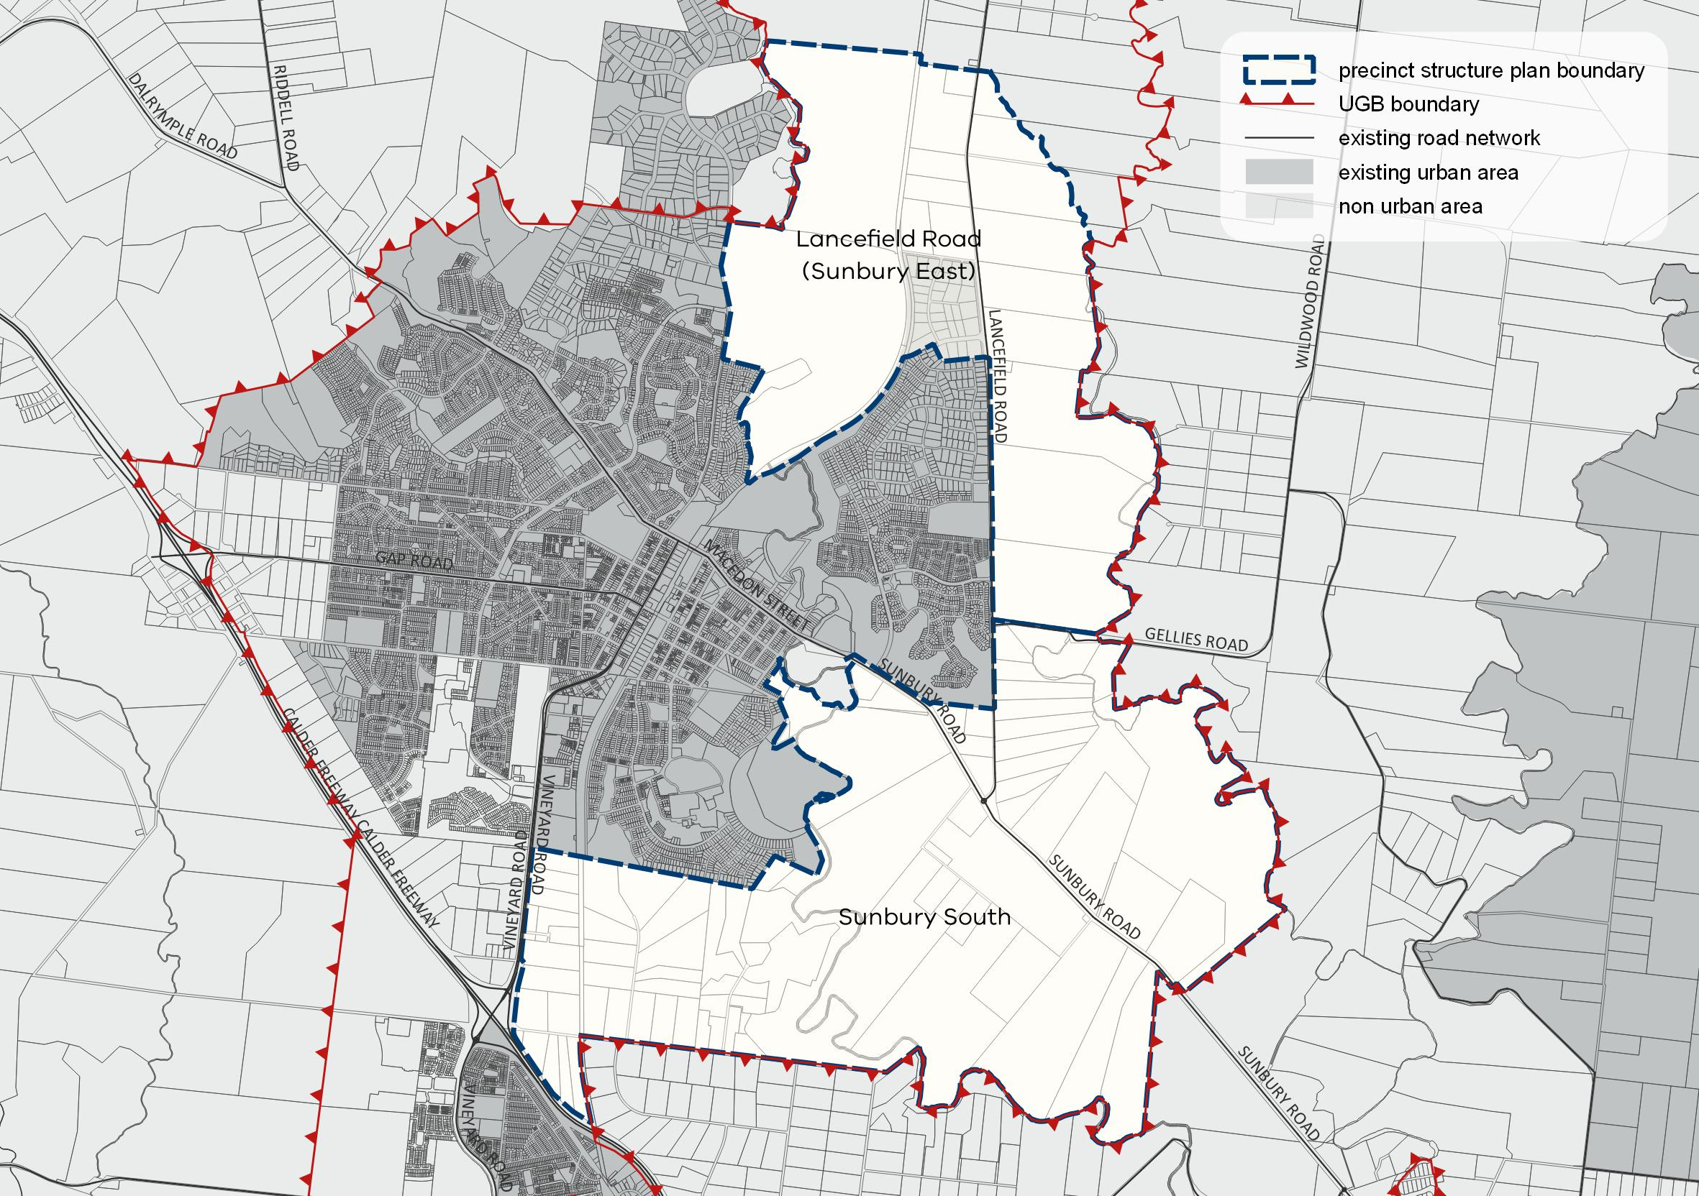

What the amendment does
The amendment proposes to make changes to the Hume Planning Scheme to replace an Infrastructure Contributions Plan (ICP) that applies to land affected by the Sunbury South and Lancefield Road PSPs. These PSPs were approved by the Minister for Planning and gazetted on 17 January 2019 under Hume Amendments C207 and C208, respectively. This ICP will replace the ‘interim’ Sunbury South and Lancefield Road ICP incorporated in the Hume Planning Scheme, which was approved by the Minister for Planning and gazetted on 5 December 2019 under Hume Amendment C230hume.

More specifically the proposed amendment:
- Amends Schedule 1 (ICO1) to Clause 45.11 Infrastructure Contributions Overlay.
- Amends the Schedule to Clause 72.04 to delete the existing incorporated document titled Sunbury South and Lancefield Road Infrastructure Contributions Plan, November 2019and include a new incorporated document titled Sunbury South and Lancefield Road Infrastructure Contributions Plan, April 2020.
- Applies the new Public Acquisition Overlay (PAO2) in favour of Hume City Council consistent with the extension and widening of Buckland Way between Jacksons Hill precinct to the north and Watsons Road to the south, as shown in the Sunbury South PSP.
- Deletes the existing PAO2 in favour of Hume City Council, which is an obsolete alignment of the extension and widening of Buckland Way.

Strategic assessment of the amendment
Why is the amendment required?
The ICP system has been revised to improve the method for securing land for public purposes. On 2 July 2018, the Planning and Environment Amendment (Public Land Contributions) Act 2018 came into operation. This Act requires all public land identified in an ICP to be provided as a direct land contribution, thereby removing a monetary contribution (i.e. the existing public land standard levy amount) from the ICP system. The Act also prescribes the method by which the cost of providing all public land is equalised across all landowners with a PSP area.
An ‘interim’ Sunbury South and Lancefield Road ICP was approved under section 20(4) of the Planning and Environment Act 1987 to ensure that, following legislative changes, collecting agencies could lawfully collect infrastructure contributions from landowners.
The approval of the interim ICP on 5 December 2019 enabled Hume City Council, as responsible authority, to consider and grant permits within the PSP areas.
A final ICP has now been prepared and is the subject of this amendment and makes the following updates to the interim ICP:
- Standard Levy Rate adjusted to 2019/20 rate and associated changes to the supplementary rate;
- Updated land valuation for property SS-59 and associated changes to land credit and equalisation amounts and rates.

The interim ICP did not include the correct land valuation for property SS-59 resulting in an undervaluation of the equalisation rate. The result of this, is the interim ICP under-collects the total credit amount. Specifically, the interim ICP total credit amount came to $100,558,853 whilst it should be collecting $102,020,751. The total difference is $1,461,898, equating to a 1.5% difference. The final ICP has been amended to correct this and includes changes to Tables 3, 10 and 11.
ICPs and the associated planning controls are required to ensure collecting agencies can lawfully collect infrastructure contributions from landowners. This amendment incorporates an interim ICP into the Hume Planning Scheme and applies it to land affected by the Sunbury South and Lancefield Road PSPs, which were approved by the Minister for Planning and were gazetted on 17 January 2019 under Hume Planning Scheme Amendments C207 and C208. On 5 December 2019, the Minister for Planning approved Hume Amendment C242hume, which updated the Sunbury South Precinct Structure Plan and the Lancefield Road Precinct Structure Plan to ensure alignment with the interim Sunbury South Lancefield Road Infrastructure Contribution Plan, November 2019.
The ICP is necessary to deliver all the infrastructure items required within the Sunbury South and Lancefield Road PSP areas. Specifically, the supplementary levy component is included to cover the costs of construction of supplementary ICP transport items.
The ICP provides timeframes (short 0-5 years, medium 10-15 years and long term 15 years onwards) for the delivery of ICP funded infrastructure projects.
The amendment proposes to delete the existing PAO2 that applies to Buckland Way and its future extension and reapply it consistent with the alignment shown in the Sunbury South PSP. The Hume City Council has requested Public Acquisition Overlay is included in their favour to deliver the extension and widening of Buckland Way. The PAO is an appropriate tool in the Victorian Planning Provisions to identify land required for a public purpose and allow for its early acquisition.
The Hume City Council was the acquiring authority for the existing PAO and will be the acquiring authority for the revised alignment.
How does the amendment implement the objectives of planning in Victoria?
The amendment will implement an infrastructure contributions scheme to fund community and development infrastructure to service the future urban land within the approved PSP, which is within the Urban Growth Boundary of Metropolitan Melbourne.
It will implement applicable objectives of planning in Victoria under section 4 of the Planning and Environment Act 1987 (Act) through the implementation of a contributions collection scheme to facilitate the delivery of infrastructure to service the approved precinct structure plan.
The amendment applies the necessary planning controls to implement the ICP, which will provide a clear structure of contributions required to fund development and community infrastructure within the precincts for residential and commercial development and will ensure the fair and equitable provision of community and development infrastructure.
How does the Amendment address any environmental, social and economic effects?
Environmental effects
The amendment does not result in environmental impacts as it seeks to introduce mechanisms to allow the responsible authority to collect financial contributions towards infrastructure required for the PSP areas.
The infrastructure required and its environmental impacts were considered as part of Hume Amendments C207 and C208, which introduced the PSPs into the Hume Planning Scheme.
Economic effects
This amendment proposes to update the ICP for the PSP areas, which identifies the financial levy required to be paid by developers to fund the infrastructure required for the precinct, and thus sets out an equitable and transparent means of collecting financial contributions towards servicing the future community. This reduces the burden on the responsible authority and existing communities to fund future local infrastructure.
Social effects
The approved PSPs identify the infrastructure necessary to service the future communities, including sports and community facilities, road and trail upgrades and parks. The new infrastructure items will ensure that new residents do not place an unfair burden on existing community assets in the area. The infrastructure will maximise opportunities for new residents to safely and efficiently access employment and everyday services, including shopping and engaging in locally based social activities.
Does the amendment address relevant bushfire risk?
The amendment updates the mechanism to collect infrastructure contributions and will not result in an increase to the risk of life as a priority, property, community infrastructure and the natural environment as a result of bushfire.
Does the amendment comply with the requirements of any Minister’s Direction applicable to the amendment?
The amendment complies with the Ministerial Direction on the Form and Content of Planning Schemes under section 7(5) of the Act. The amendment also complies with the following relevant Ministerial Directions:
Direction No. 9 - Metropolitan Strategy
Direction 9 has been considered in preparing this amendment and it complies with this direction.
The amendment will facilitate the collection of developer levies to fund the required infrastructure to service the future urban land within the Urban Growth Boundary (UGB).
Direction No. 11 - Strategic Assessment of Amendments
This direction seeks to ensure a comprehensive strategic evaluation of a planning scheme amendment. This report addresses the requirements outlined in this direction.
Ministerial Direction on the Preparation and Content of Infrastructure Contributions Plans and Ministerial Reporting Requirements for Infrastructure Contributions Plans
The Planning & Environment Amendment (Public Land Contributions) Act 2018 introduced a land contribution model for the ICP system. The land contribution model enables land for public purposes to be provided as part of an infrastructure contribution when land is developed. It changes the way land is acquired for public purposes, instead of requiring a monetary levy it will require a percentage, similar to the operation of Clause 53.01 of the Hume Planning Scheme.
The ICP system came into effect on 2 July 2018. The system is based on standard levies that are pre-set for particular development and land uses in order to fund the construction of basic and essential infrastructure to service the growing urban communities. This system also allows for a supplementary levy, in addition to the standard levy, if required to fund infrastructure that cannot be adequately funded by the standard levy.
This direction guides planning authorities in relation to the preparation and content of developer contributions.
This amendment proposes to amend the Infrastructure Contributions Overlay schedule to update the monetary component and levy rate payable within the amendment area. The overlay reflects the Planning & Environment Amendment (Public Land Contributions) Act 2018 model for collection of infrastructure contributions.
The presently incorporated Sunbury South and Lancefield Road ‘interim’ ICP sets out funding of infrastructure works for the precinct. The proposed ‘final’ ICP will continue to levy a certain amount from developers in the precincts with the balance of funding being the responsibility of the council and other state agencies, as well as directly funded by developers through developer works. The PSPs provide the strategic justification for the ICP items.
How does the amendment support or implement the Planning Policy Framework and any adopted State policy?
This amendment is consistent with Clause 19.03-1S – Development and infrastructure contributions plans Infrastructure of the Planning Policy Framework as it will implement mechanisms to collect developer contributions to fund infrastructure throughout the PSPs.
How does the amendment support or implement the Local Planning Policy Framework, and specifically the Municipal Strategic Statement?
The amendment will ensure developers financially contribute to the necessary infrastructure for the precincts, which has considered the Local Planning Policy Framework of the Hume Planning Scheme during the preparation of the PSPs.
Does the amendment make proper use of the Victoria Planning Provisions?
Yes, the ICO is the appropriate mechanism for giving effect to the ICP in the Hume Planning Scheme.
A PAO is an appropriate tool in the Victorian Planning Provisions to identify land required for a public purpose and allow for its early acquisition to deliver Buckland Way identified in the Sunbury South PSP.
How does the amendment address the views of any relevant agency?
All relevant agencies will be notified during the exhibition of the amendment and invited to make submissions. If submissions are unable to be resolved, they will be referred to an independent planning panel for review and recommendations.
The ICP affects land that is subject to two PSPs, which were initially approved by the Minister for Planning and gazetted on 17 January 2019. The PSPs were subject to extensive consultation processes, including formal exhibition and panel hearings, to identify infrastructure items to be funded. All relevant agencies, including Hume City Council, were extensively involved in the development of the PSPs and the infrastructure items specified in the gazetted PSPs.
Does the amendment address relevant requirements of the Transport Integration Act 2010?
The amendment implements mechanisms to collect financial developer levies to fund essential transport infrastructure that are identified in the Sunbury South and Lancefield Road PSPs.

Resource and administrative costs
- What impact will the new planning provisions have on the resource and administrative costs of the responsible authority?
The amendment will assist the responsible authority as it ensures the collection of infrastructure contributions by developers to fund necessary infrastructure to be delivered by the responsible authorities.
Where you may inspect this Amendment:
The amendment is available for public inspection, free of charge, during office hours at the following places:

Victorian Planning Authority  Level 25, 35 Collins Street  Melbourne 3000  www.vpa.vic.gov.au | Hume City Council  1079 Pascoe Vale road  Broadmeadows 3047  www.hume.vic.gov.au

The amendment can also be inspected free of charge at the Department of Environment, Land, Water and Planning website at www.planning.vic.gov.au/public-inspection.

Should you not have access to the internet and the above offices are closed or not accessible during office hours, please contact Megan Taylor, Director Outer Melbourne at the VPA on 9651 9600 to make alternative arrangements to obtain a copy of this amendment.

These extra measures have been put in place to ensure accessibility of this amendment in the context of COVID -19 and any changes to office hours.

Submissions
Any person who may be affected by the amendment may make a submission to the planning authority. Submissions about the amendment must be received by 9 June 2020.
A submission referencing Hume Amendment C243hume must be sent to:

Victorian Planning Authority  Level 25  35 Collins Street  Melbourne 3000  www.vpa.vic.gov.au | Hume City Council  1079 Pascoe Vale Road  Broadmeadows  VIC 3047  https://www.hume.vic.gov.au

Or via email: amendments@vpa.vic.gov.au

Panel hearing dates
In accordance with clause 4(2) of Ministerial Direction No.15 the following panel hearing dates have been set for this amendment:
- Directions hearing: Week commencing 4 August 2020
- Panel hearing: Week 2 November 2020

