Small Lot Housing Code and Practice Note Change Summary Table, September 2019

Introduction:

The table below describes the changes to the Small Lot Housing Code (shown in the BLUE section) and the Practice Note (shown in the ORANGE section). The left-hand side of the document is the current August 2014 version of the Code, the right-hand column is the proposed wording.

The column ‘Update Type’ describes the type category of change as defined below:

- Update Definitions by:

  - Updating their alignment with the Victorian Planning Provisions (VPPs) and Building Regulations 2018.
  - Including new definitions where further clarity was required.
  - Centralising definitions at the front of the document.
  - Including clarification that was included in the practice note.

- Reduce complexity of Standards by:

  - Splitting standards that had different objectives, so the purpose of the standard is clear.
  - Reducing the number of words in standards to simplify their reading.

- Streamline Code by:
  - Removing Standards that do not have measurable requirement (some of these standards became definitions at 1a).

- Update Practice Note to:
  - Align with the changes in the Code.
  - Simplify definitions.
  - Align with Provisions VPPs and Building Regulations 2018.
  - Update diagrams

- Address unintended design issues by:
  - Amending design standards to address minor design gaps
  - Updating standards to align with VPP’s

A summary of the change is provided in the far-right column.

Feedback

Please provide feedback to the proposed changes to the standards in the right columns.

August 2014 |  |  | September 2019 |  |  | Feedback
Update Type | Standard No. / Definition | Old Standard | Standard No. / Definition | New Standard | Summary of change | Support change  (y/n) | Comment
Small Lot Housing Code
Definitions
1b | N/A | N/A | Definition | “front street” means the street which the front of the dwelling faces, if the allotment has more than one street (not a lane) frontage, the plans may nominate which street is the front street; | New definition.
1b | N/A | N/A | Definition | “front wall” means the wall most forward of the building towards the Street Alignment | New definition.
1a | Definition | habitable room means a room used for normal domestic activities, and –  (a) includes a bedroom, living room, lounge room, music room, television room, kitchen, dining room, sewing room, study, playroom, family room, sunroom and the like; but  (b) excludes a bathroom, laundry, water closet, pantry, walk-in robe, corridor, hallway, lobby, photographic darkroom, clothes-drying room and other spaces of a specialised nature occupied neither frequently nor for extended periods; | Definition | “habitable room” means any room of a dwelling or residential building other than a bathroom, laundry, toilet, pantry, walk-in wardrobe, corridor, stair, lobby, photographic darkroom, clothes drying room and other space of a specialised nature occupied neither frequently nor for extended periods. | Updated definition to align with VPP’s.
1d | Definition | height in relation to –  (a) a building (other than a wall or fence) at any point, means the vertical distance between natural ground level and the top of the roof covering; and  (b) a wall at any point, means the vertical distance between the natural ground level at the base of the wall and the point at which the outer wall intersects the plane of the top of the roof covering, or the top of a parapet, whichever is higher; and  (c) a fence, means the vertical distance between natural ground level at the base of the fence and the top of the fence at any point along the fence; | Definition | “height” in relation to -  - a building (other than a wall or fence) at any point, means the vertical distance between natural ground level and the top of the roof covering; and  - a wall at any point, means the vertical distance between the natural ground level at the base of the wall and the point at which the outer wall intersects the plane of the top of the roof covering, or the top of a parapet, whichever is higher; and  - a fence means the vertical distance between natural ground level at the base of the fence and the top of the fence at any point along the fence;  Chimneys, flues and service pipes are not included when measuring heights | Clarification included from practice note that “Chimneys, flues and service pipes are not included when measuring heights”.
1c | N/A | N/A | Definition | “raised open space” means a landing with an area of more than 2 square metres, a balcony, a terrace, a deck or a patio that has a floor level of more than 800mm above natural ground level. | New definition adopted from standard.
1c | N/A | N/A | Definition | “recreational private open space” means any part of private open space on an allotment –  - which is -  - at the side or rear of an existing dwelling on the allotment; or  - is a rooftop area; and  - which is primarily intended for outdoor recreation activities. | New definition adopted from standard.
1c | N/A | N/A | Definition | “required habitable room window” is a window that provides all or some of the minimum amount of light or ventilation to a habitable room in accordance with volume 2 of the Building Code of Australia; | New definition adopted from standard.
1b | N/A | N/A | Definition | “side street” means, for an allotment with more than one street frontage, any other street (not a lane) that is not the front street; | New definition.
1c | N/A | N/A | Definition | “storey” means that part of a building between floor levels. If there is no floor above, it is the part between the floor level and ceiling. It may include an attic, basement, built over car parking area, and mezzanine. | New definition adopted from standard.
1c | N/A | N/A | Definition | “wall on boundary” means  - buildings on a side or rear boundary of an allotment; and  - carports constructed on or within 1.0 metre of a side or rear boundary of an allotment and which is open on the side facing the boundary or boundaries. | New definition adopted from standard.
PART 1 - SINGLE CLASS 1a BUILDINGS AND ASSOCIATED CLASS 10a BUILDINGS
N/A | 1 (1) | The front wall of a new Class 1a Building must not be set back from the front street alignment more than 1.5m than the street setback specified in Table 2. | 1.1 | The front wall of a new Class 1a Building must not be set back from the front street alignment more than 1.5 metres than the street setback specified in Table 2. | No change to standard.
2a | 2(1) | 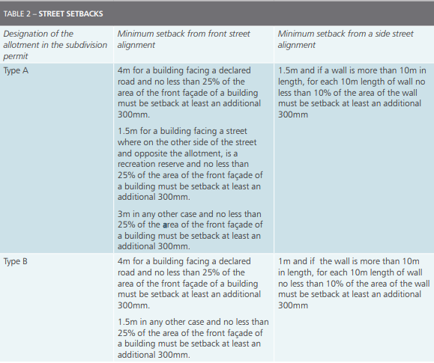 | 2.1 | 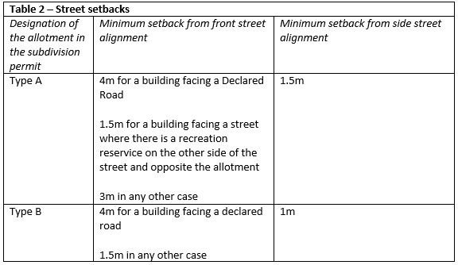 | Table updated to extract requirement for articulation.
2a | N/A | N/A | 2.2 | 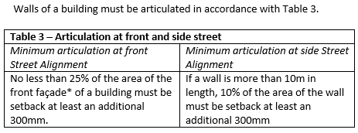  For the purposes of this standard, the area of the front façade at this Standard, means the area of the walls of the building facing the front street and measured from a two-dimensional elevation and excludes any roof area and the area of garage and carports doors / opening. | New standard for articulation that was extracted from old standard 2(1)
2b | 2(2) | The front door of any garage or carport, or the access opening to any garage or carport where a front door is not provided, that is accessed from the front street, must be setback no less than 5.0m from the front street alignment. | 2.3 | The entrance of any garage or carport, that is accessed from the front street alignment (not a lane), must be setback no less than 5.0 metres from the front street alignment. | Updated text.  Deleted reference to “where a carport is not provided” and made it clear that the setback is not required from a laneway.
N/A | 2(3) | The following may encroach into the setback distance required by standard 2(1) by no more than 1.5m –  - eaves, fascia and gutters; and  - decks, steps or landings less than 800mm in height;  provided these encroachments do not project over a street alignment. | 2.4 | The following may encroach into the setback distance required by standard 2.1 by no more than 1.5 metres -  - eaves, fascia and gutters; and  - decks, steps or landings less than 800mm in height;  provided these encroachments do not project over a street alignment. | No change.
2b | 2(4) | One or a combination of the following design features must be provided to the front of the building and may encroach into the front setback required by standard 2(1) –  - a porch, verandah or pergola that –  - is open on at least 2 sides;  - has a width of no more than 80% of the frontage of the allotment or 4m, whichever is the greater; and  - (iii) must project at least 800mm and no more than 1.5m forward of the front wall to which it is attached; or  - a balcony at the second storey or above that has a width of less than 80% of the width of the frontage of the allotment or 4m whichever is the greater and;  - must project at least 300mm and no more than 1.0m forward of the front wall to which it is attached, if the balcony is roofed; or  - must project at least 800mm and no more than 1.5m forward of the front wall to which it is attached, if the balcony is not roofed; or  - fin/s or sunhood/s having a minimum aggregate dimension of 3.1m which must project at least 300mm and not more than 1m forward of the front wall to which it is attached. | 2.5 | At least one of the following design features must be provided to the front of the building and may encroach into the setbacks required by standard 2.1 –  - a porch, verandah or pergola that –  - is open on at least 2 sides;  - has a width that does not exceed 80 percent of the frontage of the allotment or 4.0 metres, whichever is the greater; and  - projects at least 800mm and no more than 1.5 metres forward of the front wall;  or  - a balcony on the second storey or above that –  - has a width that does not exceed 80 percent of the frontage of the allotment or 4 metres, whichever is the greater; and  - must project at least 300mm and no more than 1.0 metre forward of the front wall, if the balcony is roofed; or  - must project at least 800mm and no more than 1.5 metres forward of the front wall, if the balcony is not roofed;  or  - fin/s or sunhood/s having a minimum combined dimension of 3.1 metres which must project at least 300mm and not more than 1.0 metre forward of the front wall to which it is attached. | Minor change to wording to simplify standard. No change to built form outcome intended.
3a | 2(5) | In this standard:  street, does not include lane, footway, alley or right of way;  aggregate dimension, means total length of the fin/s and/or sunhood/s;  area of the front façade, of the building is measured from a two dimensional elevation and excludes any roof area and any area of garage or carport door(s) and/or opening(s). | N/A | N/A | Standard deleted. Definitions relocated into central glossary.  Notes included within standard.
5a | 3(1) | The height of a building must not exceed –  - 11m if the slope of natural ground level at any cross section of the site of the building that is wider than 4m and is 2.5° or more; and  - 10m in any other case. | 3.1 | The height of a building must not exceed –  - The height specified in the Zone, or if no height specified:  - 11.0 metres if the slope of natural ground level at any cross section of the site of the building that is wider than 4 metres and is 2·5° or more; and  - 10.0 metres in any other case. | Updated to ensure heights align with the zone or applied zone in the first instance.
3a | 4(1) | Buildings must not occupy more of the allotment than the site coverage specified in Table 4.  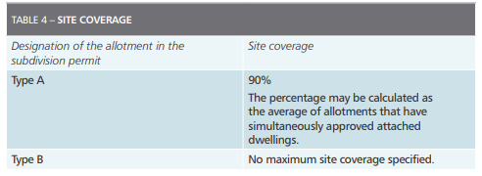 | 4.1 | The site area covered by buildings must not exceed the area specified in Table 4.*  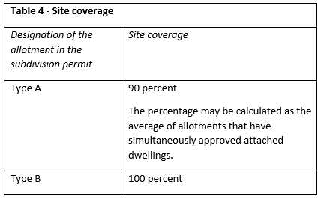  *When calculating site coverage under standard 4.1, eaves, fascia and gutters not exceeding 600mm in total width, unroofed swimming pools, unroofed terraces, unroofed patios, unroofed decks and pergolas may be disregarded. | Incorporated the note at Standard 4(2) into the new Standard 4.1.  No change to built form outcome intended.
3a | 4(2) | When calculating site coverage under standard 4 (1), eaves, fascia and gutters not exceeding 600mm in total width, unroofed swimming pools, unroofed terraces, unroofed patios, unroofed decks and pergolas may be disregarded. | N/A | N/A | 4.2 deleted.
2b | 5(1) | The area of an allotment that can be covered by impermeable surfaces must not exceed the area specified in Table 5.  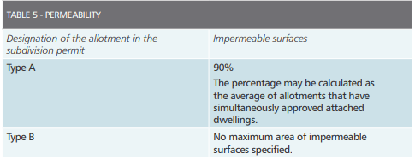 | 5.1 | The site area covered by pervious surfaces must be at least the area specified in Table 5.  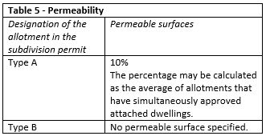 | Minor change to simplify text.  No change to built form outcome intended.
N/A | 6(1) | Provision must be made for the number of car parking space(s) specified in Table 6.  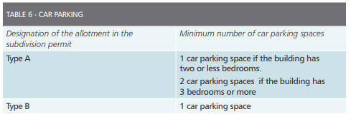 | 6.1 | Provision must be made for the number of car parking space(s) specified in Table 6.  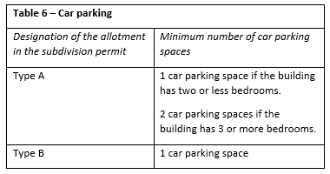 | No change
N/A | 6(2) | The car parking space(s) required under standard 6(1) must be accessible from a public street or lane or right of way, however, if the allotment has a frontage width of less than 6.0m access to the car parking space(s) must only be from the rear of the allotment. | 6.2 | The car parking space(s) required under standard 6.1 must be accessible from a public street or lane or right of way, however, if the allotment has a frontage width of less than 6.0m access to the car parking space(s) must only be from the rear of the allotment. | Reference to standards updated.
N/A | 6(3) | If 1 car parking space is required under standard 6(1) it must be at least 6.0m long and 3.5m wide. | 6.3 | If 1 car parking space is required under standard 6.1 it must be at least 6.0 metres long and 3.5 metres wide. | Reference to standards updated.
N/A | 6(4) | If 2 car parking spaces are required under standard 6(1) –  (a) one space must be at least 6m long and 3.5m wide; and  (b) the second space must be at least 4.9m long and 2.6m wide | 6.4 | If 2 car parking spaces are required under standard 6.1 –  - one space must be at least metres 6.0 metres long and 3·5 metres wide; and  - the second space must be at least 4·9 metres long and 2·6 metres wide | Reference to standards updated.
2b | 6(5) | A building may project into a car parking space if it is at least 2.1m above that space | 6.5 | The minimum ceiling height to a garage, carport or car parking space is 2.1 metres. | Standard updated to reflect text in practice note.
N/A | 6(6) | Despite standard 6(4), if the 2 required car parking spaces adjoin each other in a garage or carport or in a space constrained by walls, the double space may be 5.5m in width. | 6.6 | Despite standard 6.4, if the 2 required car parking spaces adjoin each other in a garage or carport or in a space constrained by walls, the double space may be 5·5 metres in width. | Update reference to Standard
3a | 6(7) | If the car parking space(s) required under standard 6(1) is in a garage or carport and the door(s) or opening(s) to the garage or carport faces the front street –  (a) the width of the door(s) or opening(s) must not exceed 50% of the width of the frontage of the allotment; or  (b) the area of the door(s) or opening (s) must not exceed 30% of the area of the front façade of the building. | 6.7 | If the car parking space(s) required under standard 6.1 is in a garage or carport and the door(s) or opening(s) to the garage or carport faces the front street -  - the width of the door(s) or opening(s) must not exceed 50% of the width of the of the frontage of the allotment; or  - the area of the door(s) or opening (s) must not exceed 30% of the area of the front façade of the building. For the purposes of this standard, the area of the front façade of the building means the area of the walls of the building facing the front street, measured from a two-dimensional elevation and excluding any roof area. | Definition of front façade incorporated into Standard.  Reference to standards updated.
1c | 6(8) | The area of the front façade of the building under standard 6(7)(b) means the area of the walls of the building facing the front street and measured from a two dimensional elevation and excludes any roof area. | N/A | N/A | Definitions relocated into central glossary.
5a | 7(1) | A building must be set back from a side or rear boundary not less than the distance specified in Table 7.  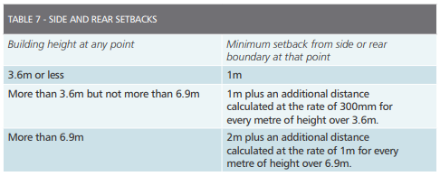 | 7.1 | A building must be set back from a side or rear boundary not less than the distance specified in Table 7.  Table 7 - Side and Rear Setbacks  Building height at any point Minimum setback from side or rear boundary  3⋅6 metres or less 1.0 metre  More than 3.6 metres but not more than 6·9 metres 1.0 metre plus 0.3 metres for every metre of height over 3.6 metres  More than 6·9 metres 2.0 metres plus 1.0 metre for every metre of height over 6.9 metres. | Reworded to align with Clause 54.  No change to built form outcome intended.
N/A | 7(2) | The following may encroach into the setback distance required by Table 7 by not more than 500mm –  - porches and verandahs;  - masonry chimneys;  - sunblinds and sunhoods;  - flues and pipes;  - domestic fuel tanks and water tanks; and  - heating and cooling equipment and other services. | 7.2 | The following may encroach into the setback distance required by Table 7 by not more than 500mm –  - porches and verandahs;  - masonry chimneys;  - sunblinds and sunhoods;  - flues and pipes;  - domestic fuel tanks and water tanks; and  - heating and cooling equipment and other services. | No change.
N/A | 7(3) | Eaves, fascias and gutters may encroach into the setback distance required by Table 7 by not more than 600mm. | 7.3 | Eaves, fascias and gutters may encroach into the setback distance required by Table 7 by not more than 600mm. | No change.
N/A | 7(4) | The following may encroach into the setback distance required by Table 7 –  - landings with an area of not more than 2m2 and less than 1m high;  - unroofed stairways and ramps;  - pergolas;  - shade sails; and  - decks less than 800mm above natural ground level. | 7.4 | The following may encroach into the setback distance required by Table 7 –  - landings with an area of not more than 2 square metres and less than 1.0 metre high;  - unroofed stairways and ramps;  - pergolas;  - shade sails; and  - decks less than 800mm above natural ground level.  Note this standard does not apply to a wall of a building or a carport that complies with standard 8. | No change.
3a | 7(5) | This standard does not apply to a wall of a building or a carport that complies with standard 8 | N/A | N/A | Standard deleted and note included at start Standard 7.
3a | 8(1) | This standard applies to the construction of –  (a) buildings on a side or rear boundary of an allotment; and  (b) carports constructed on or within 1m of a side or rear boundary of an allotment and which is open on the side facing the boundary or boundaries. | N/A | N/A | Deleted and new wall on boundary definition included in Glossary.
3a | 8(2) | The maximum height of a building on and within 1.0m of a side or rear boundary, or a carport on or within 1.0m of a side or rear boundary, must not exceed 3.6m. | N/A | N/A | Standard consolidated into new standard 8.1
3a  5a | 8(3) | Notwithstanding standard 8(2) the height of a building or carport may exceed 3.6m where –  (a) it abuts an existing building on the adjoining allotments or will abut a simultaneously approved building on the boundary; and  (b) the height difference between the existing adjoining building or the simultaneously approved building or carport does not exceed 3.6m.  (c) notwithstanding standard 3(a) the length difference between the existing or simultaneously approved building may be a maximum 2.0m, provided the additional length does not impact on a light court. | 8.1 | The maximum height of a wall on or within 1.0 metre of a side or rear boundary, or a carport on or within 1.0 metre of a side or rear boundary, must not exceed 7.2 metre unless:  - it abuts an existing building on the adjoining allotments or will abut a simultaneously approved building on the boundary; and  - the height difference between the existing adjoining building or the simultaneously approved building or carport does not exceed 3.6 metres.  - notwithstanding standard 3.1 the length difference between the existing or simultaneously approved building must not exceed 2.0 metres, and the additional length must not impact on a light court. | This standard consolidates old Standard 8(2) and 8(3)  Update Standard to allow dwelling to have two storeys built on boundary.
5a | N/A | N/A | 8.2 | There is no maximum a wall may be constructed along a boundary. | New standard added to make it clear there is no maximum wall on boundary.
N/A | 9(1) | No specific standards are required to be met. | 9.1 | No specific standards are required to be met. | No change.
N/A | 10(1) | No specific standards are required to be met. | 10.1 | No specific standards are required to be met. | No change.
3a | 11(1) | A building and/or fence must not reduce the sunlight to any recreational private open space of an existing building on an adjoining allotment to less than 6m2, with a minimum dimension of 2m. | 11.1 | A building must not reduce the sunlight to any recreational private open space of an existing building on an adjoining allotment to less than 6 square metres, with a minimum dimension of 2.0 metres.  For the purposes of calculating the area of direct sunlight under this standard, the length of the shadow cast by buildings and/or fences shall be 0.9h when measured perpendicular to the building and/or fence, where h is the height of the building and/or fence and when the sun is true north. | No change to standard. Note included from standard 11(2).
3a | 11(2) | For the purposes of calculating the area of direct sunlight under this standard, the length of the shadow cast by buildings and/or fences shall be 0.9h when measured perpendicular to the building and/or fence, where h is the height of the building and/or fence and when the sun is true north. | N/A | N/A | Old standard incorporated into note at Standard 11.1.
3a | 11(3) | In this standard recreational private open space means any part of private open space on an allotment –  (a) which is –  (i) at the side or rear of an existing dwelling on the allotment; or  (ii) is a rooftop area; and  (b) which is primarily intended for outdoor recreation activities. | N/A | N/A | Deleted and recreational private open space definition included in Glossary.
5a | 12(1) | A window in a habitable room, where the floor level of the room is more than 2.5m above natural ground level and the window faces a side or rear boundary, the window must either –  (a) be setback from side and rear boundaries by at least 4.5m;  (b) have a sill height at least 1.7m above floor level; or  (c) have fixed obscure glazing in any part of the window below 1.7m above floor level. | 12.1 | A window in a habitable room, where the floor level of the room is more than 2.5 metres above natural ground level and the window faces secluded private open space or habitable room windows of an existing dwelling within a horizontal distance of 4.5 metres, or is within 4.5 metres of a vacant residential allotment the window must either –  - have a sill height at least 1·7 metres above floor level; or  - have fixed obscure glazing in any part of the window below 1·7 metres above floor level.  In this standard, ‘faces’ means at an angle of less than 45° to the boundary; and ‘residential allotment’ means a lot that may be developed for the purpose of a dwelling and excludes reserves. | Updated wording so that only windows which overlook private open space, or habitable room windows are required to be screened.
5a | 12(2) | If a habitable room window in standard 12(1) faces a lane, footway, alley or right of way the setback required in standard 12(1)(a) is taken from the middle of the lane, footway, alley or right of way. | N/A | N/A | This standard has been deleted.
5a | 12(3) | A raised open space must be –  (a) setback 4.5m from a side or rear boundary; or  (b) screened to a height of at least 1.7m above the floor level at any part of the perimeter of the raised open space that faces and is within 4.5 metres of a side or rear boundary. | 12.2 | A raised open space that faces secluded private open space or habitable room windows of an existing dwelling within a horizontal distance of 4.5 metres, or is within 4.5 metres of a vacant residential allotment must be screened to a height of at least 1.7m above the floor level and be no more than 25 percent transparent.  In this standard, ‘faces’ means at an angle of less than 45° to the boundary; and ‘residential allotment’ means a lot that may be developed for the purpose of a dwelling and excludes reserves. | Updated wording so that only raised open space which overlook private open space, or habitable room windows are required to be screened.
5a | 12(4) | If a raised open space faces a lane, footway, alley or right of way the setback required in standard 12(3)(a) is taken from the middle of the lane, footway, alley or right of way | N/A | N/A | This standard has been deleted.
3a | 12(5) | In this standard – raised open space means a landing with an area of more than 2m2 , a balcony, a terrace, a deck or a patio that has a floor level of more than 800mm above natural ground level. faces means at an angle of less than 45° to the boundary. screened means a permanent and fixed screen that has no more than 25% of its area open which obscures overlooking. | N/A | N/A | Definitions in standard incorporated into Glossary.
5b | 13(1) | Each required habitable room window of a building on an allotment must face –  (a) an outdoor space or light court with a minimum area of 3m2 and a minimum dimension of 1m clear to the sky, not including land on an adjoining allotment; or  (b) a verandah on the allotment if it is open for at least one third of its perimeter; or  (c) a carport on the allotment if –  (i) it has 2 or more sides open; and  (ii) it is open for at least one third of its perimeter. | 13.1 | Each required habitable room window of a building on an allotment must face –  - an outdoor space or light court with a minimum area of 3 square metres and a minimum dimension of 1.0 metre clear to the sky, not including land on an adjoining allotment; or  - a verandah provided it is open for at least one third of its perimeter; or  - a carport provided it has two or more open sides and is open for at least one third of its perimeter  For the purposes of this standard, a side of a carport or verandah will be open if the roof covering of the carport or verandah is not less than 500mm from another building on the allotment or the adjoining allotment boundary. | Updated to align with Victoria Planning Provisions.  No change to built form outcome intended.
3a | 13(2) | For the purposes of standard 13(1), a side of a carport or verandah will be open if the roof covering of the carport or verandah is not less than 500mm from another building on the allotment or the adjoining allotment boundary. | N/A | N/A | Old standard 13(2) has been incorporated into standard 13.1
3a | 13(3) | In this standard a required habitable room window is a window that provides all or some of the minimum amount of light or ventilation to a habitable room in accordance with volume 2 of the Building Code of Australia. | N/A | N/A | Definitions in standard incorporated into Glossary.
3a | 14(1) | If a dwelling on an allotment has three or more bedrooms it must have –  (a) at least 24m2 of private open space at the side or rear of the building with a minimum dimension of 3m; or  (b) a balcony or roof-top area of at least 12m2 of private open space with a minimum dimension of 3m. | 14.1 | If a dwelling on an allotment has three or more bedrooms it must have –  - at least 24 square metres of private open space at the side or rear of the building with a minimum dimension of 3 metres; or  - a balcony or roof-top area of at least 12 square metres of private open space with a minimum dimension of 3 metres.  Private open space may be provided in 2 or more parcels provided that each parcel is at least 12 square metres and at least 1 parcel complies with standard 14.3. | Old standard 14(2) has been incorporated into this standard and the standard reference has been updated.
3a | 14(2) | Private open space under standard 1(a) may be provided in 2 or more parcels provided that each parcel is at least 12m2 and at least 1 parcel complies with standard 14(4) | N/A | N/A | Standard has been incorporated into standard 14.1
N/A | 14(3) | If a building on an allotment has two or less bedrooms it must –  (a) have at least 12m2 of private open space at the side or rear of the building with a minimum dimension of 3m; or  (b) a balcony or rooftop area that is at least:  (i) 10% of the total floor area of the building excluding garages and carports; or  (ii) 6m2 with a minimum dimension of 2m, whichever is the greater. | 14.2 | If a dwelling on an allotment has two or less bedrooms it must –  - have at least 12 square metres of private open space at the side or rear of the building with a minimum dimension of 3.0 metres; or  - a balcony or rooftop area that is at least:  - 10% of the total floor area of the building excluding garages and carports; or  - 6 square metres with a minimum dimension of 2.0 metres, whichever is the greater. | No change.
3a | 14(4) | If the private open space is provided at the side or rear of the dwelling or as a roof top area, an area of at least 6m2 , with a minimum dimension of 2m, must have access to direct sunlight. | 14.3 | If the private open space is provided at the side or rear of the dwelling or as a roof top area, an area of at least 6 square metres, with a minimum dimension of 2.0 metres, must have access to direct sunlight.  For the purposes of calculating the area of direct sunlight at this standard, the length of the shadow cast by buildings and/or fences shall be 0.9h when measured perpendicular to the building and/or fence, where h is the height of the building and/or fence and when the sun is true north. | Old standard 14(5) has been incorporated into this standard.
3a | 14(5) | For the purposes of calculating the area of direct sunlight under standard 14(4), the length of the shadow cast by buildings and/or fences shall be 0.9h when measured perpendicular to the building and/or fence, where h is the height of the building and/or fence and when the sun is true north. | N/A | N/A | Standard has been incorporated into standard 14.3.
PART 2 CLASS 10b BUILDINGS
N/A | 15(1) | A fence, or part of a fence, within 3m of the street alignment at the front of that allotment must not exceed the relevant maximum height specified in Table 15.  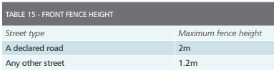 | 15.1 | A front fence on or within 3m of the street alignment must not exceed the maximum height specified in specified in Table 15.  Table 15 - Front fence height  Street type Maximum fence height  A declared road 2 metres.  Any other street - metres. | No change
5b | 15(2) | A front fence, other than a front fence to a declared road, must be no more than 85% solid above 700mm height. | 15.2 | A front fence, other than a front fence to a declared road, must be at least 15 per cent transparent above 700mm height. | Updated to align with Victoria Planning Provisions.  No change to built form outcome intended.
5b | 16(1) | A fence that is setback more than 150mm from a side or rear boundary must not exceed 2.5m in height and the part of the fence between 2m and 2.5m in height must have at least 25% of its area open. | 16.1 | A fence that is setback more than 150mm from a side or rear boundary must not exceed 2.5 metres in height and the part of the fence between 2.0 metres and 2.5 metres in height must be at least 25 per cent transparent. | Updated to align with Victoria Planning Provisions.  No change to built form outcome intended.
2a | 16(2) | Any part of a fence that is constructed forward of the front wall of a dwelling must comply with standard 15(1) and 15(2). | N/A | N.A | Moved to new standard 18.1
5b | 17(1) | A fence that is on or within 150mm of a side or rear boundary must not exceed 2.5m in height and the part of the fence between 2m and 2.5m in height must have at least 25% of its area open. | 17.1 | A fence that is on or within 150mm of a side or rear boundary must not exceed 2.5 metres in height and the part of the fence between 2.0 metres and 2.5 metres in height must be at least 25 per cent transparent. | Updated to align with Victoria Planning Provisions.  No change to built form outcome intended.
2a | 17(2) | Any part of a fence that is constructed forward of the front wall of a dwelling must comply with standard 15(1) and 15(2). | N/A | N.A | Moved to new standard 18.1
2a | N/A | N/A | 18.1 | Any part of a fence that is constructed forward of the front wall of a dwelling must comply with the height and transparency requirements of standards 15.1 and 15.2 | Old standard 16(2) and 17(2) have been incorporated into this standard.
3a | 18(1) | Despite standards 15(1) and 18(2), a fence within 3m of a point of intersection of street alignments must not exceed a height of 1m above footpath level. | 19.1 | Despite standards 15.1 and 15.2, a fence within 3m of a point of intersection of street alignments must not exceed a height of 1.0 metre above footpath level. | Reference to standards updated.
2b | 18(2) | A fence facing and within 1m of a side street alignment must not –  (a) exceed 2m in height; and  (b) be constructed with solid materials for more than 65% of the length of the side street boundary and the remaining length of the side street boundary must not be constructed with materials that are more than 85% solid. | 19.2 | A fence within 1.0 metre of a side street alignment -  – must not exceed 2.0 metres in height; and  -may be solid for no more than 65 percent of its length, the remaining length of the fence must be at least 15 percent transparent | Updated wording to provide clarity.
N/A | 18(3) | A fence on a rear street alignment must not exceed 2m in height above natural ground level. | 19.3 | A fence on a rear street alignment must not exceed 2.0 metres in height above natural ground level. | No change.
N/A | 18(4) | A fence adjacent to and within 1m of a street alignment or public open space must not contain barbed wire or other sharp protrusions. | 19.4 | A fence adjacent to and within 1.0 metre of a street alignment or public open space must not contain barbed wire or other sharp protrusions. | No change.
3a | 18(5) | In this standard street does not include lane, footway, alley or right of way | N/A | N/A | Standard has been moved to beginning of Standard as a note.
N/A | 19(1) | No specific standards are required to be met. | 20.1 | No specific standards are required to be met. | No change.
N/A | 20(1) | No specific standards are required to be met. | 21.1 | No specific standards are required to be met. | No change.
N/A | 21(1) | No specific standards are required to be met. | 22.1 | No specific standards are required to be met. | No change.
Practice Note
Introduction
N/A | Purpose | The purpose of this Practice Note is to provide clarification of the standards established in the Small Lot Housing Code. This Practice Note is not intended as a substitute for making direct reference to the relevant standards in the Code. | Purpose | The purpose of this Practice Note is to provide clarification of the standards established in the Small Lot Housing Code. This Practice Note is not intended as a substitute for making direct reference to the relevant standards in the Code. | No change.
4c | Background | The Small Lot Housing Code applies to the construction of a house and associated outbuildings in an Urban Growth Zone where a Precinct Structure Plan has been incorporated into the planning scheme. The Code encourages one, two or three storey houses that can be attached, semi- detached or detached housing on lots less than 300m² in area. There are no minimum lot sizes under the code. The Code is not mandatory, as a developer or house builder can opt to use the existing planning permit process, however if the standards in this code are met it eliminates the need for planning permits even for houses on lots less than 300m² in area. The standards are prescriptive - a standard is either met or not met. The standards establish an envelope that deals with all the siting matters covered in Part 4 of the Building Regulations 2006. There are no options, discretions or variations involved in this code however the current planning permit process can be used for houses that do not met the standards, so there is no loss of flexibility. | Background | The Small Lot Housing Code applies to the construction of a house and associated outbuildings in an Urban Growth Zone where a Precinct Structure Plan has been incorporated into the planning scheme. The Code encourages one, two or three storey houses that can be attached, semi- detached or detached housing on lots less than 300m² in area. There are no minimum lot sizes under the code. The Code is not mandatory, as a developer or house builder can opt to use the existing planning permit process, however if the standards in this code are met it eliminates the need for planning permits even for houses on lots less than 300m² in area. The standards are prescriptive - a standard is either met or not met. The standards establish an envelope that deals with all the siting matters covered in Part 4 of the Building Regulations 2018. There are no options, discretions or variations involved in this code however the current planning permit process can be used for houses that do not met the standards, so there is no loss of flexibility. | Update reference to Building Regulations 2018.
N/A | How is the code implemented? | The mechanism that activates the use of the code is set out in the Schedule to the Urban Growth Zone. The Schedule provides that a planning permit is not required to construct one dwelling on a lot with an area less than 300 square metres where a site is identified as a lot to be assessed against the Small Lot Housing Code via a restriction on title, and it complies with the Small Lot Housing Code. The restriction should identify each lot as “Type A” or “Type B” under the Small Lot Housing Code. Approval for the construction of housing that meets all the standards is in the form of a building permit issued by a Relevant Building Surveyor (RBS). House designers must provide sufficient information on the plans to enable the RBS to determine compliance with the standards and the RBS must ensure that an application for a building permit provides sufficient information to determine that the application complies with the standards. | How is the code implemented? | The mechanism that activates the use of the code is set out in the Schedule to the Urban Growth Zone. The Schedule provides that a planning permit is not required to construct one dwelling on a lot with an area less than 300 square metres where a site is identified as a lot to be assessed against the Small Lot Housing Code via a restriction on title, and it complies with the Small Lot Housing Code. The restriction should identify each lot as “Type A” or “Type B” under the Small Lot Housing Code. Approval for the construction of housing that meets all the standards is in the form of a building permit issued by a Relevant Building Surveyor (RBS). House designers must provide sufficient information on the plans to enable the RBS to determine compliance with the standards and the RBS must ensure that an application for a building permit provides sufficient information to determine that the application complies with the standards. | No change.
4c | Exception Concerning Approved Building Envelopes | The exception concerning approved building envelopes under 406(2) of the Building Regulations 2006 continues to apply. If an adjoining lot is not subject to the Code or is not shown on the same certified plan of subdivision, regulations 414, 415, 416, 417, 418, 419, 425, 426, 428, 429 and 430 apply to the extent that they relate to that adjoining lot. | Exception Concerning Approved Building Envelopes | The exception concerning approved building envelopes under 406(2) of the Building Regulations 2018 continues to apply. If an adjoining lot is not subject to the Code or is not shown on the same certified plan of subdivision, regulations 414, 415, 416, 417, 418, 419, 425, 426, 428, 429 and 430 apply to the extent that they relate to that adjoining lot. | Update reference to Building Regulations 2018
Definitions
4b  4d | Definitions | The definitions at the beginning of the code apply to all standards in the code however there are other terms used in the code that only apply to a particular standard and are detailed at the end of those particular standards.  Further clarification is provided for some of the definitions. “clear to the sky” – gutters or spouting should not be regarded as being clear to the sky.  “existing building” and “existing wall” – the status as “existing” only applies to buildings or walls that have been completed and an ‘occupancy permit’ or a ‘certificate of final inspection’ has been issued and forwarded to the relevant council. Buildings that have obtained a building permit only, or buildings that are under construction, are not considered as “existing”.  “height” – heights are measured vertically from natural ground level at the base of a wall or fence or, in the case of a building, vertically below the top of the roof covering. Chimneys, flues and service pipes are not included when measuring heights. (see diagram 1)  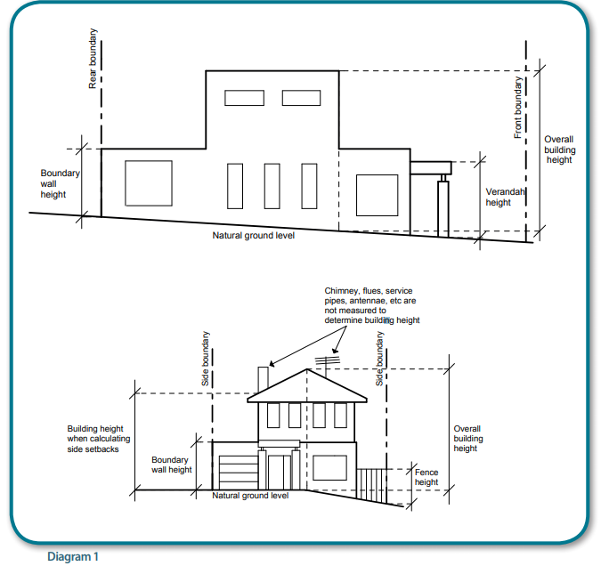  Diagrams 2 and 3 show the measurements of fence heights from natural ground level. Natural ground level can be difficult to ascertain when the subject allotment has undergone a cut and fill or other earth works.  Natural ground level may be taken as being a line across the allotment that connects any two points, either within the allotment or on adjoining allotments. (see diagram 3)  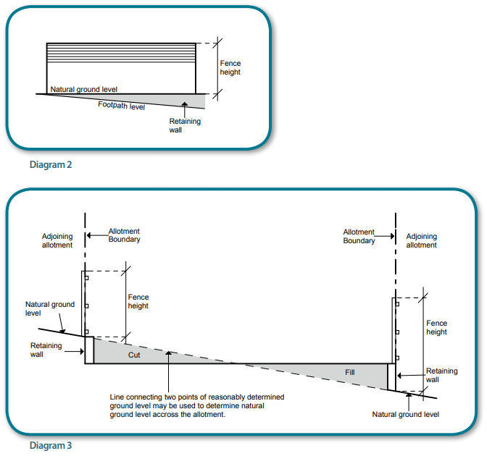  Where land has undergone extensive ‘reshaping’ earthworks, the new levels created by the reshaping can be taken as the natural ground level where the adjoining allotments have also been subject to the same earthworks or are at the same level.  “pergola” – is a structure that does not collect or discharge rain water and therefore must be either unroofed or if covered, with an open style permeable shade material. Plastic, polycarbonate or fiberglass sheeting as a roof covering changes the structure from a pergola to a verandah.  “simultaneously approved” – means developments that are approved on the same day. This would normally be the case when a developer has purchased a number of contiguous allotments who would be interested in constructing a number of two or three storey terrace style houses. The allowances are also offered to developments where the building permits are issued on the same day and the neighbours can co-ordinate their buiding permits. | Definitions | The definitions at the beginning of the code apply to all standards in the code however there are other terms used in the code that only apply to a particular standard and are detailed at the end of those particular standards.  Further clarification is provided for some of the definitions. “clear to the sky” – gutters or spouting should not be regarded as being clear to the sky.  “existing building” and “existing wall” – the status as “existing” only applies to buildings or walls that have been completed and an ‘occupancy permit’ or a ‘certificate of final inspection’ has been issued and forwarded to the relevant council. Buildings that have obtained a building permit only, or buildings that are under construction, are not considered as “existing”.  “front street alignment” is the street the dwelling is oriented towards (for example has the entrance at this frontage), for corner lots or lots with more than one road frontage (not a laneway), the plans may nominate which street is the front street and which street is the side street.  “height” – heights are measured vertically from natural ground level at the base of a wall or fence or, in the case of a building, vertically below the top of the roof covering. Chimneys, flues and service pipes are not included when measuring heights. (see diagram 1)  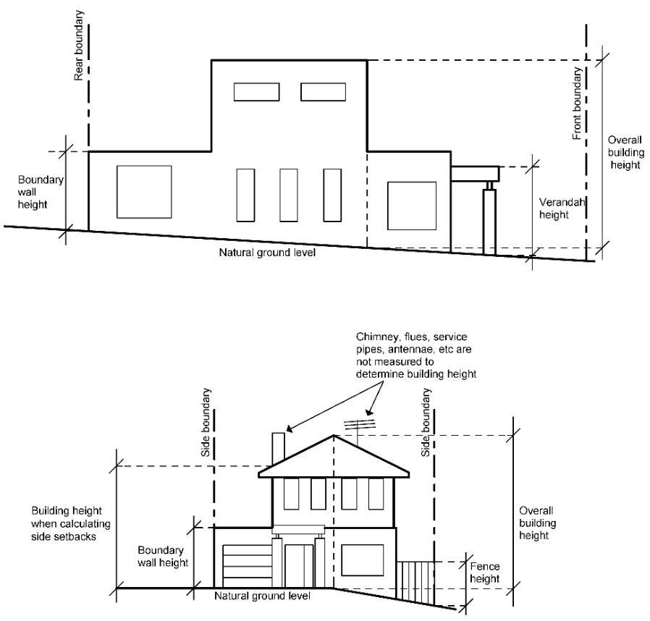  Diagram 2 shows the measurements of fence heights from natural ground level. Natural ground level can be difficult to ascertain when the subject allotment has undergone a cut and fill or other earth works.  Natural ground level may be taken as being a line across the allotment that connects any two points, either within the allotment or on adjoining allotments. (see diagram 3)  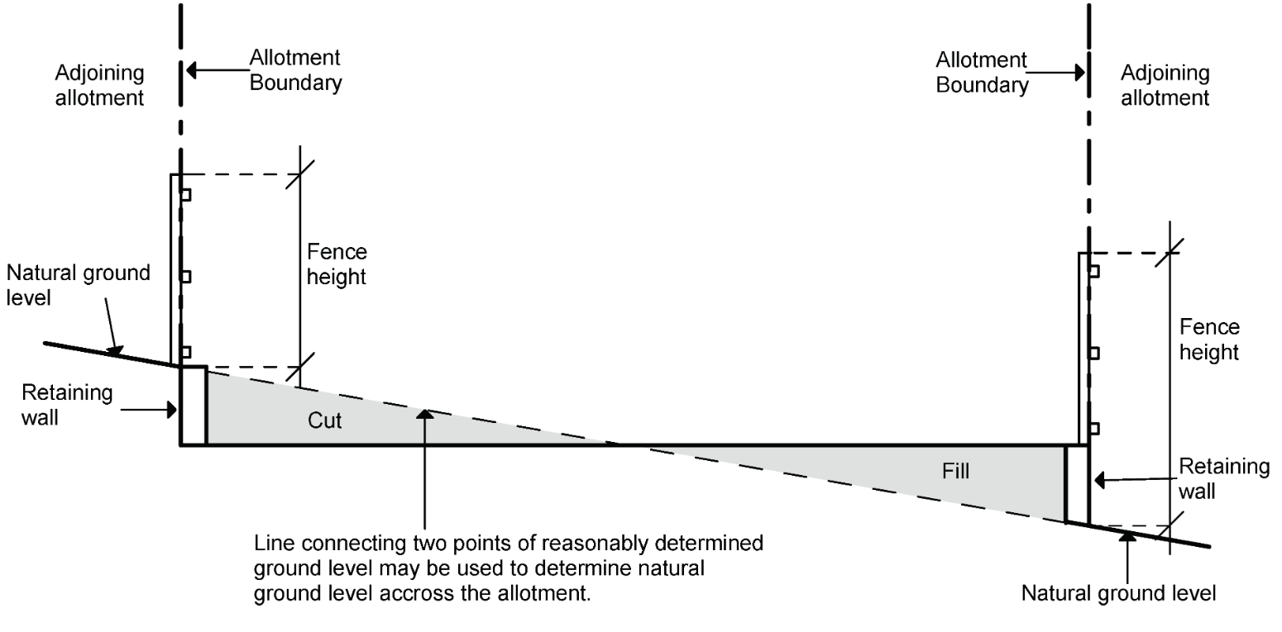  Where land has undergone extensive ‘reshaping’ earthworks, the new levels created by the reshaping can be taken as the natural ground level where the adjoining allotments have also been subject to the same earthworks or are at the same level.  “pergola” – is a structure that does not collect or discharge rain water and therefore must be either unroofed or if covered, with an open style permeable shade material. Plastic, polycarbonate or fiberglass sheeting as a roof covering changes the structure from a pergola to a verandah.  “simultaneously approved” – means developments that are approved on the same day. This would normally be the case when a developer has purchased a number of contiguous allotments who would be interested in constructing a number of two or three storey terrace style houses. The allowances are also offered to developments where the building permits are issued on the same day and the neighbours can co-ordinate their building permits. | Correction to spelling error.  Inserted clarification on front street alignment.  Deleted diagram 2.
Part 1 Single Class 1a Buildings and associated Class 10a Buildings
N/A | Part 1 Single Class 1a Buildings and associated Class 10a Buildings | The standards in this part apply to single dwellings and their associated garages, carports, sheds and the like. Small boarding houses, rooming houses or guest houses (Class1b buildings) are not covered by this code and would require a planning permit. The siting of in-ground or above ground swimming pools are not regulated under this code and fences (Class 10b buildings) are covered in Part 2 of the code. | Part 1 Single Class 1a Buildings and associated Class 10a Buildings | The standards in this part apply to single dwellings and their associated garages, carports, sheds and the like. Small boarding houses, rooming houses or guest houses (Class1b buildings) are not covered by this code and would require a planning permit. The siting of in-ground or above ground swimming pools are not regulated under this code and fences (Class 10b buildings) are covered in Part 2 of the code. | No change
N/A | 1 | This standard applies to the construction of a new dwelling only - not additions to an existing dwelling or to a garage or carport etc. However standard 2(2) requires doors or openings to garages and carports to be setback 5m from the front street alignment, which, on non-declared roads, will always mean that the garage or carport door or opening is setback further than the front wall of the dwelling | 1 | This standard applies to the construction of a new dwelling only - not additions to an existing dwelling or to a garage or carport etc. However standard 2.3 requires doors or openings to garages and carports to be setback 5m from the front street alignment, which, on non-declared roads, will always mean that the garage or carport door or opening is setback further than the front wall of the dwelling. | Update to reference to standard.
N?A | 2 | Before determining the required front and side street setbacks, the designation of the allotment into Type A or Type B must be obtained from the plan of subdivision and the classification of the road as either a declared or non-declared must be established from the VicRoads website on – Maps of Declared Roads. http://maps.vicroads.vic.gov.au/website/declared/viewer.htm | 2 | Before determining the required front and side street setbacks, the designation of the allotment into Type A or Type B must be obtained from the plan of subdivision and the classification of the road as either a declared or non-declared must be established from the VicRoads website on – Maps of Declared Roads. http://maps.vicroads.vic.gov.au/website/declared/viewer.htm | No change
4a  4d | 2(1) | The term facing means oriented towards the street (i.e. the plane of the wall is less than 90º to the street alignment). If the wall is not parallel to the street alignment, the closest part of the wall to the street alignment is the point at which the setback is measured. There are no prescribed setbacks for rear streets however standard 7 (side and rear setbacks) will apply. Diagram 4 illustrates methods of measuring front and side street setbacks in some situations.  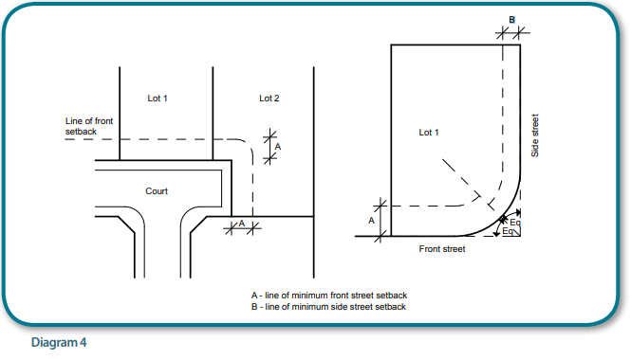  Reduced frontage setbacks for properties opposite recreational reserves is allowed on Type A allotments and diagram 5 indicates which properties would be eligible for the reduced front setbacks.  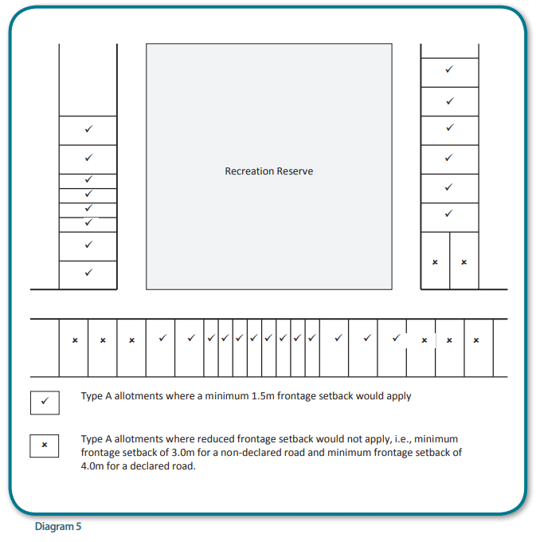  The concept of articulation of the front façade of the building and for walls adjacent to side streets that exceed 10m in length, have been introduced in Table 2, with a required increase in the setbacks for sections of the front and side walls being a minimum 300mm. (see diagram 6)  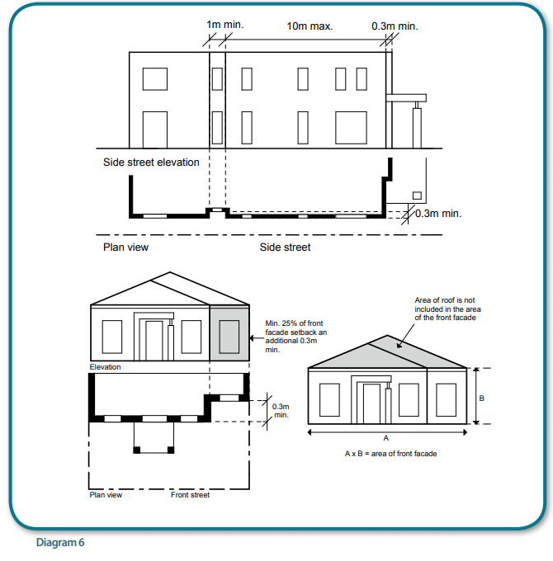 | 2.1 | The term facing means oriented towards the street (i.e. the plane of the wall is less than 90º to the street alignment). If the wall is not parallel to the street alignment, the closest part of the wall to the street alignment is the point at which the setback is measured. There are no prescribed setbacks for rear streets however standard 7 (side and rear setbacks) will apply. Diagram 3 illustrates methods of measuring front and side street setbacks in some situations.  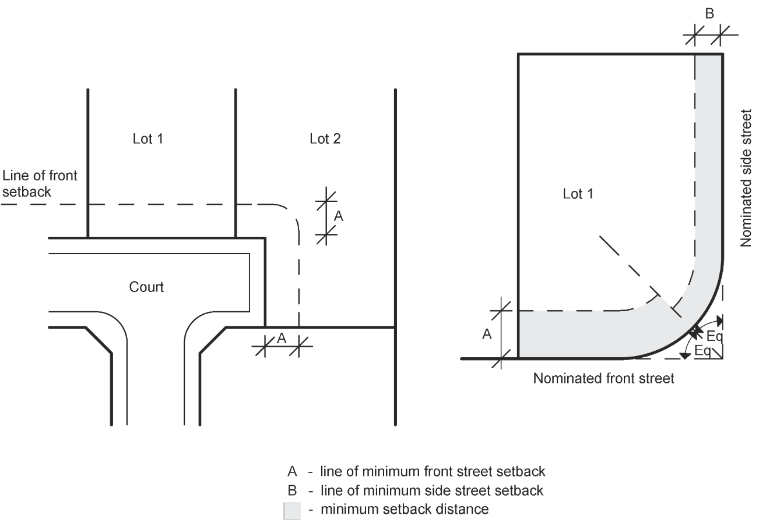  Reduced frontage setbacks for properties opposite recreational reserves is allowed on Type A allotments and diagram 4 indicates which properties would be eligible for the reduced front setbacks.  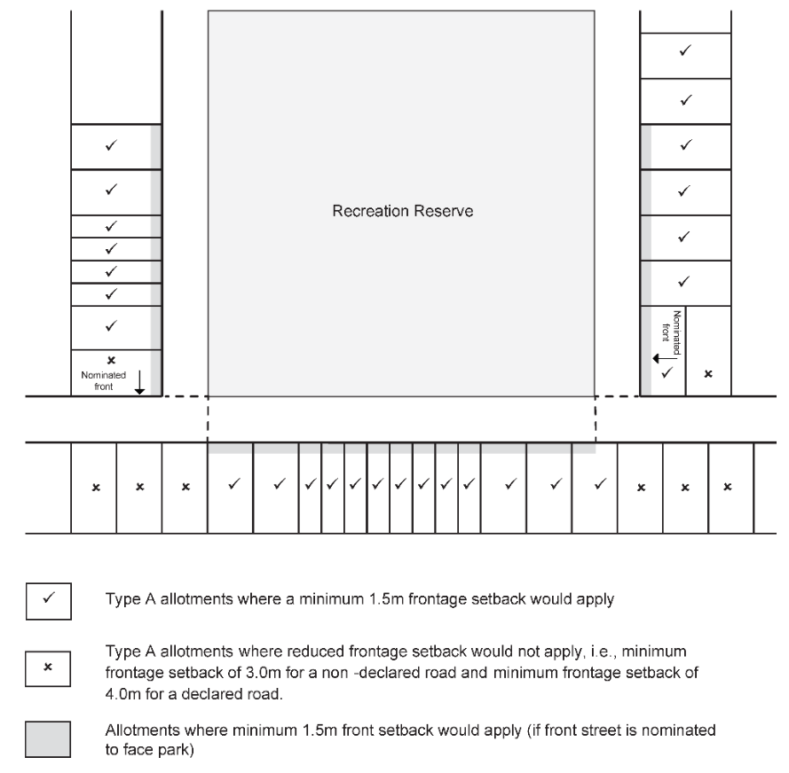 | Update diagram 5.  Articulation requirement (on page 6) moved to new section 2.3
4a  4d | N/A | N/A | 2.2 | The concept of articulation of the front façade of the building and for walls adjacent to side streets that exceed 10m in length, have been introduced in Table 2, with a required increase in the setbacks for sections of the front and side walls being a minimum 300mm. (see diagram 5)  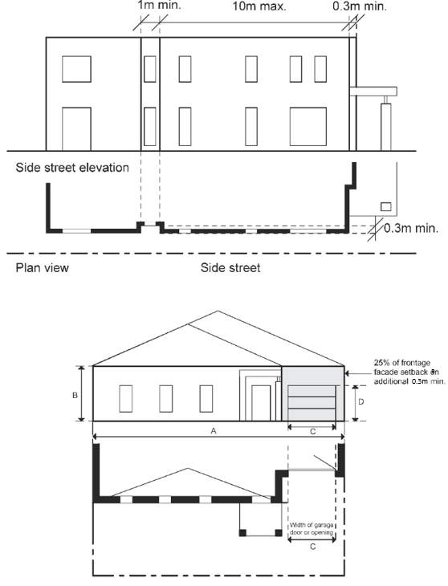 | Articulation requirement taken from old standard 2(1) and put in own section at 2.3  New diagram 6.
4a  4d | 2(2) | The minimum setback to the front door of a garage or carport, or to the access opening to a garage or carport, must be a minimum of 5.0m. This can be achieved by recessing the front door, as shown in diagram 7.  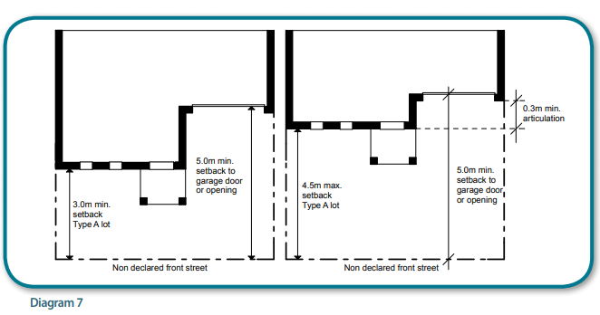 | 2.3 | The minimum setback to the front door of a garage or carport, or to the access opening to a garage or carport, must be a minimum of 5.0m from a street (not a laneway). This can be achieved by recessing the front door, as shown in diagram 6.  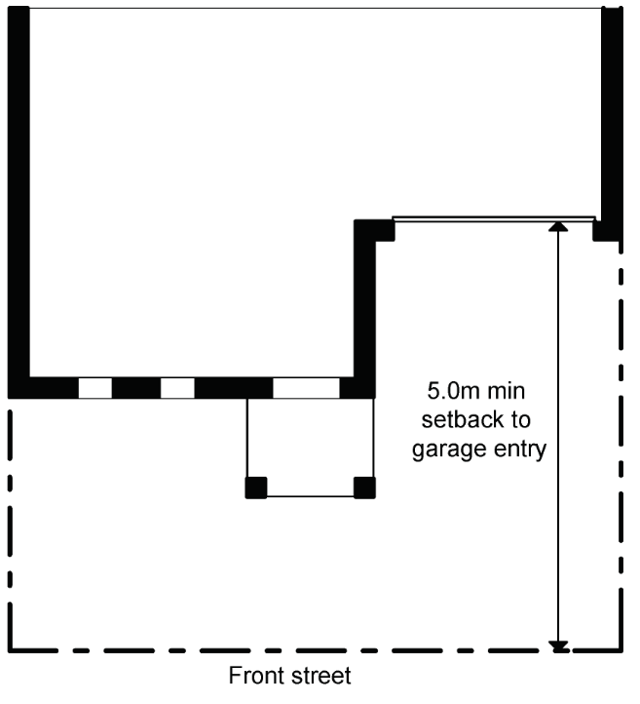 | Clarity added to allow for 0 metre setback from laneway.
N/A | 2(3) | This standard also allows decks, steps & landings that are less than 800mm in height and eaves, fascia & gutters to encroach 1.5m into the required front and side street setbacks, however at no time can any of these structures project over the title boundary. | 2.4 | This standard also allows decks, steps & landings that are less than 800mm in height and eaves, fascia & gutters to encroach 1.5m into the required front and side street setbacks, however at no time can any of these structures project over the title boundary. | No change.
4d | 2(4) | To further encourage front façade articulation, an open porch, verandah or pergola, an upper floor balcony, or fin/s or sunhood/s, or a combination of the above, must project forward of the front wall of the dwelling and may encroach into the required front setback. (see examples in diagram 8)  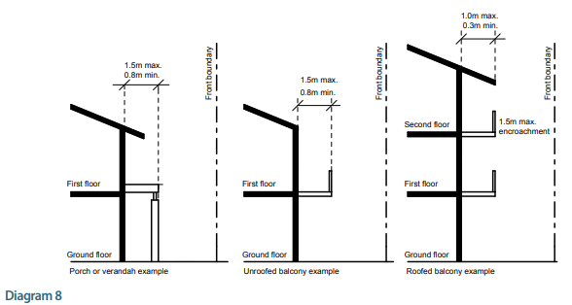  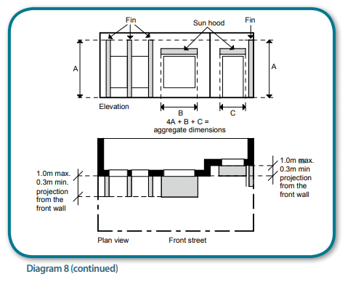 | 2.5 | To further encourage front façade articulation, an open porch, verandah or pergola, an upper floor balcony, or fin/s or sunhood/s, or a combination of the above, must project forward of the front wall of the dwelling and may encroach into the required front setback. (see examples in diagram 7 and 8).  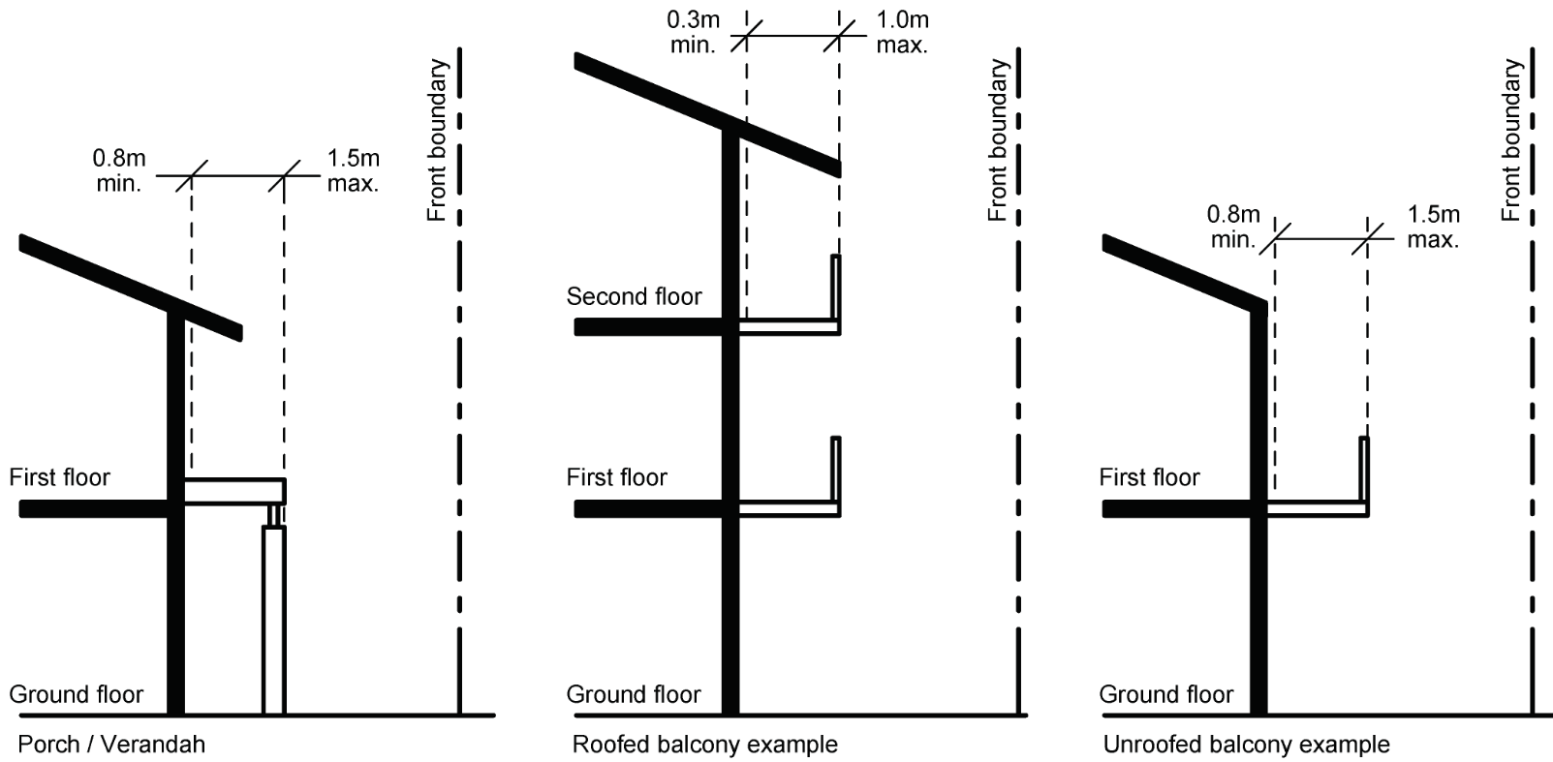  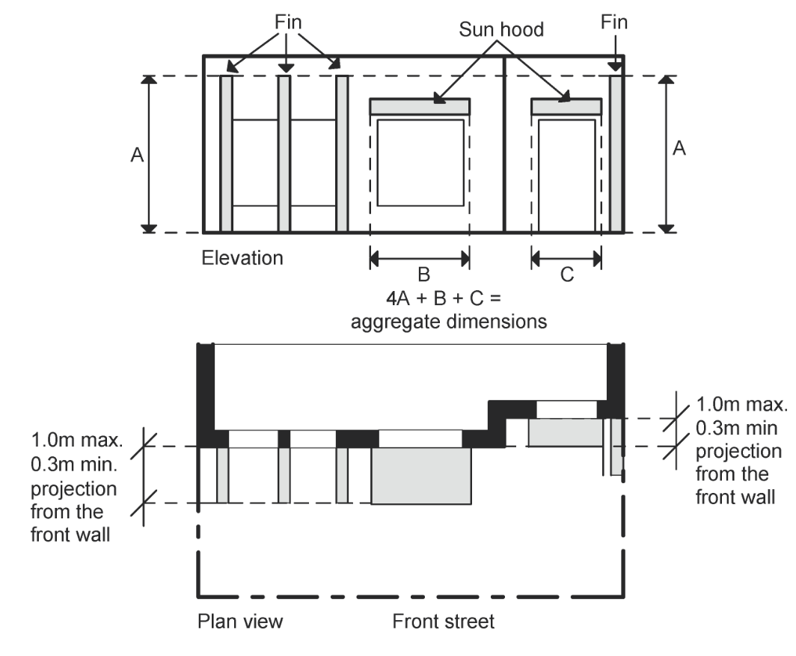 | Update diagrams.
4a  4d | 2(5) | Although “street” in the definitions includes lane, footway, alley and right of way, the street setback in this standard are not setbacks from lanes, footways, alleys or right of ways. The setbacks from, or the option to build on a lane, footway, alley or right of way, are set out in standards 7 & 8 respectively. How you determine “area of front façade’ and ‘aggregate dimensions’ are explained in this standard and are shown in diagram 9.  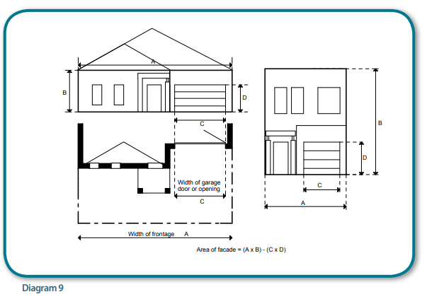 | N/A | N/A | 2(5) deleted. Diagram 9, incorporated into Diagram 6.
4a | 3 | This standard allows a maximum building height of 11m where the slope of the ground is 2.5º or more across a 4m section of the building. This is equal to a ratio of 1:23 or a rise or fall over the 4m section of 175mm. (see diagram 10). If the site does not fall 2.5º, the maximum overall building height above natural ground level is 10m.  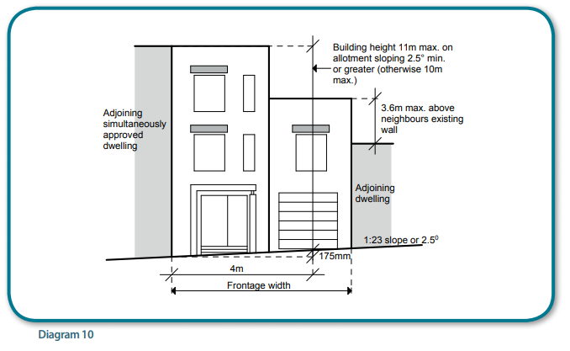 | 3 | The building height must not exceed the amount specified in the Zone or the Applied Zone, typically the General Residential Zone or the Residential Growth Zone. Where there is no maximum height specified in the Zone, the standard allows a maximum building height of 11m where the slope of the ground is 2.5° or more across a 4m section of the building. If the site does not fall 2.5°, the maximum overall building height above natural ground level is 10m. | Updated to specify building height is to accord with Zone and diagram 10 deleted.
N/A | 4 | There is only a maximum site coverage specified for Type A allotments and this maximum percentage (90%) may be calculated as the average over adjoining allotments, if the dwellings are simultaneously approved.  All existing buildings must be included when calculating site coverage however there are stated structures in standard 4(2) that may be disregarded. | 4 | There is only a maximum site coverage specified for Type A allotments and this maximum percentage (90%) may be calculated as the average over adjoining allotments, if the dwellings are simultaneously approved.  All existing buildings must be included when calculating site coverage however there are stated structures in standard 4.1 that may be disregarded. | Update to reference to standard.
N/A | 5 | There is only a maximum impermeable surface requirement specified for Type A allotments and this maximum percentage (90%) may be calculated as the average over adjoining allotments, if the dwellings are simultaneously approved.  A permeable surface is one that allows water to be absorbed through the material and therefore on-site infiltration of storm waters. | 5 | There is only a maximum impermeable surface requirement specified for Type A allotments and this maximum percentage (90%) may be calculated as the average over adjoining allotments, if the dwellings are simultaneously approved.  A permeable surface is one that allows water to be absorbed through the material and therefore on-site infiltration of storm waters. | No change.
N/A | 6 | The purpose of this standard is to ensure new dwellings have adequate on-site car parking. Car parking spaces can be nominated anywhere on an allotment, however a complying car parking space must be accessible from a public street, lane or right of way and be fully contained within the allotment. If the spaces are within a structure the dimensions are to be taken as the internal dimensions of that structure. (see diagram 11) | 6 | The purpose of this standard is to ensure new dwellings have adequate on-site car parking. Car parking spaces can be nominated anywhere on an allotment, however a complying car parking space must be accessible from a public street, lane or right of way and be fully contained within the allotment. If the spaces are within a structure the dimensions are to be taken as the internal dimensions of that structure. (see diagram 9) | Update to reference of diagram.
N/A | 6(1) | To determine the number of car spaces required, the allotment designation (Type A or B) and the number of bedrooms must be established. A bedroom includes any habitable room with a floor area greater than 6m2 that is enclosed on all sides, that contains a window. This means that enclosed rooms labeled study or library etc would need to be counted as a bedroom for the purposes of this standard if they exceed 6m2 in floor area and the room contains a window | 6.1 | To determine the number of car spaces required, the allotment designation (Type A or B) and the number of bedrooms must be established. A bedroom includes any habitable room with a floor area greater than 6m2 that is enclosed on all sides, that contains a window. This means that enclosed rooms labelled study or library etc would need to be counted as a bedroom for the purposes of this standard if they exceed 6m2 in floor area and the room contains a window | Correction to spelling error.
N/A | 6(2) | Allotments with frontage widths of less than 6m will not have car access from the front of the allotment. | 6.2 | Allotments with frontage widths of less than 6m will not have car access from the front of the allotment. | No change
N/A | 6(3), (4) & (6) | These standards are best explained in diagram 11.  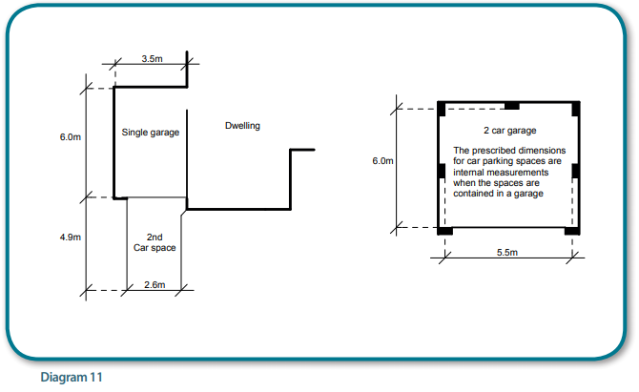 | 6.3, 6.4, 6.6 | These standards are best explained in diagram 9. | Update to reference of diagram.
N/A | 6(5) | The minimum ceiling height to a garage, carport or car parking space is 2.1m | 6.5 | The minimum ceiling height to a garage, carport or car parking space is 2.1m | No change.
N/A | 6(7) | These standards are explained in diagram 12.  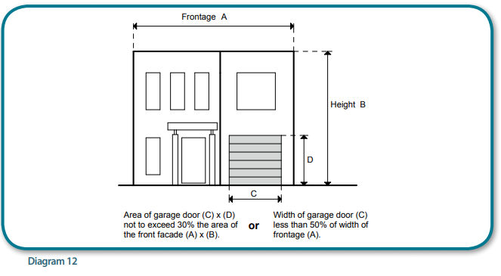 | 6.7 | These standards are explained in diagram 10. | Update to reference of diagram.
4a  4c  4d | 7 | The envelope within which a building must be constructed is established by this regulation and regulation 8, as shown in diagram 13. The envelope established by Table 1 commences at a 1m setback from the side or rear boundary, allowing a 3.6m height at this point. The ebvelope established by standard 8 limits building heights inclduing the roof structure, to 3.6m within 1.0m to a side or rear boundary.. Standards 7(2), (3) & (4) specify the allowable encroachments into the required setback and includes decks up to a maximum height of 800mm above natural ground level, which is not the case under the Building Regulations 2006.  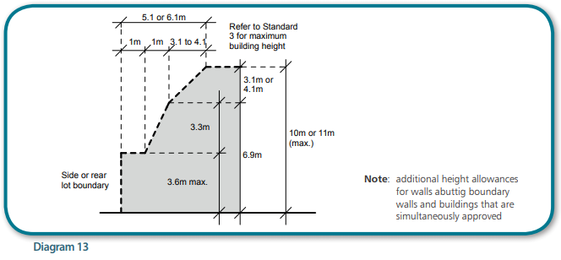  The table below is a quick way of establishing the side and rear setback requirement for certain building heights.  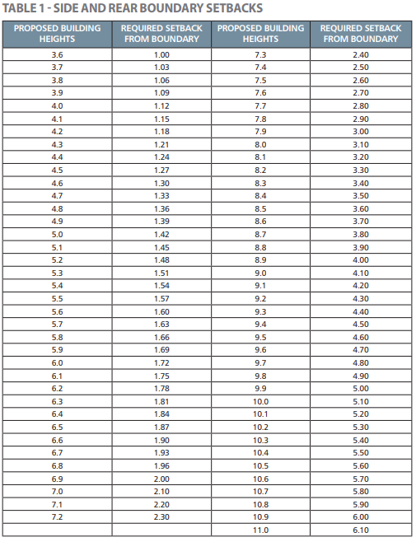 | 7 | Standard 7 does not apply to a wall of a building or a carport that complies with standard 8.  The envelope within which a building must be constructed is established by this regulation, as shown in diagram 11. The envelope established commences at a 1m setback from the side or rear boundary, allowing a 7.2m height at this point. The envelope established by standard 8 limits building heights including the roof structure, to 7.2m within 1.0m to a side or rear boundary.  Standards 7.2, 7.3 & 7.4 specify the allowable encroachments into the required setback and includes decks up to a maximum height of 800mm above natural ground level, which is not the case under the Building Regulations 2018. | Correction to spelling error.  Update to reference to standard.  Update to reference Building Regulations 2018.  Update reference to diagram.  Delete Table 1.
4c | 8 | This regulation applies to buildings that are built abutting a side or rear boundary or carports built on or within 1.0m of a side or rear boundary. If the requirements of this standard are not met then the building or carport must be setback a minimum of 1m from the side or rear boundary, in compliance with the setback requirements in standard 7. The walls of buildings cannot be 150mm from a side or rear boundary, as is the case with the current Building Regulations, but buildings must abutt a side or rear boundary. If it is proposed to construct a pitched roof off a boundary wall, the roof must be within the envelope shown on diagram 13 | 8 | This regulation applies to buildings that are built within 200mm or abutting a side or rear boundary or carports built on or within 1.0m of a side or rear boundary. If the requirements of this standard are not met then the building or carport must be setback a minimum of 1m from the side or rear boundary, in compliance with the setback requirements in standard 7. If it is proposed to construct a pitched roof off a boundary wall, the roof must be within the envelope shown on diagram 11.  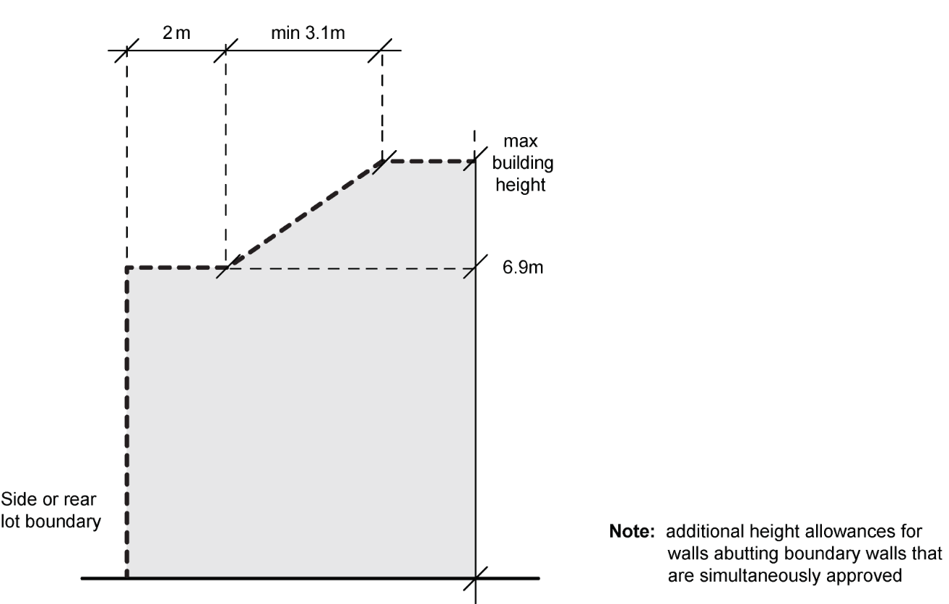 | Correction to spelling error.  Update reference to 200mm permitted in 2018 Building Regulations.  Update reference to diagram.
4a | 8(2) & (3) | The maximum height of a boundary wall or carport is 3.6m unless constructed adjacent to an existing or simultaneously constructed boundary wall or carport on the adjoining allotment, in which case the height difference can be up to 3.6m, provided the length does not exceed the length of the existing or simultaneously approved boundary wall or carport by more than 2m. (see diagram 14) There is otherwise no stated maximum length of a wall on a side boundary.  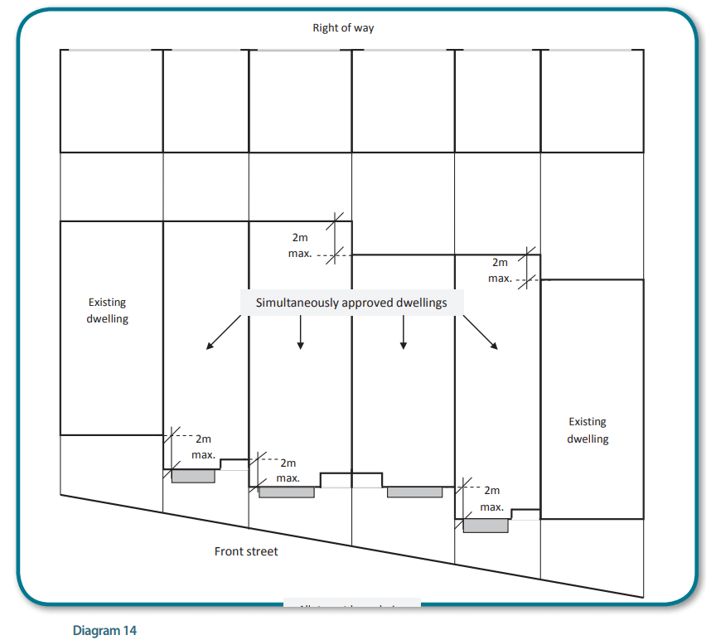  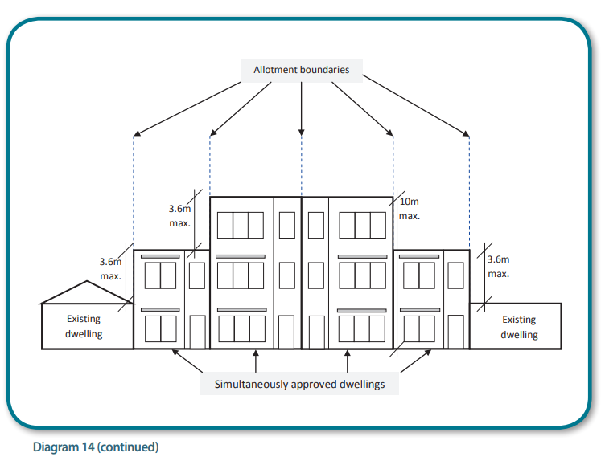 | 8.1 & 8.2 | The maximum height of a boundary wall or carport is 7.2m unless constructed adjacent to an existing or simultaneously constructed boundary wall or carport on the adjoining allotment, in which case the height difference can be up to 3.6m, provided the length does not exceed the length of the existing or simultaneously approved boundary wall or carport by more than 2m. (see diagram 12)  There is otherwise no stated maximum length of a wall on a side boundary.  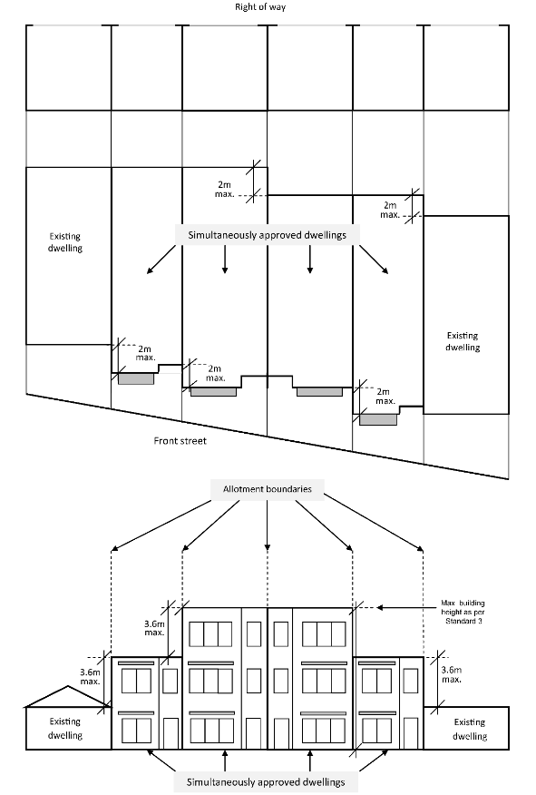 | Update reference to diagram.  Update to allow for two storey building to be built on boundary without the dwelling being simultaneously approved.
4c | 9 | There are no standards under this heading as all buildings constructed in accordance with the code provide their own light courts in accordance with Standard 13 and there are no requirements imposed on a house builder to increase setbacks on their property to provide daylight to neighbouring properties. This standard heading has been placed in the code for consistency with the Building Regulations 2006. | 9 | There are no standards under this heading as all buildings constructed in accordance with the code provide their own light courts in accordance with Standard 13 and there are no requirements imposed on a house builder to increase setbacks on their property to provide daylight to neighbouring properties. This standard heading has been placed in the code for consistency with the Building Regulations 2018. | Update to reference Building Regulations 2018.
4c | 10 | There are no standards under this heading as all buildings constructed in accordance with the code provide their own light courts in accordance with Standard 13 and if additional northern solar access is desired then this must be provide by the house builder without imposing increase setbacks on the neighbouring properties. This standard heading has been placed in the code for consistency with the Building Regulations 2006. | 10 | There are no standards under this heading as all buildings constructed in accordance with the code provide their own light courts in accordance with Standard 13 and if additional northern solar access is desired then this must be provided by the house builder without imposing increase setbacks on the neighbouring properties. This standard heading has been placed in the code for consistency with the Building Regulations 2018. | Correction to spelling error.  Update to reference Building Regulations 2018.
4b | 11 | The purpose of this standard is to ensure protection of overshadowing of adjoining allotments existing recreational private open space (RPOS) and links with the requirements of standard 14(3) in that a minimum 6m², with a minimum dimension of 2m, of the neighbors RPOS must have direct sunlight after determining the length of shadow.  The length of shadow cast by a wall or fence is calculated as 0.9 x the height of the wall when the sun is true north. (see diagram 15)  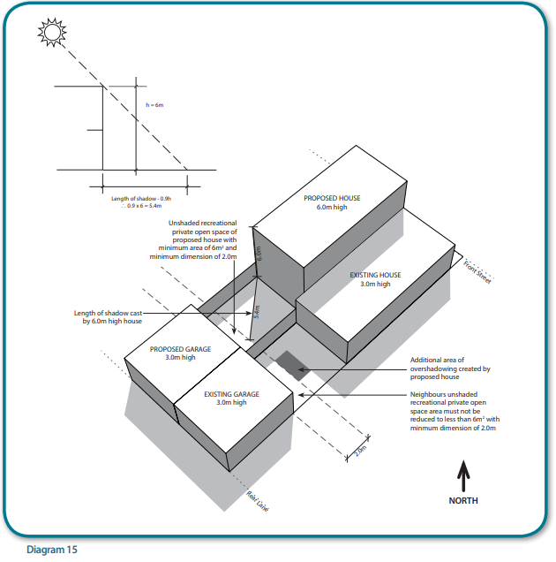  This requirement does not apply to RPOS provided as a balcony.  A simple single overshadowing diagram, with the shadow lengths being 0.9 x wall height, south of the building, need only be submitted.  The definition of RPOS includes the term “primarily intended for outdoor recreational activities”. It is anticipated that in most instances the RPOS of the adjoining allotment will be the same as the private open space as defined in the definitions except for clothesline areas, bin storage/compost areas, service areas, narrow access ways providing access to service areas, driveways and any area within the front setback. | 11 | The purpose of this standard is to ensure protection of overshadowing of adjoining allotments existing recreational private open space (RPOS) and links with the requirements of standard 14.2 in that a minimum 6m², with a minimum dimension of 2m, of the neighbours RPOS must have direct sunlight after determining the length of shadow.  The length of shadow cast by a wall or fence is calculated as 0.9 x the height of the wall when the sun is true north. (see diagram 13)  This requirement does not apply to RPOS provided as a balcony.  A simple single overshadowing diagram, with the shadow lengths being 0.9 x wall height, south of the building, need only be submitted. | Correction to spelling error.  Update to reference to standards.  Delete definition from standard.  Update reference to diagram.
4a  4d | 12 | This standard sets out setbacks, sill heights and/or screen provisions that will reduce the overlooking from habitable room windows or raised open space (ROS) areas. The windows affected must be in habitable rooms with a floor level more than 2.5m above natural ground level at the window location and the ROS areas (i.e. landings with an area of more than 2m², balconies, terraces, decks or patios) that have a floor level of more than 800mm above natural ground level. There are reductions in the boundary setback requirements for windows in habitable rooms or ROS areas that face lanes, footways, alleys or right of ways, with the measurements being taken from the middle of the abutting lane, footway, alley or right of way. There is no need for architects or draftspersons to produce overlooking diagrams under this regulation. Diagram 16 details some of the requirements of this standard.  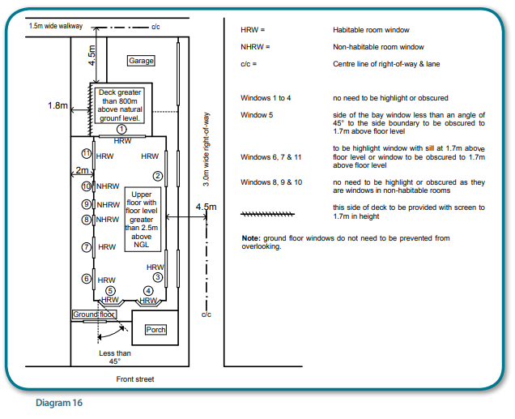 | 12 | This standard sets out setbacks, sill heights and/or screen provisions that will reduce the overlooking from habitable room windows or raised open space (ROS) areas. The windows affected must be in habitable rooms with a floor level more than 2.5m above natural ground level at the window location and the ROS areas (i.e. landings with an area of more than 2m², balconies, terraces, decks or patios) that have a floor level of more than 800mm above natural ground level.  There is no need for architects or draftspersons to produce overlooking diagrams under this regulation. Diagram 14 details some of the requirements of this standard.  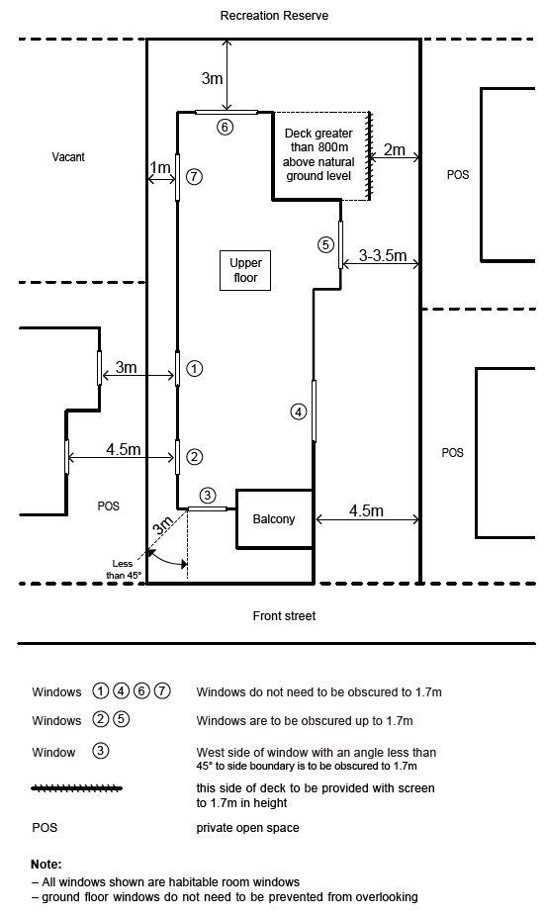 | Delete reference to measurement being taken from laneway.  Update reference to diagram.  Update diagram.
N/A | 13 | This standard ensures that all required habitable room windows receive adequate light without imposing any requirements or restrictions on the neighbouring properties. Diagram 17 details some of the requirements of this standard.  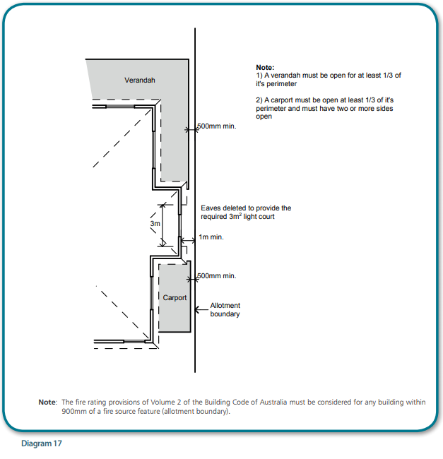 | 13 | This standard ensures that all required habitable room windows receive adequate light without imposing any requirements or restrictions on the neighbouring properties. Diagram 15 details some of the requirements of this standard. | Update reference to diagram.
4d | 14 | The area of private open space (POS) that needs to be provided on an allotment is determined by the number of bedrooms in the dwelling. A bedroom includes any room that is enclosed on all sides, that contains a window and is more than 6m2 in floor area. This means that enclosed rooms labeled study or library etc may need to be counted as a bedroom for the purposes of this standard.  POS can be at ground level, on a balcony or at roof top level. (see diagram 18).  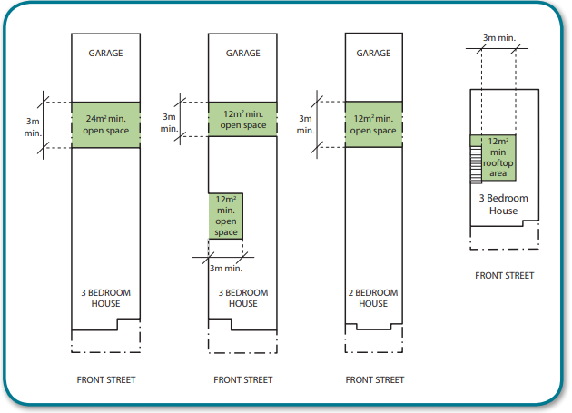  If POS is provided at the side or rear of the dwelling or as a roof top area it must have a minimum area of 6m², with a minimum dimension of 2m, that receives direct sunlight at noon on the equinox. To determine if the POS receives or does not receive direct sunlight, the length of shadow cast by a wall or fence in calculated as 0.9 x the height of the wall when the sun is true north as shown in diagram 19.  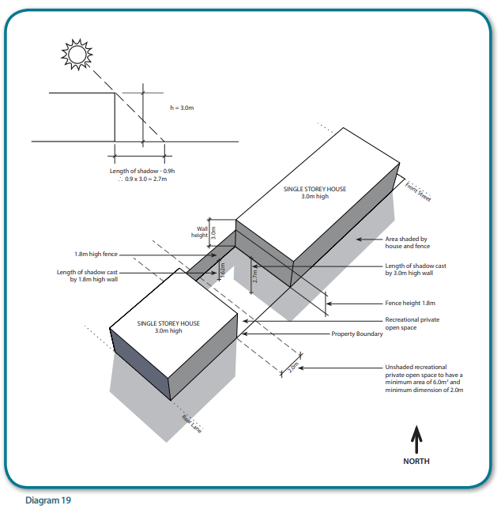 | 14 | The area of private open space (POS) that needs to be provided on an allotment is determined by the number of bedrooms in the dwelling. A bedroom includes any room that is enclosed on all sides, that contains a window and is more than 6m2 in floor area. This means that enclosed rooms labelled study or library etc may need to be counted as a bedroom for the purposes of this standard.  POS can be at ground level, on a balcony or at roof top level. (see diagram 16).  If POS is provided at the side or rear of the dwelling or as a roof top area it must have a minimum area of 6m², with a minimum dimension of 2m, that receives direct sunlight at noon on the equinox. To determine if the POS receives or does not receive direct sunlight, the length of shadow cast by a wall or fence is calculated as 0.9 x the height of the wall when the sun is true north as shown in diagram 17.  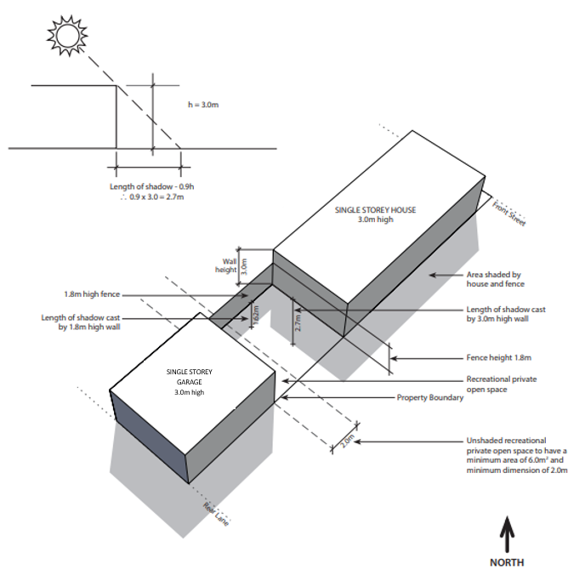 | Correction to spelling error.  Update reference to diagram.  Update diagram 19.
Part 2 Class 10B Buildings
4c | Part 2 Class 1B Buildings | The standards in this Part apply to front and other fences constructed on allotments within the Urban Growth Zone. There are no other siting standard applicable for other Class 10b buildings such as swimming pools, spas, masts, poles etc. The height provisions of regulation 431 of the Building Regulation 2006 apply in respect of masts, poles, aerials, antennae, chimneys, flues, pipes or other services. | Part 2 Class 10b Buildings | The standards in this Part apply to front and other fences constructed on allotments within the Urban Growth Zone. There are no other siting standard applicable for other Class 10b buildings such as swimming pools, spas, masts, poles etc. The height provisions of regulation 431 of the Building Regulation 2018 apply in respect of masts, poles, aerials, antennae, chimneys, flues, pipes or other services. | Update to reference Building Regulations 2018.
N/A | 15 | This standard applies to fences within 3m of the front street alignment with the maximum height and type of fence permitted depending on the street classification. | 15 | This standard applies to fences within 3m of the front street alignment with the maximum height and type of fence permitted depending on the street classification. | No change.
N/A | 15(1) | The maximum height of a front fence within 3m to a declared road is 2m whereas the maximum height of a front fence within 3m to a non-declared road is 1.2m. | 15.1 | The maximum height of a front fence within 3m to a declared road is 2m whereas the maximum height of a front fence within 3m to a non-declared road is 1.2m. | No change.
4d | 15(2) | A front fence within 3m to a non-declared road, if higher than 700mm, must have that part of the fence higher than 700mm no more than 85% open. (see diagram 20)  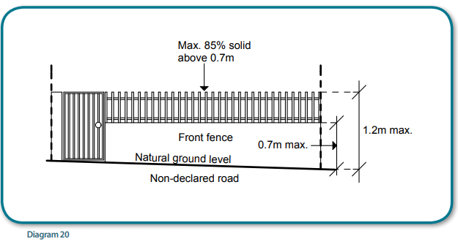 | 15.2 | A front fence within 3m to a non-declared road, if higher than 700mm, must have that part of the fence higher than 700mm be at least 15 percent transparent. (see diagram 18)  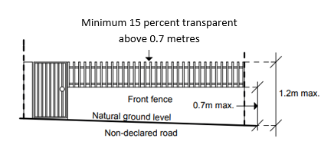 | Update reference to diagram.  Update diagram 20.
4d | 16 | The maximum height of any fence not on a side or rear boundary is 2.5m but if the fence is higher than 2m, the section of fence that is greater than 2m must have at least 25% of its area open. (see diagram 21)  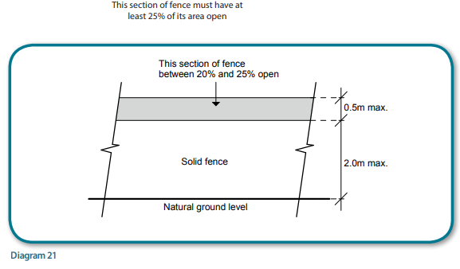 | 16 | The maximum height of any fence not on a side or rear boundary is 2.5m but if the fence is higher than 2m, the section of fence that is greater than 2m must be at least 25% transparent. (see diagram 19)  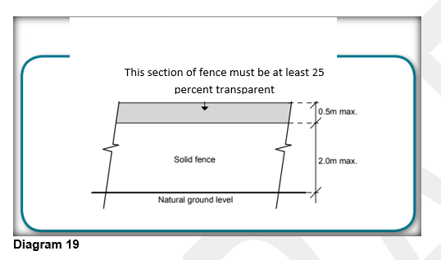 | Update reference to diagram.  Update diagram 21.  Update wording in standard to align with Victoria Planning Provisions.
N/A | 17 | The maximum height of any fence on or within 150mm of a side or rear boundary that is not of a boundary adjacent to a side or rear street, is 2.5m, but if the fence is higher than 2m, the section of fence that is greater than 2m have at least 25% of its area open. Fences on side or rear lanes, footways, alleys or right of ways can be 2.5 m high provided the section of fence that is greater than 2m in height has at least 25% of its area open. (see diagram 21). | 17 | The maximum height of any fence on or within 150mm of a side or rear boundary is 2.5m, but if the fence is higher than 2m, the section of fence that is greater than 2m must be at least 25% transparent. (see diagram 18). | Updated to reflect new standards.
4a | N/A | N/A | 18 | Fences forward of the front wall must comply with the height and transparency requirements of standards 15.1 and 15.2 | New Standard.
4d | 18 | his standard applies to fences within 3m to a point of intersection of street alignments on corner allotments and fences on a side street and rear streets. (see diagram 22). Note that “street” in this standard do not include lanes, footways, alleys or right of ways so the fence within 3m to the intersection of the side street and the rear lane not limited to the maximum height.  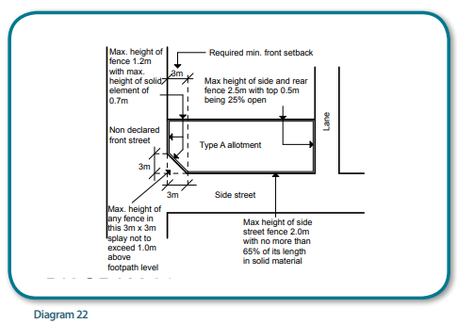  The height of the fence within 3m of the point of intersection is measured above footpath level whereas all other fence heights are measured above natural ground level. The standard also prohibits barbed wire fences or fences with sharp protrusions being adjacent to street alignments or boundaries onto public open space areas. | 19 | This standard applies to fences within 3m to a point of intersection of street alignments on corner allotments and fences on a side street and rear streets. (see diagram 20). Note that “street” in this standard does not include lanes, footways, alleys or right of ways so the fence within 3m to the intersection of the side street and the rear lane are not limited to the maximum height.  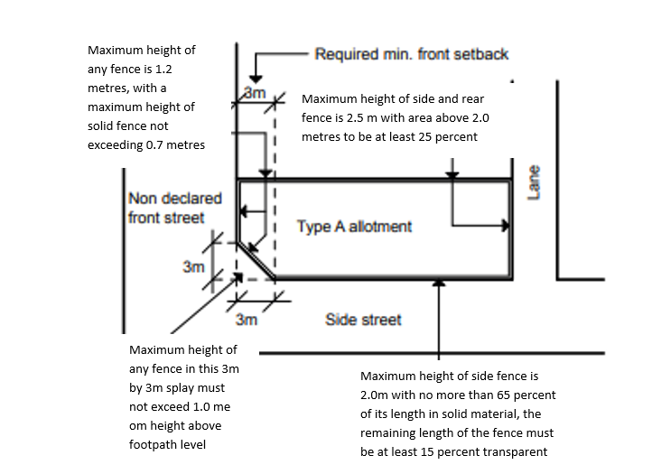  The height of the fence within 3m of the point of intersection is measured above footpath level whereas all other fence heights are measured above natural ground level. The standard also prohibits barbed wire fences or fences with sharp protrusions being adjacent to street alignments or boundaries onto public open space areas. | Update reference to diagram.  Update wording in diagram.
N/A | 19, 20, 21 | There are no requirements specified for these three standards as the maximum height of a fence is 2.5m, with the section of fence that is greater than 2m in height being 25% open. It is considered that such fences would not affect the amenity on adjoining habitable room windows or RPOS areas. These standards are included in the code for consistency with the Building Regulations. | 20, 21, 22 | There are no requirements specified for these three standards as the maximum height of a fence is 2.5m, with the section of fence that is greater than 2m in height being 25% open. It is considered that such fences would not affect the amenity on adjoining habitable room windows or RPOS areas. These standards are included in the code for consistency with the Building Regulations. | No change

