Planning and Environment Act 1987
MITCHELL PLANNING SCHEME
WHITTLESEA PLANNING SCHEME
AMENDMENT GC102
EXPLANATORY REPORT
Who is the planning authority?
This amendment has been prepared by the Victorian Planning Authority, which is the planning authority for this amendment.
The amendment has been made at the request of the Victorian Planning Authority.
Land affected by the amendment
The amendment applies to land within the boundaries of the Donnybrook-Woodstock (Whittlesea City and Mitchell Shire) Precinct Structure Plan, as depicted in Figure 1 below:
Figure 1: GC102 amendment area
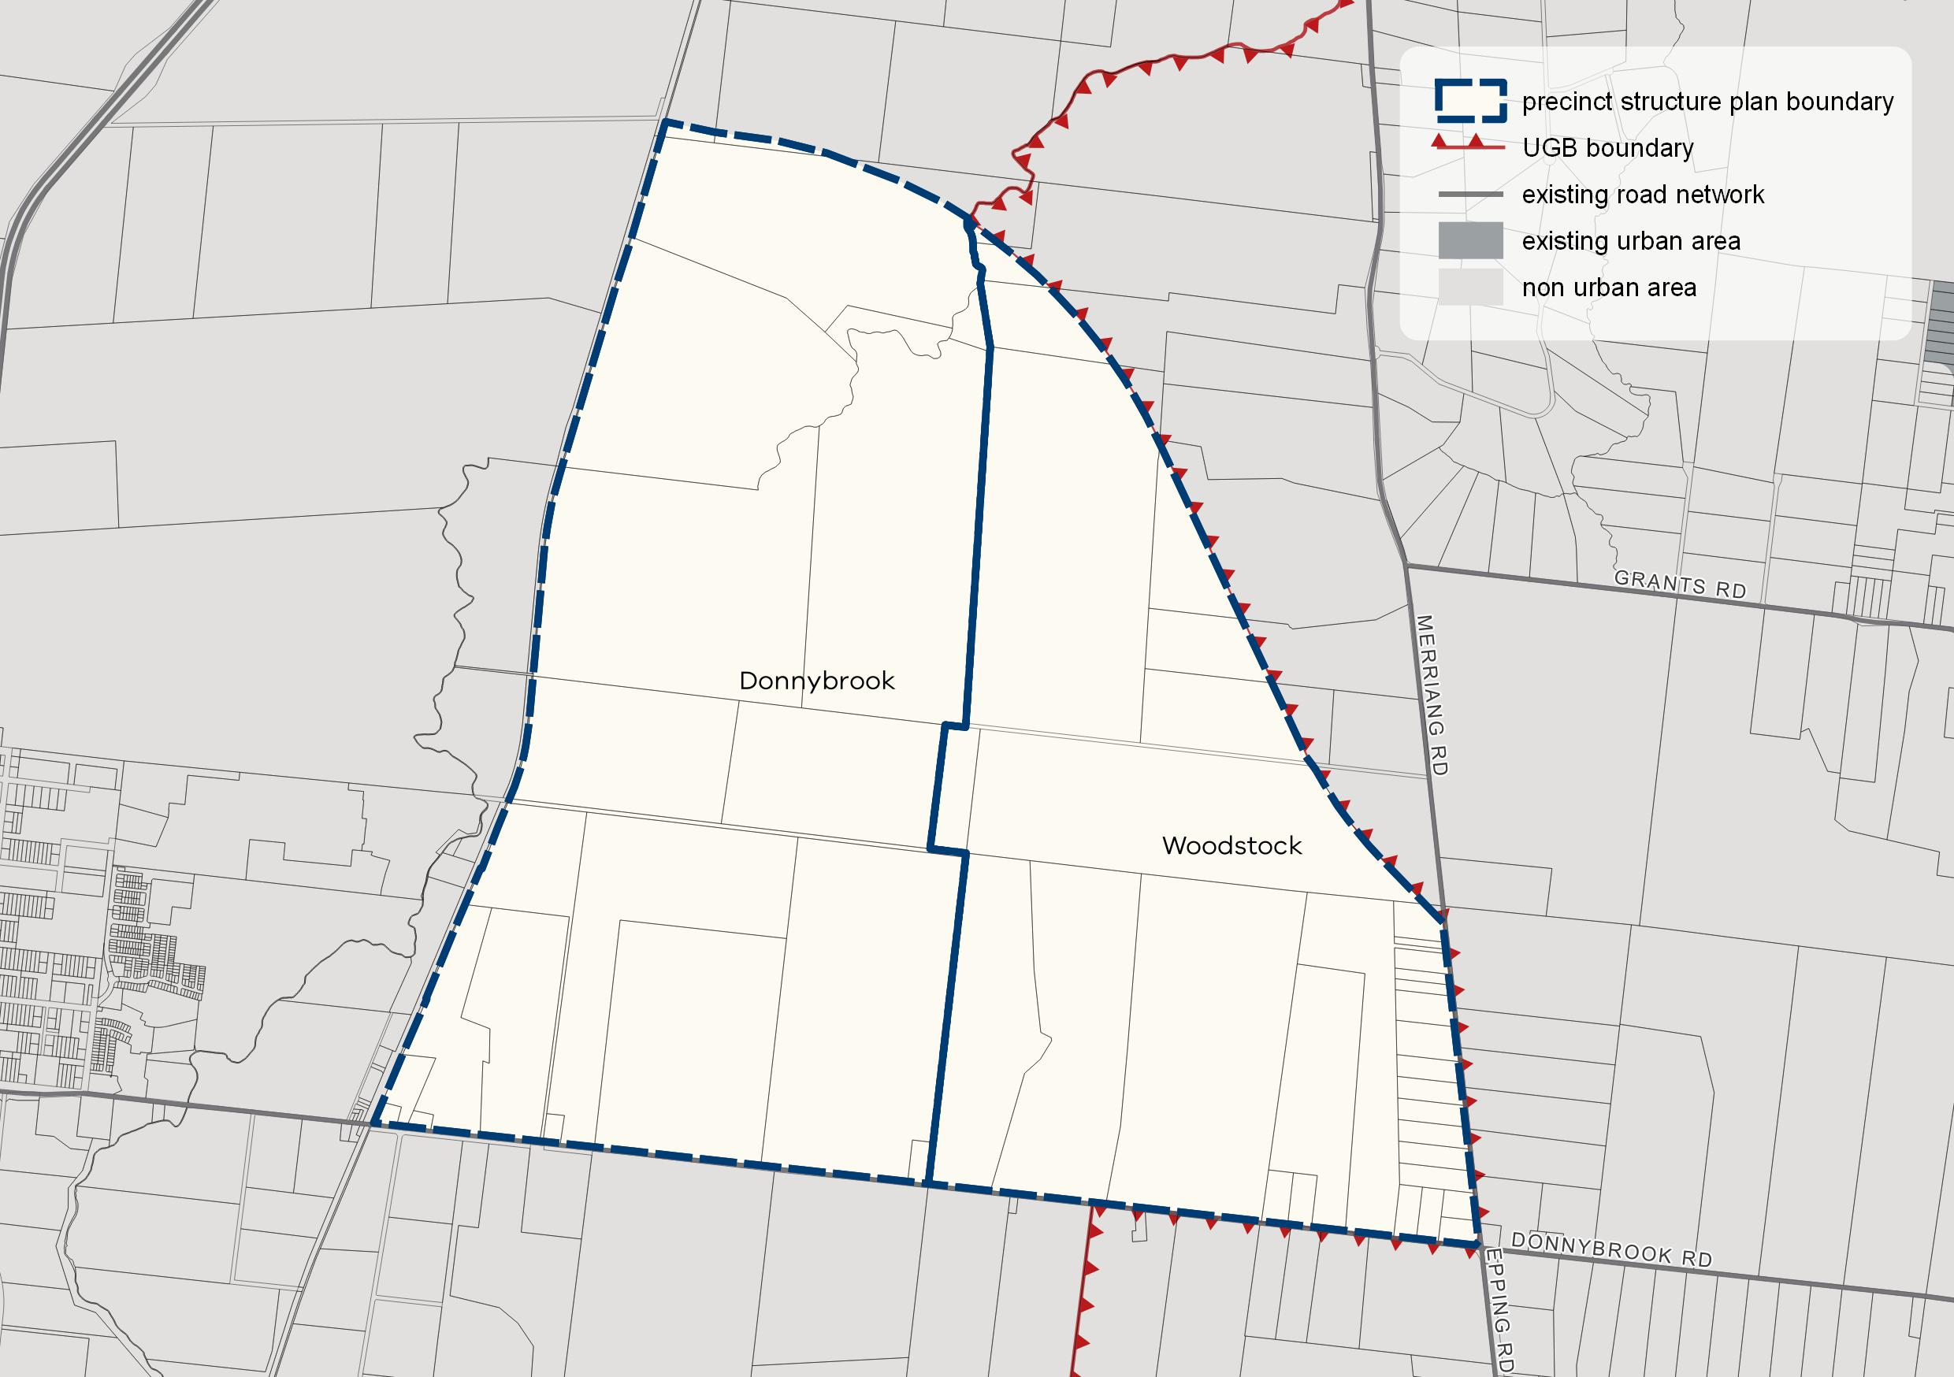

What the amendment does
The amendment makes changes to the Mitchell and Whittlesea planning schemes to update the Donnybrook-Woodstock Infrastructure Contributions Plan (ICP) to comply with recent changes to planning legislation. This ICP will replace the incorporated ‘interim’ ICP with an updated ICP and apply it to land affected by the Donnybrook-Woodstock Precinct Structure Plan (PSP).
More specifically:
The amendment proposes the following changes to the Mitchell Planning Scheme:
- Amend Schedule 1 to Clause 45.11 Infrastructure Contributions Overlay (ICO1) to update the monetary component and levy rate payable within the amendment area.
- Amend the Schedule to Clause 72.04 to delete the incorporated document titled Donnybrook-Woodstock Infrastructure Contributions Plan, July 2018 and include a new incorporated document titled Donnybrook-Woodstock Infrastructure Contributions Plan, August 2018.
The amendment proposes the following changes to the Whittlesea Planning Scheme:
- Amend Schedule 1 to Clause 45.11 Infrastructure Contributions Overlay (ICO1) to update the monetary component and levy rate payable within the amendment area.
- Amend the Schedule to Clause 72.04 to delete the incorporated document titled Donnybrook-Woodstock Infrastructure Contributions Plan, July 2018 and include a new incorporated document titled Donnybrook-Woodstock Infrastructure Contributions Plan, August 2018.
Strategic assessment of the amendment
Why is the amendment required?
This amendment incorporates a supplementary levy ICP which will be applied to the Donnybrook-Woodstock precinct structure plan area by inserting Clause 45.11 – Infrastructure Contributions Overlay and Schedule 1 to this overlay (ICO1).
On 2 July 2018, the Planning & Environment Amendment (Public Land Contributions) Act 2018 came into effect. This Act introduced a new land contribution model for the provision of infrastructure through ICPs, and consequently the Donnybrook-Woodstock Metropolitan Greenfield Growth Area Standard Levy Infrastructure Contributions Plan, August 2017, incorporated into the Mitchell and Whittlesea Planning Schemes via Amendment GC61, could no longer have any effect. An ‘interim’ ICP was approved under section 20(4) of the Act to ensure that, following legislative changes, collecting agencies are able to lawfully collect infrastructure contributions from land owners. A final ICP has now been prepared and is the subject of this amendment.
The changes to the legislation regarding the land contribution model and associated changes to levy amounts has meant that transport costs would not be fully covered under a standard levy, therefore triggering the need for a supplementary levy. All supplementary levies must undergo a full planning scheme amendment process.
The ICP is necessary to deliver all the infrastructure items required within the Donnybrook-Woodstock precinct. Specifically, the supplementary levy component is included to cover the costs of construction of supplementary ICP transport items.
The ICP provides timeframes (short 0-5 years, medium 10-15 years and long term 15 years onwards) for the delivery of ICP funded infrastructure projects. The timeframes have been updated since the gazettal of the Donnybrook-Woodstock PSP to better reflect the projected urban development growth fronts within the precincts.
How does the amendment implement the objectives of planning in Victoria?
The amendment will implement an infrastructure contributions scheme to fund community and development infrastructure to service the future urban land within the approved PSP, which is within the Urban Growth Boundary of Metropolitan Melbourne.
It will implement applicable objectives of planning in Victoria under section 4 of the Planning and Environment Act 1987 (Act) through the implementation of a contributions collection scheme to facilitate the delivery of infrastructure to service the approved precinct structure plan.
The amendment applies the necessary planning controls to implement the ICP, which will provide a clear structure of contributions required to fund development and community infrastructure within the precincts for residential and commercial development and will ensure the fair and equitable provision of community and development infrastructure.
How does the amendment address any environmental, social and economic effects?
Environmental effects
The amendment does not result in environmental impacts as it seeks to introduce mechanisms to allow the responsible authority to collect financial contributions towards infrastructure required for the PSP area.
The infrastructure required and its environmental impacts were considered as part of Amendment GC28, which introduced the PSP into the Whittlesea and Mitchell Planning Schemes.
Economic effects
This amendment applies an ICP for the PSP area, which identifies the financial levy required to be paid by developers to fund the infrastructure required for the precinct, and thus sets out an equitable and transparent means of collecting financial contributions towards servicing the future community. This reduces the burden on the responsible authority and existing communities to fund future local infrastructure.
Social effects
The approved PSP identifies the infrastructure necessary to service the future communities, including sports and community facilities, road and trail upgrades and parks. The new infrastructure items will ensure that new residents do not place an unfair burden on existing community assets in the area. The infrastructure will maximise opportunities for new residents to safely and efficiently access employment and everyday services, including shopping and engaging in locally based social activities.
Does the amendment address relevant bushfire risk?
The amendment does not impact upon bushfire risk.
Does the amendment comply with the requirements of any Minister’s Direction applicable to the amendment?
The amendment complies with the Ministerial Direction on the Form and Content of Planning Schemes under section 7(5) of the Act. The amendment also complies with the following relevant Ministerial Directions:
Direction No. 9 - Metropolitan Strategy
Direction 9 has been considered in preparing this amendment and it complies with this direction.
The amendment will facilitate the collection of developer levies to fund the required infrastructure to service the future urban land within the Urban Growth Boundary (UGB).
Direction No. 11 - Strategic Assessment of Amendments
This direction seeks to ensure a comprehensive strategic evaluation of a planning scheme amendment. This report addresses the requirements outlined in this direction.
Direction No. 12 - Urban Growth Areas
This Direction is not applicable as this amendment does not seek to introduce or change the schedules to the Urban Growth Zone (UGZ).
Ministerial Direction on the Preparation and Content of Infrastructure Contributions Plans and Ministerial Reporting Requirements for Infrastructure Contributions Plans
The Planning & Environment Amendment (Public Land Contributions) Act 2018 introduced a land contribution model for the ICP system. The land contribution model enables land for public purposes to be provided as part of an infrastructure contribution when land is developed. It changes the way land is acquired for public purposes: instead of requiring a monetary levy it will require a percentage, similar to the operation of Clause 52.01 of the Planning Scheme.
The ICP system came into effect on 2 July 2018. The system is based on standard levies that are pre-set for particular development and land uses in order to fund the construction of basic and essential infrastructure to service the growing urban communities. This system also allows for a supplementary levy, in addition to the standard levy, if required to fund infrastructure that cannot be adequately funded by the standard levy.
This direction guides planning authorities in relation to the preparation and content of developer contributions.
This amendment proposes to amend the Infrastructure Contributions Overlay schedule to update the monetary component and levy rate payable within the amendment area. The overlay reflects the Planning & Environment Amendment (Public Land Contributions) Act 2018 model for collection of infrastructure contributions.
The presently incorporated Donnybrook-Woodstock ‘interim’ ICP sets out funding of infrastructure works for the precinct. The proposed ICP will continue to levy a certain amount from developers in the precincts with the balance of funding being the responsibility of the council and other state agencies, as well as directly funded by developers through developer works. The PSP provides the strategic justification for the ICP items.
How does the amendment support or implement the State Planning Policy Framework and any adopted State policy?
This amendment is consistent with Clause 19 – Infrastructure of the State Planning Policy Framework as it will implement mechanisms to collect developer contributions to fund infrastructure throughout the PSP.
How does the amendment support or implement the Local Planning Policy Framework, and specifically the Municipal Strategic Statement?
The amendment will ensure developers contribute to the necessary infrastructure for the precincts, which have considered the Local Planning Policy Framework of each planning scheme during the preparation of the PSP.
Does the amendment make proper use of the Victoria Planning Provisions?
Yes, the ICO is the appropriate mechanism for incorporating the ICP in the Whittlesea and Mitchell Planning Schemes.
How does the amendment address the views of any relevant agency?
The ICP affects land that is subject to an incorporated PSP. Each PSP was subject to an extensive consultation processes, including formal exhibition and panel hearings, to identity infrastructure items to be funded. All relevant agencies, including Whittlesea City Council and Mitchell Shire Council, have been involved in the development of the PSP and the infrastructure items specified in the ICP reflect those identified in the incorporated PSP.
Does the amendment address relevant requirements of the Transport Integration Act 2010?
The amendment implements mechanisms to collect financial developer levies to fund essential transport infrastructure that are identified in the Donnybrook-Woodstock precinct.

Resource and administrative costs
- What impact will the new planning provisions have on the resource and administrative costs of the responsible authority?
The amendment will assist the responsible authorities (each council) as it ensures the collection of infrastructure contributions by developers to fund necessary infrastructure to be delivered by the responsible authorities.

Where you may inspect this amendment.
The amendment is available for public inspection, free of charge, during office hours at the following places:

Victorian Planning Authority
Level 25
35 Collins Street
Melbourne 3000
www.vpa.vic.gov.au
Whittlesea City Council  25 Ferres Boulevard  South Morang 3752  www.whittlesea.vic.gov.au | Mitchell Shire Council  113 High Street  Broadford 3658  www.mitchellshire.vic.gov.au

The amendment can also be inspected free of charge at the Department of Environment, Land, Water and Planning website at www.delwp.vic.gov.au/public-inspection.

Submissions
Any person who may be affected by the amendment may make a submission to the planning authority. Submissions about the amendment must be received by 14 September 2018.
A submission referencing Mitchell and Whittlesea Amendment GC102 must be sent to:

Victorian Planning Authority
Level 25,
35 Collins Street
Melbourne VIC 3000

Or via email: amendments@vpa.vic.gov.au

Panel hearing dates
In accordance with clause 4(2) of Ministerial Direction No.15 the following panel hearing dates have been set for this amendment:
- Directions hearing: Week commencing 3 December 2018
- Panel hearing: Week commencing 4 February 2019

