SCHEDULE 1 TO THE URBAN GROWTH ZONE

**DD/MM/YYYY**

**Proposed C118**

Shown on the planning scheme map as **UGZ1**

Shepparton North East Precinct Structure Plan

1. The Plan

**DD/MM/YYYY**

**Proposed C118**

Plan 1 shows the future urban structure proposed in the *Shepparton North East Precinct Structure Plan*.

Plan 1 to Schedule 1 to Clause 37.07

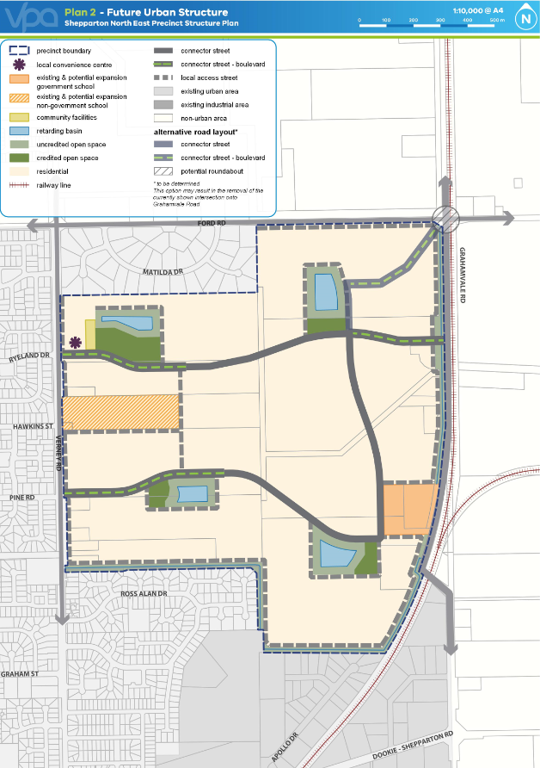

2.0 Use and development

2.1 The land

**DD/MM/YYYY**

**Proposed C118**

The use and development provisions specified in this schedule apply to the land as shown within the ‘precinct boundary’ on Plan 1 of this schedule and shown as UGZ1 on the planning scheme maps.

Note: If land shown on Plan 1 is not zoned UGZ, the provisions of this zone do not apply.

2.2 Applied zone provisions

**DD/MM/YYYY**

**Proposed C118**

Table 1 allocates the land use/development shown on Plan 1 of this schedule with a corresponding zone from this scheme.

Where the use/development in the left column is carried out or proposed generally in accordance with the incorporated *Shepparton North East Precinct Structure Plan*, the use, subdivision, construction of a building and construction and carrying out of works provisions of the corresponding zone in the right column apply.

A reference to a planning scheme zone in an applied zone must be read as if it were a reference to an applied zone under this schedule.

Note: e.g. The Commercial 2 Zone specifies ‘Shop’ as a Section 1 Use with the condition, ‘The site must adjoin, or have access to, a road in a Road Zone.’ In this instance the condition should be read as, ‘The site must adjoin, or have access to, a road in a Road Zone or an applied Road Zone in the Urban Growth Zone schedule applying to the land’

**Table 1: Applied zone provisions**

|  |  |
| --- | --- |
| Local convenience centre | Clause 34.01 – Commercial 1 Zone |
| All other land | Clause 32.08 – General Residential Zone |

2.3 Specific provisions – Use of land

**DD/MM/YYYY**

**Proposed C118**

Section 1 - Permit not required

|  |  |
| --- | --- |
| Use | Condition |
| Primary school | A permit is not required to use land for a Primary school on land shown as existing and potential expansion non-government school. |
| Secondary school | A permit is not required to use land for a secondary school on land shown as existing and potential expansion non-government school. |
| Shop – where the applied zone is Commercial 1 Zone | The combined leasable floor area of all shops must not exceed 2,000 square metres. |
| Any use listed in Clause 62.01 | Must meet the requirements of Clause 62.01. |

Section 2 - Permit required

|  |  |
| --- | --- |
| Use | Condition |
|  |  |
| None specified |  |

Section 3 – Prohibited

| Use | |
| --- | --- |
| **None specified** |  |

2.4 Specific provisions – Subdivision

**DD/MM/YYYY**

**Proposed C118**

None specified.

2.5 Specific provisions – Buildings and works

**DD/MM/YYYY**

**Proposed C118**

Buildings and works for future local parks and community facilities

A permit is not required to develop land shown in the *Shepparton North East Precinct Structure Plan* as a local park or community facility provided the development is carried out generally in accordance with the *Shepparton North East Precinct Structure Plan* and with the prior written consent of the responsible authority. Buildings and works for a non-government school

A permit is required to construct a building or construct or carry out works associated with a primary and/or secondary school on land shown as an existing and potential expansion of non-government schools unless exempt under Clauses 62.02-1 and 62.02-2.

3.0 Application requirements

**DD/MM/YYYY**

**Proposed C118**

If in the opinion of the responsible authority an application requirement listed below is not relevant to the assessment of an application, the responsible authority may waive or reduce the requirement.

Subdivision - residential development

In addition to any requirement in 56.01-2, a subdivision design response must include:

* A land budget table in the same format and methodology as those within the precinct structure plan applying to the land, setting out the amount of land allocated to the proposed uses and expected population and dwelling yields.
* A demonstration of how the subdivision will contribute to the delivery of a diversity of housing.
  + A demonstration of how the subdivision will contribute to the achievement of the residential density outcomes in the *Shepparton North East Precinct Structure Plan* applying to the land.
  + A plan that demonstrates how the local street and movement network integrates, or is capable of integrating, with existing or likely development of adjacent land parcels.

Precinct Infrastructure Plan

An application must be accompanied by a Public Infrastructure Plan which includes:

* + a stormwater management strategy that makes provision for the staging and timing of stormwater drainage works, including temporary outfall provisions, to the satisfaction of the relevant water authority;
  + what land may be affected or required for the provision of infrastructure works;
  + the provision, staging and timing of stormwater drainage works;
  + the provision, staging and timing of road works internal and external to the land consistent with any relevant traffic report or assessment;
  + the landscaping of any land;
  + what if any infrastructure set out in the *Shepparton North East* *Development Contributions Plan* is proposed as "works in lieu";
  + the provision of public open space and land for any community facilities;
  + any other matter relevant to the provision of public infrastructure required by the responsible authority.

Traffic Impact Assessment

An application that proposes to create or change access to a primary (Road Zone, Category 1) or secondary (Road Zone, Category 2) arterial road must be accompanied by a Traffic Impact Assessment Report (TIAR). The TIAR, including functional layout plans and a feasibility / concept road safety audit, must be to the satisfaction of Roads Corporation or the responsible authority, as required.

Subdivide, use or develop land for a sensitive purpose - Environmental Site Assessment

An application to subdivide, use, or develop land for a sensitive use (residential use, child care centre, pre-school centre or primary school) must be accompanied by an environmental site assessment of the land by a suitably qualified environmental professional to the satisfaction of the responsible authority which takes into account the ‘*Shepparton North East Growth Area – Environmental Site Assessment – ENSR Australia Pty Ltd., 21 October 2008*’ and provides information including:

* + Further detailed assessment of potential contaminants on the relevant land.
  + Clear advice on whether the environmental condition of the land is suitable for the proposed use/s and whether an environmental audit of all, or part, of the land is recommended having regard to the *Potentially Contaminated Land General Practice Note June 2005, Department of Sustainability and Environment*.
  + Further detailed assessment of surface and subsurface water conditions and geotechnical characteristics on the relevant land and the potential impacts on the proposed development including any measures required to mitigate the impacts of groundwater conditions and geology on the development and the impact of the development on surface and subsurface water.
  + Recommended remediation actions for any potentially contaminated land.

**Supermarket use**

An application to use land for a supermarket must be accompanied by an assessment of any likely impact on existing or proposed activity centres and a response to the other criteria at Appendix A of the *Greater Shepparton Commercial Activity Centres Strategy, November, 2015*.

1. Conditions and requirements for permits

**DD/MM/YYYY**

**Proposed C118**

Land required for community facilities

A permit for subdivision or buildings and works, where land is required for community facilities, public open space or road widening, must include the following conditions:

* The costs associated with effecting the transfer or vesting of land required for community facilities, public open space or road widening must be borne by the transferor.
* Land required for community facilities, public open space or road widening must be transferred to or vested in the relevant public agency with any designation (e.g. road, reserve or lot) nominated by the relevant agency.

Public transport

Unless otherwise agreed by the Head, Transport for Victoria, prior to the issue of Statement of Compliance for any subdivision stage, bus stop hard stands with direct and safe pedestrian access to a pedestrian path must be constructed:

* + In accordance with the Public Transport Guidelines for Land Use and Development; and compliant with the Disability Discrimination Act – Disability Standards for Accessible Public Transport 2002.
  + At locations approved by the Head, Transport for Victoria, at no cost to the Head, Transport for Victoria, and to the satisfaction of the Head, Transport for Victoria.

Road network

Any permit for subdivision or building and works must contain the following condition:

Prior to the certification of a plan of subdivision, the plan of subdivision must show the land affected by the widening of the road reserve which is required to provide road widening and/or right of way flaring for the ultimate design of any adjacent intersection.

Land required for road widening including right of way flaring for the ultimate design of any intersection within an existing or proposed arterial road must be transferred to or vested in council at no cost to the acquiring agency unless funded by the *Shepparton North East Infrastructure Contributions Plan*.

Precinct Infrastructure Plan

Any permit for subdivision must contain the following condition:

Prior to the certification of a plan of subdivision or at such other time which is agreed between Council and the owner, if required by the responsible authority or the owner, the owner must enter into an agreement or agreements under Section 173 of the *Planning and Environment Act 1987* which provides for:

* The implementation of the Public Infrastructure Plan approved under this permit.
* The purchase and/or reimbursement by the responsible authority for any provision of public open space in excess of the amount specified in the schedule to Clause 52.01.
* The timing of any payments to be made to the owner having regard to the availability of funds in the open space account.

**Management of bushfire risk during subdivisional works**

A permit for subdivision that contains a condition requiring a construction management or site management plan must ensure that the relevant plan addresses any potential bushfire risks arising from the land during construction and must include a statement from a suitably qualified professional that the proposed bushfire risk management measures are appropriate.

Environmental Site Assessment

Any permit for the subdivision, use, and/or development of land for a sensitive use (residential use, child care centre, pre-school centre or primary school) for a site that has been identified as contaminated land in the ‘*Shepparton North East Growth Area – Environmental Site Assessment – ENSR Australia Pty Ltd., 21 October 2008*’ must contain the following conditions:

* Before the commencement of the development of the land, the recommendations of the Environmental Site Assessment submitted with the application must be carried out to the satisfaction of the responsible authority.
* Upon receipt of the further testing report the owner must comply with any further requirements made by the responsible authority after having regard to the guidance set out in the *General Practice Note on Potentially Contaminated Land June 2005* (DSE).

**5.0 Exemption from notice and review not to apply to certain applications**

**DD/MM/YYYY**

**Proposed C118**

None specified.

6.0 Decision Guidelines

**DD/MM/YYYY**

**Proposed C118**

None specified.

7.0 Advertising signs

**DD/MM/YYYY**

**Proposed C118**

Advertising sign requirements are at Clause 52.05. The advertising sign category for the land is the category specified in the zone applied to the land at Clause 2.2 of this schedule. All other land is in Category 3.