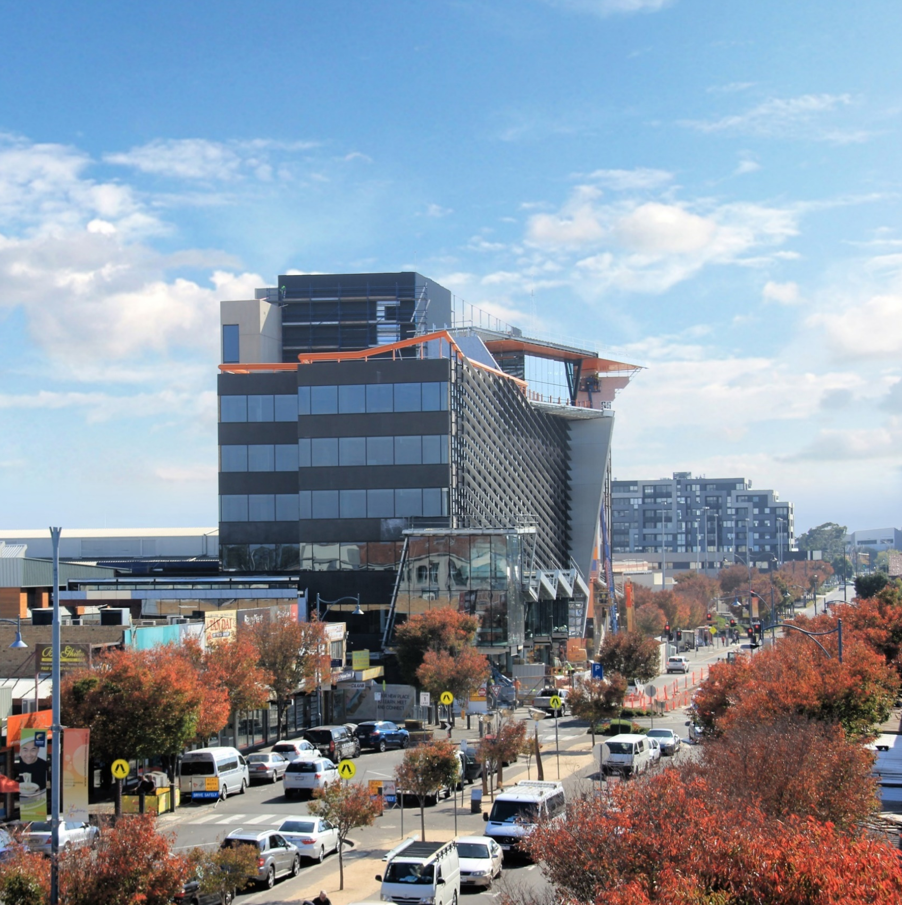
Public Engagement Outcomes
Sunshine National Employment
and Innovation Cluster
November 2017
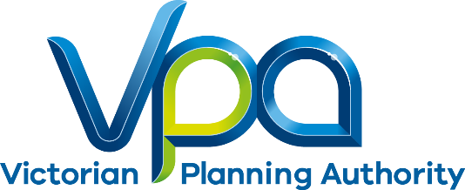

CONTENTS
1 EXECUTIVE SUMMARY 3
2 INTRODUCTION 4
3 ENGAGEMENT APPROACH 5
4 ENGAGEMENT PROGRAM AND ACTIVITIES 5
5 FEEDBACK & OUTCOMES 6
6 PROCESS AND NEXT STEPS 7

EXECUTIVE SUMMARY

Phase 2 of public engagement for the Sunshine National Employment and Innovation Cluster (NEIC) Framework Plan has been completed. In the first phase, the VPA, with support from Brimbank City Council, sought to test preliminary ideas that were used to help formulate the future land use, development and infrastructure planning for the Sunshine NEIC.
In the second phase, the VPA used the feedback from Phase 1 to draft the Sunshine NEIC Framework Plan. The framework plan was then consulted on during Phase 2.
This report summarises the activities undertaken, the feedback and how the input will be used in shaping the content and directions for the project.
Feedback was gathered using written submissions, focus groups and stakeholder conversations.
Generally, the Sunshine NEIC Framework Plan aligns with feedback raised by submitters from the Cluster’s residential, worker and business communities.
In summary, we have identified the following issues as most important to respondents:
      - Greater focus on innovation and the importance of facilitating strong linkages between industry and education, and investment that enhances the agglomeration benefits of an education, health and research cluster;
      - Improving education options through encouragement of a new private school to set up in the Cluster by 2050;
      - Site specific issues around zoning that will be addressed through future strategic projects;
      - Increasing investment in roads and public transport; and
      - Creating a more environmentally sustainable cluster and encouraging Environmentally Sustainable Design in new buildings.

INTRODUCTION

As outlined in Plan Melbourne, Melbourne’s population is set to increase to a city of 7.9 million people by 2051. To accommodate this growth, an additional 1.6 million dwellings and 1.5 million new jobs will need to be created. Growth of this scale requires long-term planning and management to sustain residents’ quality of life and Melbourne's status as one of the most liveable cities in the world. The VPA's role is facilitating the required land supply and identifying opportunities to increase housing, employment and investment within the state.

Preparing framework plans for the National Employment and Innovation Clusters is an action in Plan Melbourne aimed at growing employment opportunities.

Phase 1 of public engagement for the Sunshine NEIC Framework Plan was completed in July 2016. It was the first phase to test preliminary ideas and help formulate the future land use, development and infrastructure planning for the Sunshine Cluster.

The feedback was used to draft the Sunshine NEIC Framework Plan which was consulted on in Phase 2 of public engagement. Phase 2 was completed in April 2017.

Feedback was obtained via written submissions following a 2 hour drop-in information session, meetings with stakeholders and a comprehensive website outlining the different components of the framework plan and FAQs.

The Sunshine NEIC Framework Plan is a collaborative project being led by the Victorian Planning Authority (VPA) in collaboration with Brimbank City Council and the Victoria University, Melbourne University and Western Health. Other state government stakeholders have also been involved. The Framework Plan is underpinned by Plan Melbourne 2017-2050, the State’s metropolitan planning strategy.

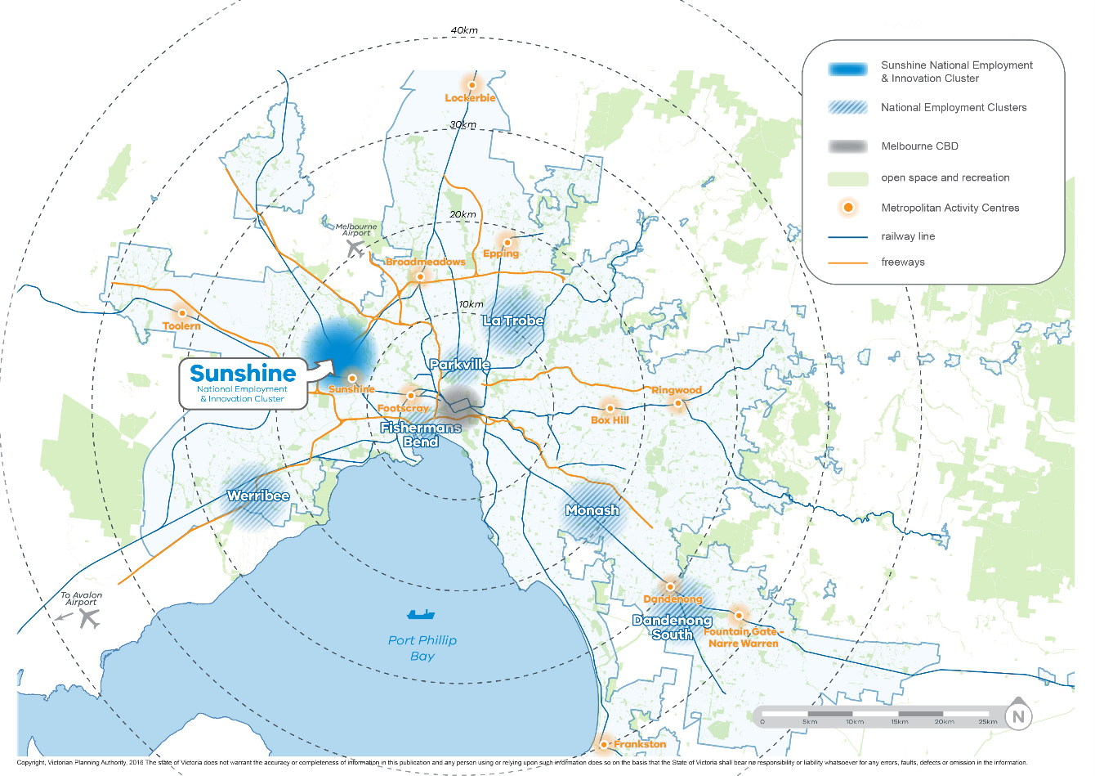
Figure 1 – Metropolitan Context Plan

ENGAGEMENT APPROACH

The VPA devised a two-phase approach to public engagement for the Sunshine NEIC Framework Plan.
The objectives of Phase 1 were to:
- Seek feedback on the vision and principles for the framework plan;
- Test the key ideas for delivery of the vision and principles, including opportunities for new ideas and suggestions;
- Build understanding of the opportunities for development and investment;
- Build momentum for positive change in the education, health and employment areas; and,
- Offer an opportunity to contribute to and influence the direction of the draft framework plan for Sunshine.

The objective of Phase 2 public engagement was to seek comments from stakeholders and the public on the draft Sunshine NEIC Framework Plan and invite submissions.

ENGAGEMENT PROGRAM AND ACTIVITIES

Table 1 - Public Engagement Activities

Date | Public Engagement Activity | Number of participants
10 April 2017 | Presentation to the Sunshine Health, Wellbeing and Education Precinct Management Board | 18
17 March 2017 | Shape Victoria online portal launched | 98 hits on website
17 March 2017 | Email to all stakeholders (including over 200 individuals and businesses) and previous engagement participants from phase 1 | 200
17 March 2017 | Copies of draft framework plan sent to the offices of the local MP | 1
23 March 2017 | Presentation to the Sunshine Town Centre Partnership Group | 15
27 March 2017 | Drop-in information session | 20
18 April 2017 | Engagement process closed | -

Shape Victoria is the online communication and engagement platform used by the VPA for engagement on the Sunshine NEIC. It also provides information and resources about the Cluster, including maps, event information, project updates and background reports.

The webpage went live on the 17 March 2017 which was the beginning of the 4-week public engagement process (17 March – 18 April 2017). During the public engagement period, the project page within Shape Victoria, received 98 hits. The webpage allows users to engage with a range of material that will inform and provide details of what is proposed for the Sunshine Cluster.

Shape Victoria included:
    - Draft Framework Plan
    - Upcoming event information
    - Background documents and reports
    - FAQs
    - Project Timelines
    - Key contact information and direction on providing feedback.

Over the 4-week public engagement period:
    - 8 people downloaded the Draft Framework Plan

FEEDBACK & OUTCOMES

Three written submissions were received from stakeholders on the draft Framework Plan. Summary of the feedback received from phase 2 public engagement included:
      - Greater focus on innovation and the importance of facilitating strong linkages between industry and education, and investment that enhances the agglomeration benefits of an education, health and research cluster;
      - Improving education options through encouragement of a new private school to set up in the Cluster by 2050;
      - Site specific issues around zoning that will be addressed through future strategic projects;
      - Increasing investment in roads and public transport; and,
      - Creating a more environmentally sustainable cluster and encouraging Environmentally Sustainable Design in new buildings.

PROCESS AND NEXT STEPS

Following feedback, the draft framework plan will be updated and submitted to the Minister for Planning for approval. A copy of the final Sunshine NEIC Framework Plan will be posted on the VPA website.

The proposed process to develop a framework plan for the Sunshine Cluster is described below. The framework plan is in its final stage.

