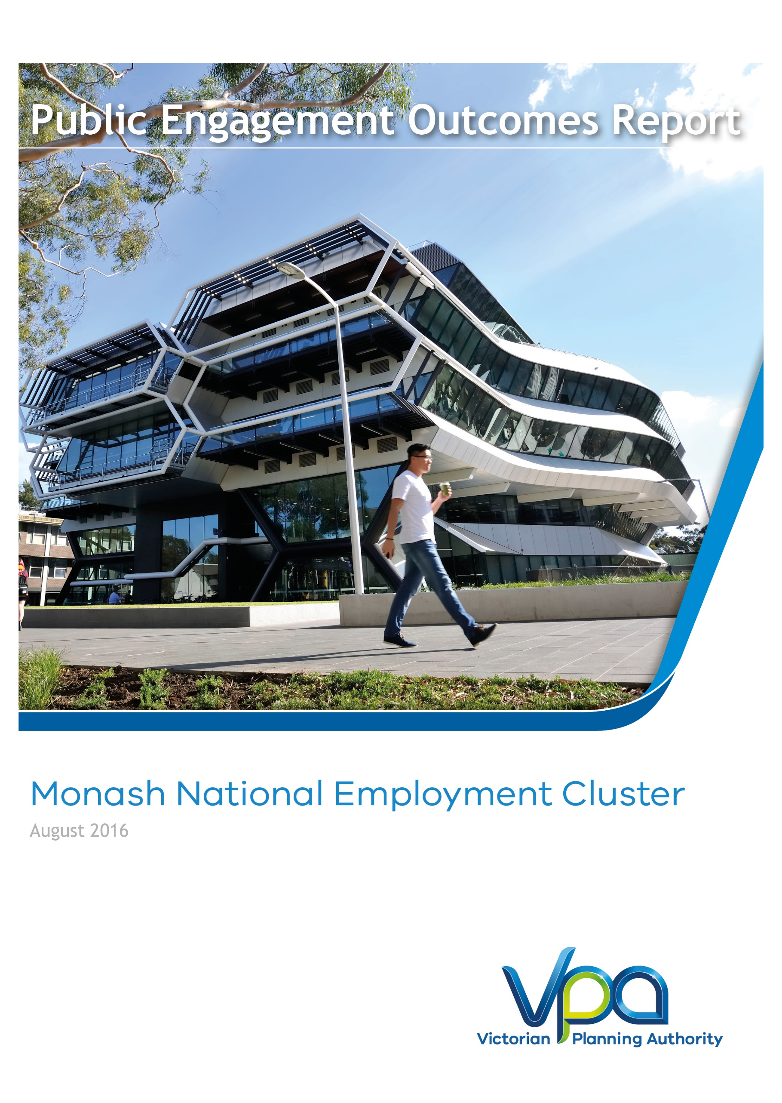
Monash National Employment and Innovation Cluster
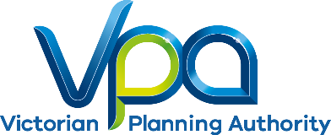
DRAFT Public Engagement Outcomes Report
Monash National Employment and
Innovation Cluster
November 2017
May 2017

CONTENTS
1 Introduction 1
2 Engagement approach 2
3 Engagement program and activities 3
4 Feedback and outcomes 4
5 Process and next steps 5

Figures
Figure 1 Metropolitan Context Plan 1

Introduction
The development of a Framework Plan for the Monash National Employment and Innovation Cluster (the Monash Cluster) is underpinned by Plan Melbourne 2017-2050, the State’s metropolitan planning strategy. This strategy forecasts that Melbourne’s population is set to reach 7.9 million people by 2051. To accommodate this growth, an additional 1.6 million dwellings and 1.5 million new jobs will need to be created. Growth of this scale requires long-term planning and management to sustain residents’ quality of life and Melbourne's status as one of the most liveable cities in the world.
The VPA's role is in this process is through facilitating the required land supply and identifying opportunities to support employment and attract investment. The VPA has been tasked with the preparation of framework plans for each of the clusters under Action 4 of Plan Melbourne 2017-2050.
Phase 1 of public engagement for the Draft Monash Cluster Framework Plan was completed in July 2016. This engagement phase aimed to test preliminary ideas and help to formulate the future land-use, development and infrastructure planning for the Monash Cluster.
The feedback received was used when creating the Draft Monash Cluster Framework Plan that was consulted on in Phase 2 of the public engagement process, completed in May 2017. This report summarises the consultation activities undertaken in Phase 2, the feedback received and how this input will be used to finalise the framework plan.
Feedback was obtained via written submissions following a 2 hour drop-in information session, meetings and phone calls with stakeholders as requested and a comprehensive website outlining the different components of the framework plan.
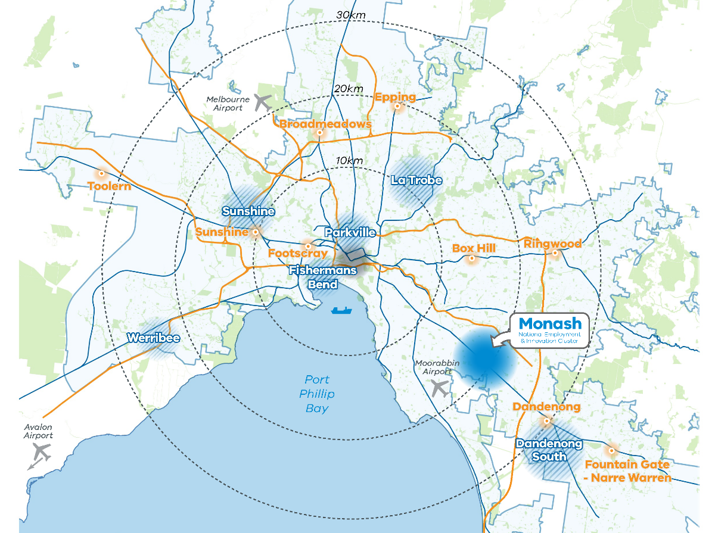
The Monash Cluster Framework Plan is a collaborative project being led by the Victorian Planning Authority in collaboration with the Cities of Monash, Kingston and Greater Dandenong as well as a range of State Government agencies.
Figure 1 Metropolitan Context Plan

Engagement approach

The VPA has devised a two-phase approach to public engagement for the Monash Cluster Framework Plan.
The objectives of Phase 1 were to:
- Seek feedback on the vision and principles for the framework plan;
- Test the key ideas for delivery of the vision and principles, including opportunities for new ideas and suggestions;
- Create understanding of the opportunities for development and investment;
- Build momentum for positive change in the education, health and employment areas; and
- Offer an opportunity to contribute to and influence the direction of the Monash Cluster Framework Plan.
The Phase 2 objectives of the public engagement process was to seek comments from stakeholders and the general public on the Draft Monash Cluster Framework Plan and invite submissions.
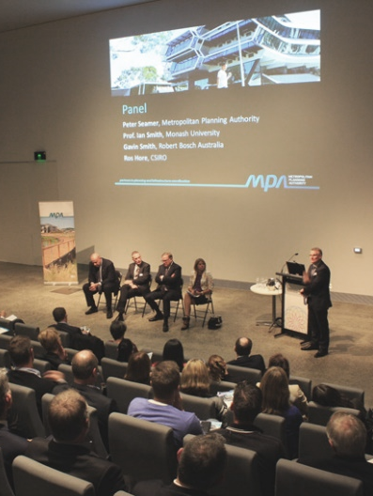
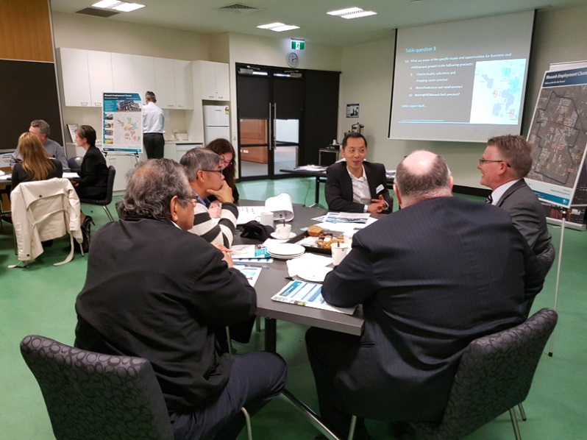
Consultation sessions associated with Phase 1 of the public engagement

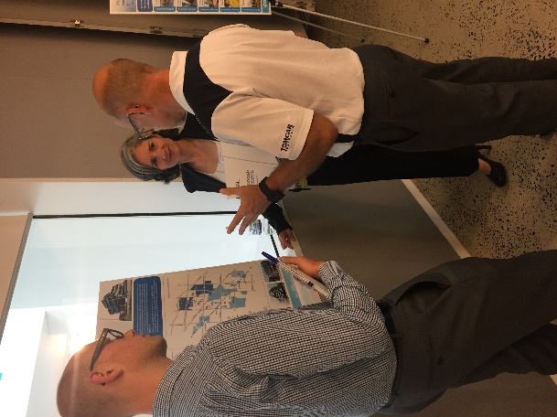
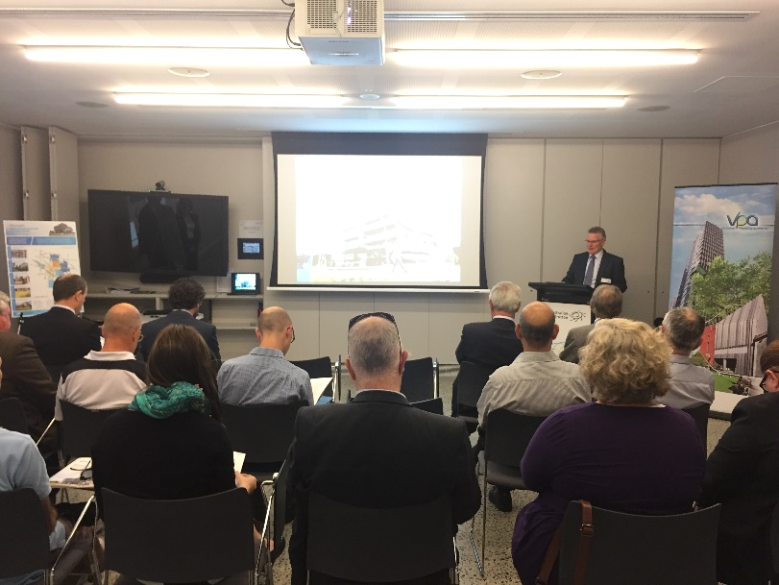
Consultation sessions associated with Phase 2 of the public engagement

Engagement program and activities

Shape Victoria is the online communication and engagement platform used by the VPA for engagement on the Monash Cluster. It also provides information and resources about the Cluster, including maps, event information, project updates and background reports.
The webpage went live on the 28 February, 2017 which was the beginning of the 4-week public engagement process (13 March - 13 April 2017). During the public engagement period the project page within Shape Victoria, received 823 hits. The webpage allows users to engage with a range of material that will inform and provide details of what is proposed for the Monash Cluster.
Shape Victoria included:
    - A short explanatory video;
    - The Draft Framework Plan;
    - Upcoming event information;
    - Background documents and reports;
    - FAQs;
    - Project Timelines; and
    - Key contact information and direction on providing feedback.

Over the four week public engagement period 265 people downloaded the Draft Framework Plan.

Table 1 - Public Engagement Activities
Date | Public Engagement Activity
 | Monash Cluster Advisory Group briefing
13 February 2017 | City of Kingston Councillor Briefing
14 February 2017 | City of Monash Councillor Briefing
20 February 2017 | City of Greater Dandenong Councillor Briefing
28 February 2017 | Shape Victoria online portal launched
28 February 2017 | Email to all stakeholders (including over 1000 businesses) and previous engagement participants from phase 1 of the public engagement
28 February 2017 | Copies of draft framework plan sent to the offices of local MPs
21 March 2017 | 2 hour drop-in information session at the Australia Synchrotron, Clayton

There was further promotion of the opportunity for input through the Victorian Planning Authority’s social media and e-newsletters.

Feedback and outcomes

Fifteen written submissions were received from stakeholders on the Draft Monash Cluster Framework Plan. These submissions covered a range of topics that were pertinent to each of the submitters. Formal submissions from those living or working in the Monash Cluster provided indispensable local knowledge to the VPA and are highly valued. The views of each submitter generally aligned with those of the VPA, however a number of changes to the framework plan were requested.
A key theme to emerge from the submissions was the role of the framework plan in supporting growth of the Monash Cluster Core. The core of the Monash Cluster is home to the specialised activities of the health, education and research institutions such as the Monash Medical Centre, CSIRO and Monash University Clayton. These sites are supported by the Monash Technology Precinct to the north and east of the cluster core. The plan will be updated to give better recognition to these important features.
In order to ensure the future success of the Monash Cluster, submitters stated that relationships and synergies must be fostered between the health, education research and other commercial industries. Digital platforms should enable connections between the local population, students and businesses to generate local employment and drive innovation. It was also highly desirable for information exchange to be enabled with face to face interactions and fostering the ‘bump into’ factor with places where people can have chance encounters and spontaneously network.
As many industrial sites transition into high-tech centres of manufacturing and professional services, the facilities and physical environment of these areas must be enhanced in order to provide the amenity that is sought by the emerging workforce and businesses choosing the Monash Cluster as their base. Knowledge based industries increasingly seek facilities that serve the everyday needs of their employees and their guests which enables face to face interactions that remain highly valued by local businesses. Activity centres, urban renewal precincts and business town centres are able to contribute to a sense of image and identity through place-making, while establishing destinations for transport links within the Monash Cluster. These are to be addressed through detailed planning.
Accessibility to existing and proposed destinations remain a key issue for many of the participants. Although access for private vehicles is considered to be important, the submissions largely focussed upon freight routes, public transport upgrades and active transport links. Leveraging development off state government funded transport projects such as the level crossing removals on the Cranbourne-Pakenham Rail Corridor was also raised as an important requirement of the plan.
Those located in the core of the cluster identified active transport links as being a key factor in the success of the plan. Not only would active transport link key institutions, residential precincts and areas of open space; these connections enable low or no-cost transport, improve health outcomes, reduce vehicular congestion and assist in the delivery of 20 minute neighbourhoods. These concepts will be updated in the framework plan.
Access to high-quality housing and the facilitation of local living in proximity to employment opportunities was another major theme to emerge from the submissions. However, it was also acknowledged that the provision of higher density housing in proximity to employment areas may result in adverse amenity issues that impact upon the viability of existing businesses. Amenity concerns relating to interface issues are most prevalent on the boundaries of the Monash Technology Precinct and around industrial areas. This is to be addressed in detailed precinct planning where changes that would introduce sensitive land uses close to industrial sites will investigate suitable outcomes having regard to Clause 52.10 Uses with Adverse Amenity policy of the relevant planning scheme and Environmental Planning Authority legislation.
Finally, it was suggested that a clearer outline of the governance arrangements needed for implementation be included at the end of the document. Further clarity should also be provided on the sequencing and timing of projects and the development of infrastructure contributions plans. There are changes occurring in overarching governance arrangements for the metropolitan regions in response to Plan Melbourne. The future of governance will be resolved having regard to the needs and requirements of the cluster and its priority projects. A new section will be added to the framework plan to address these matters.

Process and next steps

The VPA has thoroughly considered each of the fifteen submissions and will use these valuable contributions to refine and improve the framework plan. The Draft Monash Cluster Framework Plan will be updated and submitted to the Minister for Planning for approval. Once finalised, the Monash Cluster Framework Plan will be uploaded on the Shape Victoria website. This is anticipated to occur by end of 2017.

