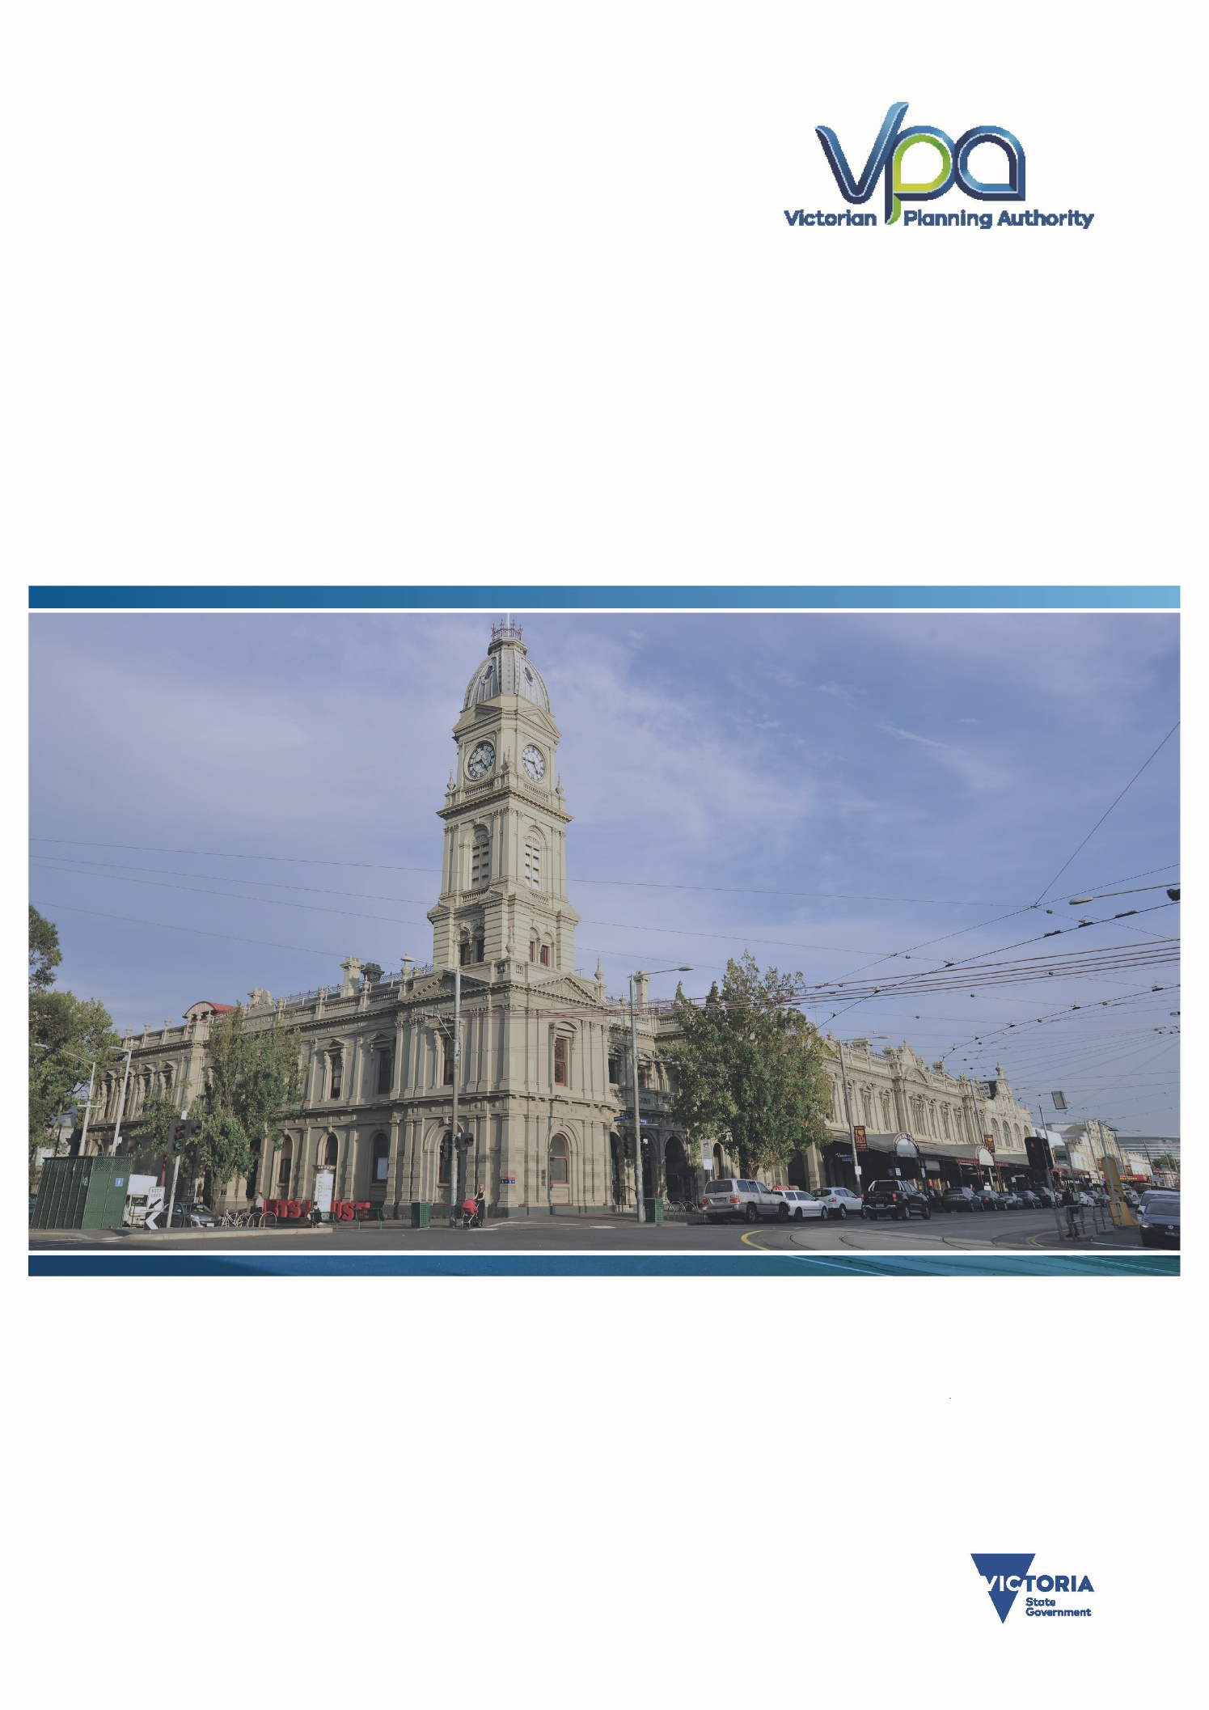
Prepared by the Victorian Planning Authority
June 2017
The VPA’s State of the State – 2nd Quarter 2017
A VPA report on Victoria’s Key Demographic & Economic Metrics

This page is intentionally left blank

Contents
Executive Summary 3

POPULATION 4
1. State Populations 4
2. Population Growth and Projections by Local Government Area 7
3. Births by Local Government Area 11
4. Deaths 13

DEVELOPMENT ACTIVITY 14
5. Building Approvals 15
a) Residential Dwelling Approvals 16
b) Value of Approvals 19
i. Commercial Buildings 21
ii. Industrial buildings 23
iii. Other Non-Residential Buildings 25
6. Crane Counts 27
7. Construction Pipeline 28

HOUSING – PRICES AND SUPPLY 28
8. Greenfields Developments in Melbourne’s Outer Growth Areas 29
a) Sales Rates 29
b) Supply and Stock 30
c) Price of Greenfield Lots 31
d) Supply of PSP land 32
9. Property Sales 33
10. Rents 41
11. Residential Rental Bonds 47

ECONOMIC – EMPLOYMENT 50
12. Unemployment 52
13. Employment Mix of Victoria 59

Executive Summary

POPULATION
- As of the end of September 2016, Victoria had a population of just over 6.1 million and had a record growth for a 12-month period of 127,500 people. This is the strongest population growth of any Australian state or territory.
- At present, approximately 75% of the state’s population live in metropolitan Melbourne and 25% live in regional Victoria.
- Victoria has had the highest interstate migration ever, with more than 17,000 people moving to Victoria from interstate in the past year.
- Within Melbourne, the outer local government growth areas and the City of Melbourne are the fastest growing locations.
- In 2016, Victoria is on track for a record of over 80,000 births. Since 2012, Victoria has been experiencing a baby boom, with 15,000 more births per year than were recorded in the early 2000s. This will result in greater demand for childhood services.
- Almost 40,000 people died in Victoria in 2015. This has also been rising in recent years due to the ageing population.
DEVELOPMENT ACTIVITY
- There were almost $26 billion worth of building approvals in the nine months to March 2017 across Victoria. The large majority (67%) of that value was for residential construction. This compares to almost $31 billion for the full 2015/16 year.
- Residential dwelling approvals remained predominantly detached dwellings, with approval for 26,725 houses, 8,331 semi-detached dwellings and 15,235 apartments in the past nine months.
- The number of new dwellings approved in 2015/16 were 67,003 across Victoria. This was made up of 35,864 detached houses (53%), 10,571 semi-detached dwellings (16%) and 20,568 units or apartments (31%).
- In addition, there were approvals for $4.26 billion worth of commercial buildings, $1.2 billion of industrial buildings and $3.18 billion worth of other non-residential buildings (nine months to March 2017).
HOUSING – SUPPLY AND PRICES
- The median sales price of a detached home exceeded one million dollars across 10 local government areas in Melbourne in 2016.
- Prices were more affordable for semi-detached dwellings and units. Also, in many rural areas prices remain more affordable than metropolitan areas.
- Median rent prices for metropolitan Melbourne ranged from $340 for a one-bedroom flat to $440 for a three-bedroom flat. However, there was a large variation at the local government level, based on the proximity to the city of the rental property.
- The number of rental bonds has increased over the past five years at a rate much faster than household formation. This suggests more households are renting and that the percentage of households owning their own home has continued to fall.
- Housing lots in Melbourne’s greenfields have been selling in record numbers, with more than 24,000 sales in the past four quarters; averaging over 65 sales per day. The Melbourne greenfields market is clearly the strongest in Australia.
- Strong sales have resulted in a reduction in the supply of lots on the market, with less than a month’s supply on the market.
- The median price for a lot in Melbourne’s greenfields has increased to $252,000 at the end of 2016. This is an increase of $34,000 per lot in a year (over $90 each day).
ECONOMIC – EMPLOYMENT
- The latest ABS labour force data (April 2017) estimates Victoria’s unemployment rate at 6.1% having stayed relatively stable for the past two years. The unemployment is not evenly spread, with Nillumbik having the lowest unemployment at 2.1% and Latrobe having the highest unemployment, at over 11.2%.
- There were 3,128,000 people employed in Victoria in November 2016. The largest industry was health care and social services, and this is growing markedly.

POPULATION
- State populations
As of the 30 September 2016, the population of Victoria stood at 6,100,877 people. Victoria clearly remains the second largest state and will remain in that position for the foreseeable future. Within Victoria, the population split is currently approximately 75% in metropolitan Melbourne and 25% in regional Victoria.

In the 12-month period to September 30 2016, Victoria’s population grew by 127,498 people, the largest increase of all the states. This is a new record for any 12-month period.

In terms of percentage change, Victoria is also the fastest growing of all states and territories, growing at over 2.1% per year. No other state or territory is growing faster than 1.5% per annum.

In terms of components of Victoria’s population growth, the natural increase was 41,700 people. There was a net inflow of 68,613 overseas migrants and a net inflow of 17,185 people migrating from interstate. Victoria and Queensland were the only two states to see a positive net interstate migration.

Historically, Victoria has at times lost population to other states but this trend seems to have reversed, with net interstate migration at levels never seen before. Net overseas migration has been fairly stable for the past few years, after the peak that occurred around 2009 and 2010, followed by a significant fall in 2011, although it has picked up in the past 12 months slightly.

In recent years Victoria has seen an increase in the number of births. In the 12 months to September 30 2017, there were over 82,000 births, so 2016 was on track to shatter the previous record of 77,278 births in a calendar year.

- Population Growth and Projections by Local Government Area
All metropolitan local government areas experienced population growth in the year prior to 30 June 2016. In that year, Victoria grew by 123,127 with 106,805 in Melbourne (87%) and 16,322 in regional Victoria (13%). The largest growth was found in Wyndham, with an additional 12,106 people. The other outer growth areas saw large increases, as did the cities of Melbourne and Moreland.
In regional Victoria, strong growth was seen in Greater Geelong, Ballarat and Bendigo. Other areas to experience large growth were peri-urban Local Government Areas (LGAs), such as Baw Baw, Moorabool, and Macedon Ranges, and coastal LGAs, like Surf Coast and Bass Coast.
Many of the more remote LGAs sustained a significant decrease in population.

The projected populations for each of Melbourne’s and regional Victoria’s LGAs up until 2031 are outlined below. As of 2031, Victoria is projected to have 7.7 million people, with 5.9 million in metropolitan Melbourne (77%) and 1.8 million in regional Victoria (23%). This is a growth of 1.7 million people in metropolitan Melbourne (84% of the total state growth) and 270,000 in regional Victoria (16% of state growth), of which over 250,000 (or 94%) are in the 10 key regional centres, peri-urban LGAs and coastal areas.

- Births by Local Government Area
Victoria had a total of 73,600 births in 2015, 57,200 of which were in metropolitan Melbourne (78%) and 16,200 of which were in regional Victoria (22%). The final figure for births in 2016 will be available in late 2017.
By Local Government Area (LGA), the City of Casey had the most births, with 4,389 babies born, followed by other Greenfield LGAs, including Wyndham (4,058), Whittlesea (3,065) and Hume (2,987).
In regional Victoria, Greater Geelong had 2,789 births and Bendigo and Ballarat both had more than 1,000 newborns. Another interesting result was recorded in Baw Baw with more than 500 babies born, the fastest growing peri-urban LGA.
Appendix 2 of this report contains maps of the 2015 Births.

- Deaths
In 2015, 39,904 people died in Victoria, a large increase compared to 2014, when only 37,958 people died. Of those who died, 26,720 were from metropolitan Melbourne (67%) and 13,104 were from regional Victoria (33%).
LGAs with younger populations tended to have fewer deaths than older, more established areas. The number of deaths has been increasing with the rising population.

DEVELOPMENT ACTIVITY
- Building Approvals
For the 2015/16 financial year, there was a total of $30.95 billion worth of building approvals in Victoria. The vast majority (72%) of building approvals were for residential dwellings of all types.

In the first nine months of 2016-17, there was a total of $26.2 billion in approvals in Victoria. Residential approvals accounted for 67% of the approvals, due to some major commercial projects that were approved.

The various categories of building approval numbers and values for both metropolitan Melbourne and regional LGAs are presented in the following charts, including:
- Residential Dwellings Numbers
- Overall Value of all Building Approval Types
- Commercial Buildings
- Industrial Buildings
- Other Non-residential Buildings

  - Residential Dwelling Approvals
The latest building approvals (March 2017) show that in the past 12 months 36,245 detached houses and 32,055 other residential dwellings were approved across the state. Historically, detached houses have been the dominant type of residential construction in Victoria. However, in the past few years, the number of other residential dwellings approved has been almost the same as detached houses. It is yet to be determined if this is a permanent trend or a short-term approbation.

In the nine months to March 2017, there were 26,725 detached houses approved and 23,566 other dwellings approved. Within the ‘other dwellings’ category in the quarter, there were 8,331 semi-detached dwellings and 15,235 apartments and flats, of which almost 90% were in buildings four storeys or more. The majority of these high-rise apartments were approved in the Melbourne central subregion, although many suburban local government areas have had significant numbers in the past nine months. There were no high-rise apartments approved in regional Victoria.
The northern subregion had more semi-detached dwellings approved than other subregions.

  - Value of Approvals
The City of Melbourne had the largest value of building approvals in the first nine months of 2016-17, totalling almost $4.6 billion. Wyndham, Casey, Boroondara and Stonnington each had over a billion dollars’ worth of building in the same time period.
In regional Victoria, the highest value of approvals were in Greater Geelong, Ballarat, Greater Bendigo and the Surf Coast.

                - Commercial Buildings
In the first 9 months of 2016-17, the City of Melbourne had the greatest value of commercial buildings approved (44% of the state total), with the majority being offices after some major projects were approved. The majority of work approved across the rest of the metropolitan Melbourne area was for retail buildings.
In regional Victoria, outside a few of the major regional cities, there were virtually no commercial buildings approved except for approximately $19 million worth of retail in Colac-Otway and $14 million worth of Offices in Baw Baw.

                - Industrial buildings
Over 70% of industrial buildings approved in the first nine months of 2016-17 were warehouses and a vast majority were located in the metropolitan area. There were only $117 million worth of factories and other production buildings across the whole state for the same period.
In regional Victoria, the most interesting event was the approval for a very large hydroponics farm in Northern Grampians announced in January 2017.

                - Other Non-Residential Buildings
In the first three quarters of 2016-17, points of interest in the other non-residential building approvals were the short-term accommodation approvals in Melbourne, educational buildings in Monash and Geelong, entertainment buildings in Ballarat and Bendigo, and health buildings approved in Brimbank, Casey and Wyndham.

- Crane Counts
Rider Levett Bucknall publishes a biannual Crane Index. The Crane Index tracks the number of cranes in the key mainland cities in Australia. This is a useful proxy for major construction work.

Across Melbourne, there were 148 cranes on sites at the start of the second quarter 2017. There have been 92 new cranes erected and 77 dismantled in the past six months. The vast majority of these were on residential project sites.

Over 30% of the cranes in Melbourne were located in the CBD, Docklands and Southbank but the remainder were spread across the rest of Melbourne.

Melbourne had the second highest number of cranes in Australia. Sydney had the greatest number of cranes, possibly as a result of Sydney’s lack of Greenfield growth, forcing multi-level residential development to meet dwelling requirements.

- Construction Pipeline
Cordell Connect collects information for their database on most construction projects across Australia, with the exception of single dwelling construction. This information is used across the construction industry.

In Victoria, the Cordell database currently has around 23,132 active projects. The majority of these projects are in the early or possible stages, with only about 25% currently underway.

In terms of value, even fewer of the works are currently underway or firm, with over $100 billion worth of projects in the early or possible stages.

Many of the projects at the registration phase are large government projects like E-gate. Other large government projects have been added to the firm stage, like the Metro Tunnel.

Tables of number and value of Projects by LGA can be found in the appendices.
HOUSING – PRICES AND SUPPLY
- Greenfields Developments in Melbourne’s Outer Growth Areas
  - Sales Rates
In the recent quarters, the Greenfields of Melbourne have been selling at a record pace, with 24,000 lots selling in the past four quarters to March 2017.
The Melbourne greenfield market is clearly the strongest in Australia in terms of demand and sales numbers. There has been an increase in the Brisbane/SEQ market and a large decrease in sales in Perth.

  - Supply and Stock
As a consequence of the strong sales rates, stocks in the growth areas have generally declined over the past year. Areas that three years ago had several months of stock have seen the numbers fall rapidly.

The average time a lot is lasting on the market is currently less than three weeks compared to over 10 months in the March 2013 Quarter.

  - Price of Greenfield Lots
The median price for a Greenfield lot was $252,000 in Melbourne. There has been a large increase in price recently with the strong demand and shortfall of supply.

Nationally, Melbourne’s Greenfield lots are now the third cheapest in Australia. Prices have been falling in Perth and South east Queensland. With the rapidly increasing prices in Melbourne’s median lot price it is possible that Greenfield lots in Melbourne will overtake the median lot price of South East Queensland in the second quarter of 2017.

  - Supply of PSP land
The Victorian Planning Authority (VPA) has conducted modelling to gauge the approximate amount of land in the Melbourne greenfields that is available to be subdivided and developed. In most cases, this is land in precinct structure plan (PSP) areas that has been approved, although some of the land pre-dates the implementation of the PSP program.
At the end of 2009, the greenfields had approximately 4.4 years’ worth of land that was undergoing or could undergo development. Since then, with the completion of PSPs, the number of years’ supply has grown to above 10 years.

The supply level varies greatly between corridors, with Wyndham having 19 years of supply whereas Whittlesea had dropped as low as 2 years supply in the middle of 2016 before the approval of Quarry Hills and Wollert boosted supply to almost eight years. Supply of PSP land will increase in 2017 as there are a number of large PSPs in the final stages of approval.

- Property Sales
In 2016, there were over 114,000 residential property sales across Victoria. This compares to over 117,000 in 2015. About three quarters of these sales were in Melbourne. As of June 2016, there was an estimated 2.575 million dwellings in Victoria, with the volume of sales therefore representing an annual turnover of around 4.4%.
In all but four inner city LGAs, detached house sales were a majority of residential property sales.

For 2016, the median price of a detached house exceeded one million dollars in 10 LGAs across Melbourne. The only LGAs where median prices were lower than $500,000 were Brimbank, Frankston and the outer growth LGAs.
In regional Victoria, the coastal areas of Queenscliffe and Surf Coast had median prices above half a million dollars. The cheapest houses in the state were in the Wimmera areas; the lowest were in Buloke where the median price was $81,000.

Semi-detached dwellings are generally cheaper than detached houses because they usually occupy less land and in some cases are cheaper to construct. Five metropolitan LGAs had median semi-detached prices over one million dollars. In some cases these medians are based on low volume numbers that should be used with caution.

The median price for units in 2016 to date were generally much lower than house prices in most LGAs of Melbourne. However, in regional areas there was less price difference between the two; in some cases the median prices for a flat was higher than a detached dwelling. Some regional LGAs had very few sales of strata title properties this year.

- Rents
The Department of Housing and Human Services prepares a Quarterly Rental Report for Victoria. This provides information on the median rents. For example, the median rent for a two-bedroom flat in Melbourne was $400 a week compared to $240 in non-metropolitan areas.

Median rents have risen in the past 12 months in both metro and non-metro in all categories. Rents rapidly rose between 2005 and 2010, then were fairly stable for several years. Recently rents in the metropolitan regions have begun to increase once more. The annual increase in weekly rents was highest for three-bedroom houses in Metropolitan Melbourne and one-bedroom flats in both Metropolitan and Regional areas (all increasing by 4.4%).

There is clearly a general trend in Melbourne that the inner city local government areas (LGAs) have higher median rents compared to LGAs that are further out. This is true of both units and houses. The difference between rents for houses and units is also greater the closer to the centre of Melbourne. In some of the fringe LGAs there is little difference in rent for a two-bedroom house and a two-bedroom flat.
In regional areas, there are generally fewer flats rented and therefore in most cases there is little difference between houses and units. In many LGAs, there were no rentals of any flats of either type and therefore no median price is shown on the graphs.

- Residential Rental Bonds
At the end of December 2016, there were 553,469 active residential rental bonds in Victoria. As there is generally one bond per residential rental property, active bond numbers are a good indicator of the number of rental properties in Victoria. The number of bonds has increased 4.2% in the past year and 30.1% in the past five years.

The split of bonds between metropolitan and regional has remained fairly steady at around 80% in Melbourne; however last year 93% of the growth was in the metropolitan area.
In the past five years the number of active rental bonds has increased by almost 128,000. The estimated net number of new residential dwellings in Victoria in the same period is 255,000. Therefore, there has been a ratio of one new rental for every two additional dwellings for the past five years. This is much higher than the ratio of one rental per three dwellings that existed at the 2011 census. With the release of the 2016 census data later in 2017, it is highly likely that the percentage of owner occupier dwellings in Victoria will have fallen significantly.
At the local government level, the City of Melbourne had the most active bonds in the state and West Wimmeria had the least. Manningham had the greatest growth in residential bonds with 8.8%, whereas Wellington was the LGA with the greatest decrease in rental bonds in the past year.

ECONOMIC – EMPLOYMENT
- Unemployment
The latest ABS labour force data (April 2017) puts Victoria’s unemployment rate at 6.1%. It has remained around 6% over the past two years.

The Department of Employment produces labour market figures for smaller areas. The latest set released was for the December 2016 quarter. Latrobe (11.2%) and Greater Dandenong (11.1%) had the highest unemployment rate for LGAs in the state and Nillumbik had the lowest (2.1%). Other areas with high rates were Brimbank, Hume and Central Goldfields.
The City of Latrobe has seen the unemployment rate increase from 8.3% to 11.2% in the past 12 months. Other LGAs in Gippsland (Bass Coast, Baw Baw, Wellington, South Gippsland and East Gippsland) have also seen large increases in unemployment.
In terms of raw numbers of unemployed persons, Casey and Brimbank both have over 10,000 unemployed people. Some of the regional areas with high unemployment rates have small populations, so the actual number of unemployed people is quite low.
The unemployment rates are not evenly spread within the LGAs. For example, Hume has an unemployment rate of 9.2% but some suburbs, such as Broadmeadows, have unemployment above 24%, whereas Sunbury has a rate of less than 4.5%. See maps in Appendix 3 for more examples.

- Employment Mix of Victoria
The largest industry sector of the Victorian Labour Force is health care and social assistance, with over 400,000 workers. Retail is the second largest sector in the state. Despite the difficulties facing this sector, manufacturing remains the third largest sector of the economy, with almost 280,000 workers.
Victoria has very few people directly employed in the mining sector, unlike many other states.

A time series of the number of people employed by industry sector is found in the appendices.
APPENDICIES
Appendix 1 – Building Approvals for 2015-16

Appendix 2 – LGA POPULATIONS June 30 2015

Appendix 3 – Cordell Connect Projects by LGA

Appendix 4 – Property Sales 2015

Appendix 5 - Components of Population Change

Appendix 6 – Maps of Births
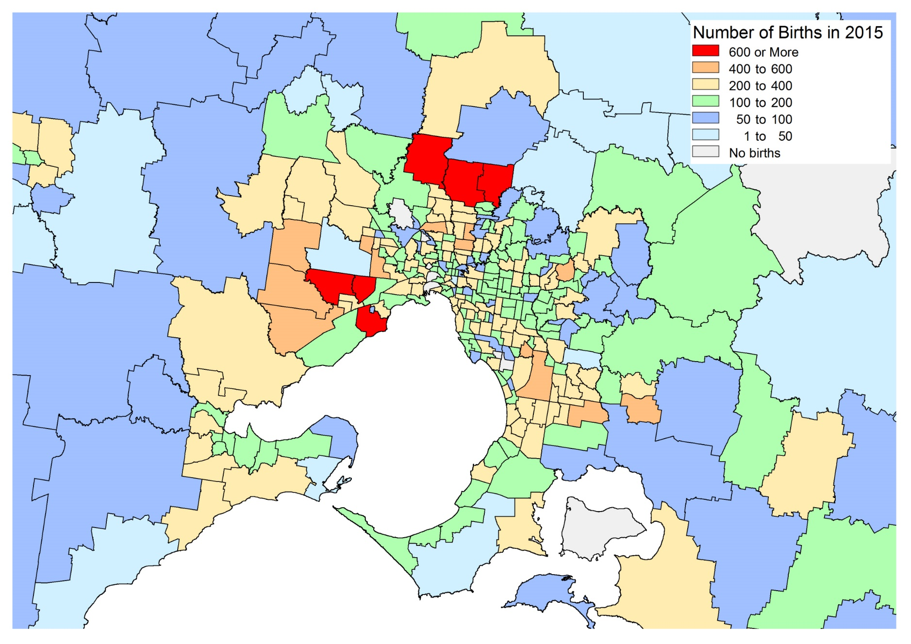

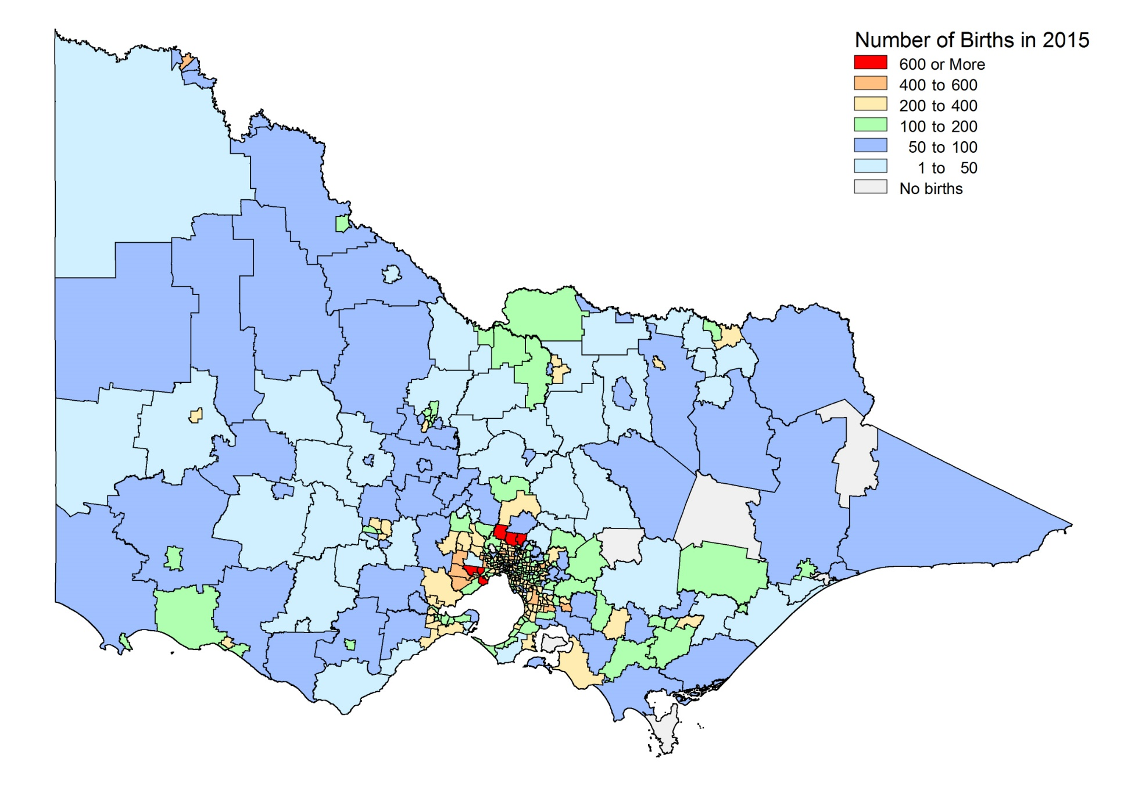

APPENDIX 7 – Maps of Unemployment
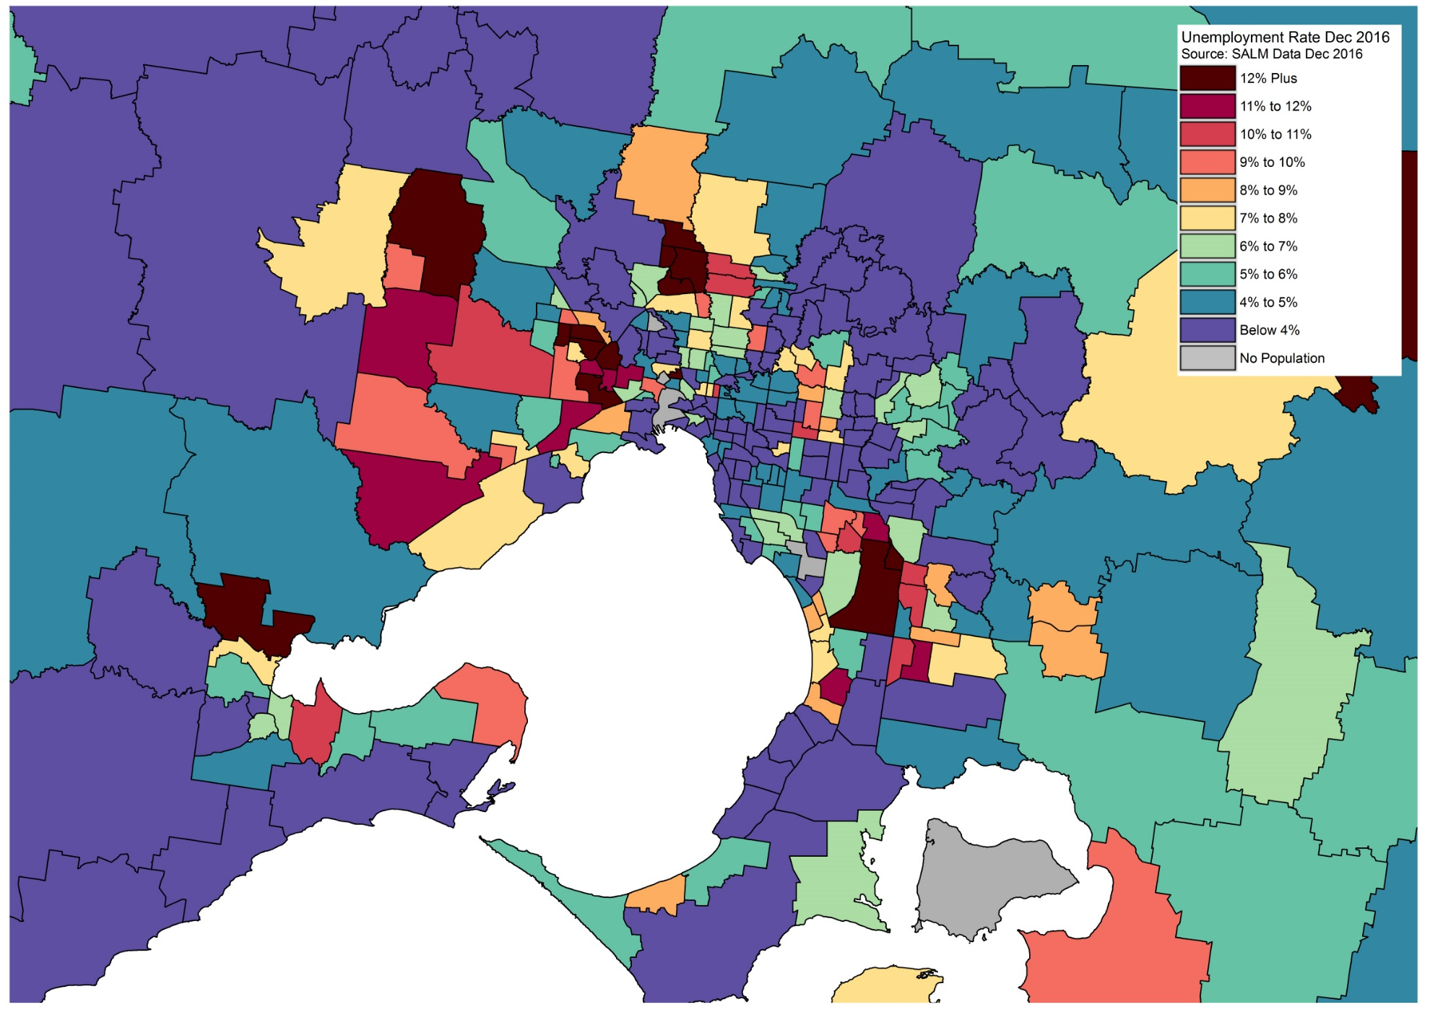
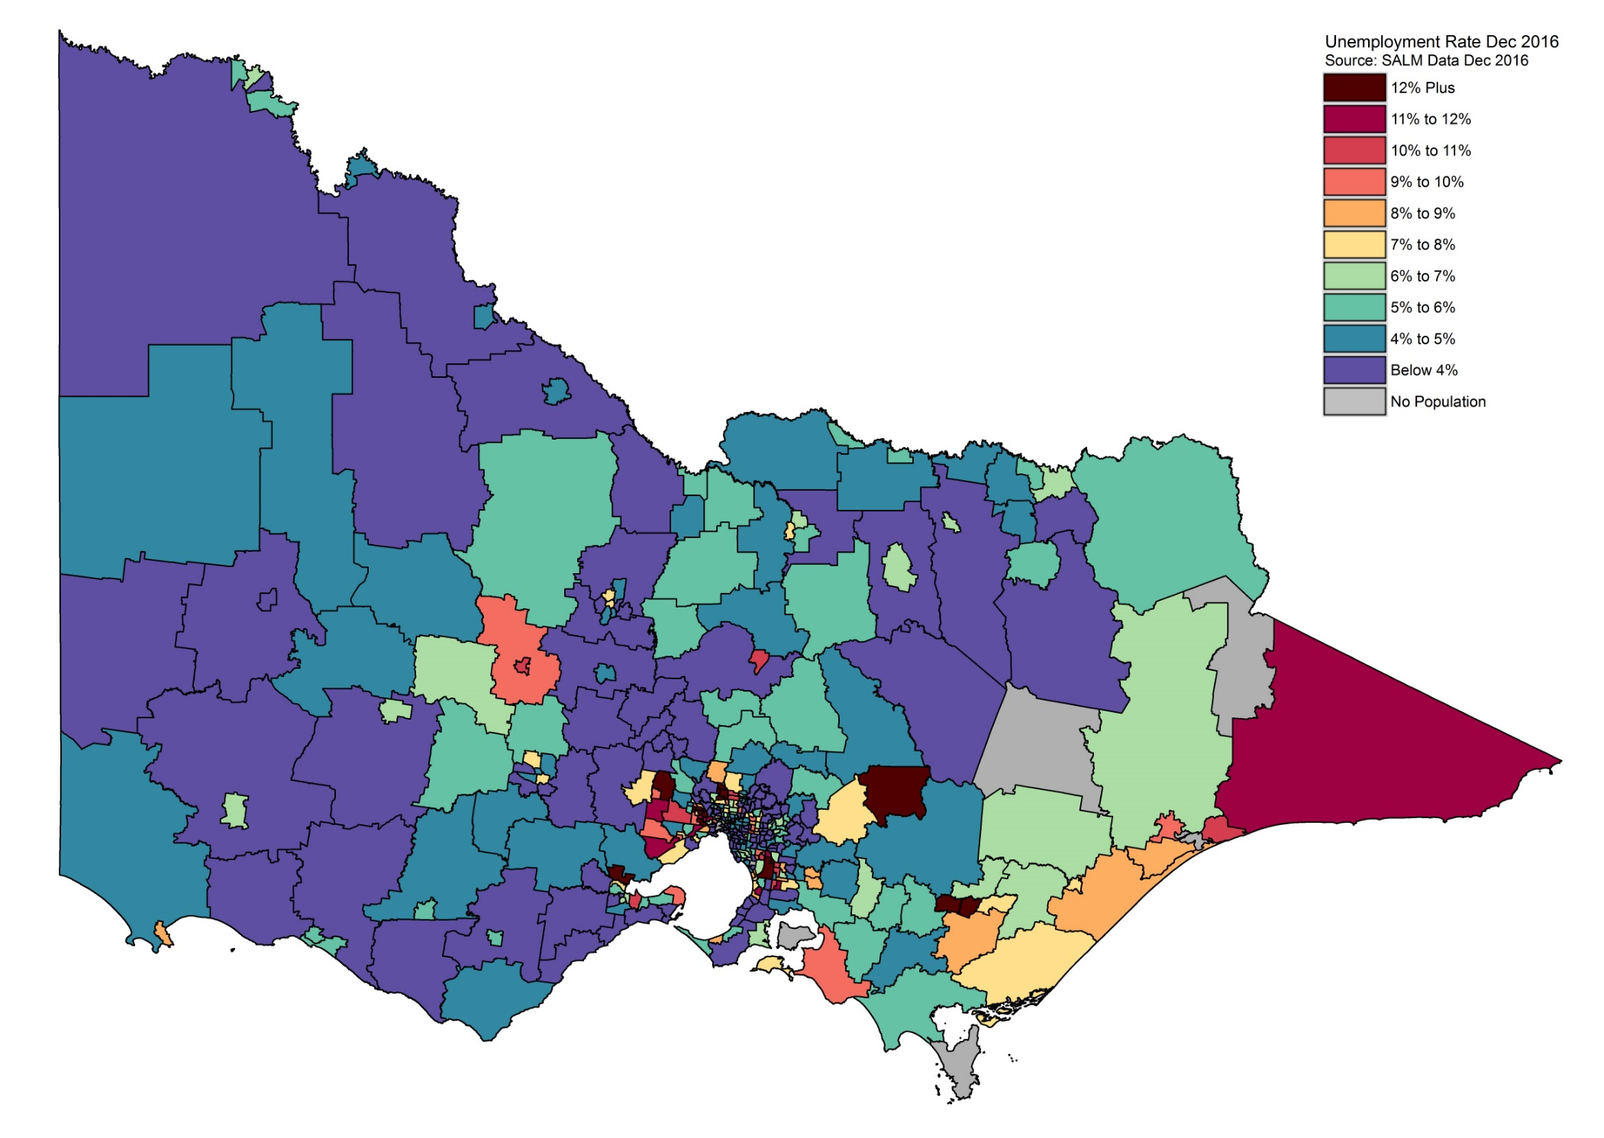
APPENDIX 8 – Active Greenfield Projects
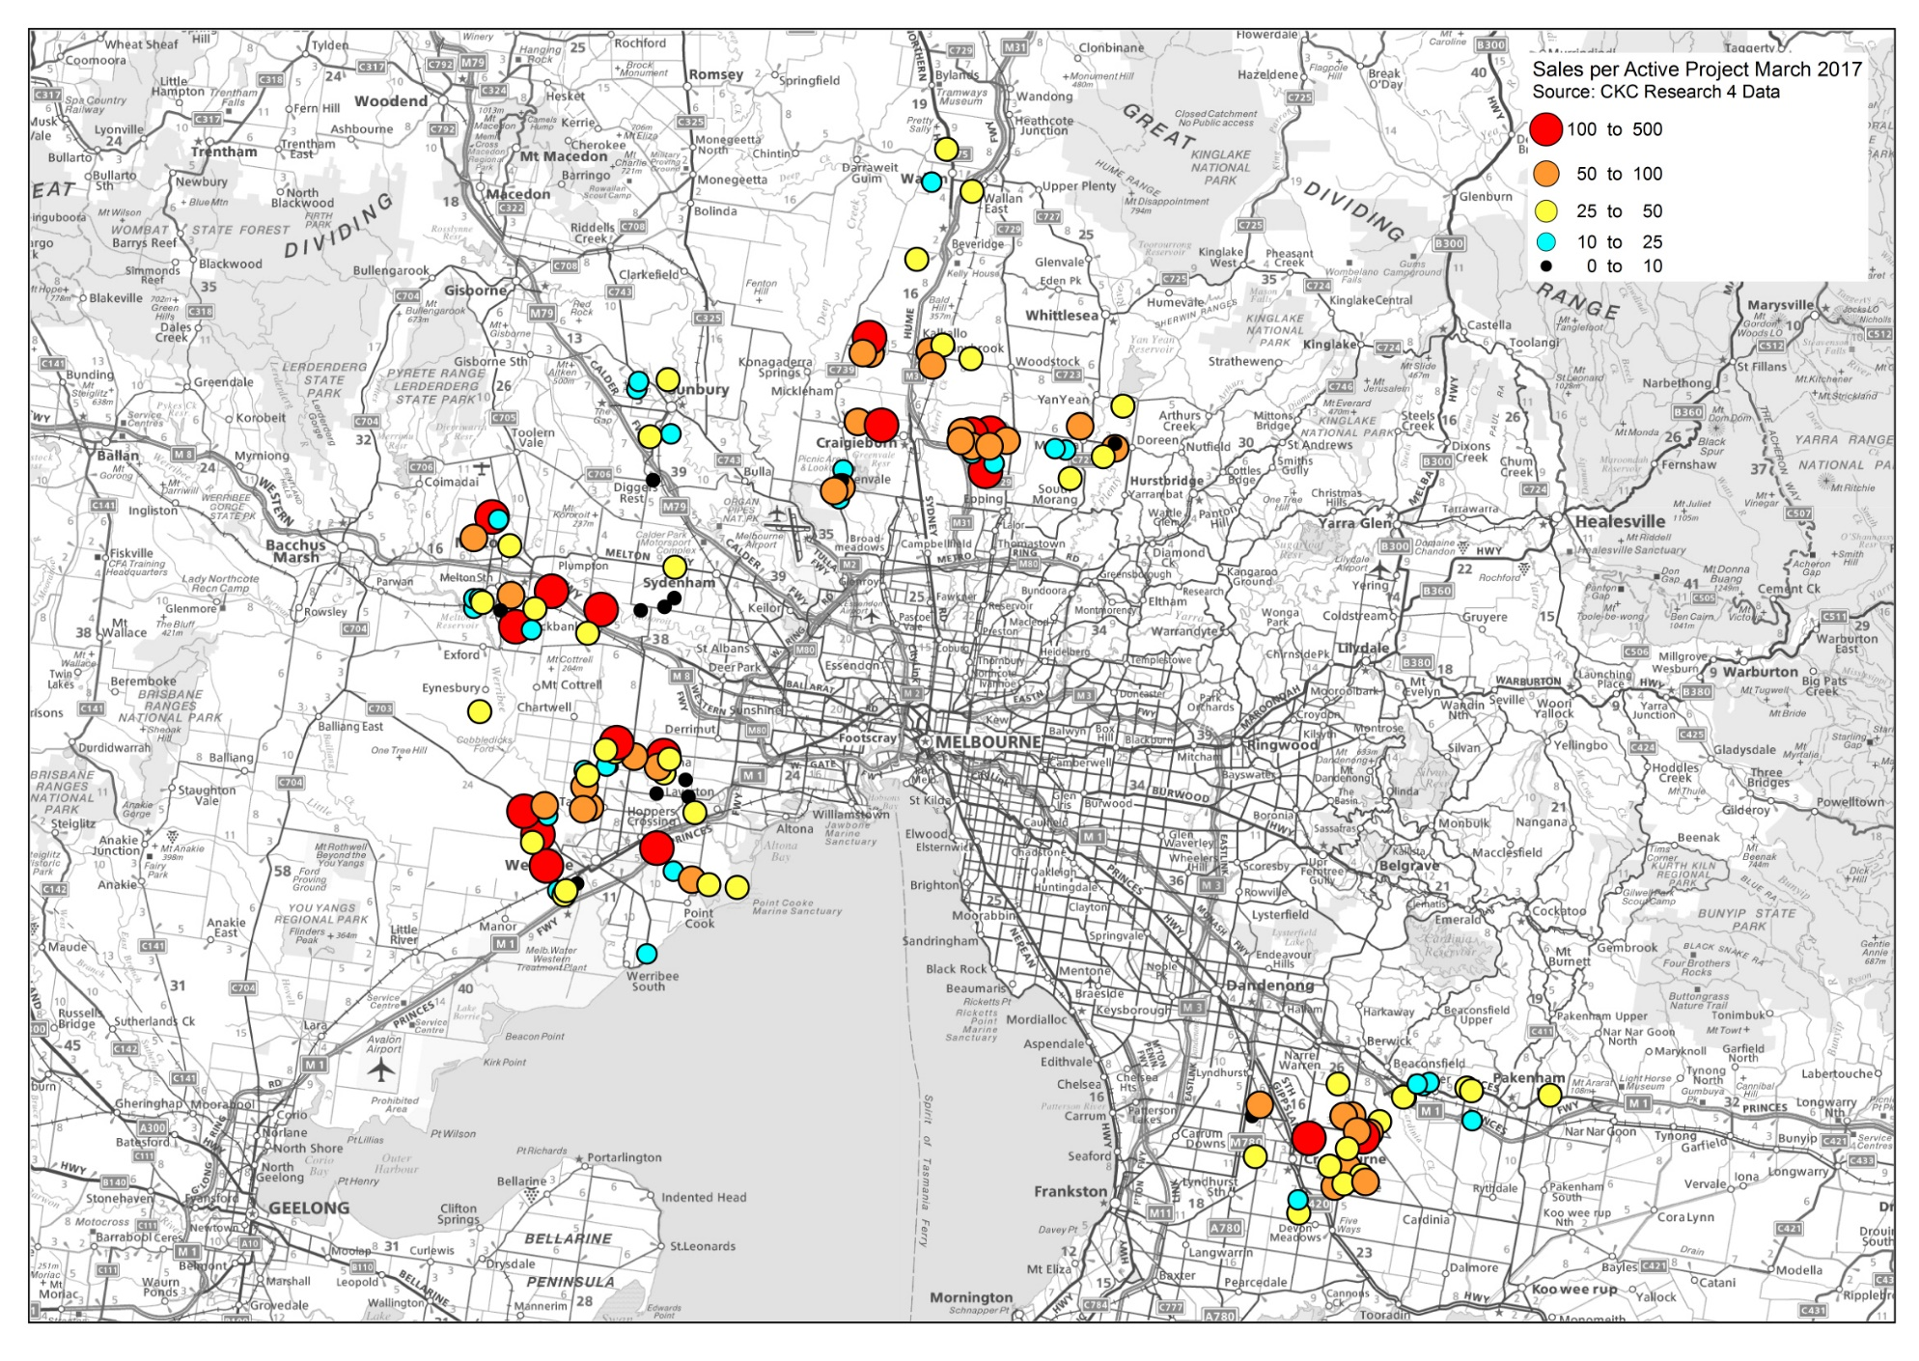
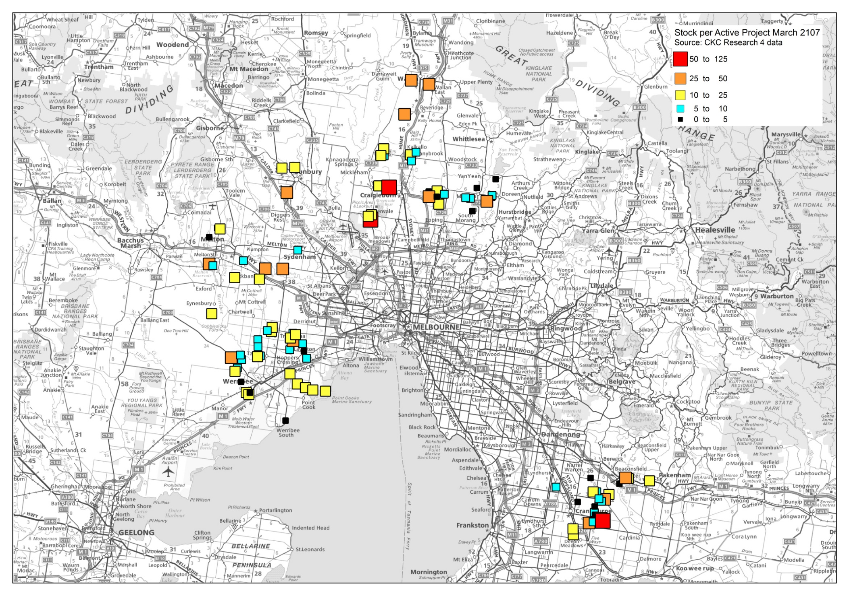
APPENDIX 9 – Industry of Employment in Victoria – Time Series

