Jacksons Hill Master Plan

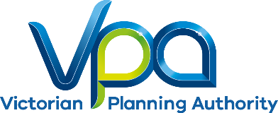

Phase 1 Community Engagement Report

June 2017

Keep page blank

**Disclaimer**This publication may be of assistance to you but the State of Victoria and its employees do not guarantee that the publication is without flaw of any kind or is wholly appropriate for your particular purposes and therefore disclaims all liability for any error, loss or other consequence which may arise from you relying on any information in this publication.

CONTENTS

1 Introduction 1

2 How we engaged 3

3 What we found 2

4 Evaluation and next steps 9

5 Appendicies 11

*Second page for table & content overflow*

(leave section break for pagination)

This page has been left blank intentionally

# Introduction

VPA’s commitment to community engagement

The Victorian Planning Authority (VPA) is committed to undertaking robust and comprehensive engagement with community and other stakeholders on all our projects. The VPA and Hume City Council recognises that inclusion and engagement, particularly at the early and formative stages of this project, is vital to building and maintaining community trust and producing a better plan.

The VPA has introduced a range of new and interactive face-to-face and online methods to ensure deeper, more meaningful and transparent engagement. The Jacksons Hill consultation has pioneered some of these new methods to ensure as many people as possible are able to participate at times and locations that suit them.

Purpose of the report

This community engagement report summarises the feedback received during the Phase 1 informal consultation process for the Jacksons Hill Master Plan project. Consultation was undertaken prior to preparing a draft master plan for the Jacksons Hill site, in order to establish the community and stakeholder aspirations for the future of the site.

Project context

Jacksons Hill is an integral part of the Sunbury community. The area was initially inhabited by its traditional Aboriginal owners, the Wurundjeri People. In 1865, the Sunbury Industrial School opened on the site, which was then developed into a psychiatric hospital fifteen years later. The site was more recently owned by Victoria University, and operated as the university’s Sunbury campus. The rich history of the site is recognised by the state government, with many of the buildings and landscape features listed on the Victorian Heritage Register.

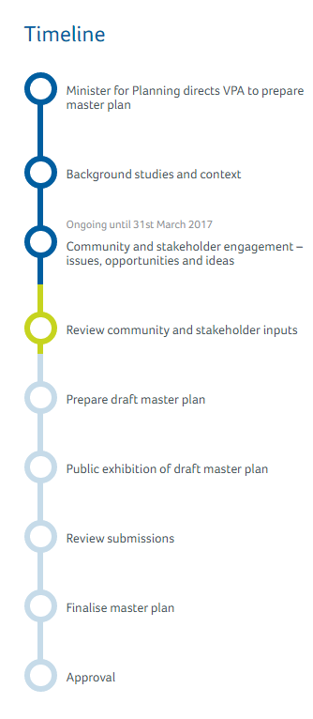The Minister for Planning has directed the VPA to engage with the community and stakeholders to develop a master plan for the site.

This plan will:

* provide a long term vision for the site
* identify an appropriate mix of potential uses
* celebrate and protect heritage values

Engagement so far

This report provides a summary of the first stage, or “Phase 1”, of community engagement for the Jacksons Hill Master Plan.

The VPA is now working with its partners to prepare a draft master plan for the site. There will be an opportunity for the community and stakeholders to provide feedback on the draft plan. Feedback will be analysed and incorporated into the plan where appropriate. The last step will be to finalise the master plan.

Phase 1 of the engagement program commenced in late 2016 when the VPA began meeting with resident and community groups in some targeted briefings.

On 28 February 2017, a community ideas workshop was hosted at the Sunbury Bowls Club. This events also launched a month-long online interactive ideas map, which allowed users to submit their ‘likes’, ‘issues’, ‘ideas’ and ‘stories’. From March to April 2017, written submissions were also accepted by the VPA project team.

All types of consultation methods are summarised is this engagement report.

Figure 1 - Project timeline

# How we engaged

Graph - Engagement participation data

Engagement framework

The engagement activities undertaken in this first phase of the Jacksons Hill Master Plan have been based on the International Association of Public Participation’s (IAP2) Public Participation Spectrum (see Appendix 1). The VPA designed its engagement approach to inform, consult and involve the community at each stage of the decision-making process.

It is hoped that at the end of the master plan process, participants will feel consulted and involved. All participants should have a strong understanding of the impact and influence of their feedback on the plan, including why the VPA chose to incorporate or exclude some suggestions in its final master plan.

Engagement purpose

The purpose of the engagement was to:

* introduce the project to the community
* determine the key ideas, likes, issues and stories the community have in relation to the site
* inform the development of an overall vision for the project which responds to community and stakeholder aspirations for the site’s future role and use

Engagement activities

The VPA engaged with stakeholders and the community in a number of ways. These approaches were used to ensure anyone interested in the project had the chance to be inform the master planning at an early stage. The VPA opted to run online and face-to-face engagement, in order to maximise participation opportunities for local residents, businesses and community organisations.

Community Ideas Workshop

The VPA met with over 180 Sunbury community members at a Community Ideas Workshop on 28 February, 2017. Attendees heard presentations from both the VPA and CHC Architects, which covered the history, background, and key issues and opportunities associated with the site. Each presentation was followed by a short question-and-answer session.

Following this, attendees broke away into smaller groups to share likes, ideas, issues, stories and the elements they liked about the Jacksons Hill project area. Workshop stations were organised around the following five master plan principles:

1. **Protect and celebrate the heritage values of the site**
2. **Strengthen the education, community and arts offering**
3. **Support a mix of complementary uses to build a vibrant place**
4. **Improve access to the site and surrounding areas**
5. **Require high quality design of buildings and public realm**

The Community Ideas Workshop provided the VPA with a sound understanding of the community’s aspirations for the site, which are outlined later in this report.

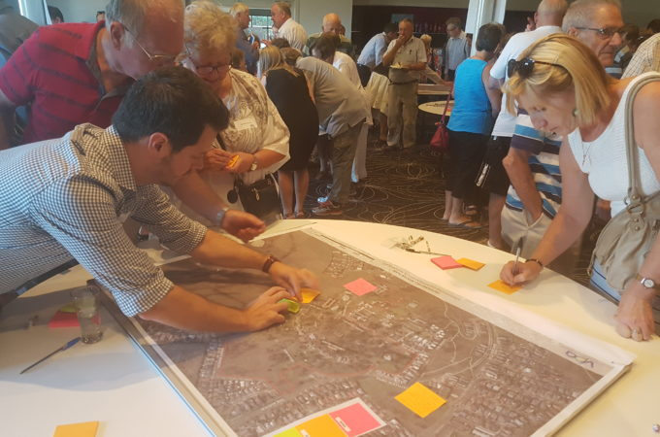

Figure - Community Ideas Workshop, 28 February 2017

Interactive online map

Following the Community Ideas Workshop, the VPA launched an online, map-based, interactive engagement platform. This map was embedded within the VPA’s website and allowed people to drop ‘pins’ on a map of Jacksons Hill, categorised into ‘likes’, ‘issues’, ‘ideas’ and ‘stories’. The interactive map also allowed participants to discuss ‘pins’ and support comments made by other submitters. The map closed on Friday 31 March, with 121 participants actively taking part in the map and a further 985 participants accessing the website to read what others were saying. A detailed report was prepared to analyse the interactive online map component of the engagement (see Appendix 2).

You also view an [interactive map on our website](https://vpa.vic.gov.au/project/jacksons-hill-masterplan/) showing all the comments people made.

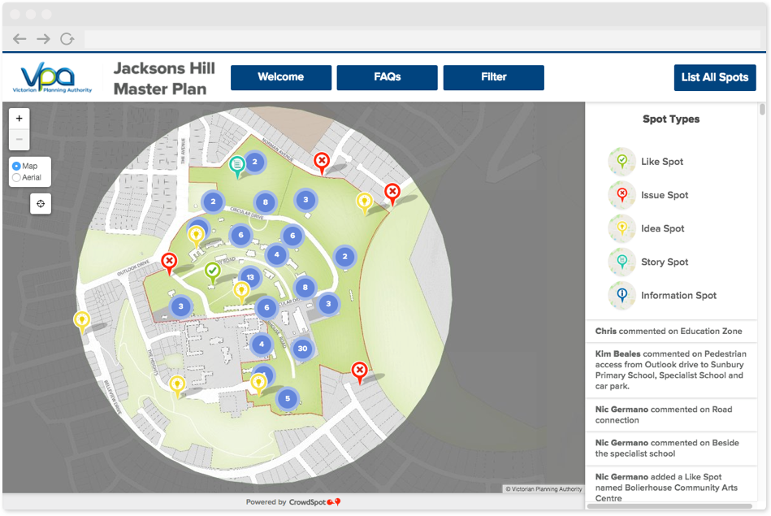

Figure - Screen capture from the interactive map

Other comments

VPA received twelve written submissions by email and through the VPA website electronic form. VPA planners also spoke to dozens of stakeholders by phone providing further invaluable feedback.

Targeted briefings

VPA staff held more than fifteen targeted briefings with groups and individuals. Groups we met with included:

* Sunbury Community Health
* Sunbury Primary School
* Sunbury and Macedon Ranges Specialist School
* National Trust of Australia (Victoria)
* Sunbury Progress Association
* Sunbury Asylum Alliance
* Sunbury Community Arts Network
* Sunbury Residents Association
* Radio 3NRG
* Sunbury Historical Society
* Sunbury Woodworkers Club
* Hume Men's Shed
* Sunbury U3A

# 

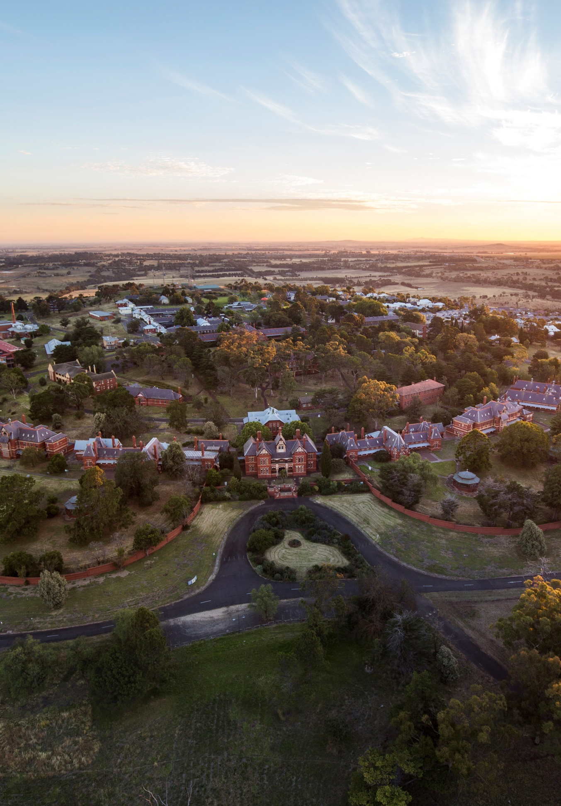

Figure - Aerial photograph of the site

# What we found

Questions that were raised

Following each presentation at the Community Ideas Workshop, the VPA opened the floor to questions from attendees.

Some of the questions that were raised following the first presentation by the VPA included:

* How long will the master plan take?
* How will you get people to the site? Where is the infrastructure?
* Will the government buy the site back from Victoria University?

The second presentation by CHC Architects was followed with questions including:

* Will this presentation be circulated?
* What size are the original cells in the buildings?
* How will people access the buildings?
* Are the current roads set to become thoroughfares?
* The site is currently zoned for education, does this mean nothing else can go there?

Key themes

Feedback generally aligned with the following themes:

* heritage values
* access and movement
* open space and landscape
* mix of uses
* maintenance and security

Heritage values

The community expressed a strong desire for Aboriginal and post-contact heritage values of the site to be recognised. This recognition includes sharing stories from previous occupation and use to restoring and celebrating the value of existing heritage-listed buildings and landscape features.

**“Preserve heritage characteristics.”**- Community Ideas Workshop

Access and movement

Key priorities for access and movement include safe management of vehicle movements, providing a new connection to the site from The Heights, ensuring that car parking opportunities are retained and improved, providing public transport access to the site, and improving pedestrian access. Ensuring that public access to the site is provided is also a priority for the community.

**“I love walking through the central body of buildings.   
Please maintain this open access throughout with a walking track network.”**- Community Ideas Workshop

Open space and landscape

While the site is owned by Victoria University, some areas are used by the community for informal recreation. Priorities for open space and landscape include providing open space areas for sport and informal recreation purposes, providing opportunities for barbeque and picnic areas, and including space for outdoor events and markets. The formal garden qualities around the heritage core are valued by the community.

**“*Please keep the open land surrounding the site for now and future generations to use as a recreation area and to appreciate the heritage buildings from this perspective...”***- Extract from comment on interactive map

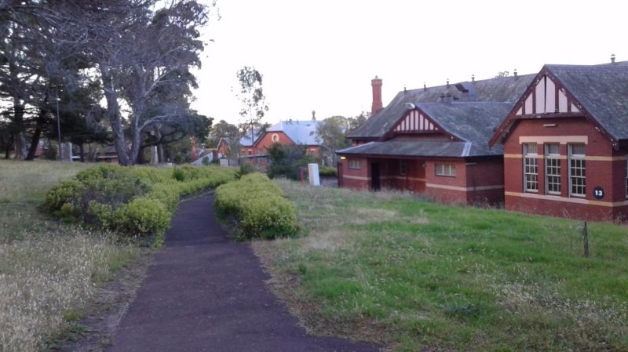

Figure – Formal landscape area in the heritage core, photo pinned to interactive map by Linden

Mix of uses

**“Victoria's restaurant was a great place to sit and eat - what a waste to have lost it.   
Surely it could be redeveloped without too much effort?”**   
- Community Ideas Workshop

A wide range potential uses for the site were identified. Community, education and training, creative and cultural, and food and beverage uses were well supported. A range of other uses were also identified as contributing to the overall vibrancy and activation of the site.

Comments made during the question-and-answer sessions at the Community Ideas Workshop demonstrate concern about the site being developed for residential purposes. Similar views were also mentioned in some targeted stakeholder briefings and, to a lesser extent, through the online engagement. Views on residential use of the site ranged from not wanting any housing on the site, to support for some housing in areas of lower heritage sensitivity.

Ideas for hotel and short term accommodation, as well as opportunities for retirement, aged care and supported living were shared by the community.

**“Love the idea of a first class hotel that maintains heritage.”**  
- Community Ideas Workshop

Graph – Preferred future uses for the site identified in the Community Engagement Workshop

Maintenance and security

A number of comments address a need for improved maintenance, and concerns with vandalism and other anti-social behaviour at the site.

There is particular concern that heritage buildings and structures are not being appropriately protected and maintained.

**“If the current vandalism continues there will be nothing left to develop - action not words.”**  
- Community Ideas Workshop

Figure 6 - Tyre marks from ‘hooning’ on the site, photo pinned to interactive map

Big ideas

A number of specific ideas for the site were shared through the engagement. We have identified the top fifteen ideas and will investigate opportunities to support these through the master planning, where possible. Some of the ideas are medium and long term propositions that will require significant financial and stakeholder support. Other ideas may be suitable to support early activation of the site.

Ideas with higher levels of support will generally be a focus for short-term outcomes in the draft master plan.

Graph – Top fifteen ideas captured from all engagement sources

Performance and events space

The Boilerhouse Theatre is a highly valued cultural asset for the community.

In addition to the need for upgrades to the existing theatre, there is a desire for increased performance capacity as well as facilities for conferences, events, and dance and exercise classes.

Figure 7 - Boilerhouse theatre,   
photo pinned to interactive map

Expand Specialist School

**“…It seems that it would only be just that consideration be given to enabling the Specialist School to expand its educational provision in the buildings that once, in the dim dark ages, housed both children and adults with intellectual disabilities in institutional care.  
Surely our kids deserve this.”**  
- Extract from comment on interactive map

Expanding the Sunbury and Macedon Ranges Specialist School emerged as strong idea, particularly through the online engagement. Ideas included expanding into existing nearby buildings, and improving traffic access and car parking from The Heights.

Food precinct

There was strong support for food related uses at Jacksons Hill. Ideas included simply a having the opportunity to buy a good coffee, through to supporting boutique food, wine and beer industries, and reopening the former Victoria’s Restaurant.

Vocational training centre

A number of submissions addressed a desire for the site to support training and vocational education. The site has a legacy of education and training, and this was identified as an important attribute that the community would like to see retained within the future use.

Gallery and creative studios

**“…Rooms for rent (small cells) for artists, office use, small stores such as local made goods.”**   
- Community Ideas Workshop

There was broad ranging support for the site’s creative industries. A number of submissions included ideas for gallery and studio spaces for artists, film makers and crafts people.

Hotel and accommodation

A range of ideas for hotel and accommodation uses were suggested. The heritage buildings are seen as an asset that could support boutique hotel accommodation. Other ideas include short-stay and supported living opportunities for people with disabilities, as well as aged care and respite accommodation.

Community ‘shed’

A number of ideas addressed the potential for community spaces at the site. Some spaces, such as meeting rooms, could be shared between groups. However, there is also a need for secure spaces, including offices and workshops.

Recreation space

There is support for provision of recreation space as part of the master plan. Ideas included a major sporting complex involving ovals and courts, a running and walking trail, off-leash dog area, equestrian club, children’s play area, as well as barbeque and picnic facilities.

Secondary school

Some comments related to an interest in seeing secondary education provided at the site. Most comments on this issue identified a Government secondary school as being appropriate and complementary to the other education uses adjacent to the site.

Productive landscape

There is an aspiration to use some areas of the site for productive uses, including growing food for use in an on-site restaurant, education and research. A community garden was also suggested.

Museum and cultural centre

**“Given the history of the site a museum devoted to remembering the impacts of mass institutionalisation of children, women and people who were diagnosed as having a mental illness would be apt. It may also act as a memoriam and place of healing for people.”**   
- Comment on interactive map

The layered Aboriginal and post-contact heritage associated with the site and local area are valued by the community. There is a desire to see this important heritage acknowledged and interpreted through a museum or cultural centre at the site.

Formal gardens

The existing gardens that surround the buildings in the heritage core are clearly valued by the community. Some submissions proposed ideas for formal or botanic gardens at the site that could showcase indigenous plants.

University

The closure of Victoria University’s campus on the site is keenly felt by the community. Some ideas proposed re-opening a university campus on the site.

Market

The potential for Jacksons Hill to support a market, with a focus on produce and crafts was identified as an opportunity to activate the site and promote local industries and identity.

Archive centre

There is some support for an archive centre to be developed on the site.

# Evaluation and next steps

Were the engagement objectives met?

The objectives of Phase 1 engagement were:

* stakeholders understand the process of developing the plan and how they can provide ideas and feedback
* stakeholders recognise that the process of gaining their feedback has been inclusive, transparent and thorough
* current and future users of the site are both given opportunity to influence the master plan
* the views of landowners and occupiers, community members including residents and local businesses, and potential investors about the project area are well understood
* stakeholders understand the engagement timeline and opportunities for input

The VPA believes that Phase 1 engagement was successful in gathering information about the views of stakeholders. Many of these views will be reflected in the draft master plan.

Feedback about the engagement process was generally very positive and also suggested that the planning process for Jacksons Hill is better understood following engagement.

Insights and observations

As part of its engagement practises, the VPA asked attendees of the workshop to complete an optional exit survey. From this, the VPA has learnt that the main reason for people to attend was for the chance to express views and ideas about the area’s future planning. Learning more about the planning process was also a popular reason.

55% of workshop attendees who responded to the survey learnt of the workshop via direct mail, and 40% of respondents saw one of three newspaper ads. Most people said the event start time was ‘good’, as was the event duration. Event promotion was viewed as ‘satisfactory’. Of the answered surveys, 50/54 said they would attend a similar event in the future, and 48 people said the workshop helped improve their understanding of the VPA’s role in the project.

Review of approach and suggested improvements

The VPA reviews every engagement event it hosts, to build on success and amend processes that didn’t hit targets. Following this review, we have identified some areas for improvement:

Community Ideas Workshop

#### Improved registration process

The Community Ideas Workshop had higher than expected attendance. The VPA was not clear of its requirements that attendees should register their interest in attending prior to the event. In the future, we will aim to run a more streamlined registration process to better capture the volume of our audience.

#### More question and answer time in a different format

We heard that not all participants felt they had the chance to ask their question on the night. If we ran another workshop, we would ensure more question and answer time was allocated. We would also consider adopting an ‘expert panel’ to answer questions more specifically.

#### Presentation copies to hand out

Some feedback indicated that it would have been more convenient to attendees if they could follow the presentations while they were happening. The VPA made both presentations on the night available online, but in future, we will print copies of the presentation for attendees to use.

Interactive online map

#### Improved opportunities for a young and older people to participate

The interactive map allowed people to easily share ideas and participate in the discussion about the future of the site. Whilst most age groups are represented in the online participation, there was limited participation from people over 60 years of age and, more particularly under 24 years of age. In the future, VPA will work to improve awareness of the project engagement with people in these age groups.

Next steps

The VPA is currently working with Hume City Council, and government departments and agencies to develop a draft master plan. This draft plan will incorporate many of the themes and ideas gathered through this consultation.

We will return to the community with a draft master plan for further comment later in the year.

# Appendicies

You can find the following appendices on our website at [vpa.vic.gov.au](http://www.vpa.vic.gov.au/) or by using the links below:

[Appendix 1](http://vpa.vic.gov.au/wp-content/uploads/2017/06/IAP2_Public_Participation_Spectrum.pdf)

[International Association of Public Participation (IAP2) Public Participation Spectrum](http://vpa.vic.gov.au/wp-content/uploads/2017/06/IAP2_Public_Participation_Spectrum.pdf)

[Appendix 2](http://vpa.vic.gov.au/wp-content/uploads/2017/06/Jacksons-Hill-Phase-1-Engagement-Appendix-2.pdf)

[Engagement report for interactive map](http://vpa.vic.gov.au/wp-content/uploads/2017/06/Jacksons-Hill-Phase-1-Engagement-Appendix-2.pdf)

(section break for back page – do not delete)

(back page – do not delete)

Contact us

Call **(03)** **9651 9600**  
or email **info@vpa.vic.gov.au**

Victorian Planning Authority  
Level 25, 35 Collins Street  
Melbourne VIC 3000

**vpa.vic.gov.au**