SCHEDULE 2 TO THE COMPREHENSIVE DEVELOPMENT ZONE
--/--/2017
Proposed C207
Shown on the planning scheme map as CDZ2.
BERWICK HEALTH & EDUCATION PRECINCT COMPREHENSIVE DEVELOPMENT PLAN (‘The CDP’)
Land
Map 1 to Schedule 2 to Clause 37.02
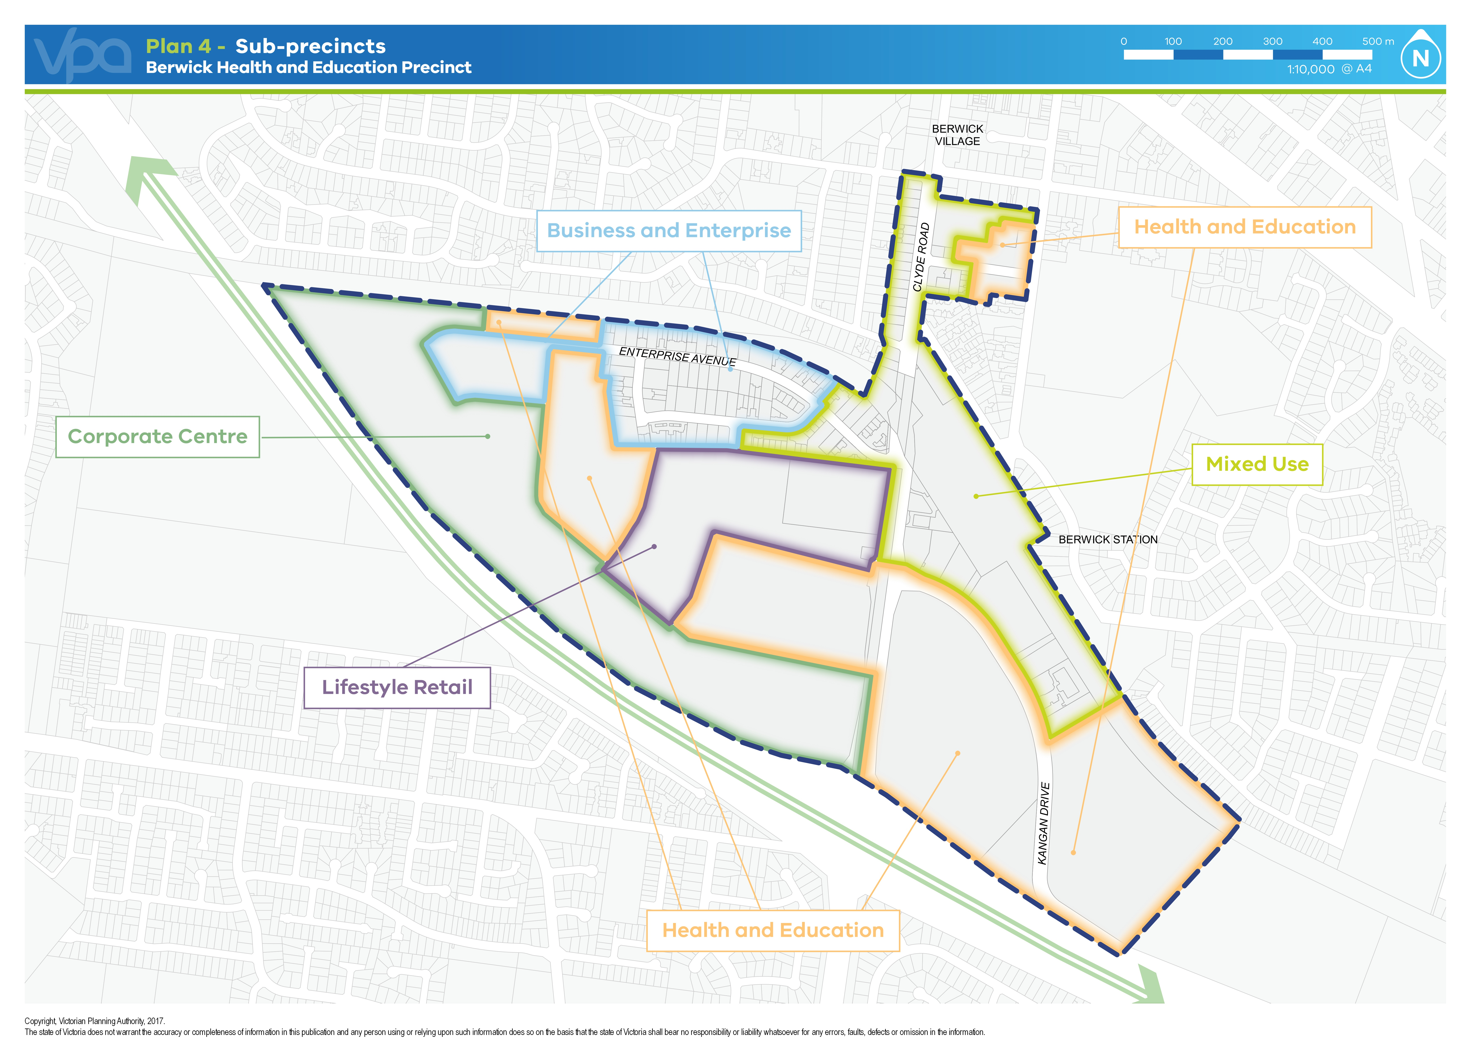
Purpose
To facilitate intensive business and employment activity.
To promote health, education and related uses.
To facilitate high density residential, retailing and services in appropriate locations.
To provide for the development of integrated transport, utility and open space networks.
To facilitate building, street and site design that enhances amenity for pedestrians.
- Table of uses
--/--/2017
Proposed C207
Section 1 - Permit not required
Use | Condition
Accommodation (other than Camping and caravan park, Corrective institution, Dependent person’s unit and Residential aged care facility) | Must be in the Mixed Use or Lifestyle Retail sub-precincts; and  Any frontage at ground floor level must not exceed 2 metres (other than a bed and breakfast and caretaker's house);  or  Must be in the Core Health and Education; and  Must be student housing.  A dwelling must not have a frontage at ground floor level of more than 2 metres.
Art gallery
Caretaker’s house
Child care centre | Must not be in the Buisness & Enterprise or Corporate Centre sub-precincts.  The gross floor area of all buildings must not exceed 250 square metres.
Convenience shop
Dependent person’s unit | Must be the only dependenet person’s unit on the lot.
Education centre (other than primary school)
Emergency services facility
Exhibition centre  Function centre | Must be in the Mixed Use, Lifestyle Retail or Corporate Centre sub-precincts.
Home occupation
Hospital
Indoor recreation facility | Must be in the Mixed Use or Lifestyle Retail sub-precincts.  The gross floor area of all buildings must not exceed 500 square metres.
Office
Place of worship | The gross floor area of all buildings must not exceed 250 square metres.
Research and development centre  Research centre | Must not be in the Mixed Use or Lifestyle Retail sub-precincts.
Residential aged care facility | Must be in the Health and Education sub-precinct.
Restricted recreation facility | Must be in the Mixed Use or Lifestyle Retail sub-precincts.  The gross floor area of all buildings must not exceed 500 square metres.
Retail premises (other than Gaming premises, Hotel, Supermarket and Tavern) | Must be in the Mixed Use and Lifestyle Retail sub-precincts.  Must be south of the rail line.
Supermarket | Must be south of the rail line within the Mixed Use sub-precinct.  Must be no more than 1,500 sqm.  Must not be the only use in the building.
Tramway
Warehouse | Must be in the Business & Enterprise sub-precinct.  Must not be a use listed in Clause 52.10.
Veterinary centre | The gross floor area of all buildings must not exceed 500 square metres.  Animals kept on the premises must be accommodated indoors.
Any use listed in Clause 62.01 | Must meet the requirements of Clause 62.01.
Section 2 - Permit required
Use | Condition
Accommodation (other than dwelling) – if the Section 1 condition is not met | Must be in the Mixed Use or Lifestyle Retail sub-precincts.
Agriculture (other than Intensive animal husbandry)
Amusement parlour  Hotel | Must be in the Mixed Use or Lifestyle Retail sub-precincts.
Industry (other than Materials recycling, Refuse disposal, Research and development centre, Rural industry, Service Industry) | Must be in the Business & Enterprise sub-precinct.  Must not be a use listed in Clause 52.10.
Minor sport and recreation facility (other than Indoor recreation facility and Restricted recreation facility)
Nightclub | Must be in the Mixed Use or Lifestyle Retail sub-precincts.
Place of assembly (other than Amusement parlour, Carnival, Cinema, Circus, Drive-in theatre, Exhibition centre, Function centre, Nightclub and Place of worship)
Primary school
Service industry
Tavern | Must be in the Mixed Use or Lifestyle Retail sub-precincts.
Warehouse | Must be located in the Business & Enterprise sub-precinct.  Must not be a use listed in Clause 52.10.
Any other use not in Section 1 or 3
Section 3 - Prohibited
Use
Brothel
Camping and caravan park
Cemetery
Corrective institution
Drive-in theatre
Dwelling (other than Caretaker’s house) – if the Section 1 condition is not met
Freeway service centre
Gaming premises
Intensive animal husbandry
Leisure and recreation (other than minor sports and recreation facility)
Materials recycling
Refuse diposal
Rural industry
Saleyard
Winery
2.0 Use of land
--/--/2017
Proposed C207
A use must not detrimentally affect the amenity of the neighbourhood, including through the:
  - Transport of materials, goods or commodities to or from the land.
  - Appearance of any building, works or materials.
  - Emission of noise, artificial light, vibration, smell, fumes, smoke, vapour, steam, soot, ash, dust, waste water, waste products, grit or oil.
2.1 Remediation of potential contamination requirement
--/--/2017
Proposed C207
Before the commencement of a sensitive use on the land at 76, 76T, 77T, 100 & 120 Clyde Road, Berwick, the responsible authority must be satisfied that the environmental condition of the land is suitable for the sensitive use.
Reference document: Monash University Phase 1 Environmental Site Assessment: Berwick Campus Development, Monash University, Clyde Road, Berwick, Victoria, by Peter J Ramsay and Associates, 9 August 2016
3.0 Buildings and works
--/--/2017
Proposed C207
A permit is not required to construct a building or carry out works related to the use of the land for education or health care provided the use is carried out by or on behalf of the public land manager for the land.
3.1 Construction management plan requirement – protection of gas transmission
--/--/2017
Proposed C207
Prior to the commencement of any building or works, including demolition, on land within 50 metres of the gas easement in the incorporated Berwick Health & Education Comprehensive Development Plan, a construction management plan must be submitted to and approved by the responsible authority. The plan must:
  - Prohibit the use of rippers or horizontal directional drills unless otherwise agreed by the operator of the gas transmission pipeline.
  - Be endorsed by the operator of the gas transmission pipeline where the works are within, crossing or within 50 metres of the relevant gas transmission easement.
  - Include any other relevant matter to the satisfaction of the responsible authority.
The construction management plan must be implemented to the satisfaction of the responsible authority.
The construction management plan may be amended to the satisfaction of the responsible authority.
4.0 Requirements – use, subdivision and buildings & works
--/--/2017
Proposed C207
Any requirement in the CDP must be met.
5.0 Exemption from notice and review – use and subdivision
--/--/2017
Proposed C207
An application to use or subdivide land that is generally consistent with the Berwick Health and Education Comprehensive Development Plan is exempt from the notice requirements of Section 52(1)(a), (b) and (d), the decision requirements of Section 64(1), (2) and (3) and the review rights of Section 82(1) of the Act.
6.0 Decision guidelines – use, subdivision and buildings & works
--/--/2017
Proposed C207
Before deciding on an application to use land, the responsible authority must consider the incorporated Berwick Health & Education Comprehensive Development Plan.
7.0 Advertising signs
--/--/2017
Proposed C207
Advertising sign requirements are at Clause 52.05. Advertising Category 2 applies to CDZ2.

