Monash National Employment and Innovation Cluster
Draft Framework Plan
March 2017

CONTENTS
Executive Summary 5
Context 1
Vision 2
Principles 4
Strategic Outcomes 5
Strategic Outcome 1: Grow employment and innovation in the health, education and research precinct 6
Strategic Outcome 2: Boost jobs growth and develop attractive employment areas with business town centres 8
Strategic Outcome 3: transform the transport network to support economic growth of the cluster 11
Strategic Outcome 4: develop open space and community infrastructure 14
Strategic Outcome 5: Plan and deliver urban renewal projects and strategic sites 16
5.1 – Huntingdale activity centre 18
5.2 – Clayton activity centre 20
5.3 – Springvale activity centre 22
5.4 – PMP printing / centre road precinct 24
5.5 – Clayton business park 26
5.5 – Sandown park station precinct 28
Implementation 30
Abbreviations 32

Figures
Figure 1 Metropolitan Context Map 6
Figure 2 Monash National Employment and Innovation Cluster Framework Plan 3
Figure 3 Health, Education and Research Precinct Plan 7
Figure 4 Employment Areas Plan 10
Figure 5 Transport plan 13
Figure 6 Open Space and Community Infrastructure Plan 15
Figure 7 Huntingdale Activity Centre 19
Figure 8 Clayton Activity Centre 21
Figure 9 Springvale Activity Centre 23
Figure 10 PMP / Centre Road Precinct 25
Figure 11 Clayton Business Park 27
Figure 12 Sandown Park Station Precinct 29

Executive Summary
The Monash National Employment and Innovation Cluster (Monash Cluster) has and will continue to have the largest concentration of jobs outside of the Melbourne Central Business District. Positioned centrally within Melbourne’s south-east on key arterial roads, bus routes and the Cranbourne-Pakenham railway line, the Monash Cluster has significant investment and specialised activities providing a good foundation for the growth of knowledge industries.
Growing partnerships between the major institutions of Monash University, Monash Medical Centre, Monash Children’s Hospital, CSIRO, Australian Synchrotron with business and affiliated research and development facilities will unlock the future potential for growing employment and innovation in the precinct and surrounds.
Planning for the long term and strategic public and private investment will provide the potential to double the number of jobs in the precinct. With suitable buildings, services and facilities to serve a new breed of worker and increased accessibility for established and growing areas of Melbourne’s south-east it will thrive.
The Monash National Employment and Innovation Cluster Framework Plan (the framework plan) sets out a shared vision for the next 30 years to build on the cluster’s key assets and boost local employment by defining actions to improve the amenity of the cluster, encouraging new services and businesses to establish, improving transport links and public transport and creating partnership groups to coordinate business attraction and investment.
The plan gives the Victorian Government, Councils, developers, business and residential communities greater certainty and confidence about future development within the Monash Cluster.
The framework plan outlines a range of strategic priority outcomes to achieve this vision, including:
- Identifying priority projects and partnerships to support implementation of the framework plan;
- A transport plan to increase sustainable transport options and address congestion issues;
- Investigating high capacity public transport projects for Monash University and Monash Technology Precinct;
- Accelerating Westall Road extension project delivery;
- Planning for new business town centres and review of urban design guidelines for development in the Monash Technology Precinct;
- Precinct planning around railway stations and the Health, Education and Research Precinct to support local living and working opportunities; and
- Planning for mixed use urban renewal projects at strategic sites, e.g. Clayton Business Park and PMP Printing (Clayton).
The framework plan is an important step forward in the implementation of Plan Melbourne 2017-2050. It is a coordinating action plan aimed at increasing employment by driving economic growth in the suburbs through coordinated public and private investment. The plan shows that Monash Cluster is “open for business”, that there is a clear investment pipeline and a plan for how this city-shaping project will be delivered.

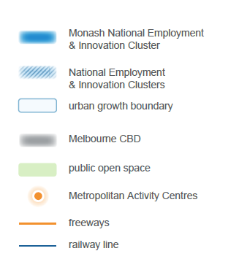
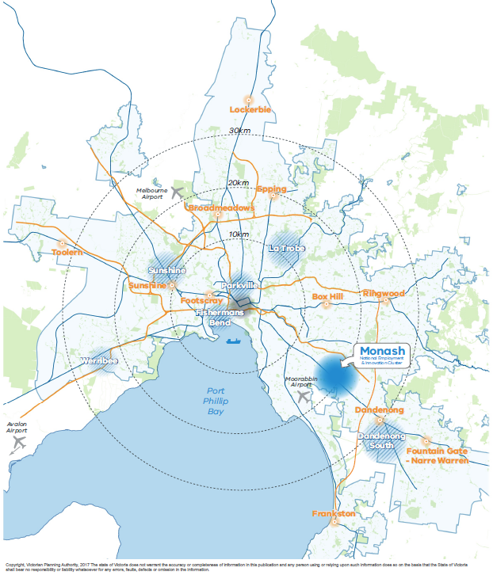
Figure 1 Metropolitan Context Map

Context
The population of metropolitan Melbourne is forecast to grow to 7.9 million people by 2050. The state government’s strategic planning policy, Plan Melbourne 2017-2050, provides directions to successfully navigate the challenges associated with this growth.
It describes Melbourne as a city of centres linked to regional Victoria. The focus of which is to achieve a productive city that attracts investment, fosters innovation and creates jobs. Driving investment into areas with the potential to foster innovation and growth of the knowledge industries will help sustain an increase in jobs at pace with population growth.
The Monash Cluster is one of seven major agglomerations of health, education and employment activities identified within Plan Melbourne. Focussing on these agglomerations and connecting them to bring jobs closer to where people live will help to reduce travel times, minimise greenhouse gas emissions and enable greater localisation of activities which contribute to enhanced liveability.
The Monash Cluster is located 20km south-east of central Melbourne and is a significant contributor to the national economy. It supports approximately 75,000 jobs across a diverse range of industries and contributes over $9.4 billion to the Victorian economy each year. It is anticipated that employment numbers within the Monash Cluster have the potential to double over the next 35 years.
With the highest concentration of jobs outside the Melbourne Central Business District, nationally significant facilities, important institutions and a skilled local workforce, the Monash Cluster has all the ingredients for a successful modern business destination.
Strategic investment in the economic precinct centred upon Monash University, Monash University Business Precinct, Australian Synchrotron, CSIRO, Monash Technology Precinct, Monash Children’s Hospital and Monash Medical Centre will contribute to employment growth and ensure that the Monash Cluster has continued economic success.
The attraction of the cluster as a middle-suburban destination on the Monash Freeway and the Cranbourne-Pakenham railway line has supported investment. However, increased road congestion, changing business needs and the expectations of a new breed of workers demands innovative approaches in planning for the cluster.
The business and worker amenity is at risk of decline in some parts of the cluster. Consistent feedback on these issues have resulted in this framework plan seeking to raise the profile of the cluster, implement public transport improvements, promote public realm enhancements and establish new business town centres as destinations that are home to restaurants, cafes, hotels and retail supporting key employment areas.
The planning of the Monash Cluster has been underway since 2014. The key outcomes and principles presented in this document, have been developed through research and diverse stakeholder engagement. The plan has evolved from the earlier consultation on the key ideas in April 2016, which received strong support. Key findings of this engagement and subsequent stakeholder consultation have been incorporated in the framework plan.
The framework plan aims to facilitate economic development and foster the intensification of key commercial, education, research and health precincts. Unifying the existing world class facilities and enhancing the image and identity of the Monash Cluster as a globally competitive destination for the brightest minds and greatest innovations will support the vision for more jobs closer to where people live. Strategic sites, activity centres and neighbourhoods close to railway stations provide focal areas for addressing future housing shortages.
This framework plan is the result of research and consultation over the past three years in collaboration with the Cities of Greater Dandenong, Kingston and Monash, as well as Monash University, research institutions, major businesses, representative organisations and the local community. These ongoing partnerships are an essential part of delivering the framework plan and will be instrumental in the ongoing success of the Monash National Employment and Innovation Cluster as it continues to prosper.

Vision
The Monash National Employment and Innovation Cluster will transform and modernise over the next three decades as a connected and exciting place for employment, education, innovation, leading-edge technology and research. It will be positioned as a globally competitive value-creating economy.
The number of jobs will double over the next 35 years with a significant increase in the education, research, health, science and technology sectors. Through place-making, transformative transport projects and urban renewal investment the cluster will be further established as a highly desirable destination with the highest job density outside of a capital city CBD in Australia.
Investment in world leading assets such as Monash University, the Monash Medical Centre, CSIRO and the Australian Synchrotron will attract new research institutions and an array of internationally recognised innovative businesses. Delivery of the Westall Road link to Monash Freeway, grade separation of the Cranbourne-Pakenham rail corridor and creation of the new linear parkland will also catalyse change.
Employment areas will thrive with the development of new business town centres and the renewal of existing activity centres. This will increase local living and create a focal point for life within the cluster. Attractive and connected walking and cycling routes combined with a ‘turn up and go’ public transport network will revolutionise access and provide connections to health, education and business destinations.
Addressing investment barriers and selecting sites for strategic mixed use renewal will encourage private investment and catalyse changes in the amenity, image and function of these areas. These changes will support a viable 24 hour hub of activity serving the needs of the cluster’s major businesses, as well as the worker and resident populations.

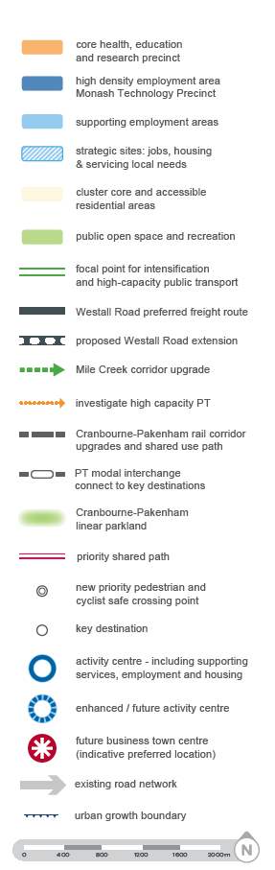
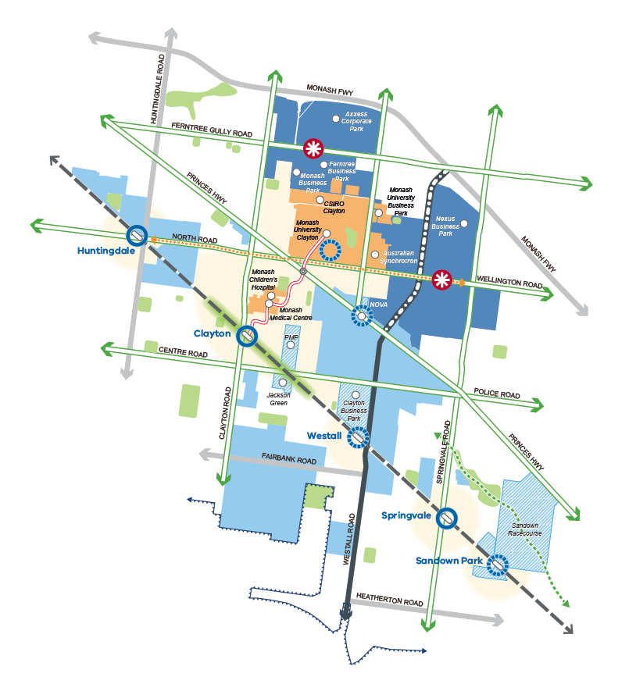
Figure 2 Monash National Employment and Innovation Cluster Framework Plan

Principles
The following principles provide a common understanding on the foundation for all future activities required to implement the vision. The principles will be used by government organisations, investors, stakeholders and communities. They are also a reference tool supporting decision-making and managing change within the cluster.

Principles
P1 | A diverse economy with local community participation.
P2 | Intensified and rejuvenated employment precincts.
P3 | Attractive, vibrant and high-quality urban environments attracting investment.
P4 | Easily recognisable destinations and activity centres where local elements are  strongly connected to the broader cluster’s sense of place.
P5 | Integrated transport networks that support economic growth.
P6 | Affordable and diverse housing that are close to jobs.
P7 | Sustainable social infrastructure and open space that meets the needs of people living, working and visiting the cluster.
P8 | Sustainable development with increased climate change resilience, integrated water management and resource efficiencies.

Strategic Outcomes
The framework plan outlines five focused strategic outcomes which build upon the aforementioned principles. These strategic outcomes provide detailed actions to realise the vision for the Monash Cluster.
The strategic outcomes below summarise the key activities that will be the focus of planning and investment in the coming decade. These are further detailed overleaf.

Strategic outcomes
SO1 | Grow employment and innovation in the health, education and research precinct.
SO2 | Boost jobs growth and develop attractive employment areas with business town centres.
SO3 | Transform the transport network to support economic growth of the cluster.
SO4 | Develop public open space and community infrastructure.
SO5 | Plan and deliver urban renewal projects and strategic sites.

Strategic Outcome 1: Grow employment and innovation in the health, education and research precinct
The Health, Education and Research Precinct encompasses the major institutions of Monash University and Business Centre, Monash Medical Centre, Monash Children’s Hospital, CSIRO and the Australian Synchrotron. These world class institutions are the major assets upon which the Monash Cluster is founded, they provide capacity for the cluster to increase employment and harness the resultant investment opportunities.
Forecast expansion of facilities at the Monash University Clayton Campus and a new Victorian Heart Hospital in the precinct will bring new opportunities that will require improved connectivity.
In particular the Health, Education and Research Precinct requires an increase in education activities, delivery of the Victorian Heart Hospital and new accommodation projects that will enable students, visiting academics, researchers and health professionals to live locally with reduced travel needs.

 | Actions | Time frame | Lead agencies
1.1 | Prepare a Structure Plan for the Health, Education and Research Precinct to:  a) Integrate land use and transport and establish walking and cycling links with safe arterial road crossings connecting from the university to research facilities, hospitals and Clayton Station;  b) Support growth of major institutions and establishment of Victorian Heart Hospital;  c) Encourage non-government investment in health, research and education activities nearby; and  d) Address the need for diverse housing opportunities within a walkable distance. | Short | VPA
1.2 | Establish a taskforce to advocate for and represent key interests from health, education and research institutions. | Short | VPA

Figure 3 Health, Education and Research Precinct Plan

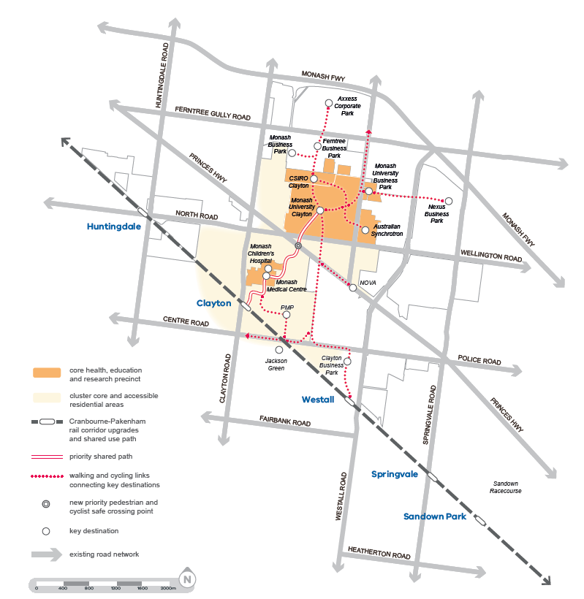

Strategic Outcome 2: Boost jobs growth and develop attractive employment areas with business town centres
To support the forecasted doubling of jobs in the Monash Cluster, a concerted effort will be required to create more vibrant activity and business centres. The cluster has been very successful as a major employment area. It must now continue to grow and modernise, in particular addressing gaps in the range of land uses and infrastructure that is sought by businesses and their employees. Addressing planning scheme limitations and investing in public transport and the public realm will catalyse positive change.
By concentrating a range of retail, business accommodation, community services and public open space within the heart of the employment areas, there will be greater potential to deliver the amenity, vibrancy and interest that is lacking in areas such as the Monash Technology Precinct. There is also increasing need to serve the employment areas with commercial, retail and entertainment opportunities which are complemented with high-quality housing nearby.
Fostering investment in the Monash Technology Precinct (high density employment area) and the industrial areas of Huntingdale, Clayton and Springvale (supporting employment areas) will also catalyse change. Diversifying business mix, taking advantage of agglomeration benefits and prioritising linkages with the health, education and research facilities will leverage opportunities for growth.

 | Actions | Time frame | Lead agencies
2.1 | Prepare a future employment and investment attraction strategy for the cluster and update planning policies for high density and supporting employment to promote investment and renewal opportunities that target jobs growth. | Short | DEDJTR
2.2 | Plan for at least two new business town centres in the Monash Technology Precinct and implement with a planning scheme amendment to:  a) Ensure the majority of employment area is within 500m walkable distance;  b) Include a mix of retail (including small supermarkets), hospitality and open space to suit business and worker needs;  c) Have convenient access to or include visitor accommodation, conference facilities; and  d) Be accessible by public transport. | Short | VPA  MCC
2.3 | Amend the Monash Planning Scheme to allow residential hotels as a permissible use within the Monash Technology Precinct to support business accommodation and conference activities that serve the employment areas. | Short | VPA
2.4 | Review the Urban Design Guidelines for the Monash Technology Precinct to support higher density employment and development of a 21st century business park environment. | Short | MCC
2.5 | Advocate for the rollout of high performance broadband to business and employment areas. | Short | DEDJTR
2.6 | Plan a network of vibrant activity centres that provide a range of services and facilities to support local living with good sustainable transport links. Refer to Strategic Outcome 5 for further detail. | Short - Medium | VPA  MCC  KCC  GDCC

Figure 4 Employment Areas Plan

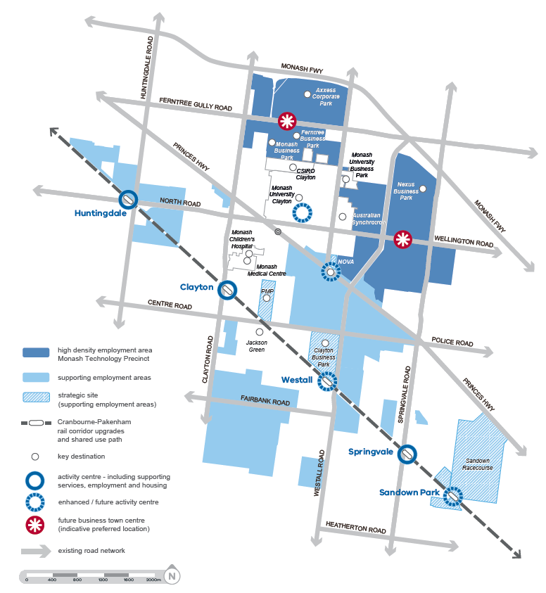

Strategic Outcome 3: transform the transport network to support economic growth of the cluster
Good transport connections to and within the Monash Cluster are critical to its success. The precinct will require a substantial shift to more walking, cycling and public transport patronage to alleviate congestion, promote commercial activity and ensure the cluster is a destination of international standing. Congestion impacts productivity and detracts from a precinct’s ability to attract employment.
With a place making role and a focus on the 10km radius of connectivity, the transport vision for the cluster and other clusters in metropolitan Melbourne will form an overlapping network within the polycentric city.
A regular mile grid and network of north-south and east-west arterial roads, the Cranbourne Pakenham railway line as well as shuttle and Smart Bus routes in the cluster offer an excellent foundation on which to overlay more convenient connections and new transport modes. A range of significant infrastructure projects complemented by small scale interventions will be required to ensure that the economic performance of the area does not decline.
 | Actions | Time frame | Lead agencies
3.1 | Plan for a range of high-frequency and high-capacity public transport solutions to be developed in the short to long term, including:  a) Investigate high-capacity public transport options to serve Monash University as well as the associated health, education and research institutions, and the Monash Technology Precinct;  b) Boost bus services along key arterial roads and connect major destinations (employment areas, activity centres and residential areas);  c) Prioritise links between key employment, retail and residential areas with the broader rail network; and  d) High-quality modal interchanges at railway stations and key destinations. | Short-  Long | TfV  VPA
3.2 | Accelerate the Westall Road preferred freight route connection to Monash Freeway, ensuring adequate levels of access in order to support the growth of local jobs. | Short | VicRoads
3.3 | Develop a high quality walking and cycling network to achieve the following:  a) Connect high demand destinations;  b) Recreational and commuter routes including continuous Cranbourne-Pakenham railway line shared path and along arterial routes connecting to the broader region; and  c) Expanding the local bike share scheme from Monash University to the surrounding areas to enable efficient and low-cost movement between key destinations. | Short-  Medium | TfV  MCC  KCC  GDCC

Figure 5 Transport plan
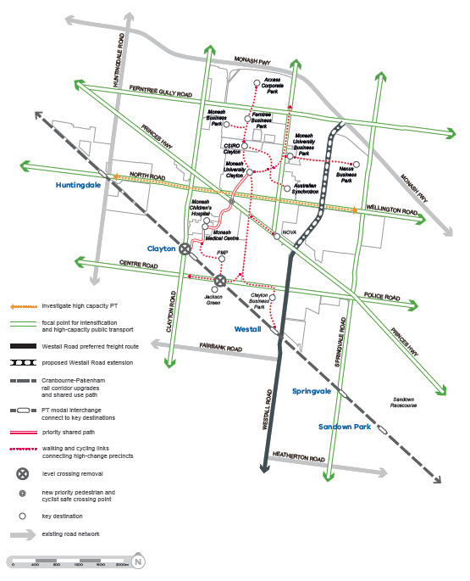

Strategic Outcome 4: develop open space and community infrastructure
A large part of the amenity and social life of the cluster is derived from the public places, buildings and services that support the needs of the local community. They offer places of respite, cultural expression and help to meet every day needs for childcare, health centres, libraries and education. Open spaces and landscaped streets also contribute to sustainability and resilience against the effects of climate change.
Community infrastructure is delivered by both the public and private sector to support the needs of the community, including workers, visitors, students and residents. Areas of higher change will require a concerted effort to plan for and deliver the types of places that meet the needs for a good quality of life. This is essential as an attractor for people who live, work in, or visit the cluster.

 | Actions | Time frame | Lead agencies
4.1 | Plan for infrastructure and open spaces within employment areas to assist in creating a sense of community and meeting worker needs such as health and fitness facilities, co-working spaces and meeting places. | Short | MCC  KCC  GDCC
4.2 | Identify community infrastructure priorities as the basis for developing an Infrastructure Contribution Plan. | Short | MCC  KCC  GDCC
4.3 | Establish public open space contribution rates that will ensure open space improvements, support anticipated change in employment, resident and visitor population needs and mitigate the urban heat island effect. | Short-  Medium | MCC  KCC  GDCC
4.4 | Develop a future education growth plan to support local population changes with appropriate expansion or upgrades to primary and secondary schools. | Short-  Medium | DET

Figure 6 Open Space and Community Infrastructure Plan
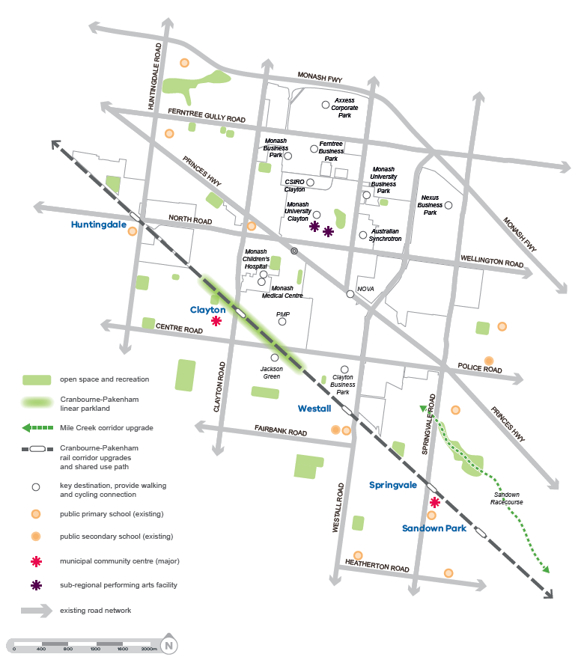

Strategic Outcome 5: Plan and deliver urban renewal projects and strategic sites
Urban renewal projects offer significant opportunities for integrated planning at the local level to address the goals of this plan and resolve specific opportunities and challenges. Planning will be delivered in a coordinated manner in the short term with development taking place in the medium to long term.
Precincts such as activity centres and underutilised industrial land offer opportunities for urban renewal.
These areas will be reimagined from segregated strip shopping centres to integrated mixed use precincts that offer a range of lifestyle activities across a larger proportion of the day and more diverse housing. Highly accessible residential areas with good access to services and facilities also offer opportunity for increased diversity of housing.
Strategic sites are places that have come to the end of Monash’s post-war manufacturing economy and are available for reinvestment. These sites require a new ‘vision’ or purpose to guide change in a way that can support the cluster.
Key precincts and strategic sites are further outlined on pages 18-30. Further work will be undertaken to scope and deliver these projects with the involvement of local communities and stakeholders.
This detailed planning work should be undertaken on the basis of the following principles:
- Optimise economic and social participation of local communities through development of ongoing local employment opportunities and new housing choices;
- Prioritise contemporary approaches to integrated mixed use development founded on walking and cycling access, and where possible maximising public transport integration;
- Establish a high standard of urban design that can contribute positively to the image and identity of the cluster;
- Plan for open spaces and landscaping that can transform the image of the precinct, mitigate the urban heat island effect, provide water retention and address recreational needs;
- Future proofing development through early planning for utilities and service provision that optimise long term efficiency and affordability;
- Social, cultural and entertainment needs of the growing and changing population are met;
- New and diverse housing around existing activity centres, in proximity to the Health Education and Research precinct, Monash Technology Precinct and at strategic sites are a priority;
- A range of housing options that provide accommodation locally for workers, students, visitors to key institutions and those choosing to age in place; and
- Address the potential risk of community displacement through the provision of social and affordable housing within the cluster.
Figure 7 Urban Renewal Precincts and Strategic Sites Plan
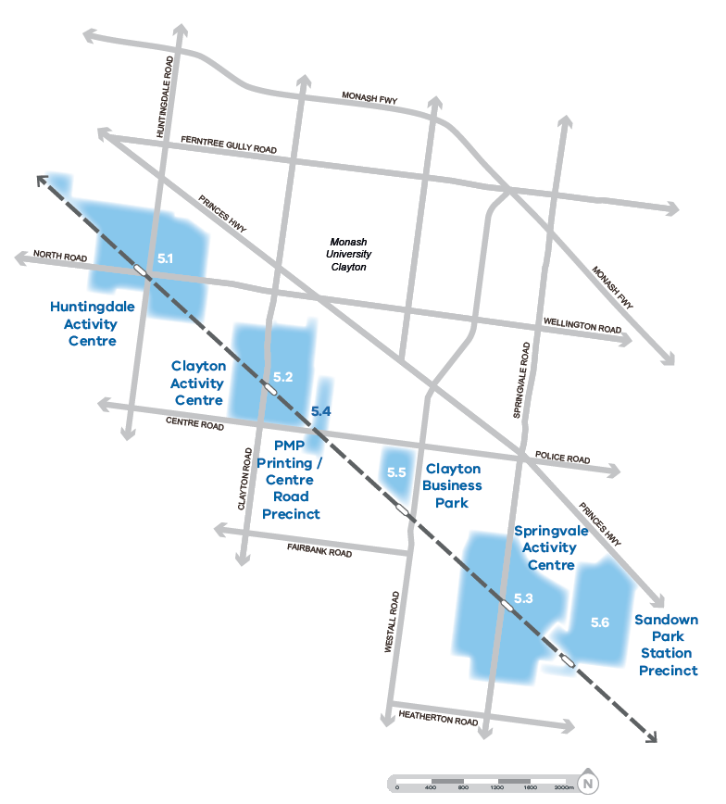

5.1 – huntingdale activity centre
Key Elements
- 238 Hectares
- Huntingdale Train Station
- Huntingdale Road strip shopping centre
- Industrial precincts aligned to the railway and North Road
- Huntingdale bus interchange
- Substantial industrial areas provide local employment
Long Term Objectives
The Huntingdale Activity Centre is an important gateway, transit interchange and node of activity for Monash University and the local community. A greatly improved public realm will change the feel of the area as a destination rather than simply acting as a transport interchange. Renewal of industrial precincts will boost local economic performance and expand the array of jobs in the cluster. Increased dwelling diversity and density will support a range of successful community, retail and recreational infrastructure.
Action
City of Monash to prepare a structure plan for the Huntingdale Activity Centre to foster the creation of a successful transport interchange, address barriers caused by road and rail infrastructure and to support renewal achieving commercial growth and residential diversity in the area.
Timing
Short term (1-5 years)
Current Status
City of Monash is preparing a project scope for future planning of the Huntingdale Activity Centre and surrounding industrial precinct. The City of Monash’s Industrial Strategy identifies the Huntingdale / Oakleigh South employment land as a future business park commercial development. Under consideration in the Monash Planning Scheme Amendment C125 is application of the General Residential Zone to much of the area, however precincts closest to the Station are identified for further work under the Monash Housing Strategy.

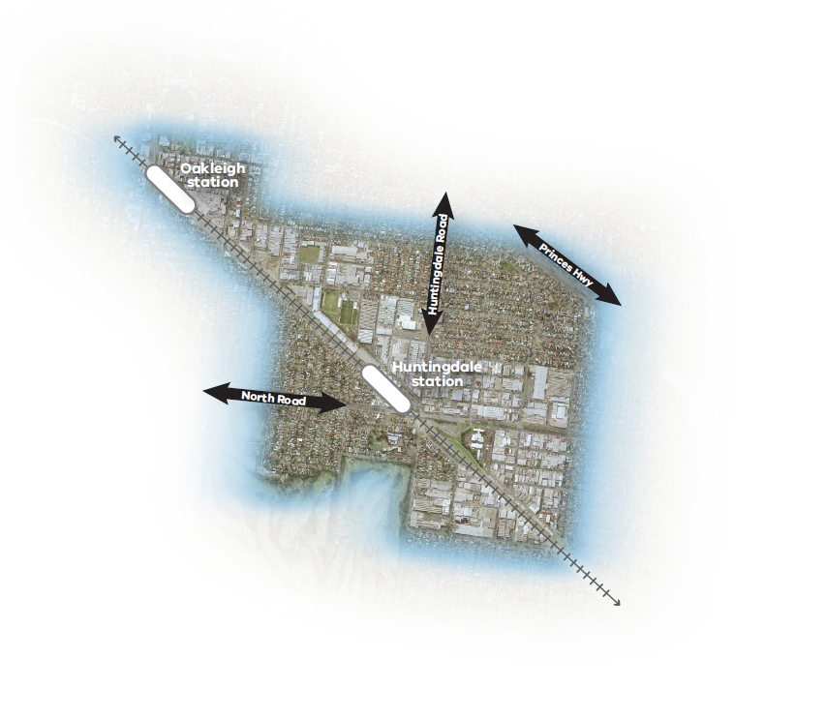
Figure 7 Huntingdale Activity Centre

5.2 – Clayton activity centre
Key Elements
- 125 Hectares
- Clayton Train Station (to be rebuilt as part of Cranbourne-Pakenham rail upgrades)
- Monash Medical Centre and Children’s Hospital
- Clayton Road shopping strip
- Proposed level crossing removals on Clayton Road and Centre Road
- Clayton Community Centre
- Fregon Reserve and Meade Reserve
Long Term Objectives
Clayton Activity Centre will be one of a series of centres in the Monash Cluster. It will be home to a diverse mix of uses that will support the local and regional community. Increased access to services and facilities, improved housing diversity and vastly improved public spaces will elevate the importance of this centre as a major destination. The level crossing removals on Clayton Road and Centre Road, provision of new public open spaces and upgrades to the railway station will be leveraged to catalyse changes nearby. These changes will further support the establishment of the Clayton Train Station transport interchange and shopping centre as a pivotal hub for the nearby Health, Education and Research Precinct.
Action
VPA (in collaboration with the Cities of Monash and Kingston) to prepare a structure plan and streetscape master plan for the Clayton Activity Centre to grow retail and employment, improve the public realm, support a greater mix of housing and develop a network of open spaces.
Timing
Short term (1-5 years)
Current Status
The VPA is currently leading the preparation of a precinct structure plan for the Clayton Activity Centre.
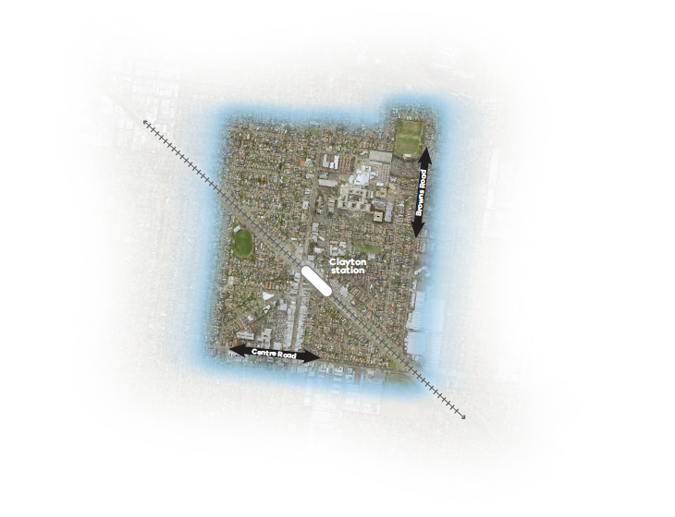
Figure 8 Clayton Activity Centre

5.3 – springvale activity centre
Key Elements
- 220 Hectares
- Springvale Train Station
- Growing night time economy and retail diversity
- Springvale Community Precinct
- Springvale Road Boulevard upgrade
- Asian Cultural Precinct
Long Term Objectives
Building on its unique cultural and food retailing strengths, Springvale Activity Centre will increasingly become a place of business growth and local employment opportunities supporting local living. A high degree of connectivity and accessibility for pedestrians and cyclists will improve movement and access. Greater housing choices and safer, more attractive streets will enliven the area. Site responsive and innovative development that achieves environmentally sustainable design outcomes and distinctive, safe and green open spaces will be provided for residents, workers and visitors to enjoy.
Action
City of Greater Dandenong to prepare a structure plan and implement public realm improvements to support the growth and vitality of the activity centre
Timing
Short term (1-5 years)
Current Status
City of Greater Dandenong are leading the preparation of the Springvale Structure Plan update. This will be finalised in 2017.
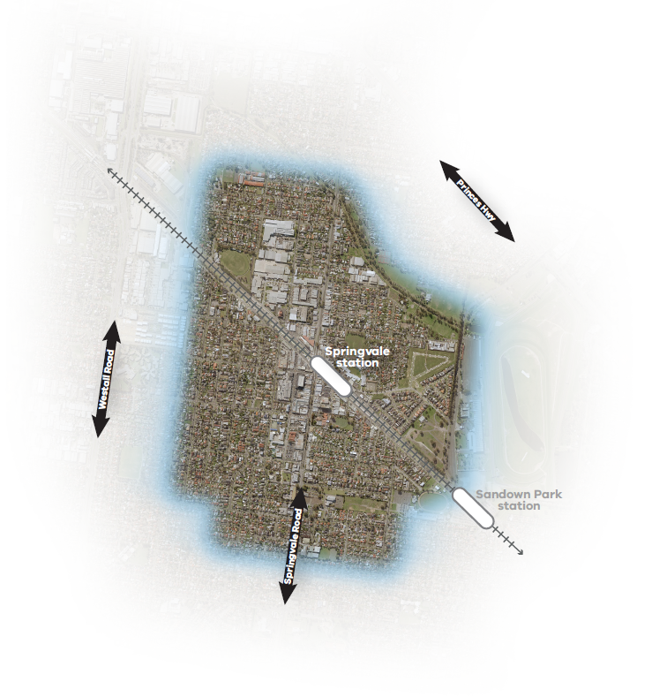
Figure 9 Springvale Activity Centre

5.4 – PMP printing / centre road precinct
Key Elements
- 22 Hectares
- PMP Printing strategic site comprises 7ha (31-49 Browns Road) and 4ha (201-209 Carinish Road)
- Adjacent Centre Road/Browns Road with the Jackson Green urban renewal site located to the south
- Bendix Drive small lot industrial precinct
Long Term Objectives
Renewal of the industrial development to complement Clayton Activity Centre and the adjacent Centre Road commercial precinct with a range of employment opportunities, diverse housing and public open space will rejuvenate and enhance the character of the precinct. Regeneration of the adjacent Commercial 1 Zone will encourage shop-top housing and retail that serves the local community.
Action
The VPA (in collaboration with City of Monash) to prepare a structure plan addressing the future of industrial land at the PMP Printing site and surrounds
Timing
Short term (1-5 years)
Current Status
The Level Crossing Removal Authority is finalising the Centre Road level crossing removal site design. VPA has commenced a process to plan the precinct with City of Monash, landowners and other stakeholders.

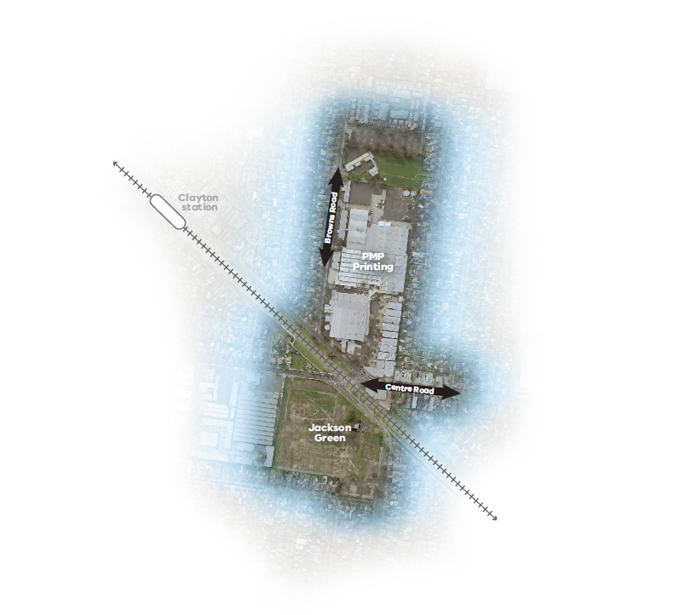
Figure 10 PMP / Centre Road Precinct

5.5 – clayton business park
Key Elements
- 31 Hectares
- Westall Train Station
- Westall Road frontage on the eastern boundary, preferred freight route
- Large industrial area to the north and east
- Westall Primary and Secondary Schools to the south
Long Term Objectives
Centred on a new high density business park with supporting retail and a mix of housing, redevelopment of the Clayton Business Park will create a contemporary mixed use precinct for the Monash Cluster. The site will offer increased access to employment, services, housing and public spaces adjacent to the Westall Train Station. The new business town centre will service the needs of the future community as well as local businesses and their employees.
Action
The VPA (in collaboration with City of Kingston and landowners) to prepare a Comprehensive Development Plan and planning scheme amendment.
Timing
Short term (1-5 years)
Current Status
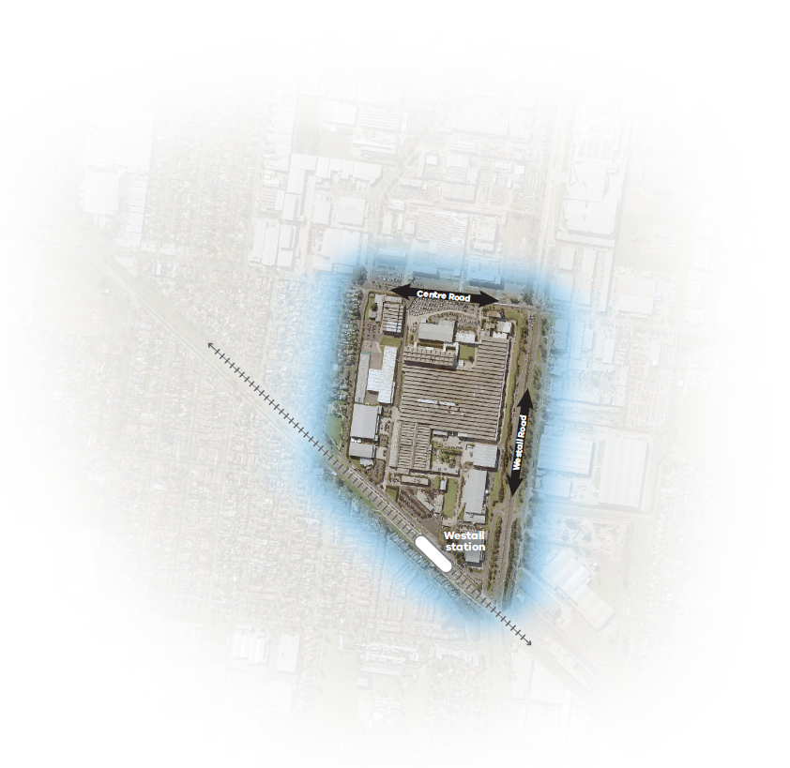
The VPA is currently working with a range of government agencies, councils and the landowner to develop a Comprehensive Development Plan for the Clayton Business Park.
Figure 11 Clayton Business Park

5.5 – sandown park station precinct
Key Elements
- 150 Hectares
- Sandown Park Train Station and Princes Highway access
- Sandown Racecourse, 110ha major cultural destination for horse and car racing facilities and function centres
- Sandown Park Greyhound, 8ha destination for greyhound racing and affiliated activities
- Good access to both Springvale and Noble Park activity centres
- Mile Creek and public reserves to the north-west and south-east
Long Term Objectives
Redevelopment within Sandown Park Station Precinct to accommodate a mix of residential, employment, retail and community uses which encourage local living and take advantage of proximity to other parts of the cluster. The Mile Creek riparian area and water management measures offer the potential to develop a distinctive urban precinct within a landscaped setting which takes advantage of the Cranbourne Pakenham railway corridor upgrades and new bus connections. The development of an activity centre, community infrastructure, open space and recreational facilities with convenient local access should be investigated.
Action
The VPA (in collaboration with City of Greater Dandenong) to prepare a structure plan for the overall precinct.
Timing
Medium term (5-10 years)
Current Status
The Melbourne Racing Club (MRC) in collaboration with the City of Greater Dandenong and Victorian Planning Authority are preparing a master plan for the Sandown Racecourse site.
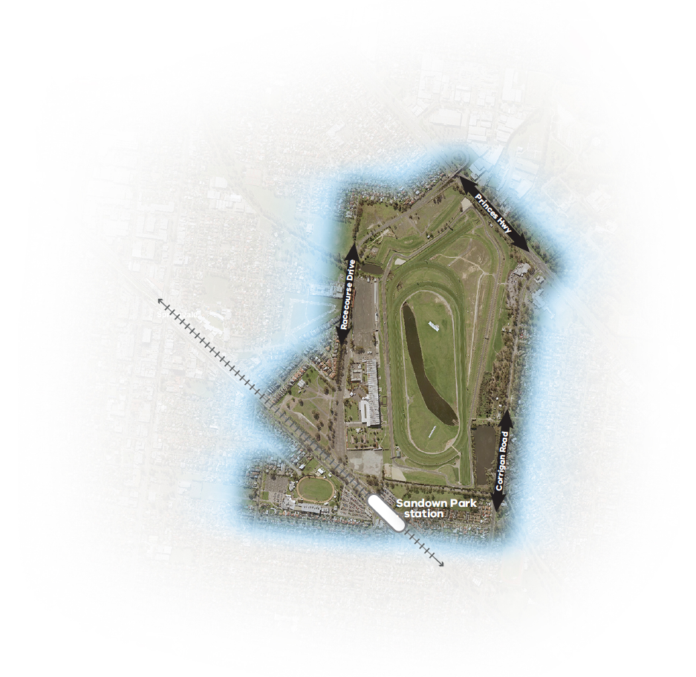
Figure 12 Sandown Park Station Precinct

implementation
Strategic Outcome 1: Grow employment and innovation in the health, education and research precinct
1.1 | Prepare a Health, Education and Research Precinct Structure Plan | Short | VPA
1.2 | Establish a taskforce to advocate for and represent key interests from health, education and research institutions | Short | VPA
Strategic Outcome 2: Boost jobs growth and develop attractive employment areas with business town centres
2.1 | Prepare a future employment and investment attraction strategy for the cluster and update planning policies for employment areas | Short | DEDJTR
2.2 | Plan for at least two new business town centres in the Monash Technology Precinct and implement planning scheme amendment | Short | VPA  MCC
2.3 | Amend the Monash Planning Scheme to allow residential hotels in the Monash Technology Precinct | Short | VPA
2.4 | Review Monash Technology Precinct Urban Design Guidelines | Short | MCC
2.5 | Advocate for the rollout of high performance broadband to business and employment areas | Short | DEDJTR
2.6 | Plan a network of activity centres that provide a range of services and facilities to support local living with good sustainable transport links (refer to Strategic Outcome 5 for detail) | Short-  Medium | VPA  MCC  KCC  GDCC
Strategic Outcome 3: Transform the transport network to support economic growth of the cluster.
3.1 | Prepare and implement a high-frequency and high-capacity public transport plan | Short-  Long | TfV
3.2 | Accelerate the Westall Road preferred freight route connection to Monash Freeway, ensuring adequate levels of access in order to support the growth of local jobs | Short | VicRoads
3.3 | Develop a high quality walking and cycling network connecting high demand destinations including between major activity nodes | Short-  Medium | TfV  MCC  KCC  GDCC
Strategic Outcome 4: Develop public open space and community infrastructure
4.1 | Plan for infrastructure and open spaces within employment areas to assist in creating a sense of community and meeting worker needs such as health and fitness, co-working spaces and meeting places | Short | MCC  KCC  GDCC
4.2 | Identify priority community infrastructure as the basis for developing an Infrastructure Contribution Plan | Short | MCC  KCC  GDCC
4.3 | Establish Public Open Space contribution rates that will ensure open space improvements, support anticipated change in employment and mitigate the urban heat island effect | Short-  Medium | MCC  KCC  GDCC
4.4 | Develop a future education growth plan to support the growing local population with appropriate expansion or upgrades to primary and secondary schools | Short-  Medium | DET
Strategic Outcome 5: Plan and deliver urban renewal projects and strategic sites
5.1 | Prepare Huntingdale Activity Centre and Industrial Precinct Structure Plan | Short | VPA  MCC
5.2 | Prepare Clayton Activity Centre Structure Plan | Short | VPA  MCC  KCC
5.3 | Prepare Springvale Activity Centre Structure Plan update | Short | GDCC
5.4 | Prepare PMP Precinct / Centre Road Structure Plan | Short | VPA  MCC
5.5 | Prepare Clayton Business Park Comprehensive Development Plan | Short | VPA  KCC
5.6 | Prepare Sandown Park Station Precinct Structure Plan | Medium | VPA  GDCC

abbreviations
CBD | Central Business District
CSIRO | Commonwealth Scientific and Industrial Research Organisation
DEDJTR | Department of Economic Development, Jobs, Transport and Resources
DET | Department of Education and Training
GDCC | Greater Dandenong City Council
KCC | Kingston City Council
MCC | Monash City Council
MRC | Melbourne Racing Club
PMP | Pacific Magazines and Printing Limited
PT | Public Transport
TfV | Transport for Victoria
VPA | Victorian Planning Authority

