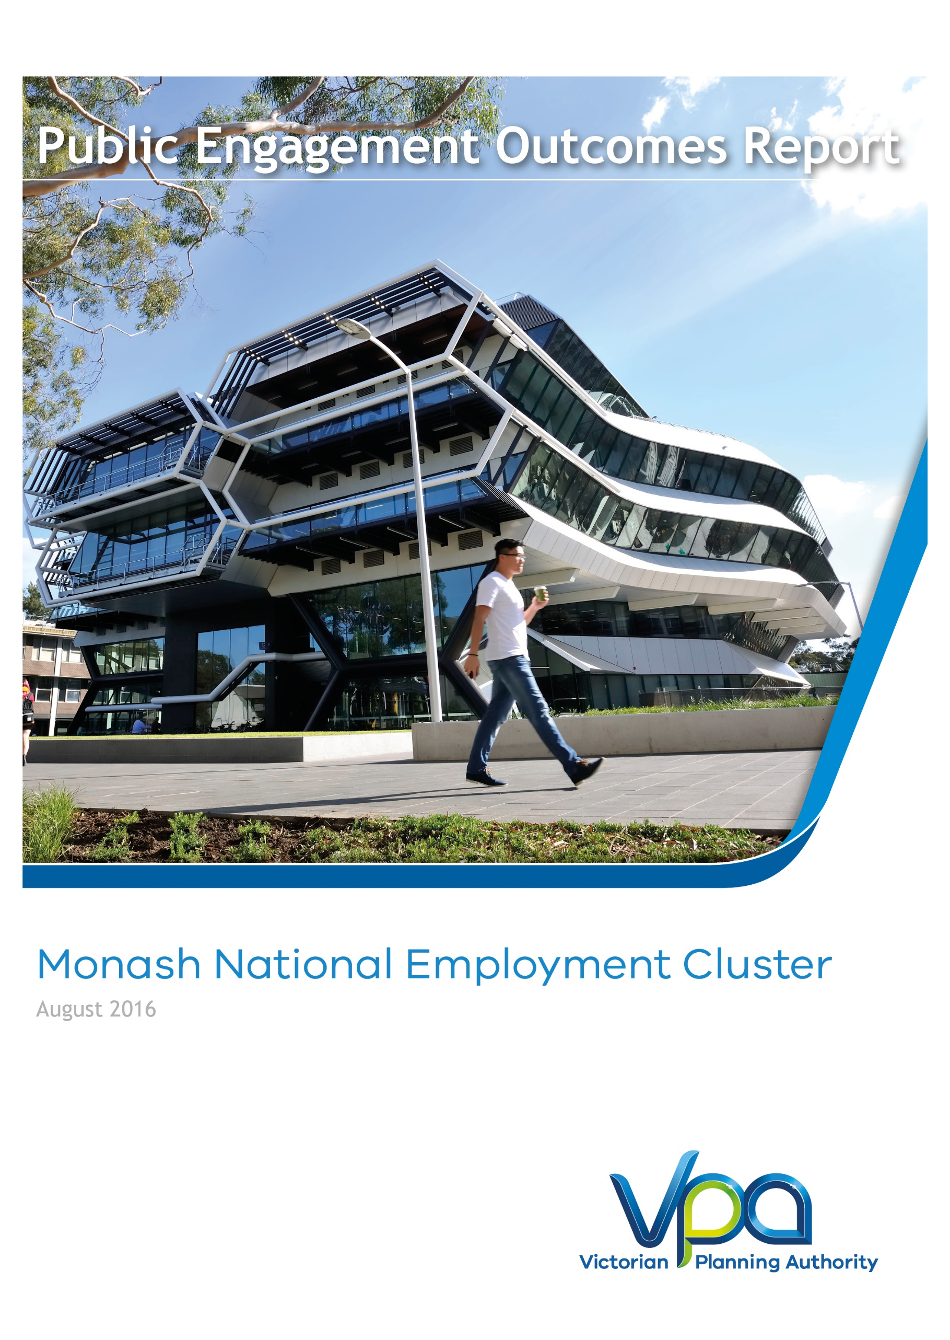
Public Engagement Outcomes Report
August 2016

CONTENTS
1 Executive Summary 3
2 Introduction 5
2.1 Purpose 5
2.2 Report Structure 5
3 Project overview: Planning for the Monash Employment Cluster 6
3.1 Context 6
3.2 Plan Melbourne Refresh 6
3.3 Monash National Employment Cluster Framework Plan 7
4 Engagement Approach 8
4.1 Phase 1 Engagement: Vision, Principles & Key Ideas 8
4.2 Phase 2 Engagement: draft Framework plan 8
4.3 Summary of Results 8
5 Engagement Program and Activities 10
5.1 Shape Victoria 10
5.2 Notification and Advertising 11
5.3 Monash Business awards 11
5.4 Monash National Employment Cluster Future Outlook Seminar 11
5.5 Business Focus Groups 13
5.6 Surveys 13
5.7 Smart Manufacturing Expo 2016 14
5.8 Ongoing stakeholder engagement 15
5.9 Culturally & Linguistically Diverse Communities 15
6 Feedback & Outcomes 16
6.1 What we Learnt 16
6.2 Vision 16
6.3 Principles & Key Ideas 18
6.4 How the feedback will be used in the Framework Plan 26
7 Process and Next Steps 27

Figures
Figure 1 - Summary of Public Engagement Activities 4
Figure 2 – Metropolitan Context Plan 6
Figure 3 – Survey Participants Relationship to the Cluster 14
Figure 4 – Participant Comments About the Monash NEC 16
Figure 5 – Vision Survey Results 17
Figure 6 – Survey results: Importance of Monash NEC Vision Key Elements 18
Figure 7 – Survey Results: Principle 1 18
Figure 8 – Survey Results: Principle 2 21
Figure 9 – Survey Results: Principle 3 23
Figure 10 – Survey Results: Principle 4 25
Figure 11 – Process and Next Steps 27

Tables

Table 1 – Public Engagement Participation Table 3
Table 2 – Public Engagement Participation Table 10

Executive Summary
Phase 1 of public engagement for the Monash National Employment Cluster (NEC) Framework Plan has been completed. It is the first phase to test preliminary ideas and help formulate the future land use, development and infrastructure planning for the Monash NEC. This report summarises the activities undertaken, the feedback and how the input will be used in shaping the content and directions for the project.
Feedback was gained via surveys, submissions, focus groups and stakeholder conversations. The VPA's aspirations for the future of the Cluster in general align with that of members of its residential, worker and business communities. VPA received many suggestions and comments as well as positive reinforcement of the directions proposed for the Cluster.
As will be further explained in Section 4, there did not seem to be any great deviation of opinion from what has been proposed for the draft Framework Plan, with majority of participants responding positively to the project’s directives. However, there were a range of contributions in regards to how best to achieve the preliminary ideas and aid the achievement of the Vision.
There was consistent feedback about the following matters which reiterated earlier surveys:
- Broad support for improvements to amenity and flexibility around commercial land uses in business and employment areas. In particular provision of hotels, convention facilities and everyday retail in/near the employment areas of the Cluster and fostering a night time economy (e.g. dining, bars, entertainment). Amenity is also about the aesthetic appeal of the areas, the character of buildings and quality of streetscapes.
- Need to address the worsening vehicle congestion with public transport and active travel (i.e. walking and cycling) solutions.
- Building the profile and identity of the Monash NEC is needed to help leverage existing investments and contribute to further business growth opportunities.
- Infrastructure supporting business growth, in particular provision of broadband with community infrastructure e.g. childcare, recreation and gyms, and open space.
- Destinations which help foster relationships and innovation, e.g. concentrations of activities that create focal points for people to come together or ‘bump into’ each other.
Overall, feedback received has been positive and constructive and has provided the VPA with a strong evidence basis from which to proceed with the drafting of the Framework Plan in the second half of 2016.
Table 1 – Public Engagement Participation Table
Date | Public Engagement Activity | No. of Participants
12 April 2016 | Shape Victoria online portal launched | 1,360 visits
13 April 2016 | Launch of Consultation at Monash Business Awards | 50 attendees
13 April - 31 May 2016 | 'Have your say' Survey | 53 responses
4 May 2016 | Monash National Employment Cluster Future Outlook Seminar | 60 attendees
10 - 19 May 2016 | Business Focus Groups (three) | 40 participants
17 May 2016 | Exhibition at the Smart Manufacturing Expo 2016 | 1,000+
31 May 2016 | Property Industry & Planning Workshop | 15 participants

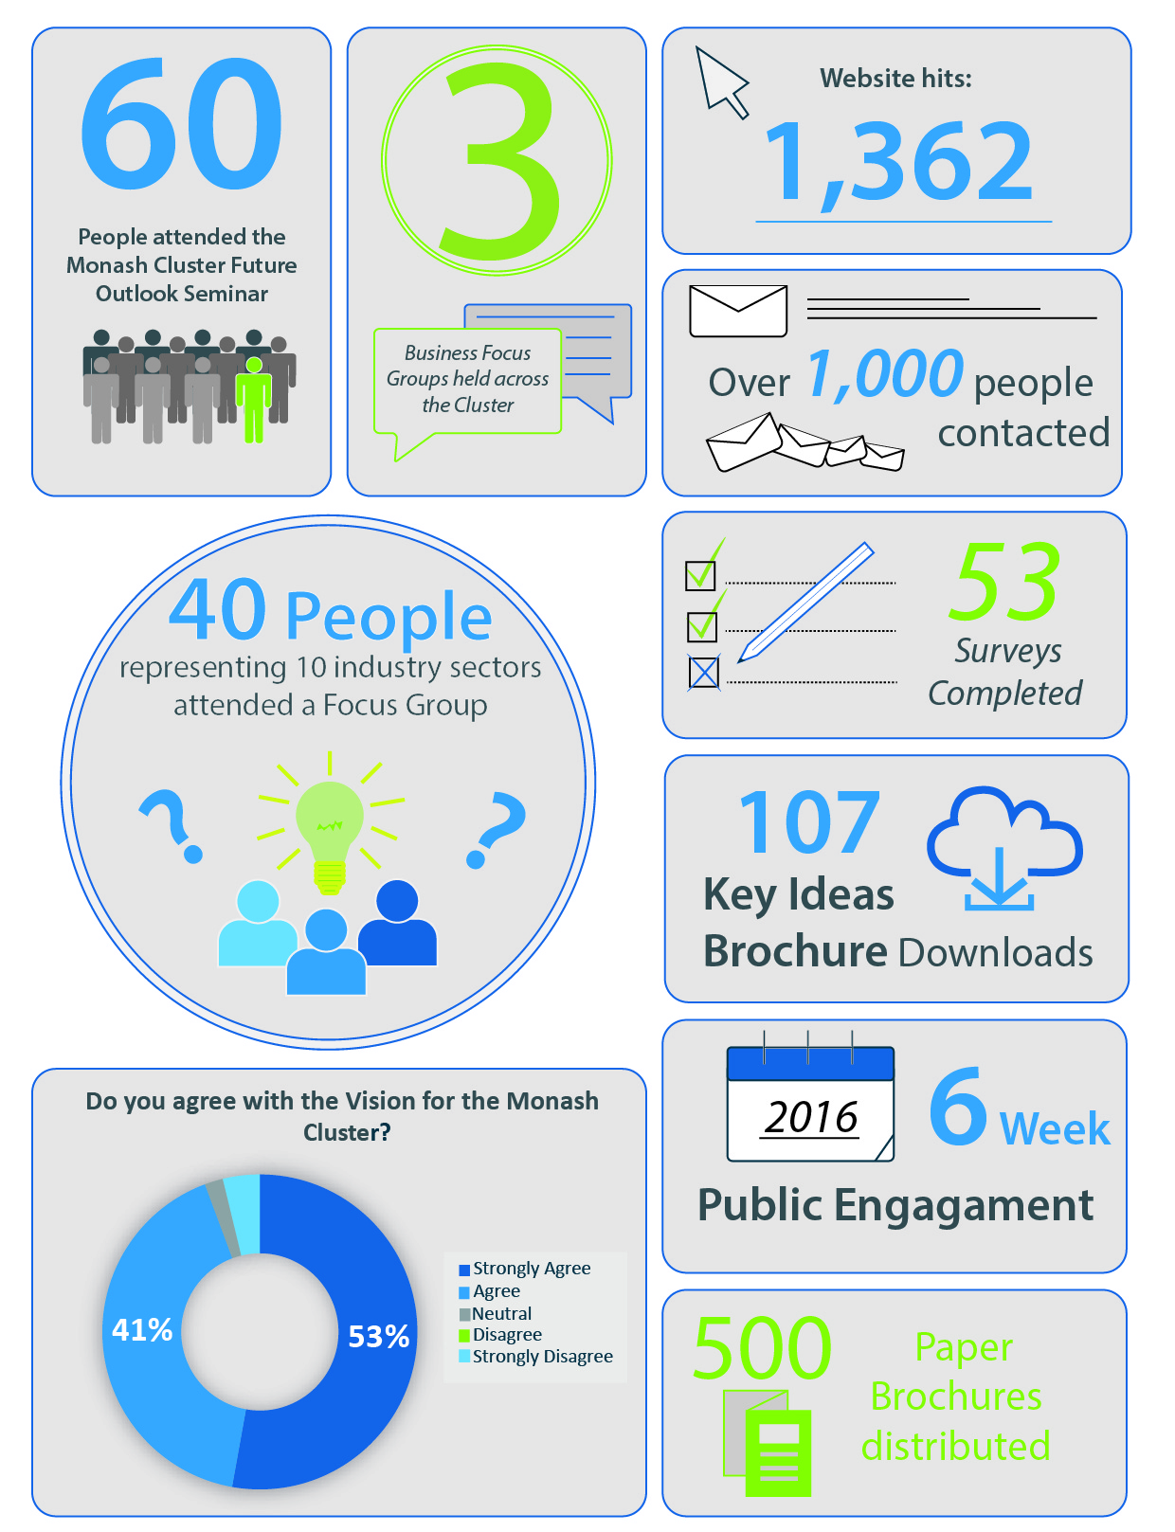
Figure 1 - Summary of Public Engagement Activities

Introduction

Purpose
This Public Engagement Outcomes Report summarises the feedback received from public engagement on the draft Vision, Principles & Key Ideas for the Monash NEC Framework Plan.
This is the first phase of public engagement to be undertaken to help develop the future land use and infrastructure planning for the Monash NEC. This report summarises the activities undertaken, the feedback and how the input will be used in shaping the content and directions for the draft Framework Plan.
Finally you may notice our organisation is now known as the Victorian Planning Authority (VPA). The VPA has succeeded the Metropolitan Planning Authority (MPA) and continues to progress projects in key precincts such as the Monash Employment Cluster. For further information see: http://www.premier.vic.gov.au/planning-for-smart-growth-across-victoria/

Report Structure
This report is broken into four sections, as follows:
Section 3: Project Overview, provides an overview of the context in which the public engagement has taken place, including the main policy drivers and why a plan is required.
Section 4: Engagement Activities, provides an overview of the engagement program and activities for the project.
Section 5: Feedback & Outcomes, summarises stakeholder feedback received on the draft Vision, Principles and Key Ideas being out forward for the Monash NEC Framework Plan.
Section 6: Next Steps, addresses how the feedback and input will be carried forward.

Project overview: Planning for the Monash Employment Cluster

Context
The Monash National Employment Cluster (NEC) Framework Plan is a collaborative project being led by the Victorian Planning Authority (VPA), in collaboration with City of Monash, City of Kingston, City of Greater Dandenong and other key State Government and agencies, and stakeholders. It aims to meet the objectives set within Plan Melbourne Refresh, the State’s metropolitan planning strategy.
By 2051 Melbourne’s population is set to increase by 3.5million, to be a city of around 8.0 million people. To accommodate this growth, an additional 1.7 million dwellings and 1.7million new jobs will need to be created. Growth of this scale requires long term planning and management to sustain quality of life and Melbourne's status, as one of the most liveable cities in the world. The VPA's role is facilitating the required land supply, and identifying opportunities to increase housing, employment and investment within the State.
Figure 2 – Metropolitan Context Plan

Plan Melbourne Refresh
Plan Melbourne Refresh is a 35 year plan for integrated land use, infrastructure and transport investment in metropolitan Melbourne. It focuses on delivering the required housing, jobs and services needed to support Melbourne’s projected growth while maintaining our quality of life for the future.
Six National Employment Clusters (NEC’s), have been identified as areas that either have established or emerging potential to provide a foundation for sustainable employment and housing densities associated with good transport connections.
Monash is Melbourne’s largest established NEC. At 82,750 jobs, it has the highest concentration of employment outside of the CBD, supporting a unique mix of health, education, research, commercial and industrial operators. Located in Melbourne’s South-East, just 20km from the CBD, Monash NEC takes in the areas of Mount Waverley, Notting Hill, Mulgrave, Huntingdale, Clayton, Springvale and Clayton South. It is serviced by Melbourne’s busiest rail lines (Cranbourne - Pakenham Rail) and benefits form a strong arterial road network, with easy access to the Monash Freeway. Due to this Monash NEC has potential to be an even greater magnet for investment, jobs, services, businesses and housing for the future.

Monash National Employment Cluster Framework Plan
Monash NEC is an area that has been historically established around traditional forms of manufacturing industry and logistics. However, a changing market context is affecting the ability of traditional industries to viably locate and operate within such areas, resulting in industry diversification or relocation to areas such as Dandenong South, the northern growth area and Moorabbin Airport.
Also growing is the medical and education sectors due to the presence of Monash Medical Centre (MMC) and Monash University. The MMC is expected to grow further with the addition of the Children’s Hospital in 2016 and Victorian Heart Hospital (to be established at the Monash University Clayton campus).
Monash University has plans to significantly grow the education, research and community services activities on the campus. CSIRO is also consolidating and growing its research activities nearby along with the strength offered by the Australian Synchrotron attracting national and international research activities to the precinct.
What has resulted in the Monash NEC is an environment optimal for a range of commercial and advanced manufacturing operators to flourish, with anticipated growth in a range of employment sectors, including:
- Professional Services
- International Education
- Medical Technologies and Pharmaceuticals
- Transport, Defence and Construction Technologies.
The change taking place is establishing a new workforce that require differing types of support services, new commercial and infrastructure needs.
To adequately manage the long term sustainable growth of the area a Framework Plan is being prepared to help guide future land use, development and infrastructure planning to support job growth in the cluster. The Framework Plan will be a high-level planning tool that sets directions for preparation of more detailed localised plans (Precinct Structure Plans)
The Monash NEC Framework Plan will:
- Identify a future Vision and Principles for the Cluster
- Guide sustainable future growth and development over the next 30 years
- Define key projects, areas for change and infrastructure requirements to support growth
- Provide greater certainty for public and private investment in the Cluster

Engagement Approach
The VPA has devised a two phase approach to public engagement for the Monash NEC Framework Plan.

Phase 1 Engagement: Vision, Principles & Key Ideas
The objectives of Phase 1 were to:
- Seek feedback on the Vision and Principles for the Framework Plan
- Test the Key Ideas for delivery of the Vision and Principles including opportunities for new ideas and suggestions
- Build understanding of the opportunities for development and investment
- Build momentum for positive change in the education, health and employment areas
- Offer an opportunity to contribute and influence the direction of the draft Framework Plan for the Monash NEC.
The feedback gathered from Phase 1 will help develop the Framework Plan further and highlights elements requiring more work.

Phase 2 Engagement: draft Framework plan
The objectives of Phase 2 public engagement will be to:
- Seek comments from stakeholders and the public on draft Monash National Employment Cluster Framework Plan and invite submissions.
- Exhibit planning scheme amendments to support the implementation of the Monash National Employment Cluster Framework Plan

Summary of Results
Feedback received from the Monash NEC Phase 1: Vision, Principles and Key Ideas public engagement (from surveys, submissions, focus groups and stakeholder conversations) has identified that the VPA's aspirations for the future of the Cluster in general align with that of members of its residential, worker and business communities.
Many positive suggestions and comments were received and these have assisted to refine and improve the key ideas and proposed outcomes. There are not any great deviations of opinion from what has been proposed for the draft Framework Plan, with majority of participants responding positively to the directions and Key Ideas for the Monash NEC. However, there were differences of opinion in how to best achieve key ideas for the Cluster.
Overall, feedback received for Phase 1: Vision, Principles & Key Ideas, was positive and constructive, and offers the VPA confidence to proceed with the drafting the Framework Plan.
In summary, the main feedback included:
- Broad support for improvements to amenity and flexibility around commercial land uses in business and employment areas. In particular provision of hotels, convention facilities and everyday retail in/near the employment areas of the Cluster and fostering a night time economy (e.g. dining, bars, entertainment). Amenity is also about the aesthetic appeal of the areas, the character of buildings and quality of streetscapes.
- Need to address the worsening vehicle congestion with public transport and active travel (i.e. walking and cycling) solutions.
- Need to build the profile and identity of the Monash NEC to help leverage existing investments and contribute to further business growth opportunities.
- Develop infrastructure supporting business growth in particular provision of broadband with community infrastructure e.g. childcare, recreation and gyms, and open space.
- Establishing destinations which help foster relationships and innovation, e.g. concentrations of activities that create focal points for people to come together or ‘bump into’ each other.

Engagement Program and Activities
Table 2 – Public Engagement Participation Table
Date | Public Engagement Activity | No. of Participants
12 April 2016 | Shape Victoria online portal launched | 1,360 hits to date
13 April 2016 | Launch of Consultation at Monash Business Awards | 50 attendees
13 April - 31 May 2016 | 'Have your say' Survey | 53 responses
4 May 2016 | Monash National Employment Cluster Future Outlook Seminar | 60 attendees
10 - 19 May 2016 | Business Focus Groups x 3 | 40 participants
17 May 2016 | Exhibition at the Smart Manufacturing Expo 2016 | 1,000+
31 May 2016 | Property Industry & Planning Workshop | 15 participants

Shape Victoria
Shape Victoria is the online communication and engagement platform used by the VPA for engagement on the Monash NEC. It also provides information and resources regarding the Monash NEC maps, descriptions, event information, project updates and background reports.
The webpage went live on the 12 April, 2016 and signalling the beginning of the 6 week public engagement process (12 April – 31 May 2016). During the public engagement process the project page within Shape Victoria received 1,362 hits, with 60% of users frequenting the webpage more than once. The webpage allows users to engage with a range of material that will inform and provide details of what is proposed for the Monash Cluster.
Shape Victoria offered users access to:
- Information Brochure, Maps and Presentations on the Monash NEC
- Upcoming event information
- Background documents and reports
- Latest news from the Monash NIEC
- ‘Have your say!’ survey
- Project timeline
- An extensive list of FAQ’s
- Useful links to external resources such as other State and Local Government websites
- Key contact information
- Updates about activities completed
Over the 6 week public engagement period:
- 98 stakeholders downloaded the Future Planning Outlook Seminar presentation
- 107 downloaded the Key Ideas Brochure
- 103 downloaded the Future Planning Ideas Map
- 178 downloaded one of the background reports for the project.

Notification and Advertising
Upon commencing consultation the VPA worked with The Department of Economic Development, Jobs, Transport and Resources (DEDJTR) to identify businesses in and near to the precinct to receive email communications. Approximately 1000 businesses and interested parties were invited to participate in the public engagement activities. Three emails were issued during the course of the feedback period to promote the events, the survey and the website.
Furthermore, advertising notices were placed in each of the Greater Dandenong, Monash, and Moorabbin Leader newspapers on 25, 26 and 27 April 2016, respectively.

Monash Business awards
On 13 April 2016, the VPA presented at the Monash Business Awards Lunch, held at the Mulgrave Country Club, Wheelers Hill. The event combined a presentation to launch public engagement for Monash cluster with the Monash Business Awards and was attended by around 50 members of the local business community and showcased individuals exhibiting outstanding excellence in their fields.
This was the first opportunity the VPA had to present and discuss the Monash NEC ideas with the business community. A range of brochures, maps, surveys and upcoming event information were made available on the day for attendees. Attendees were able to discuss the project one-on-one with officers before and after the formalities of the event.

Monash National Employment Cluster Future Outlook Seminar
On 4 May 2016, the VPA in conjunction with the Department of Economics (DEDJTR) held the Monash National Employment Cluster Future Outlook Seminar at the Australian Synchrotron, Clayton.
The aim of the event was to bring together business owners, investors, key institutions and members of the general public interested in the future aspirations for employment growth and investment opportunities in the Monash NEC.
Key speakers and panellists on the night included:
- Peter Seamer, CEO, Metropolitan Planning Authority
- Professor Ian Smith, Vice-Provost, Research & Research Infrastructure, Monash University
- Gavin Smith, President, Bosch Australia
- Roslyn Hore, Director Strategic Initiatives & Collaborations, CSIRO
Approximately 60 guests attended the night from a cross section of business and research sectors, along with representatives from the VPA, City of Monash, City of Greater Dandenong, City of Kingston, VicRoads, and state government Departments of Economic Development (DEDJTR), Land Environment Water and Planning (DELWP), Health and Human Services (DHHS), and Department of Education and Training (DET).
At the event VPA staff were on hand to discuss the Key Ideas with attendees one-on-one supported by displays and information brochures. ‘Have your say!’ surveys were provided to all those who attended. VicRoads, City of Greater Dandenong and City of Monash representatives shared in the opportunity for attendees to discuss current projects by each of the organisations.
The seminar included VPA introducing the Monash NEC Key Ideas for future planning and development to the audience followed by speakers discussing the issues and opportunities in regards to their view on the future of research, innovation and business activities in the Cluster. Panel discussions ended the night, with the opportunity for the audience to ask questions and participate in discussion to close the event.
General stakeholder feedback on the night generally supported the identified issues and opportunities that have driven the proposed Vision, Principles and Key Ideas. A greater depth of understanding and insights were gained through the shared stories of panel and audience members.
Key topics raised during the panel and audience discussion included:
- Traffic congestion
- Public transport access
- Bicycle access and safety
- Lack of business services
- Lack of worker amenities
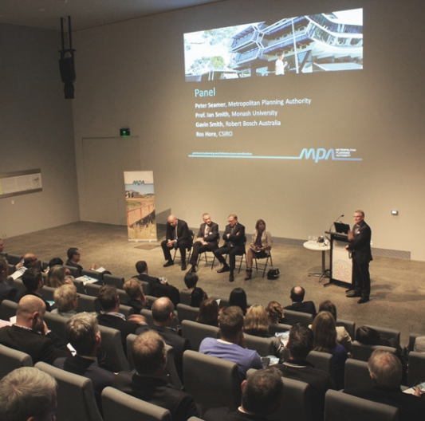
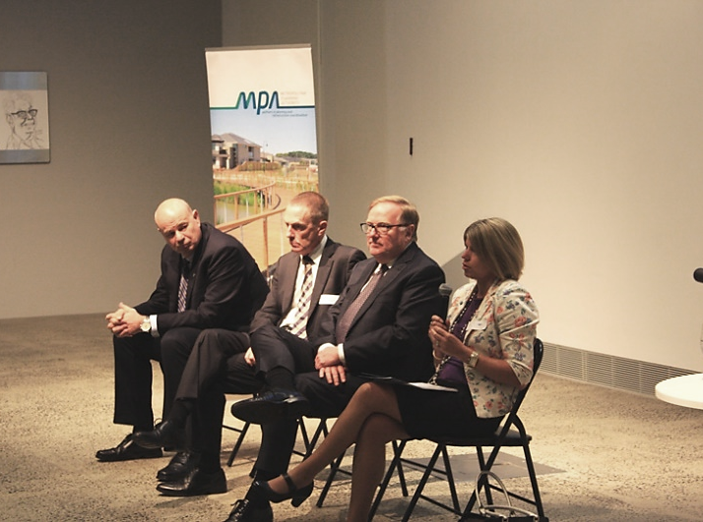
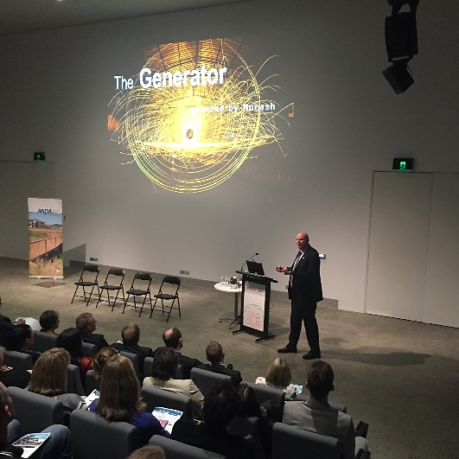
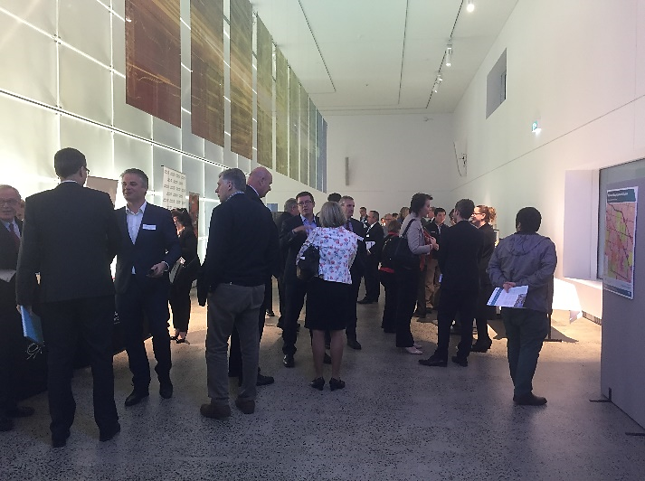
Monash National Employment Cluster Future Outlook Seminar – 4 May 2016 – Australian Synchrotron

Business Focus Groups
Following the Future Outlook Seminar the VPA undertook three Business Focus Groups. These were held between 10-19 May 2016 in various locations across the Cluster with an aim to gain feedback and ideas on the Monash NEC proposed Vision, Principles & Key Ideas for the draft Framework Plan. Forty people attended across the 3 sessions, representing 10 different industry sectors operating in the area.
The VPA, with the aid of VicRoads and Local Government representatives facilitated the small interactive forum discussions at each event, with all feedback formally recorded by the VPA for the purposes of this report. Key topics for discussion were structured around growing employment, transport network, walking & cycling connections, open space and community services within the Cluster.
At the conclusion of each event we asked participants to give feedback on the conduct of the focus groups. These exit surveys received comments such as the following:
- ‘Positive engaging discussions.’
- ‘Good to see you taking feedback.’
- ‘Well organised and impressed how thoroughly the VPA are engaging with the community.’
- ‘It was good to be a part of the discussion group and provide thoughts on the future.’
Results from the survey highlighted that out of those who attended 100% of respondents said they learnt something new during the focus group would consider attending another event like this in the future.

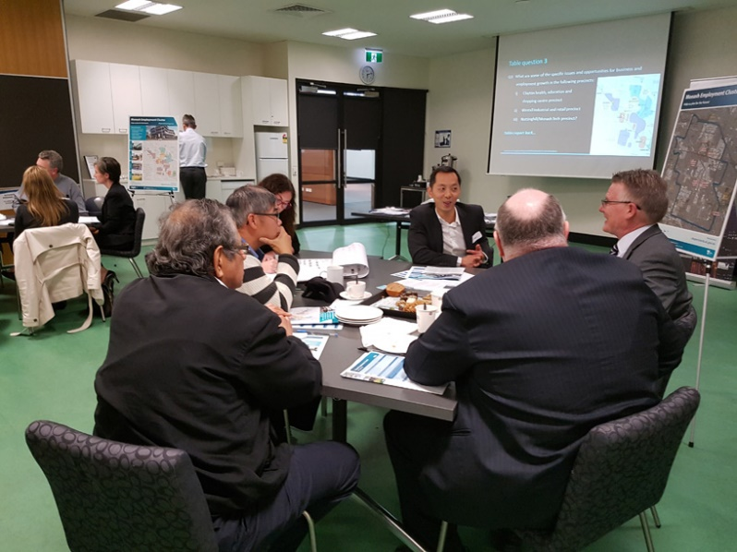
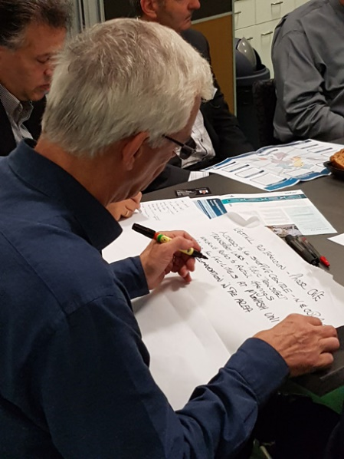

Monash National Employment Cluster Focus Groups – 10-19 May 2016 – Clayton Community Centre

Surveys
The ‘Have your say!’ Survey was the primary form for giving feedback adopted by stakeholders during the process and was available online and in hard copy. The survey was designed to give stakeholders the opportunity to provide feedback in a quick, simple, but meaningful fashion to aid the development of the draft Framework Plan.
There were a total of 53 survey respondents from industry, workers, students, residents and visitors within the Monash NEC. The majority of responses were from people who live, work or own a business in the Cluster as noted in Figure 3 below.
Figure 3 – Survey Participants Relationship to the Cluster

Smart Manufacturing Expo 2016
On 17 May 2016 the VPA in conjunction with the City of Monash took part in the Smart Manufacturing Expo 2016, held in Dandenong. The expo was an industry showcase that aimed to promote Dandenong and South-East Melbourne as the largest and most innovative manufacturing area in the State. Over 60 exhibitors took part in the 2016 event attended by over 1,000 people, organised in conjunction with the City of Dandenong, and the South East Melbourne Manufacturing Alliance (SEMMA), a key industry body in the area. Job growth and investment opportunities in manufacturing underpinned the event.
Representatives of the VPA spoke with the public, answered questions and handed out information brochures, maps, ‘Have your say!’ surveys and event information to attendees. This event was a great opportunity for the VPA to promote what is happening in the Monash NEC and to engage with business representative and members of the general public alike about the future of the area.
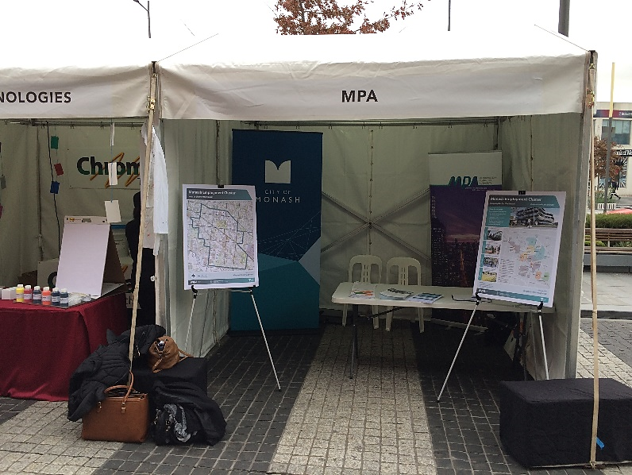
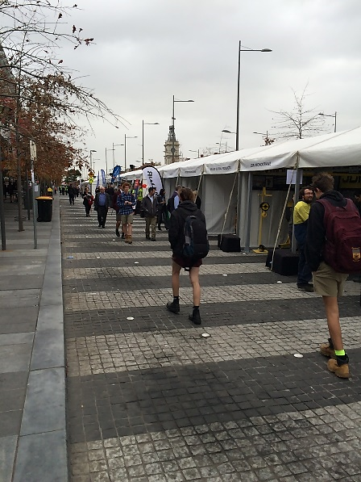
Smart Manufacturing Expo 2016 – 17 May 2016 – Lonsdale Street, Dandenong

Ongoing stakeholder engagement
The VPA will continue to work collaboratively with stakeholders on developing the ideas for the Framework plan, and a range of key strategic sites and projects within the Monash NEC.
Ongoing facilitation and involvement in projects relating to key sites, such as the Clayton Business Park redevelopment, Monash Technology Precinct, Westall Road extension planning and business case, PMP Printing future site planning, and the Clayton Shopping Centre Structure Plan, are vital pieces of the puzzle in the successful transformation of the Cluster. The VPA’s aim is that these sites achieve optimal integration within the wider context and work towards meeting the proposed Vision, Principles and Key Ideas of the future Framework Plan. It is anticipated that involvement with key sites and projects in the Cluster will continue as the project progresses.

Culturally & Linguistically Diverse Communities
Translation services were made available in the seven identified primary languages of the area. All information provided to the public for the Monash NEC draft Framework Plan were made digitally and graphically accessible for screen readers and the colour blind, and in downloadable in various formats (both PDF & Word DOC).
There were no requests for translation services made during the public engagement period, however 45 stakeholders took advantage of downloading the brochure in an alternative format.

Feedback & Outcomes

What we Learnt
Participation in the six week engagement period in the ‘Have your say!’ survey, focus groups, written submissions and general discussions with stakeholders has helped the VPA to develop a better understanding of issues with many participants offering up ideas for what should be done to achieve the Monash NEC Vision.

Figure 4 – Participant Comments About the Monash NEC
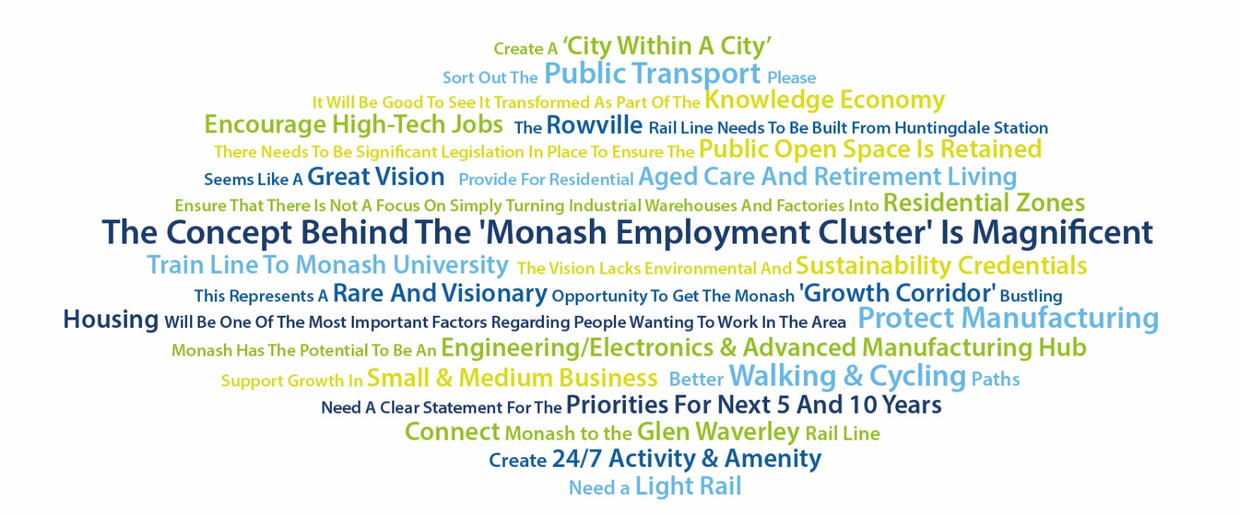

Vision
The Vision proposed for the Monash NEC is:
“Growing jobs and investment in the Cluster by:
- Creating a place that attracts 21st Century jobs
- Improving local access and transport networks
- Building on the investment of significant government infrastructure”

Figure 5 – Vision Survey Results

The survey results show that there is clear support by the respondents for the proposed Vision for the Monash NEC (refer Figure 5). With minimal difference in the level of importance between the 3 driving elements of the proposed Vision (refer Figure 6).
A range of feedback comments were received including the following:
- ‘Achieving your Vision will likely promote local people working locally if the jobs are available, minimizing the need for travel and subsequent congestion on roads and public transport.’
- ‘Transportation access is the key. Also good places for people to dine, especially when they have business partners come over.’
- ‘The university and business types and density are great. As an electronics engineering company, it is great to have businesses and Monash Uni in such close proximity.’
- ‘We are looking for Monash to become a sub city in itself that attracts talent from all over, to live and work.’
- ‘It would be great to see a small portion of some sites set aside for social enterprises to enjoy low or no cost space to start up and become viable within a prescribed time limit. This will add to both quality of lifestyle (necessary to attract talent) and the economic diversity of the cluster.’
- ‘I think it all sounds great as long as the green/environmental parts of the Vision are not left out, that is, planning for green spaces and recreation and spaces for trees and birds etc. to be part of our future.’

Figure 6 – Survey results: Importance of Monash NEC Vision Key Elements

Principles & Key Ideas

Principle 1 – Create better places to work and do business
Figure 7 – Survey Results: Principle 1

A range of feedback comments were received including the following:
- ‘Monash does not reflect the modern business or their needs, buildings and access to services are not reflecting a good ‘brand’ or ‘identity’ to attract and retain high value adding business or workers.’
- ‘Lack of hotels within 5-10 mins of the area.’
- ‘Need more large multi-national pull and increase visitor base.’
- ‘The area needs to attract more food and beverage vendors from the city.’
- ‘Struggle to attract high quality staff to area due to lack of amenity and unaffordable house and land prices.’
- ‘Ability to work and play is also needed to attract people.’
- ‘Lifestyle facilities are needed.’
Key Discussion Themes
Employment
Businesses have indicated that there is a clear industry shift occurring in the Cluster, with traditional types of Industry diversifying practices or relocating (mostly to locations like Dandenong South and in the south-eastern suburbs of Melbourne) and being replaced by commercial and advanced industry uses.
As a result many commercial businesses are operating under Industrial 1 Zone provisions, such as in Clayton South and Huntingdale, or under the Special Use Zone of the Monash Technology Precinct. According to some participants in these areas, zoning provisions are limiting business growth and diversification impeding business’ ability to create a 21st Century business environment for their workers. Consequently businesses are finding it difficult to attract and retain workers in their sectors to the Cluster, with locations such as the CBD and inner suburbs being a much more attractive location for workers due the level of access to services and amenity it offers.
Feedback also reiterated the need to be planning for the future of the Cluster and taking account of telecommunication needs, the shift toward the digital economy and connection to global markets.
Industry Needs & Desires
In depth discussions with representatives from over 10 industry sectors operating in the Cluster presented similar issues:
- A need for short stay business styled accommodation services (e.g. residential hotels, serviced apartments).
- A need for increased access to business spaces, such as meeting, seminar and conference rooms.
- A need for increase access to convenience amenities, such as cafes, restaurants, small supermarkets, post offices, dry cleaners and small retail.
- Recognition that telecommunication access, such as high speed broadband, is just as important as transport connections, with increasing levels of international business and collaboration occurring between businesses. This is particularly relevant in the Cluster with large education and research institutions as well as IT businesses operating.
- The desire for an urban landscape that reflects the types of businesses that are operating in the area. Business want to be seen, not hidden away in the landscape, ‘this is not how businesses operate in the 21st century’.
However when asked where would be the optimal locations for these elements, there was a strong 'let the market decide' attitude.
Identity
There was discussion of what qualities reflect a 21st Century business environment and views that the Monash NEC lacks distinguishing character or identity.
When asked 'What are the key sectors participants associated with the Cluster?' common responses included:
- Health – Monash Medical Centre
- Education - Monash University
- Research – CSIRO, Australian Synchrotron
Though these elements were clearly identifiable by participants, alone they were not considered large enough to establish an identity (or brand) for the Cluster, distinguishable from other locations. In many instances awareness of the breadth of services and activities taking place at some of these organisations was not fully appreciated. Feedback also reiterated that engaging with some organisations and their facilities was challenging because it was unknown how to or who to approach to discuss business development or research matters. One suggestion received is to describe the University and Hospital parts of the cluster as the ‘Health, Education and Research Precinct’ in recognition that it is more than just education, a core part of the precinct is the research function at Monash University, CSIRO and Australian Synchrotron.
Amenity & Activity
A common response to the question 'What can be improved to help business do better in the Monash NEC?' was access to amenity and level of activity or ‘buzz’ in the area. At the moment participants commented the Cluster is lacking in what can be described as businesses which stimulate 24/7 activity, attracting people to the area outside of business hours. As a result there is a limited or dispersed night time economy in the Cluster, placing limitations to the diversity of businesses that can viably operate outside of business hours. For example there are limited restaurants, bars, entertainment facilities such as cinemas in the area resulting in a large amount of movement to other locations such as Oakleigh, Glen Waverley, Chadstone and more frequently the inner city area of Melbourne where the widest range of choice is available.
This is not only important to people working in the area but also business visitors and guests. Though Monash University Clayton Campus houses a diverse offering of activity, it is seen by many as exclusive and not for general public usage. The Monash University masterplan seeks to address these concerns and build more connections with the surrounding community by improvements to wayfinding on site increasing the university’s participation and collaboration within the Cluster.

Principle 2 – Better connections within the south-east corridor

Figure 8 – Survey Results: Principle 2

A range of feedback comments were received including the following:
- ‘IT access is just as important as transport.’
- ‘Need accessibility to the rest of Melbourne.’
- ‘Lack of connection to key entertainment destinations, e.g. Chadstone.’
- ‘Unclutter existing thoroughfares…particularly for public transport.’
- ‘Buses and trains very hard to get to.’
- ‘Some businesses have stronger connections with other inner city institutions such as RMIT in the city which has strong student involvement in the Cluster and a high percentage of graduate workforce is drawn from RMIT.’
- ‘South east connections must be improved.’
Key Discussion Themes
Roads
The Monash NEC's existing connections within the wider road network are seen as an asset, benefitting from both access to the Monash Freeway and good arterial road connections to Melbourne’s south-east and inner suburbs. Road congestion is a concern raised frequently, with feedback highlighting that road congestion is at a level that is impacting business productivity and beginning to deter certain business and workers from locating in the Monash NEC as travel time increase. What was once the competitive advantage is suffering from its own success and growth in activity. The issue needs to be addressed holistically as part of an integrated transport plan considering all modes of travel.
The proposed Westall Road extension is seen as a necessary intervention in the existing road network, with the hope that it may reduce conflict between heavy vehicles and other modes of transport on the road, with increased benefits of creating better penetrations into commercial areas in the Cluster.
Parking
The need for adequate provision of car parking in employment areas was raised in regards to Monash Technology Precinct. Investor feedback highlighted that many businesses seeking to locate in new office premises closer to the Monash Freeway were requesting rates of car parking provision in excess of what planning schemes require. Businesses and workers have reported that they prefer driving for the convenience it offers getting to and from work, as well as freedom to leave to travel nearby for coffee meetings, run errands at lunchtime or pick up lunch.
This feedback correlates with other comments that public transport service in the area is not convenient or frequent enough to warrant leaving the car home. It is also known that over 90% of workers commute by private car to work in the Monash Technology Precinct. Therefore high levels of car parking provision are needed to support the current travel patterns of the majority.
In contrast there is feedback that in other areas of the Cluster, located close to the rail line or frequent direct bus routes, there are advantages offered by public transport helping to attract workers and provides better access for those who choose not to drive.
Rail
With recent works underway for the Caulfield - Dandenong Level Crossing Removal Project, including service and capacity increases of 42% (accommodating an extra 11,000 commuters in peak times), current south-east rail provisions are considered an asset for those located close to the rail. Further benefits are envisaged in helping businesses in and around Clayton to flourish due to better access, as the barrier presented by the boom gates being down for significant periods of time affects patronage of local businesses or access to Clayton from nearby employment areas of the Cluster.
However, an issue identified through the public engagement process was the need for an additional rail connection to the Cluster, with calls for renewed commitment to the Rowville Rail extension. A rail connection to Monash University was one of the most frequently mentioned topics in feedback received, with alternative routes suggested such as to connect Chadstone through to Monash University via an extension of the Alamein Rail Line instead of the proposed Rowville rail alignment.
Buses
Buses in the Monash NEC were considered by respondents in all feedback to be infrequent, indirect and poorly integrated with other public transport services. Consistent feedback suggests that significant upgrades are sought to improve bus usage in the Cluster, with calls for new bus interchanges at Huntingdale Station (already committed) and Clayton Station (proposed as a part of the Level Crossing Removal Project). The need for increased bus priority lanes on all arterial roads through the Cluster was also frequently raised in discussion, as well as upgrades to accessibility and safety of bus stops.
Interestingly there were some respondents that did not support bus improvements and instead advocated for effort to be placed in alternative modes of public transport such as trams and trains. Bus travel is perceived as a second rate mode of public transport by some workers and business operators, who identified that they would rather drive to work than take a bus, due to the poor perception attached, even if upgrades were to occur. The feedback highlights the need to address bus connections, service levels and perceptions of bus travel.

Principle 3 – Better connect people to places in the Monash NEC

Figure 9 – Survey Results: Principle 3

A range of feedback comments were received including the following:
- ‘Improved transport options that penetrates into business areas of MNEC are needed.’
- ‘Commuting to Monash University is a major issue.’
- ‘Need links between high technology businesses and university.’
- ‘It’s not just paths and roads, its spaces and places where people can connect (including virtually).’
- ‘Clayton Road suffers high levels of congestion.’
Key Discussion Themes
Public Transport
The gap in public transport provisions in the Cluster, particularly in terms of trams and light rail, were a frequent response when asked 'How we can better connect people to places within the Cluster?' The suggestion by respondents that trams or light rail be introduced to the Cluster garnered a great deal of support through discussions, with suggestion to connect areas such as the Monash University, CSIRO and the Monash Technology Precinct to key rail station and activity nodes within the Cluster. Frequently suggested was the option to create a rail link servicing Monash University/Monash Technology Precinct.
Walking
Respondents raised concerns about the quality and amenity of walking connections between key destinations. Inadequate footpaths and unattractive streetscapes reduced the desire to frequent areas by foot, with increasing mentions of safety and indirect connections between desired destinations cited as reasons not to walk.

In addition, the arterial road network that serves the Cluster was seen as a significant barrier to movement by foot between key destinations. With the pedestrian connections between Monash University, Monash Medical Centre and Clayton Station being highlighted as an important desire line that requires attention.
Cycling
Businesses have indicated that cycling is growing in popularity as travel mode of choice by many of its workers. However, many raised concerns as to the safety of the current cycling provision on the roads and off-road paths of the Cluster. Feedback raised concerns about conflicts occurring between vehicle and cyclists on the main arterial roads. These roads provide some of the most direct routes between key destinations within and beyond the Cluster.
Some businesses (such as Bosch Australia) indicated that they are incorporating ‘end of trip’ facilities (e.g. secure bicycle storage, change rooms, etc.) into their building for their workers, but more needs to be done to ensure that cyclists are catered for to improve safety for cyclists riding to work. There are some perceptions that the Cluster does not support the needs and wants of its changing workforce travel choices.
Housing
Housing is seen as a key ingredient in making the Vision of the Monash Cluster viable. Participants consistently emphasised that workers within the Cluster are not choosing to live in the Cluster. Reasoning as to why include:
- Affordability ($900,000 median housing prices in Clayton).
- Lack of housing choice and diversity as housing stock does not suit the workforce.
- Lack of amenity and quality of housing stock deter some people from wanting to live in the area.
Many respondents suggested the incorporation of more mixed use style housing in activity centres, such as what has occurred in Springvale. The Health and Education Precinct was nominated as the primary location for high density residential development, in close proximity to the Hospital and University.

Principle 4 – Support a greener and more attractive place, with better community services.

Figure 10 – Survey Results: Principle 4

A range of feedback comments were received including the following:
- ‘Currently little open space and recreational facilities, therefore these are needed.’
- ‘We don’t need open space for open space sake. Open spaces need structure, activity and safety.’
- ‘The availability of open space close to workers is important, enables ability to get out of the office and results in more efficient and happier workers.’
- ‘There is a lack of pedestrian connections due to barriers being created by arterial roads.’
- ‘Need pleasant walking and cycling tracks.’
Key Discussion Themes
Open Space
A clear message that resonated through responses when asked about the level of open space in the Cluster, was there is a need for better access and use of existing open space. Interestingly comments such as ‘we don’t want open space, for open space sake!’ came out of discussion, with the desired qualities of open space being structure, activity and safety. People want places to go to eat their lunch or go for a walk on their break, however there was no clear preference between types, be it park or plaza, as long as it serves a purpose.
Community Services & Facilities
While many of the participants do not live in the Cluster when asked what community services and facilities they desired common responses included childcare and recreational facilities like gyms. There were mixed preferences about whether people preferred these facilities close to where they work as opposed to where they live.

How the feedback will be used in the Framework Plan
Feedback received from the Phase 1 Public Engagement process will be used to inform and test the proposed Vision, Principles and Key Ideas for the draft Monash NEC Framework Plan. Feedback received during the 6 week public engagement process will form a basis to further develop the future directions and actions within the Framework Plan.
We have heard that the following issues are important to respondents:
- Better public transport connections to the major destinations and employment areas within the Monash Cluster are needed.
- Many businesses need better amenity and more flexibility to be able to grow and sustain their business and employees’ needs. We are examining how this can be best achieved through the planning scheme and other changes.
- The area has many major businesses and institutions including major research and innovation organisations of national significance, however it lacks an identity and image, and ways for business, research and education to come together.

Process and Next Steps
The preparation of the Monash National Employment Cluster Framework Plan is proposed to progress from the current stage ‘Public Engagement Phase 1’ to formulating the draft plan for further engagement in 2017 as outlined in the process to date. The key steps in the process are outlined below in Figure 11.

Figure 11 – Process and Next Steps

Appendices

Appendix 1
Monash Employment Cluster ‘Have Your Say’ Survey

