SCHEDULE TO CLAUSE 52.01
14/04/2016
Proposed C221
Type or Location of Subdivision | Amount of contribution for public open space
All land shown on Plans 1.1 and 1.2 forming part of this schedule
CR1: | 10%
CR2: | 8%
CR3: | 7.5%
CR4: | 7%
CR5: | 5%
CR5a: | 4%  As to the composition of the contribution, it must be made in the manner set out and explained in the Berwick Waterways Precinct Structure Plan, October 2014.
CR6: | 11%
CR7: | 3.08%
CR8: | 3.75%
CR9: | 5.9%
CR10: (Land north of Ballarto Road)  (Land south of Ballarto Road) | 7.52%  1.61%
CR11: | 3.54%
CR12: | 1.5%
CR13: | 4.04%  As to the composition of the contribution, it must be made in the manner set out and explained in the Cranbourne North Stage 2 Precinct Structure Plan, June 2011.
CR14: | 4.21%  As to the composition of the contribution, it must be made in the manner set out and explained in the Botanic Ridge Precinct Structure Plan, December 2012.
CR15 | 2% Employment  4% Residential  As to the composition of the contribution, it must be made in the manner set out and explained in the Thompsons Road Precinct Structure Plan, October 2014
CR16 | 4%  As to the composition of the contribution, it must be made in the manner set out and explained in the Clyde Creek Structure Plan, October 2014
CR17 | 4%  As to the composition of the contribution, it must be made in the manner set out and explained in the Casey Fields South Residential Precinct Structure Plan, October 2014
CR18 | 20%  As to the composition of the contribution, it must be made in the manner set out and explained in the Former Amstel Golf Course Development Plan
CR21 | 3.6%  As to the composition of the contribution, it must be made in the manner set out and explained in the McPherson Precinct Structure Plan, May 2016
These amounts do not apply to:  - the subdivision of land to create lots for existing dwellings, for which the amount is: | Not specified
- the subdivision of any land not in a residential zone, Urban Growth Zone or Precinct Structure Plan area for which the amount is:  - This exemption does not apply to land in Cranbourne North Service Business Precinct (CR12). | Not specified
Plan 1.1 to Clause 52.01
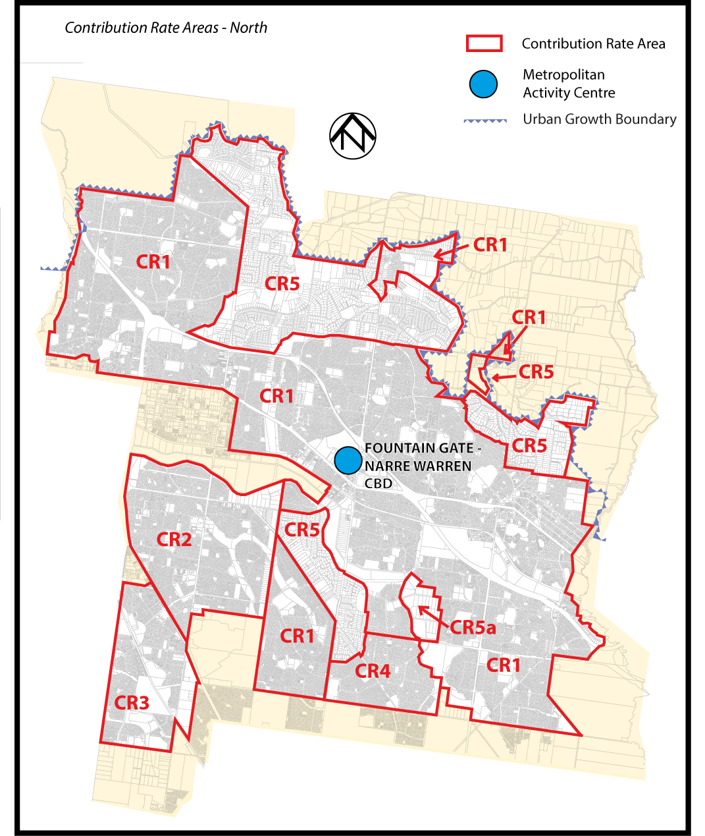
Plan 1.2 to Clause 52.01
