SCHEDULE 11 TO THE URBAN GROWTH ZONE
DD/MM/YYYY Proposed C146

Shown on the planning scheme map as UGZ11.
Plumpton Precinct Structure Plan
1.0 The plan
DD/MM/YYYY Proposed C146

Map 1 below shows the future urban structure proposed in the Plumpton Precinct Structure Plan. It is a reproduction of Plan 3 in the Plumpton Precinct Structure Plan.
Map 1 to Schedule 11 to Clause 37.07
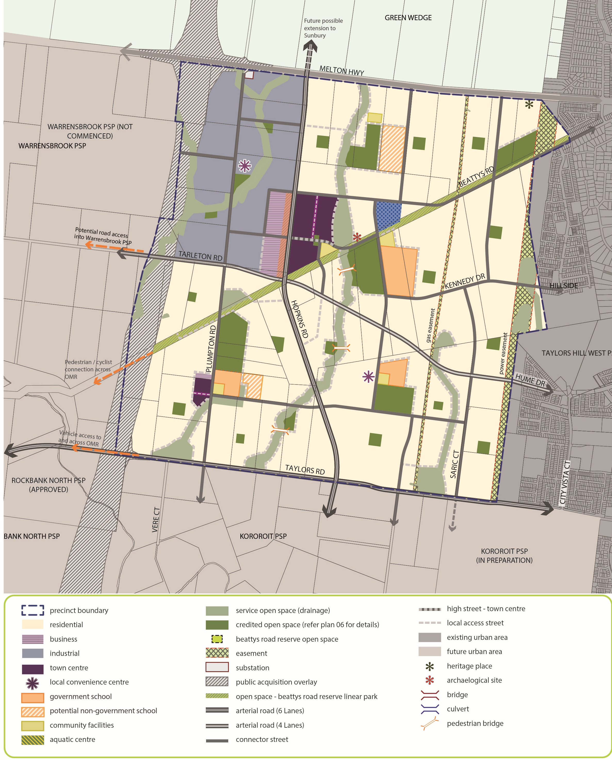
2.0 Use and development
DD/MM/YYYY Proposed C146

2.1 The land
DD/MM/YYYY Proposed C146

The use and development provisions specified in this schedule apply to the land as shown within the ‘precinct boundary’ on Map 1 of this schedule and shown as UGZ11 on the planning scheme maps.
Note: If land shown on Map 1 is not zoned UGZ, the provisions of this zone do not apply.
2.2 Applied zone provisions
DD/MM/YYYY Proposed C146
The use, subdivision, construction of a building and construction and carrying out of works provisions of the following zones in this scheme apply as set out in Table 1.
Table 1: Applied Zone Provisions
Land use/development (carried out or proposed) generally in accordance with the precinct structure plan applying to the land | Applied zone provisions
Arterial Road | Clause 36.04 – Road Zone
Business | Clause 34.02 – Commercial 2 Zone
Connector Street | Clause 36.04 – Road Zone
Industry | Clause 33.01 – Industrial 1 Zone
Town Centre  Local Convenience Centre | Clause 34.01 – Commercial 1 Zone
Mixed Use | Clause 32.04 – Mixed Use Zone
All other land | Clause 32.07 – Residential Growth Zone
2.3 Specific provision – Reference to a planning scheme zone is a reference to an applied zone
DD/MM/YYYY Proposed Cxx

DD/MM/YYYY Proposed C146
A reference to a planning scheme zone in an applied zone must be read as if it were a reference to an applied zone under this schedule.
Note: e.g. The Commercial 2 Zone specifies ‘Shop’ as a Section 1 Use with the condition, ‘The site must adjoin, or have access to, a road in a Road Zone.’ In this instance the condition should be read as, ‘The site must adjoin, or have access to, a road in a Road Zone or an applied Road Zone in the Urban Growth Zone schedule applying to the land’
2.4 Specific provision – Use and development of future public land
DD/MM/YYYY Proposed Cxx

DD/MM/YYYY Proposed C146
A permit is not required to use or develop land shown in the Plumpton Precinct Structure Plan as open space (local parks and local sports reserves) or community facilities provided the use or development is carried out generally in accordance with the Plumpton Precinct Structure Plan and with the prior written consent of the responsible authority.

2.5 Specific provision – Use of land
DD/MM/YYYY Proposed Cxx

DD/MM/YYYY Proposed C146
The following provisions apply to the use of land.
Table 2: Use
Use | Requirement
Shop (other than Restricted retail) where the applied zone is Commercial 1 Zone | A permit is required to use land for a Shop if the combined leasable floor area of all shops exceeds:  - 45,000 square metres for land shown as a Major Town Centre in the Plumpton Precinct Structure Plan.  - 7,200 square metres for land shown as a Local Town Centre in the Plumpton Precinct Structure Plan.  - 500 square metres for land shown as a Local Convenience Centre in the Plumpton Precinct Structure Plan.
Restricted retail where the applied zone is Commercial 2 Zone | A permit is required to use land for a Restricted retail premises if the combined leasable floor area of all Restricted retail premises exceeds:  - 20,000 square metres for land shown as Business in the incorporated Plumpton Precinct Structure Plan
Dwelling where the applied zone is Mixed Use Zone | A permit is required to use land for a dwelling if any frontage at ground level exceeds 2 metres.
Primary school | A permit is not required to use land for a Primary school on land shown as Potential Non Government Primary School in the Plumpton Precinct Structure Plan.
Secondary school | A permit is not required to use land for a Secondary school on land shown as Potential Non Government Secondary School in the Plumpton Precinct Structure Plan.
Place of worship  Residential aged care facility | A permit is required to use land for a Place of worship and Residential aged care facility, in the gas pipeline measurement length depicted on Plan 11 of the Plumpton Precinct Structure Plan.
2.6 Specific provision – Dwellings on a lot less than 300 square metres
DD/MM/YYYY Proposed C146

A permit is not required to construct or extend one dwelling on a lot with an area less than 300 square metres where a site is identified as a lot to be assessed against the Small Lot Housing Code via a restriction on title, and it complies with the Small Lot Housing Code incorporated pursuant to Clause 81 of the Melton Planning Scheme.

2.7 Specific provision – Buildings and works for a school
DD/MM/YYYY Proposed C146

A permit is required to construct a building or construct or carry out works associated with a Primary school or Secondary school on land shown as a potential non- government school unless exempt under Clauses 62.02-1 and 62.02-2.
2.8 Specific provision – Construction management plan required whether or not a permit is required
DD/MM/YYYY Proposed C146

Prior to the commencement of any works, including demolition, on land shown as gas pipeline measurement length on Plan 11 – Utilities in the incorporated Plumpton Precinct Structure Plan, a construction management plan must be submitted to and approved by the responsible authority. The plan must:
- Prohibit the use of rippers or horizontal directional drills unless otherwise agreed by the owner/operator of the high pressure gas pipeline;
- Be endorsed by the owner/operator of the high pressure gas transmission pipeline where the works are within, crossing or in close proximity to the relevant gas transmission easement; and
- Include any other relevant matter to the satisfaction of the responsible authority.
The construction management plan must be implemented to the satisfaction of the responsible authority.
The construction management plan may be amended to the satisfaction of the responsible authority.
2.9 Specific provision – Urban Design Framework – Plumpton Major Town Centre and Business and Industrial Precinct (part)
DD/MM/YYYY Proposed C146

Except with the consent of the responsible authority and the Growth Areas Authority, a permit must not be granted to use or subdivide land, or construct a building and carry out works on land identified as ‘Plumpton Major Town Centre’ or the ‘Business and Industrial Precinct (part) UDF extent’ on Plan 5 in the incorporated Plumpton Precinct Structure Plan, until an urban design framework for the area has been prepared to the satisfaction of the responsible authority and the Growth Areas Authority.
An urban design framework approved under this schedule must be generally in accordance with the precinct structure plan applying to the land.
An application for use and/or development on land identified as ‘Plumpton Major Town Centre’ or the ‘Business and Industrial Precinct (part) UDF extent’ on Plan 5 in the incorporated Plumpton Precinct Structure Plan must be consistent with any urban design framework approved under this schedule.
A permit may be granted to subdivide land or to construct a building or construct and carry out works prior to the approval of an urban design framework for the relevant area if, in the opinion of the responsible authority, the permit is consistent with the requirements for the urban design framework and the permit implements the objectives in the Plumpton Precinct Structure Plan.
The responsible authority may allow an urban design framework to be prepared in stages.
The urban design framework may be amended to the satisfaction of the responsible authority and the Growth Areas Authority.
2.10 Specific provision – Referral of applications – Plumpton Major Town Centre and Local Town Centre
DD/MM/YYYY Proposed C146

An application to subdivide land, or construct a building or carry out works (where value to those works in in excess of $500,000) on land identified in Plan 5 in the incorporated Plumpton Precinct Structure Plan as ‘Plumpton Major Town Centre’ and ‘Plumpton Local Town Centre’ must be referred in accordance with section 55 of the Planning and Environment Act 1987 to the Growth Areas Authority.

3.0 Application requirements
DD/MM/YYYY Proposed C146

If in the opinion of the responsible authority an application requirement listed below is not relevant to the assessment of an application, the responsible authority may waive or reduce the requirement.
3.1 Subdivision - Residential development
DD/MM/YYYY Proposed C146

In addition to the requirements of Clause 56.01-2, a Subdivision Design Response for a residential subdivision of less than 60 lots must show the proposed use and development of each part of the land, and the staging of the development for all land in contiguous ownership with the land under application.
An application for a residential subdivision of 10 lots or more must be accompanied by:
- A written statement that sets out how the subdivision implements the incorporated Plumpton Precinct Structure Plan.
- Subdivision and Housing Design Guidelines, prepared to the satisfaction of the responsible authority, in accordance with the incorporated Plumpton Precinct Structure Plan.
- A table setting out the amount of land allocated to the proposed uses and expected population, dwelling and employment yields.
- A Traffic Impact Assessment Report to the satisfaction of the relevant road management authority.
- A hydrogeological assessment of the groundwater conditions on the site and the potential impacts on the proposed development including any measures required to mitigate the impacts of groundwater on the development and the impact of the development on groundwater.
- A preliminary site assessment of the potential for contaminated land as a result of previous land uses, carried out by a suitably qualified person.
3.2 Local Town Centres
DD/MM/YYYY Proposed C146

An application to use, subdivide land, construct a building or construct or carry out works for a Local Town Centre must also include the following information, as appropriate, to the satisfaction of the responsible authority:
- A design response report and plans that:
  - address the Local Town Centre requirements, the Local Town Centre Guidelines and the Local Town Centre Concept Plan in the Plumpton Precinct Structure Plan;
  - address any relevant design guidelines prepared by the Victorian Government or the Melton City Council;
  - demonstrate how the proposal relates to existing or approved development in the area;
  - demonstrate site responsive architecture and urban design;
  - demonstrate how the proposal will contribute to the urban character of the Local Town Centre;
  - explain how the proposal responds to feedback received following consultation with relevant infrastructure agencies such as the Department of Transport;
  - include environmental sustainability initiatives including integrated water management and energy conservation;
  - include provisions for car parking including the location and design of car parking areas and car parking rates for proposed uses within the centre;
  - address the provision of advertising signs;
  - include arrangements for the provision of service areas and for deliveries and waste disposal including access for larger vehicles and measures to minimise the impact on the amenity of the centre and adjoining neighbourhoods; and
  - demonstrate how opportunities for medium and higher density housing and future commercial expansion can be incorporated into the centre (including on future upper levels and through future car park redevelopments).
- An overall landscape concept/master plan for the centre including a design of the town square/ public space.
3.3 Public Infrastructure Plan
DD/MM/YYYY Proposed C146

An application for subdivision and/or use and development of land must be accompanied by a Public Infrastructure Plan which addresses the following:
- What land may be affected or required for the provision of infrastructure works;
- The provision, staging and timing of road works internal and external to the land consistent with any relevant traffic report or assessment;
- What, if any, infrastructure set out in the development contributions plan (or infrastructure contributions plan) applying to the land is sought to be provided as "works in lieu" subject to the consent of the collecting agency;
- The provision of public open space and land for any community facilities; and
- Any other matter relevant to the provision of public infrastructure required by the responsible authority.
3.4 Traffic Impact Assessment
DD/MM/YYYY Proposed C146

An application that proposes to create or change access to a primary or secondary arterial road must be accompanied by a Traffic Impact Assessment Report (TIAR). The TIAR, including functional layout plans and a feasibility / concept road safety audit, must be to the satisfaction of VicRoads or responsible authority, as required.
3.5 Subdivide, use or develop land for a sensitive purpose – Environmental Site Assessment
DD/MM/YYYY Proposed C146

An application to subdivide land or to use or develop land as identified in Table 3 of this Schedule, for a sensitive use (residential use, child care centre, pre-school centre or primary school) must be accompanied by an Environmental Site Assessment prepared by a suitably qualified environmental professional to the satisfaction of the responsible authority which takes account of the report titled Growth Areas Authority, Plumpton and Kororoit Precincts, Land Capability Assessment, (GHD, October 2013) and provides information including:
- Further detailed assessment of potential contaminants on the relevant land;
  - Clear advice on whether the environmental condition of the land is suitable for the proposed use/s and whether an environmental audit of all, or part, of the land is recommended having regard to the Potentially Contaminated Land General Practice Note June 2005, DSE;
  - Further detailed assessment of surface and subsurface water conditions and geotechnical characteristics (including soil and groundwater sampling) on the relevant land and the potential impacts on the proposed development including any measures required to mitigate the impacts of groundwater conditions and geology on the development and the impact of the development on surface and subsurface water; and
  - Recommended remediation actions for any potentially contaminated land.
Table 3: Environmental Site Assessment
Address | Legal Description
1048 Taylors Road, Plumpton | Lot 1 on PS709426
1052 Taylors Road, Plumpton | Lot 1 on PS604066
4.0 Conditions and requirements for permits
DD/MM/YYYY Proposed C146

4.1 Conditions for subdivision permits that allows the creation of a lot less than 300 square metres
DD/MM/YYYY Proposed C146

Any permit for subdivision that allows the creation of a lot less than 300 square metres must contain the following conditions:

- Prior to the certification of the plan of subdivision for the relevant stage, a plan must be submitted for approval to the satisfaction of the responsible authority. The plan must identify the lots that will include a restriction on title allowing the use of the provisions of the Small Lot Housing Code incorporated pursuant to Clause 81 of the Melton Planning Scheme; and
- The plan of subdivision submitted for certification must identify whether type A or type B of the Small Lot Housing Code applies to each lot to the satisfaction of the responsible authority.
4.2 Conditions for subdivision or buildings and works permits where land is required for community facilities, public open space and road widening
DD/MM/YYYY Proposed C146

Land required for community facilities or public open space shown as ‘credited open space’, as set out in the Plumpton Precinct Structure Plan or the Plumpton and Kororoit Infrastructure Contributions Plan must be transferred to or vested in Council at no cost to Council unless the land is funded by the Plumpton and Kororoit Infrastructure Contributions Plan.
Land required for road widening including right of way flaring for the ultimate design of any intersection with an existing or proposed arterial road must be transferred to or vested in Council or VicRoads at no cost to the acquiring agency unless funded by the Plumpton and Kororoit Infrastructure Contributions Plan.
Land required for a community facility, road, or public open space must be on a Plan of Subdivision submitted for Certification as a reserve in favour of Melton City Council or the relevant agency, at no cost to Council or the relevant agency.
4.3 Condition - Kangaroo Management
DD/MM/YYYY Proposed
C146

A permit granted for subdivision of land must include the following conditions:
- Before the certification of the Plan of Subdivision, a Kangaroo Management Plan must be approved by the Secretary to the Department of Environment, Land, Water and Planning. Once approved the plan will be endorsed by the responsible authority and form part of the permit.The endorsed Kangaroo Management Plan must be implemented to the satisfaction of the responsible authority.

4.4 Requirement - Salvage and Translocation
DD/MM/YYYY Proposed C146

Salvage and translocation of threatened flora and fauna species and ecological communities must be undertaken in the carrying out of development to the satisfaction of the Secretary of the Department of Environment, Land, Water and Planning.
4.5 Requirement - Protection of conservation areas and native vegetation during construction
D/MM/YYYY Proposed C146

A permit granted to subdivide land where construction or works are required to carry out the subdivision, or a permit granted to construct a building or carry out works, on land including or abutting a conservation area or patch of native vegetation or scattered tree identified for retention in the incorporated Plumpton Precinct Structure Plan must ensure that:
- Before the start of construction or carrying out of works in or around a conservation area, scattered native tree or patch of native vegetation the developer of the land must erect a conservation area/vegetation protection fence that is:
- highly visible
- at least 2 metres in height
- sturdy and strong enough to withstand knocks from construction vehicles
- in place for the whole period of construction
- located the following minimum distance from the element to be protected:

ELEMENT | MINIMUM DISTANCE FROM ELEMENT
Conservation area | 2 metres
Scattered tree | Twice the distance between the tree trunk and the edge of the tree canopy
Patch of native vegetation | 2 metres

- Construction stockpiles, fill, machinery, excavation and works or other activities associated with the buildings or works must:
- be located not less than 15 metres from a waterway;
- be located outside the vegetation protection fence;
- be constructed and designed to ensure that the conservation area, scattered tree or patches of native vegetation are protected from adverse impacts during construction;
- not be undertaken if it presents a risk to any vegetation within a conservation area; and
- be carried out under the supervision of a suitable qualified ecologist or arborist.
4.6 Management of bushfire risk during subdivisional works
DD/MM/YYYY Proposed C146

A permit for subdivision that contains a condition requiring a construction management or site management plan must ensure that the relevant plan addresses any potential bushfire risks arising from the land during construction and must include a statement from a suitably qualified professional that the proposed bushfire risk management measures are appropriate.

4.7 Condition for public transport
DD/MM/YYYY Proposed C146

Unless otherwise agreed to by Public Transport Victoria, prior to the issue of a statement of compliance for any subdivision stage, bus stops must be constructed, at full cost to the permit holder as follows:

- Generally in the location identified by Public Transport Victoria
- In accordance with the Public Transport Guidelines for Land Use and Development with a concrete hard stand area, and in activity centres a shelter must also be constructed
- Be compliant with the Disability Discrimination Act – Disability Standards for Accessible Public Transport 2002; and
- Be provided with direct and safe pedestrian access to a pedestrian path.
All to the satisfaction of Public Transport Victoria and the responsible authority.

4.8 Condition – Environmental Site Assessment
DD/MM/YYYY Proposed C146

Any permit for the use and development of land, as listed in Table 3 of this schedule, for a sensitive use (residential use, child care centre, pre-school centre or primary school) must contain the following conditions:
- Before the commencement of the development of the land, the recommendations of the Environmental Site Assessment submitted with the application must be carried out to the satisfaction of the responsible authority.
- Upon receipt of the further testing report the owner must comply with any further requirements made the responsible authority after having regard to the guidance set out in the General Practice Note on Potentially Contaminated Land June 2005 (DSE). The plan of subdivision must not be certified until the responsible authority is satisfied that the land is suitable for the intended use.
Any permit for the subdivision of land listed in Table 3 of this schedule must contain the following conditions:
- Before a plan subdivision is certified under the Subdivision Act 1988, the recommendations of the Environmental Site Assessment submitted with the application must be carried out to the satisfaction of the responsible authority.
- Upon receipt of the further testing report the owner must comply with any further requirements made the responsible authority after having regard to the guidance set out in the General Practice Note on Potentially Contaminated Land June 2005 (DSE). The plan of subdivision must not be certified until the responsible authority is satisfied that the land is suitable for the intended use.

5.0 Advertising Signs
DD/MM/YYYY Proposed C146

Land is in the category specified in the applied zone.
5.1 Land and home sales signs
DD/MM/YYYY Proposed C146

Despite the provisions of Clause 52.05, signs promoting the sale of land or homes on the land (or on adjoining land in the same ownership) may be displayed without a permit provided:
- The advertisement area for each sign does not exceed 10 square metres;
- Only one sign is displayed per road frontage. Where the property has a road frontage of more than 150 metres multiple signs may be erected provided there is a minimum of 150 metres distance between each sign, with a total of not more than 4 signs per frontage;
- The sign is not animated, scrolling, electronic or internally illuminated sign;
- The sign is not displayed longer than 21 days after the sale (not settlement) of the last lot.; and
- The sign is setback a minimum of 750mm from the property boundary.
A permit may be granted to display a sign promoting the sale of land or homes on the land (or on adjoining land in the same ownership) with an area greater than 10 square metres.
If the sign does not meet all of the requirements listed above, it must comply with the provisions of Clause 52.05.

5.2 Education / community promotion signs

DD/MM/YYYY
Proposed C146

Despite the provisions of Clause 52.05, a permit may be granted, for a period of not more than 5 years, to display an advertising sign greater than two square metres in area that promotes a community facility or education centre on the land identified as community facilities, potential government school, potential non-government school and credited open space on Map 1 to this schedule.

6.0 Notice to gas transmission pipeline owner and operator
DD/MM/YYYY Proposed C146

Notice must be given to the person or body listed in the Schedule to Clause 66.06 of an application to use land for any of the following within the ‘gas pipeline measurement length’ shown on Plan 11 Utilities in the incorporated Plumpton Precinct Structure Plan
  - Child care centre
  - Cinema
  - Education centre
  - Hospital
  - Residential aged care facility
  - Corrective institution
  - Place of assembly
Notice must be given to the person or body listed in the Schedule to Clause 66.06 of an application for a residential development of four or more storeys within the ‘high pressure gas transmission pipeline measurement length’ shown on Plan 11 Utilities in the incorporated Plumpton Precinct Structure Plan.
7.0 Decision Guidelines
DD/MM/YYYY Proposed C146

Before deciding on an application to use land for a shop in a town centre, in addition to the decision guidelines at Clause 37.07-14, the responsible authority must consider, as appropriate:
- The local catchment and PSP catchment demand for the additional floor area; and
- The effect on existing and future major town centres within City of Melton.
8.0 Exemption from notice and review not to apply to certain applications

DD/MM/YYYY
Proposed
C146

An application to use land for a use listed in Section 2 of the Residential Growth Zone on land where the applied zone listed at Table 1 of this schedule is Residential Growth Zone is not exempt from the notice requirements of section 52(1)(a), (b) and (d), the decision requirements of section 64(1), (2) and (3) and the review rights of section 82(1) of the Act.

