Planning and Environment Act 1987
MELTON PLANNING SCHEME
AMENDMENT C195
EXPLANATORY REPORT
Who is the planning authority?
This Amendment has been prepared by the Victorian Planning Authority, which is the planning authority for this amendment.
The Amendment has been made at the request of the Victorian Planning Authority and the Melton City Council.
Land affected by the amendment
The Amendment applies to land within the Plumpton Precinct Structure Plan area that is currently zoned Urban Growth Zone Schedule 11, which is generally bounded by Melton Highway to the north, the approved Taylors Hill West Precinct to the east, Taylors Road to the south and the Outer Metropolitan Ring (OMR) road reservation to the west.
The Amendment also applies to the Kororoit Precinct Structure Plan area that is currently zoned Urban Growth Zone Schedule 12 and is bounded by Taylors Road to the north, Monaghans Lane (north of Kororoit Creek), Kororoit Creek and Sinclairs Road (south of Kororoit Creek) to the east, Western Freeway to the south and the OMR road reservation to the west.

Melton C195 amendment area
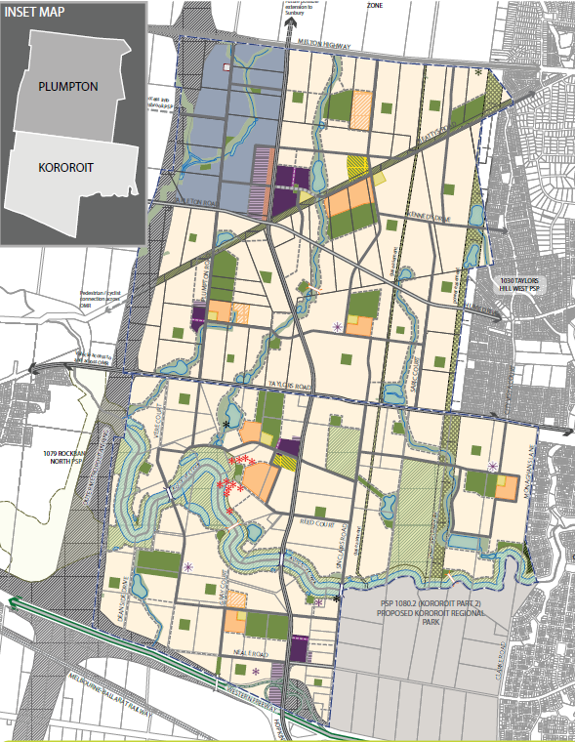

What the amendment does
The amendment introduces Clause 45.11 Infrastructure Contributions Overlay into the Melton Planning Scheme to implement the Plumpton & Kororoit Infrastructure Contributions Plan, April 2018. More specifically, the amendment proposes the following changes:
- Insert Clause 45.11 Infrastructure Contributions Overlay (ICO) and Schedule 1 to this Overlay, and apply the ICO Schedule 1 (ICO1) to land within the amendment area
- Amend the Schedule to Clause 61.03 to include new maps 9ICO, 10ICO, 13ICO, and 14ICO
- Amend the Schedule to Clause 81.01 to include a new incorporated document titled Plumpton & Kororoit Infrastructure Contributions Plan, April 2018.
Strategic assessment of the amendment
Why is the amendment required?
This Amendment will incorporate a supplementary levy Infrastructure Contributions Plan (ICP) and apply this to both the Plumpton and Kororoit precinct structure plan areas by inserting Clause 45.11 – Infrastructure Contributions Overlay and Schedule 1 to this overlay (ICO1).
This ICP is necessary to deliver all the infrastructure items required within both Plumpton and Kororoit precincts. Specifically, the supplementary levy component is included to cover the costs of construction of supplementary ICP transport items.
The ICP provides timeframes (short 0-5 years, medium 10-15 years and long term 15 years onwards) for the delivery of ICP funded infrastructure projects. The timeframes have been updated since the gazettal of the Plumpton and Kororoit PSPs to better reflect the projected urban development growth fronts within the precincts.
How does the amendment implement the objectives of planning in Victoria?
The Amendment will implement an infrastructure contributions scheme to fund community and development infrastructure to service the future urban land within the approved Plumpton and Kororoit precinct structure plan areas that are within the Urban Growth Boundary of Metropolitan Melbourne.
It will implement applicable objectives of planning in Victoria under Section 4 of the Planning and Environment Act 1987 (Act) through the implementation of a contributions collection scheme to facilitate the delivery of infrastructure to service both the approved Plumpton and Kororoit precinct structure plans (the PSP’s).
The Amendment applies the necessary planning controls to implement an Infrastructure Contribution Plan (ICP) that will provide a clear structure of contributions required to fund development and community infrastructure within the both precincts for residential and commercial development and will ensure the fair and equitable provision of community and development infrastructure.
How does the Amendment address any environmental, social and economic effects?
Environmental effects
The Amendment does not result in environmental impacts as it seeks to introduce a mechanism to allow the responsible authority to collect financial contributions towards infrastructure required for both the Plumpton and Kororoit PSP areas.
The infrastructure required and its environmental impacts were considered by the amendments to introduce the PSP’s.
Economic effects
This Amendment will introduce an ICP that identifies the financial levy required to be paid by developers to fund the infrastructure required for both precincts, and thus sets out an equitable and transparent means of collecting financial contributions towards servicing the future communities. This reduces the burden on the responsible authority and existing communities to fund future local infrastructure.
Social effects
The approved Plumpton and Kororoit PSP’s identified the infrastructure necessary to service the future communities, including sports and community facilities, road and trail upgrades, and parks. This new infrastructure will ensure that new residents do not place an unfair burden on existing community assets in the area. The infrastructure maximises opportunities for new residents to safely and efficiently access employment and everyday services including shopping and engage in locally based social activities.
This Amendment will introduce a mechanism to collect financial contributions to fund this infrastructure, thereby ensuring the future communities are well serviced.
Does the amendment address relevant bushfire risk?
This is not relevant as the Amendment seeks to introduce a mechanism to collect financial contributions to fund necessary infrastructure.
Does the amendment comply with the requirements of any Minister’s Direction applicable to the amendment?
The Amendment complies with the Ministerial Direction on the Form and Content of Planning Schemes under section 7(5) of the Act. The Amendment also complies with the following relevant Ministerial Directions:
Direction No. 9 - Metropolitan Strategy
Direction 9 has been considered in preparing this Amendment and it complies with this direction.
The Amendment will facilitate the collection of developer levies to fund the required infrastructure to service the future urban land within the Urban Growth Boundary (UGB).
Direction No. 11 - Strategic Assessment of Amendments
This direction seeks to ensure a comprehensive strategic evaluation of a planning scheme amendment. This report addresses the requirements outlined in this direction.
Direction No. 12 - Urban Growth Areas
This Direction is not applicable as this Amendment does not seek to introduce or change the schedules to the Urban Growth Zone (UGZ).
S46GF and 46GM - Direction on Infrastructure Contributions Plan
This direction seeks to guide planning authorities in relation to the preparation and content of developer contributions.
The Infrastructure Contributions Plan (ICP) system came into effect in October 2016. The system is based on standard levies that are pre-set for particular development and land uses in order to fund the construction of basic and essential infrastructure to service the growing urban communities. This system also allows for a supplementary levy, in addition to the standard levy, if required to fund infrastructure that cannot be adequately funded by the standard levy.
The ICP sets out funding of infrastructure works for both precincts. The ICP levies a certain amount from developers in the precincts with the balance of funding being the responsibility of the Melton City Council and other state agencies, as well as directly funded by developers through developer works. The PSP provides the strategic justification for the ICP items.
The ICP uses the 2017/18 standard levy rate. In line with the Direction, following indexation of the rate, the standard levy rate will be adjusted accordingly. There will also be a corresponding change in the supplementary rate
This Amendment seeks to incorporate an ICP for the Plumpton and Kororoit precincts.
The ICP will also reflect the public land contribution model in response to the new Planning & Environment Amendment (Public Land Contributions) Act 2018 that received Royal Assent on 27 February 2018 but is not yet in effect.
The Planning & Environment Amendment (Public Land Contributions) Act 2018 introduces a land contribution model for the Infrastructure Contributions Plan (ICP) system. The land contribution model enables land for public purposes to be provided as part of an infrastructure contribution when land is developed. It changes the way land is acquired for public purposes: instead of requiring a monetary levy it will require a percentage, similar to the operation of Clause 52.01 of the Planning Scheme.
It is understood that this Act is likely to come into effect between July 2018 and 1 September 2018.
This Amendment introduces into the Melton Planning Scheme the new Clause 45.11 – Infrastructure Contributions Overlay Schedule 1 (ICO1) and applies it to the Amendment area, as this new overlay reflects the Planning & Environment Amendment (Public Land Contributions) Act 2018 model for collection of infrastructure contributions.
How does the amendment support or implement the State Planning Policy Framework and any adopted State policy?
This Amendment is consistent with Clause 19 – Infrastructure of the State Planning Policy Framework as it will implement a mechanism to collect developer contributions to fund infrastructure throughout both precincts.
How does the amendment support or implement the Local Planning Policy Framework, and specifically the Municipal Strategic Statement?
The Amendment will ensure developers financially contribute to the necessary infrastructure for the precincts consistent with the policy basis of Clause 22.04 – Urban Development Policy of the Melton Planning Scheme.
Does the amendment make proper use of the Victoria Planning Provisions?
The Amendment meets the form and content requirements of the Victoria Planning Provisions. Importantly, the application of the ICO and implementation of an ICP is consistent with the new method for collecting infrastructure levies in the metropolitan growth areas.
How does the amendment address the views of any relevant agency?
The Amendment has been prepared in consultation with relevant agencies. A draft of the Amendment and relevant documentation was provided to relevant agencies and their comments incorporated into the updated Amendment as appropriate. Key organisations and agencies to be consulted include (but not limited to):
- Melton City Council;
- Department of Environment, Land, Water, and Planning (DELWP – Environment and Planning);
- Melbourne Water;
- Sports and Recreation Victoria; and,
- VicRoads.
Does the amendment address relevant requirements of the Transport Integration Act 2010?
The Amendment implements a mechanism to collect financial developer levies to fund essential transport infrastructure that is identified in both the Plumpton and Kororoit precincts.

Resource and administrative costs
- What impact will the new planning provisions have on the resource and administrative costs of the responsible authority?
The Amendment will assist the responsible authority as it ensures the collection of infrastructure contributions by developers to fund necessary infrastructure to be delivered by the responsible authority.
Where you may inspect this Amendment.
The Amendment is available for public inspection, free of charge, during office hours at the following places:
Melton City Council Victorian Planning Authority
Melton Civic Centre Level 25
232 High Street 35 Collins Street
Melton 3337 Melbourne 3000
www.melton.vic.gov.au www.vpa.vic.gov.au

The Amendment can also be inspected free of charge at the Department of Environment, Land, Water and Planning website at www.delwp.vic.gov.au/public-inspection.

Submissions
Any person who may be affected by the amendment may make a submission to the planning authority. Submissions about the amendment must be received by Friday 15 June 2018. A submission referencing Melton Amendment C195 must be sent to:
Victorian Planning Authority
Level 25,
35 Collins Street
Melbourne VIC 3000

Or via email: amendments@vpa.vic.gov.au

Panel hearing dates
In accordance with clause 4(2) of Ministerial Direction No.15 the following panel hearing dates have been set for this amendment:
- Directions hearing: During the week commencing 02nd July 2018.
- Panel hearing: During the week commencing 23rd July 2018.

