SCHEDULE 3 TO THE URBAN GROWTH ZONE
01/08/2013

Proposed C232

Shown on the planning scheme map as UGZ3.
OFFICER PRECINCT STRUCTURE PLAN (SEPTEMBER 2011, Amended March 2018) – RESIDENTIAL AREA
1.0 The Plan
12/01/2012
Proposed C232

Map 1 shows the future urban structure proposed in the Officer Precinct Structure Plan (September 2011, Amended March 2018).
Map 1 to Schedule 3 to Clause 37.07
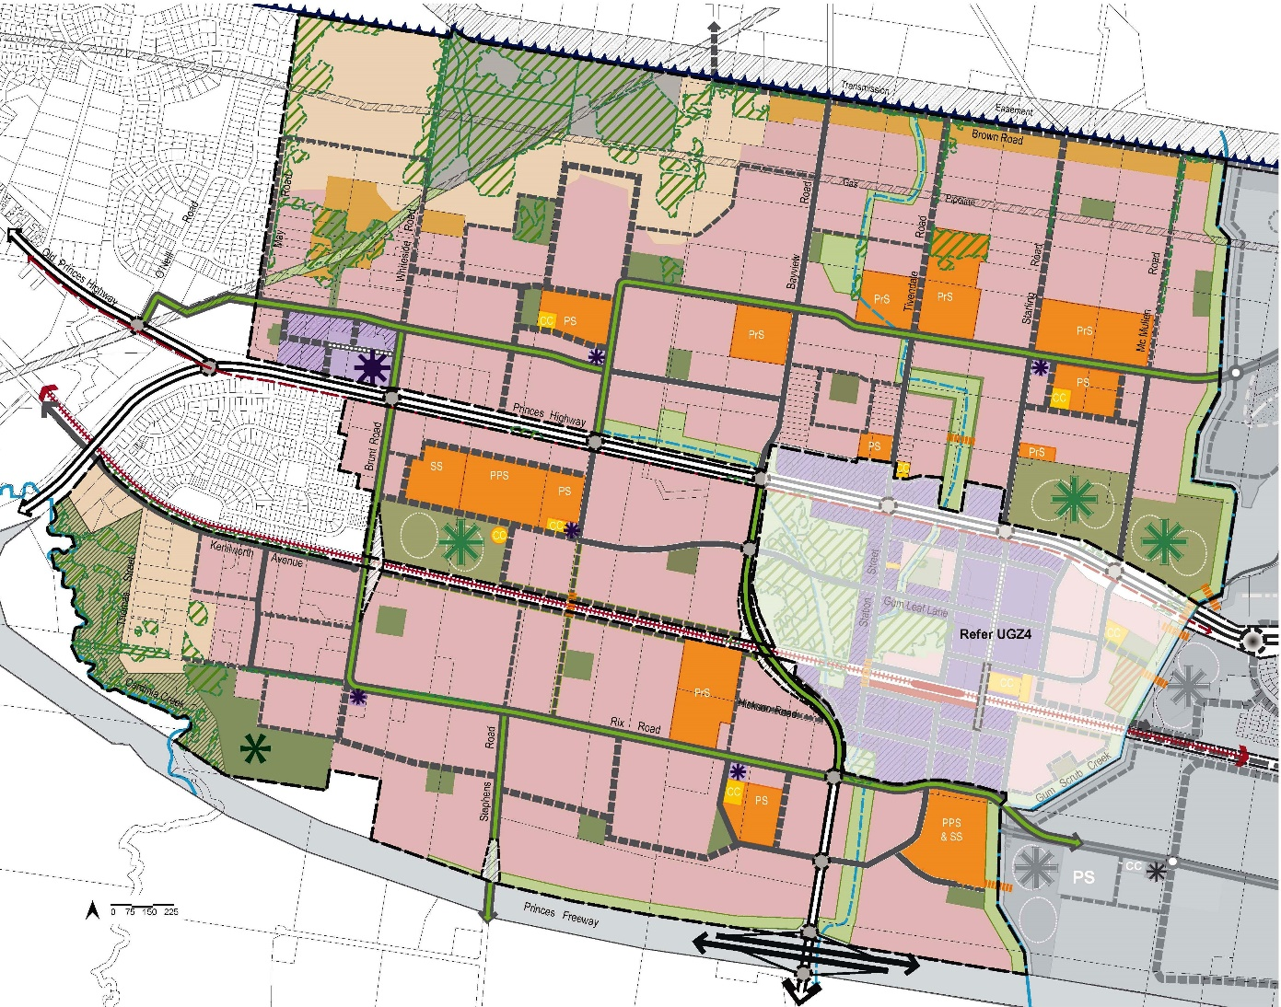
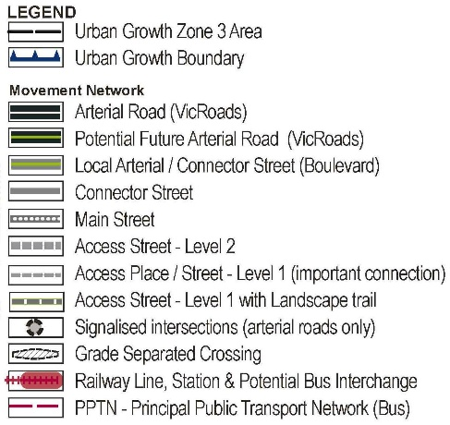
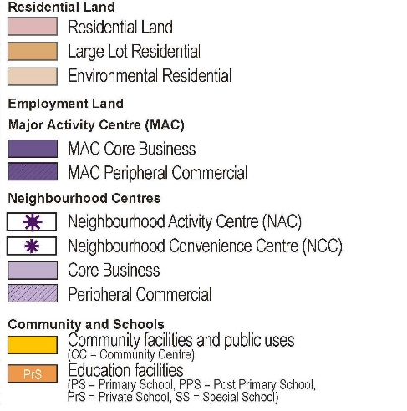
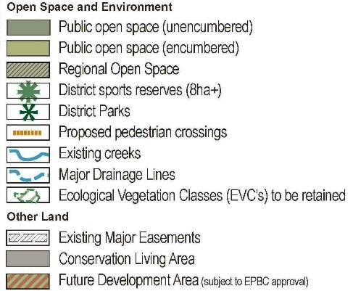

2.0 Use and development
2.1 The Land
12/01/2012
C149

01/08/2013
C194

The use and development provisions specified in this schedule apply to the land shown in Map 2.
Map 2 to Schedule 3 to Clause 37.07
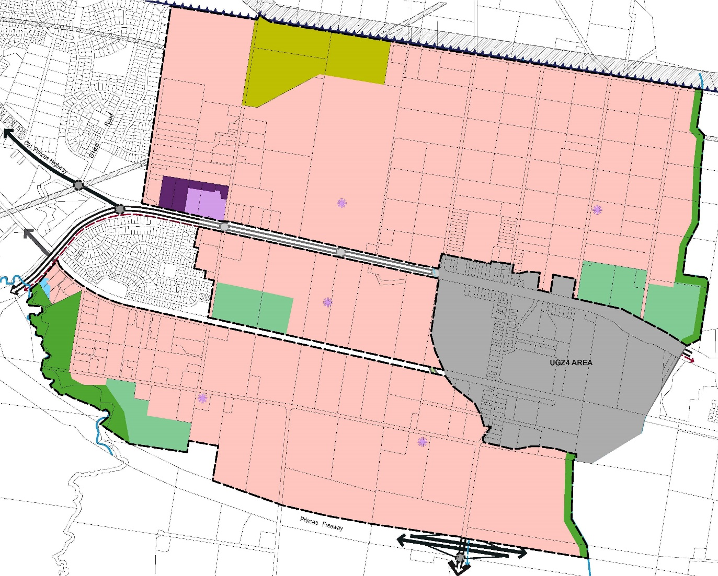
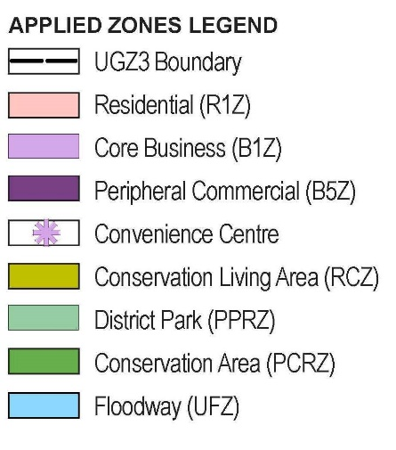
2.2 Applied zone provisions
The applied zones set out in Table 1 apply to the land shown on Map 2.
01/08/2013
C194

Table 1: Applied zone provisions
Land shown on Map 2 of this Schedule | Applied Zone Provisions
Core Business / Convenience Centre /  Peripheral Commercial | Clause 34.01 – Commercial 1 Zone
Conservation Living Area | Clause 35.06 – Rural Conservation Zone
District park | Clause 36.02 – Public Park and Recreation Zone
Conservation area | Clause 36.03 – Public Conservation and Resource Zone
Floodway | Clause 37.03 – Urban Floodway Zone
All other land | Clause 32.08 – General Residential Zone
The precise boundary of the zone is to be determined by the designation of land in a relevant plan of subdivision to the satisfaction of the responsible authority.
Where a public land zone is applied in Table 1 and the land is in private ownership the bodies specified below are the public land manager for the purposes of the applied zone.
Applied Zone | Public Land Manager
Public Park and Recreation Zone | Cardinia Shire Council
Public Conservation and Resource Zone (adjacent to Cardinia Creek) | Parks Victoria
Public Conservation and Resource Zone (adjacent to Gum Scrub Creek) | Melbourne Water or Cardinia Shire Council as appropriate
2.3 Specific provisions - Use of land for a dwelling
12/01/2012
C149
Prior to the use of any dwelling:
- the dwelling must be connected to a reticulated recycled water supply system for toilet flushing and garden watering where available to the lot; or
- where a reticulated recycled water supply system is not available to the lot, the dwelling must be connected to a rainwater tank with a minimum capacity of 2,500 litres for toilet flushing and garden watering or an alternative grey water recycling system to the satisfaction of the responsible authority; and
- the dwelling must be connected to a reticulated sewerage system.
2.4 Specific provisions - Use of land
01/08/2013
C194

The following provisions apply to the use of land.
Table 2: Use
Use | Requirement
Where the applied zone is General Residential Zone:  Car wash  Food and drink premises (other than Restaurant)  Service station | The use is a Section 3 Use.
Residential Aged Care Facility where the applied zone is General Residential Zone | The use is a Section 2 Use.
On land marked as peripheral commercial on Map 1:  Beauty salon  Hairdresser | The use is a Section 2 Use.
On land marked as peripheral commercial on Map 1:  Retail Premises (other than beauty salon and hairdresser)  Industry | The use is a Section 3 Use.
Shop where the applied zone is Commercial 1 Zone (except where shown as peripheral commercial on Map 1 to this schedule) | A permit is required to use land for a shop if the combined leasable floor area of all shops exceeds the following areas (square metres) for the relevant centre as described in the Officer Precinct Structure Plan:  8000 – Neighbourhood Activity Centre – Princes Highway and Whiteside Road  2000 – Neighbourhood Convenience Centre – Timbertop Boulevard North  500 – any other neighbourhood convenience centre
2.5 Specific provisions - Berwick Pottery Site
12/01/2012
C149
A permit may be granted for the following uses on properties numbered 185 & 186 in the Officer Precinct Structure Plan (Lot 1 on TP20791 and Lot 1 on TP20642), also known as the Berwick Pottery:
Use | Condition
Retail premises (other than Food and drink premises, Community market, Convenience shop, Plant nursery, Tavern, Betting agency, Gambling premises, Gaming premises, Motor vehicle, boat, or caravan sales and Shop)
Restricted retail premises | Must be in one occupation with a leasable floor area of at least 1000 square metres.
2.6 Specific provisions - Subdivision of area shown as Environmental Residential (north of Princes Highway)
12/01/2012
Proposed C232

An application to subdivide land in the area shown as Environmental Residential B in Plan 8 of the Officer Precinct Structure Plan (September 2011, Amended March 2018) and Lot 2 PS312844 must provide lots that are a minimum of 4000 square metres where any proposed lot contains native vegetation to be retained in the Officer Native Vegetation Precinct Plan (September 2011, Amended March 2018) unless a planning permit has been granted for the removal of native vegetation within the proposed lot.
2.7 Specific provisions - Subdivision of Whiteside Road Neighbourhood Activity Centre
12/01/2012
C149
An application to subdivide land in the Whiteside Road Neighbourhood Activity Centre including all land south of the Boulevard Connector between May and Whiteside Roads in Map 1 must be consistent with an urban design framework approved under this schedule.
2.8 Specific provisions - Construction of one dwelling on a lot
12/01/2012
C149
A permit is not required to construct or extend one dwelling on a lot with an area less than 300 square metres where an approved building envelope as defined in Part 4 of the Building Regulations 2006 applies to the lot.
2.9 Specific provisions - Construction and extension of one dwelling on a lot of 1000 square metres or more
01/08/2013
C194

A permit is required to construct or extend one dwelling on a lot of 1000 square metres or more where the applied zone is General Residential Zone, except where buildings and works are generally in accordance with an approved building envelope (as defined in Part 4 of the Building Regulations 2006).
2.10 Specific provisions – Buildings and works on Encumbered Open Space
12/01/2012
C149
A permit is required for buildings and works on land shown as Encumbered Open Space in Map 1 except works carried out by or on behalf of the public land manager.
2.11 Public transport referral requirements
12/01/2012
Proposed C232

For the purpose of Clause 52.36-1 of the scheme a development is generally in accordance with the Officer Precinct Structure Plan (September 2011, Amended March 2018) where the following requirements are met:
- A road nominated on Plan 17 – Public Transport in the Officer Precinct Structure Plan as a potential bus route is constructed in accordance with its corresponding cross section in the Officer Precinct Structure Plan; and
- Signalised intersections that contain a proposed Principal Public Transport Network (PPTN) route in the Officer Precinct Structure Plan include bus priority measures to mitigate delays to bus travel times, to the satisfaction of the Director of Public Transport; and
- Any roundabouts or other road management devices on potential bus routes are constructed to accommodate ultra low floor buses in accordance with the Public Transport Guidelines for Land Use and Development; and
- The proposal includes the construction of the bus stops shown on Plan 16 – Public Transport in the Officer Precinct Structure Plan (September 2011, Amended March 2018), including bus stop hard stands with direct and safe pedestrian access to a pedestrian path (all in accordance with the Public Transport Guidelines for Land Use and Development and compliant with the Disability Discrimination Act – Disability Standards for Accessible Public Transport 2002) at no cost to the Director of Public Transport all to the satisfaction of the Director of Public Transport.
A responsible authority may address any of the above matters through planning permit conditions.
3.0 Application requirements
12/01/2012
C149
If the responsible authority is satisfied that a requirement is not relevant to the evaluation of an application, the responsible authority may waive or reduce the requirement unless otherwise indicated below.
3.1 General subdivision
12/01/2012
Proposed C232

All applications for subdivision must be accompanied by the following information to the satisfaction of the responsible authority.
- Details of the proposed use and development of each part of the land.
- A table setting out:
- the amount of land allocated for the proposed uses; and
- the mix of lot sizes.
- An indication of staging of subdivision and timing.
- Details of how the road connections, open space, pedestrian and bicycle linkages and drainage networks of the proposed development integrates with and responds to existing and planned developments on adjacent sites.
- Include a Transport Impact Assessment Report to the satisfaction of the relevant roads authority (be it VicRoads or Council).
- A plan showing access arrangements for properties adjacent to all existing and future arterial roads.
- A Public Infrastructure Plan which addresses:
- The extent of any stormwater drainage works and road works proposed or required under this permit.
- The land which is required to be set aside for infrastructure identified in the Officer Development Contributions Plan (September 2011, Amended March 2018) or the Officer Precinct Structure Plan (September 2011, Amended March 2018) including land required for public open space and community facilities and any proposed reconciliation payment in respect of the land having regard to its value set out in the Officer Development Contributions Plan (September 2011, Amended March 2018).
- An estimate of the extent of equalization which is required in respect of public open space to be provided having regard to the Officer Precinct Structure Plan (September 2011) and the Officer Development Contributions Plan (September 2011, Amended March 2018).
- Subject to the consent of the Collecting Agency, any infrastructure works set out in the Officer Development Contributions Plan (September 2011, Amended March 2018) which can be provided “in lieu” of development contributions in accordance with the Officer Development Contributions Plan (September 2011, Amended March 2018).
- The effects of the provision of infrastructure on the land or any other land.
- Any other relevant matter related to the provision of infrastructure reasonably required by the responsible authority.
- A hydrogeological assessment of groundwater conditions on the site and the potential impacts on the proposed development including any measures required to mitigate the impacts of groundwater conditions on the development.
- An approved Cultural Heritage Management Plan that is endorsed by the future public land manager/s of any reserve to be created as part of the development or advice from a suitably qualified cultural heritage professional that confirms that a Cultural Heritage Management Plan is not required. This requirement may not be waived.
- A Conservation Management Plan for land within the Heritage Overlay, prepared in accordance with Conservation Management Plans: Managing Heritage Places – A Guide (Heritage Council of Victoria 2010).
- A Safety Management Study for any land adjacent to or including a gas pipeline easement to the satisfaction of Energy Safe Victoria.
- A site assessment of the land by a suitably qualified environmental professional including:
- detail of the nature of the previous and existing land use/activities on the land;
- an assessment of the potential level and nature of contamination on the land.
- advice on whether the environmental condition of the land is suitable for the proposed use/s and whether an environmental audit of all, or part, of the land is recommended having regard to the Potentially Contaminated Land General Practice Note June 2005, DSE, as amended from time to time.
3.2 Residential subdivision
12/01/2012

Proposed C232

In addition to the general subdivision requirements, an application that includes subdivision of land shown as residential on Map 1 must be accompanied by the following information to the satisfaction of the responsible authority:
- An overall masterplan for all land in contiguous ownership of the landowner demonstrating the lot yield, diversity and distribution across the subject area, consistent with the principles outlined in the Officer Precinct Structure Plan (September 2011, Amended March 2018).
- Subdivision and Housing Design Guidelines prepared to the satisfaction of the responsible authority in accordance with the Officer Precinct Structure Plan (September 2011, Amended March 2018).
- A building envelope plan that addresses the planning and design guidelines set out in the Officer Precinct Structure Plan (September 2011, Amended March 2018) for land:
- shown as Environmental Residential (north of the Princes Highway) in Map 1;
- included in Character Area 1c (CA1c) shown in Plan 7 of the Officer Precinct Structure Plan (September 2011).
The building envelope must provide for:
- All outbuildings and water tanks to conform with the building envelope on the relevant lot;
- A setback of at least 30 metres from any native vegetation in the relevant lot, which is identified to be protected and retained under the Officer Native Vegetation Precinct Plan (September 2011), unless a planning permit is approved for the removal of that vegetation.
This requirement may not be waived or reduced.
- A Fire Risk Assessment prepared by a suitably qualified bushfire risk management professional for all land in contiguous ownership that is located within the area shown as Environmental Residential (north of the Princes Highway) in Map 1, including:
- identification of the Bushfire Attack Level (BAL) curves generated by the fire threat/s;
- an assessment of the BAL standards applicable to each individual building envelope;
- advice about the impact of dwellings in closer proximity to the identified fire threat/s on the requirements for lots within than 100 metres of the fire threat/s, including requirements for defendable space and applicable BAL standards for dwellings.
This requirement may not be waived or reduced.
3.3 Neighbourhood Convenience Centres
12/01/2012
Proposed C232

Applications for buildings and works must be accompanied by a Site Context Report to the satisfaction of the responsible authority for Neighbourhood Convenience Centres.
The site context report must address the requirements set out in the Officer Precinct Structure Plan (September 2011, Amended March 2018) (specified in section 4.3.3b).
An application to use land for a shop in a Neighbourhood Convenience Centre must be accompanied by a retail demand assessment to the satisfaction of the responsible authority.
3.4 Whiteside Road Neighbourhood Activity Centre
12/01/2012
Proposed C232

An application to use or subdivide land, or to construct a building or construct and carry out works within the Whiteside Road Neighbourhood Activity Centre must be accompanied by an urban design framework which is to the satisfaction of the responsible authority.
The urban design framework must be generally in accordance with the Officer Precinct Structure Plan (September 2011, Amended March 2018). The urban design framework may be amended to the satisfaction of the responsible authority.
3.5 Sustainability statement requirements
12/01/2012
Proposed C232

An application for subdivision of 60 or more lots, or to construct a building in the areas shown as Peripheral Commercial or Core Business must be accompanied by a Sustainability Statement as set out in the Officer Precinct Structure Plan (September 2011, Amended March 2018).
4.0 Conditions and requirements for permits - general
12/01/2012
C149
Urban Design Framework
A permit within an area of an approved urban design framework must be generally in accordance with the approved urban design framework.
A permit may be granted to subdivide land or to construct a building or construct and carry out works prior to the approval of an urban design framework if, in the opinion of the responsible authority, the grant of the permit is consistent with the requirements for the Urban Design Framework as set out in the Officer Precinct Structure Plan (September 2011).
4.1 Native Vegetation Precinct Plan Implementation
12/01/2012
C149
Any:
- Works carried out in respect of any subdivision;
- Construction of buildings and associated works; and
- Removal, lopping or destruction of native vegetation on the land as authorised by the Native Vegetation Precinct Plan (NVPP) applying to the land -
must be carried out in accordance with all of the requirements set out in the incorporated NVPP applying to the land to the satisfaction of the responsible authority.
Only the native vegetation which is identified for removal in the incorporated NVPP applying to the land may be removed, lopped or destroyed without a permit.
Before the removal, destruction or lopping of any native vegetation within any property (identified by the PSP Property Number in Map 1 of the Officer NVPP) the owner of the land from which the native vegetation is being removed must provide offsets consistent with the incorporated NVPP by either:
- providing an allocated credit extract issued by the Department of Sustainability and Environment; or
- preparing and submitting an Offset Plan to the satisfaction of the Department of Sustainability and Environment and have the Offset Plan approved by responsible authority.
Where an Offset Plan is approved:
- before the removal, destruction or lopping of any native vegetation, the owner of the land from which the native vegetation is being removed must provide on-title security for the Offset Site to the satisfaction of Department of Sustainability and Environment that provides for the implementation of the Offset Plan and pay the reasonable costs of the preparation, execution and registration of any on-title agreement; and
- offsets must be initiated within 12 months of approval of the Offset Plan or before the removal of Very High Conservation Significance vegetation, whichever is earlier, and be implemented according to the schedule of works in the Offset Plan to the satisfaction of the responsible authority.
4.2 Environmental Assessment of Potentially Contaminated Land
12/01/2012
C149
Before the development associated with the subdivision starts, (this requirement does not apply to bore holes and excavation associated with an environmental site assessment), an environmental site assessment of the land by a suitably qualified environmental professional must be undertaken which provides information including:
- The nature of the previous and existing land use/activities on the land.
- An assessment of the potential level and nature of contamination on the land.
- Advice on whether the environmental condition of the land is suitable for the proposed use/s and whether an environmental audit of all or part of the land is recommended having regard to the Potentially Contaminated Land General Practice Note June 2005, DSE, as amended from time to time.
If an environmental site assessment recommends an environmental audit of all or part of the land, then:
- prior to the commencement of any use for a sensitive purpose; or
- prior to any buildings or works; or
- prior to the certification of a plan of subdivision
whichever is the earlier of or in respect of all or that part of the land as the case may, the following must be provided to the responsible authority, either:
- A certificate of environmental audit issued for the relevant land in accordance with Part 1XD of the Environmental Protection Act 1970, or
- A statement by an environmental auditor appointed under the Environment Protection Act 1970, in accordance with Part 1XD of that Act that the environmental conditions of the relevant land are suitable for a sensitive use (with or without conditions on the use of the site);
If a Statement of Environmental Audit is provided rather than a Certificate of Environmental Audit and the Statement of Environmental Audit indicates that the environmental conditions of the relevant land are suitable for a sensitive use subject to conditions, the owner of the land must enter into an agreement with the responsible authority under Section 173 of the Planning and Environment Act 1987 before the issue of a Statement of Compliance or before the construction of any building on the relevant land, whichever is the earlier;
- implementation of and on-going compliance with all conditions in the Statement of Environmental Audit; and
- the responsible authority's reasonable legal costs and expenses of drafting/reviewing and registering the agreement to be borne by the owner of the relevant land.
4.3 Construction Environmental Management Plan
12/01/2012
C149
Prior to the commencement of any buildings or works a Construction Environmental Management Plan (CEMP) is to be prepared, where appropriate.
The CEMP must specifically address significant flora and fauna where the buildings or works are within:
- 50 metres of any native vegetation to be retained in the Officer Precinct Native Vegetation Precinct Plan (September 2011); and/or
- 100 metres of any waterbody (including creeks, drains, dams and wetlands) under the provisions of the Officer Precinct Structure Plan Conservation Management Plan (excluding Cardinia Creek) (15 September 2011); and/or
- the area shown as Environmental Residential (south of the railway line) in Map 2.
The CEMP must address all requirements specified in the Officer Native Vegetation Precinct Plan (September 2011) and the relevant Conservation Management Plan and be to the satisfaction of the responsible authority.
4.4 Conservation Management Plan
12/01/2012

Proposed C232

Where the Officer Precinct Structure Plan Conservation Management Plan (excluding Cardinia Creek) (Ecology Partners, 15 September 2011) or the Officer Precinct Structure Plan Cardinia Creek Conservation Management Plan (Ecology Australia, 8 September 2011) has been approved by the Secretary to the Department of Sustainability and Environment and it applies to the land (refer Plan 13 of the Officer Precinct Structure Plan (September 2011, Amended March 2018)), any permit granted for subdivision or the construction of a building or the carrying out of works must include the following conditions:
- The actions which identify the responsible agent as the “landowner” or “developer” in the Conservation Management Plan (CMP) must be implemented to the satisfaction of the Department of Sustainability and Environment.
and the following conditions, where appropriate:
- Prior to any works commencing within 100 metres of the edge of any waterbody which is to be retained, a highly visible fence is to be installed 20 metres from the edge of the water body.
- No polluted and/or sediment laden run-off is to be discharged directly or indirectly into drains or watercourses.
- Pollution or litter traps must be provided on the land at appropriate points along the drainage system or drainage lines.
- A salvage and translocation plan must be prepared and implemented to the satisfaction of the Department of Sustainability and Environment and the approval of the responsible authority.
Where the land is identified to have suitable habitat approved to be removed in Appendix 8 of the Officer Precinct Structure Plan: Cardinia Creek Conservation Management Plan (8 September 2011), any permit granted for subdivision or development must contain the following condition:
- Prior to the issue of a Statement of Compliance under the Subdivision Act, the landowner must enter into a legally binding agreement (or an alternative agreement approved by DSE) for the payment to implement the Officer Precinct Structure Plan: Cardinia Creek Conservation Management Plan (8 September 2011) in accordance with Section 2.3.1 Management Responsibilities and Funding and Appendix 8 to the satisfaction of the Department of Sustainability and Environment. The landowner must pay the reasonable costs of the preparation, execution, and registration of the agreement.
4.5 Subdivision permits
12/01/2012
Proposed C232

Any permit for subdivision must contain the following conditions as appropriate:
- The setback from the rail reserve and interface between the rail line and the proposed subdivision is to be to the satisfaction of the Department of Transport and the approval of the responsible authority.
- If any part of the land is shown in the incorporated Officer Precinct Structure Plan (September 2011, Amended March 2018) as unencumbered passive public open space that land must be transferred to Council subject to equalisation in accordance with the equalisation provisions in the incorporated Officer Precinct Structure Plan (September 2011, Amended March 2018). This requirement does not apply if the responsible authority advises the owner that it does not require the land.
- Land required for road widening must be transferred to or vested in the relevant roads authority at no cost to the relevant road authority unless the land is funded by the Officer Development Contributions Plan (September 2011, Amended March 2018).
4.6 Small lot housing code
12/01/2012
Proposed C232

Any permit for subdivision that allows the creation of a lot less than 300 square metres must contain the following conditions:
- The Small Lot Housing Code forming part of the Officer Precinct Structure Plan (September 2011, Amended March 2018) applies to the subdivision of the land under this permit and the application of the Small Lot Housing Code must be shown on any endorsed plans which are part of this planning permit.
- Before a plan is certified for a subdivision (or the relevant stage of a subdivision) where a building envelope is proposed, the plans endorsed under this planning permit must show a building envelope for each lot with an area less than 300 square metres that is in accordance with the Small Lot Housing Code forming part of the Officer Precinct Structure Plan (September 2011, Amended March 2018) to the satisfaction of the Responsible Authority.
4.7 Use of a building envelope plan
12/01/2012
C149
Where a building envelope plan is proposed and/or required, any permit for subdivision must contain the following conditions:
- The building envelopes must be applied as a restriction on the plan of subdivision or through an agreement under section 173 of the Act that is registered on the title to the land. The restriction or the agreement must provide for:
- the building envelope plan to apply to each relevant lot;
- all buildings being constructed in accordance with the building envelope on the relevant lot;
- the construction of a building outside the building envelope only with the written consent of the Responsible Authority; and
- a building envelope to cease to apply to any building on a lot less than 300 square metres that is affected by the envelope after the issue of a Certificate of Occupancy for the whole of a dwelling and any garage or carport on the land.
- Advertising signs
01/08/2013
C194

Advertising sign requirements are set out in the relevant applied zones shown in Table 1.
Despite the provisions of Clause 32.08, a permit may be granted to display an advertising sign that promotes the sale of land or dwellings. The permit must specify an expiry date of 5 years from the date the permit is issued.
5.1 Land and home sales signs
12/01/2012
C149
Despite the provisions of Clause 52.05, signs promoting the sale of land or homes on the land (or on adjoining land in the same ownership) may be displayed without a permit provided:
- The advertisement area for each sign does not exceed 10 square metres.
- Only one sign is displayed per road frontage. Where the property has a road frontage of more than 150 metres multiple signs may be erected provided there is a minimum of 150 metres distance between each sign, with a total of not more than 4 signs per frontage.
- The sign is not animated, scrolling, electronic or internally illuminated sign.
- The sign is not displayed longer than 21 days after the sale (not settlement) of the last lot.
- The sign is setback a minimum of 750mm from the property boundary.

