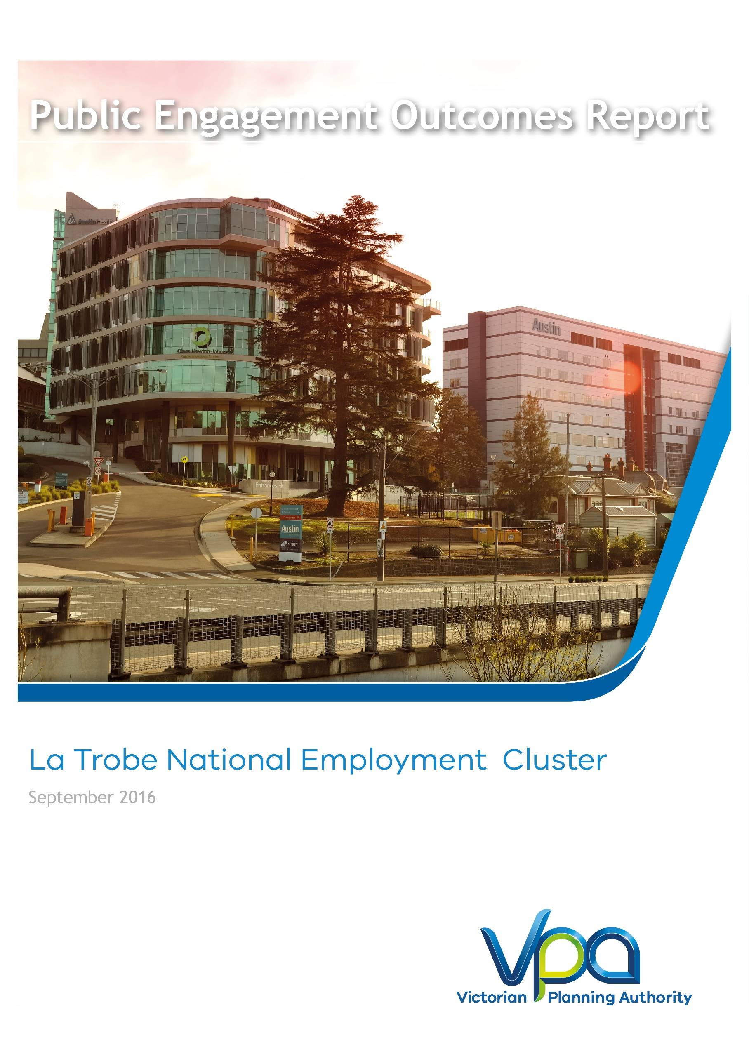

# La Trobe National Employment and Innovation Cluster Framework Plan

# Phase 2 Public Engagement Outcomes

# September 2017

La Trobe National Employment and   
Innovation Cluster Framework Plan

November 2017

CONTENTS

1 INTRODUCTION 3

2 ENGAGEMENT APPROACH 4

3 ENGAGEMENT PROGRAM AND ACTIVITIES 4

4 FEEDBACK & OUTCOMES 5

5 PROCESS AND NEXT STEPS 5

# INTRODUCTION

As outlined in *Plan Melbourne*, Melbourne’s population is set to increase to a city of 7.9 million people by 2051. To accommodate this growth, an additional 1.6 million dwellings and 1.5 million new jobs will need to be created. Growth of this scale requires long-term planning and management to sustain residents’ quality of life and Melbourne's status as one of the most liveable cities in the world. The VPA's role is facilitating the required land supply and identifying opportunities to increase housing, employment and investment within the state.

Preparing framework plans for the National Employment and Innovation Clusters is an action of *Plan Melbourne 2017-2050* to grow employment opportunities.

Phase 1 of public engagement for the La Trobe National Employment and Innovation Cluster (NEIC) Framework Plan was completed in July 2016. It was the first phase to test preliminary ideas and help formulate the future land use, development and infrastructure planning directions for the La Trobe Cluster.

The feedback was used in drafting the La Trobe National Employment and Innovation Cluster Draft Framework Plan which was consulted on in Phase 2 of public engagement. Phase 2 was completed in April 2017(process ran publically from 16 March to 18 April 2018) is the subject of this report.

This report summarises public engagement activities undertaken in phase 2, the feedback received and how this input will be used to finalise the framework plan.

Feedback was obtained via written submissions following a 2 hour drop-in information session, meetings with stakeholders as requested and a comprehensive website outlining the different components of the framework plan and Frequently Asked Questions.

The La Trobe National Employment and Innovation Cluster Framework Plan is a collaborative project being led by the Victorian Planning Authority (VPA) in collaboration with City of Darebin, City of Banyule, La Trobe University and Austin Health. Other state government stakeholders have also been involved. The framework plan is underpinned by *Plan Melbourne 2017-2050*, the State’s metropolitan planning strategy.

Figure 1 – Metropolitan Context Plan



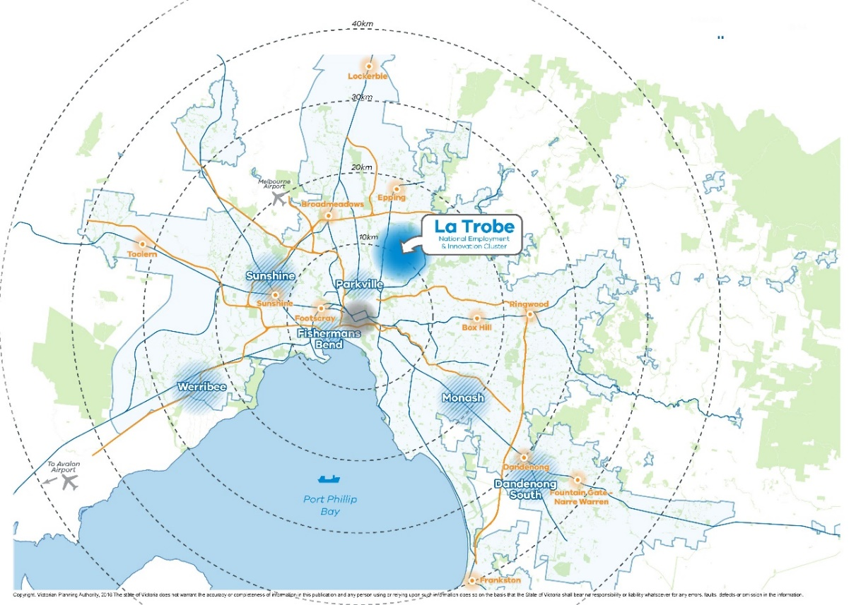

# ENGAGEMENT APPROACH

The VPA devised a two-phase approach to public engagement for the La Trobe Cluster Framework Plan. The objectives of Phase 1 were to:

* Seek feedback on the vision and principles for the framework plan
* Test the key ideas for delivery of the vision and principles, including opportunities for new ideas and suggestions
* Build understanding of the opportunities for development and investment
* Build momentum for positive change in the education, health and employment areas
* Offer an opportunity to contribute to and influence the direction of the draft framework plan for La Trobe

The feedback from Phase 1 informed the preparation of the draft Framework Plan. The objective of Phase 2 public engagement was to seek comments from stakeholders and the public on the draft La Trobe National Employment and Innovation Cluster Draft Framework Plan and invite submissions.

# ENGAGEMENT PROGRAM AND ACTIVITIES

Table 1 - Public Engagement Activities

|  |  |
| --- | --- |
| **Date** | **Public Engagement Activity** |
| **6 March 2017** | Banyule City Council Councillor Briefing |
| **9 March 2017** | E-bulletin provided to Darebin City Council Councillors |
| **22 March 2017** | Shape Victoria online portal launched |
| **22 March 2017** | Email to all stakeholders (including over 1000 businesses) and previous engagement participants from phase 1 |
| **22 March 2017** | Copies of draft framework plan sent to the offices of the three local MPs |
| **28 March 2017** | Drop-in information session |

Shape Victoria is the online communication and engagement platform used by the VPA for engagement on the La Trobe NEIC. It also provides information and resources about the Cluster, including maps, event information, project updates and background reports.

The VPA also used social media to promote the events.

The webpage went live on the 22 March, 2017 which was the beginning of the 4-week public engagement process (22 March – 18 April 2017). During the public engagement period the project page within Shape Victoria, received 376 visits. The webpage allows users to engage with a range of material that will inform and provide details of what is proposed for the La Trobe Cluster. The website gives direct access to VPA project officers through email and phone links to make further enquiries.

Shape Victoria included:

* + - Draft Framework Plan;
    - Upcoming event information;
    - Background documents and reports;
    - FAQs;
    - Project Timelines; and
    - Key contact information and direction on providing feedback

Over the 4-week public engagement period:

* + - 111 people downloaded the Draft Framework Plan with additional hard copies distributed by the VPA.

# FEEDBACK & OUTCOMES

Based on four written submissions, public enquiries and stakeholder meetings, a summary of the feedback received from phase 2 public engagement included:

* Greater state government commitment to having a pipeline of infrastructure investment including major transport projects;
* Greater clarity around infrastructure contributions plans;
* A clear outline of the governance arrangements needed for implementation;
* A focus on active and public transport as preferred means of travel;
* A need to include a stronger emphasis on housing;
* Re-enforce the role of the cluster as a centre for emerging employment sectors and innovation ;
* A stronger focus on WSUD issues and the ongoing management of water across the cluster; and
* A process for considering new community infrastructure needs such as schools and open space.

Changes to the Framework Plan will be made as a result of feedback.

The Framework Plan has proposed changes to roads to allow for better vehicle and bus movements and it has an action to prepare an Integrated Transport Plan which will address transport infrastructure needs. The transport section of the Framework Plan will include an emphasis on active and public transport modes of travel.

Housing within the cluster is within the key precincts of Heidelberg Major Activity Centre, the Northland Urban Renewal Precinct and La Trobe University. There is major change occurring in housing development in the Heidelberg West residential area which will be addressed in the Framework Plan.

The role of the cluster as a major area of innovation will be reinforced by adding a section that highlights the specialised activities of La Trobe University and Austin Health.

# PROCESS AND NEXT STEPS

Following feedback, the draft framework plan will be updated and submitted to the Minister for Planning for approval.

A copy of the final La Trobe National Employment and Innovation Cluster Framework Plan will be posted on the VPA website.