SCHEDULE 9 TO CLAUSE 37.07 URBAN GROWTH ZONE
DD/MM/YYYY
Proposed C205
Shown on the planning scheme map as UGZ9
Lindum Vale Precinct Structure Plan
- The Plan
DD/MM/YYYY
Proposed C205
Map 1 shows the Future Urban Structure proposed in the Lindum Vale Precinct Structure Plan.
Map 1 to Schedule 9 to Clause 37.07
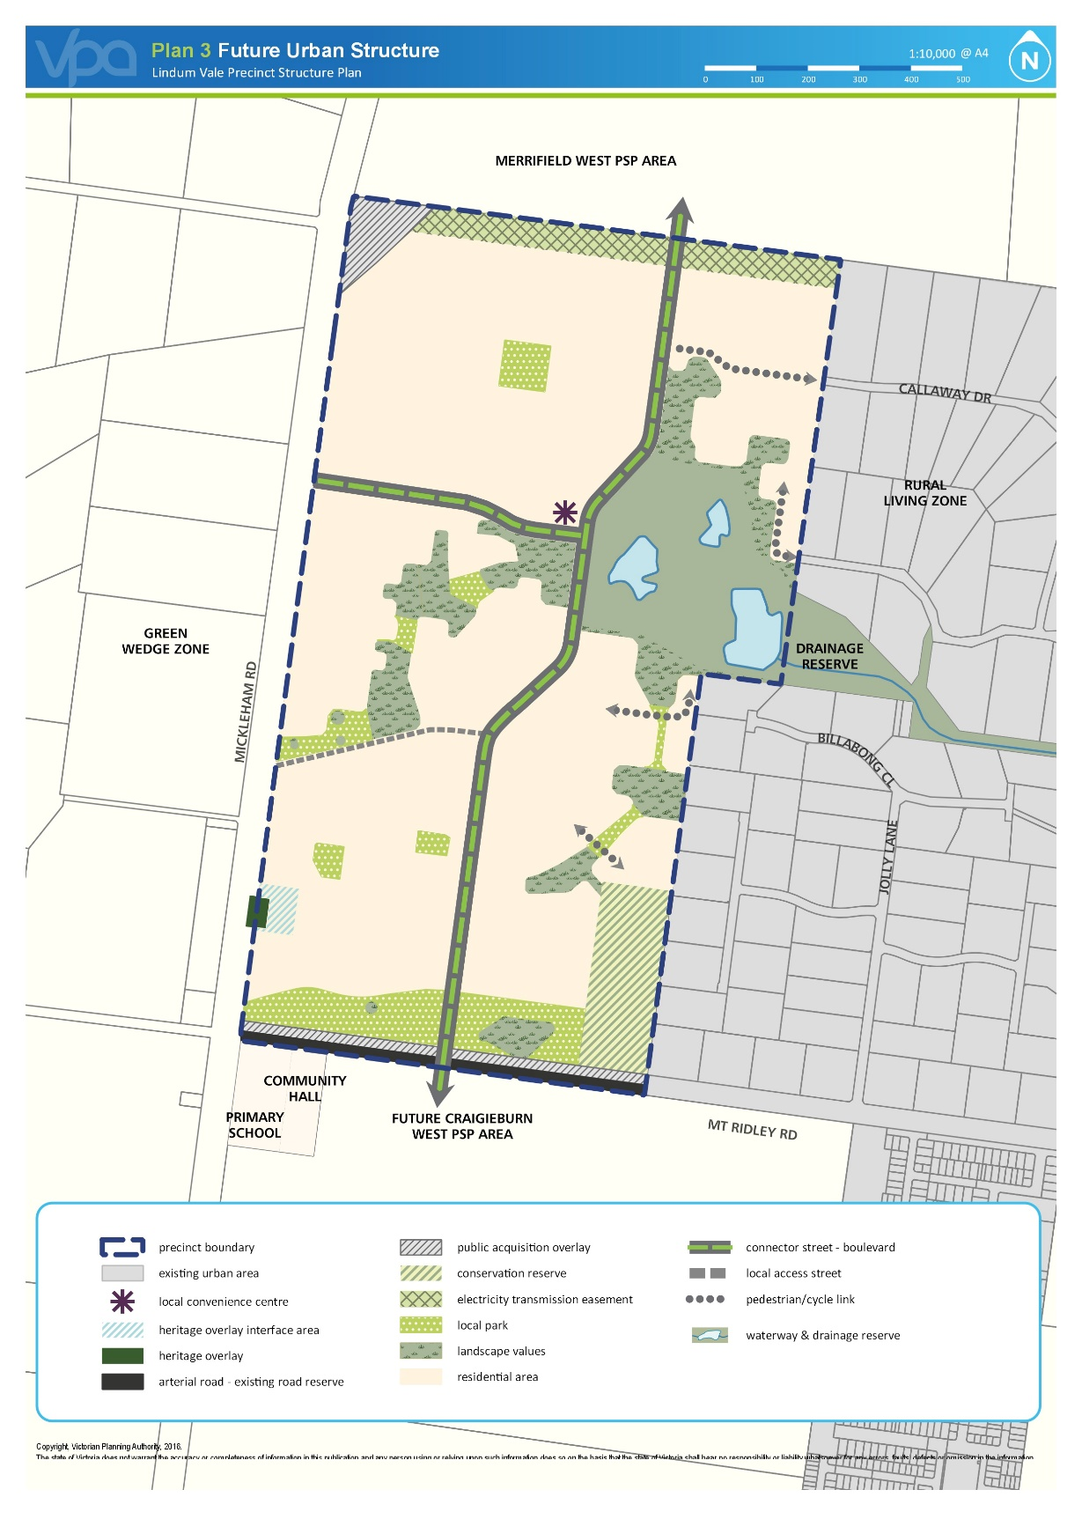
- Use and development
DD/MM/YYYY
Proposed C205

2.1 The land
DD/MM/YYYY
Proposed C205
The use and development provisions specified in this schedule apply to the land within the ‘precinct boundary’ on Map 1 and shown as UGZ9 on the planning scheme maps. This schedule must be read in conjunction with the Lindum Vale Precinct Structure Plan (PSP).
2.2 Applied zone provisions
DD/MM/YYYY
Proposed C205
The provisions of the following zones in this scheme apply to the use and subdivision of land, construction of a building, and construction and carrying out of works, by reference to Plan 1 of this schedule.
Table 1: Applied zone provisions
Land use/development (carried out or proposed) generally in accordance with the Precinct Structure Plan applying to the land (Refer Map 1) | Applied zone provisions
Local Convenience Centre | Clause 34.01 – Commercial 1 Zone
All other land | Clause 32.07 – General Residential Zone 1
2.3 Specific provisions – Use of land
DD/MM/YYYY
Proposed C205
Section 1 - Permit not required
Use | Condition
Shop | Where the applied zone is Commercial 1 Zone, permit is required to use land for a shop if the combined leasable floor area of all shops exceeds:  - 1,200 square metres for land shown as a local Convenience Centre in the incorporated Lindum Vale Precinct Structure Plan.
Any use listed in Clause 62.01 | Must meet requirements of Clause 62.01.
Section 2 - Permit required
Use | Condition
Any other use not in Section 1 or 3
Section 3 – Prohibited
Use
None specified, except where specified in the applied zone.

2.4 Specific provisions – Subdivision
DD/MM/YYYY
Proposed C205
None specified.
2.5 Specific provisions – Buildings and works
DD/MM/YYYY
Proposed C205
Dwellings on a lot less than 300 square metres
A permit is not required to construct or extend one dwelling on a lot with an area less than 300 square metres where a site is identified as a lot to be assessed against the Small Lot Housing Code via a restriction on title, and it complies with the Small Lot Housing Code incorporated pursuant to Clause 81 of the Hume Planning Scheme.
Construction of a dwelling adjacent to the east boundary
A permit is required to construct a dwelling on a lot adjacent to the eastern boundary of the Lindum Vale Precinct Structure Plan which:
  - Is within 10 metres of the east boundary of the Lindum Vale precinct;
  - Has a setback of less than 3 metres from the boundary, which is perpendicular to the east side boundary of the Lindum Vale precinct.
3.0 Application requirements
DD/MM/YYYY
Proposed C205

The following application requirements apply to an application for a permit under Clause 37.07, in addition to those specified in Clause 37.07 and elsewhere in the scheme and must accompany an application, as appropriate, to the satisfaction of the responsible authority:
Subdivision - Residential Development
In addition to any requirement in 56.01-2, a subdivision design response must include:
  - A land budget table in the same format and methodology as those within the precinct structure plan applying to the land, setting out the amount of land allocated to the proposed uses and expected population and dwelling yields.
  - A demonstration of how the application will contribute to the achievement of the residential density outcomes in the precinct structure plan applying to the land.
  - A demonstration of lot size diversity by including a colour-coded lot size plan, reflecting the lot size categories outlined in Table 2 - Lot Size and Housing Type Guide in the Lindum Vale Precinct Structure Plan, October 2016.
  - A demonstration of how the subdivision will contribute to the delivery of a diversity of housing.
  - A written statement that sets out how the proposal implements the objectives and planning and design requirements and guidelines in accordance with the incorporated Lindum Vale Precinct Structure Plan, October 2016.
  - A mobility plan that demonstrates how the local street and movement network integrates with adjacent urban development or is capable of integrating with future development on adjacent land parcels.
  - An arboricultural report identifying all trees on the site and a tree retention plan identifying how the application responds to Map 2 - Trees to be Retained and Removed in the incorporated Lindum Vale Native Vegetation Precinct Plan, October 2016 - and any tree protection requirements and guidelines within the Lindum Vale Precinct Structure Plan, October 2016.
  - Potential bus route and bus stop locations prepared in consultation with Public Transport Victoria.
  - An assessment of the existing surface and subsurface drainage conditions on the site, including any potential impacts on the proposed development, prepared by a suitably qualified professional. The assessment must include any measures required to mitigate the impacts of the development on groundwater and drainage.
  - Subdivision and Housing Design Guidelines, prepared to the satisfaction of the responsible authority, which demonstrate how the proposal responds to and achieves the objectives and planning and design requirements and guidelines shown within the ‘Interface treatment’ at Section 3.1.2 of the Lindum Vale Precinct Structure Plan, June 2017 incorporated in this scheme.
  - Where relevant, demonstration of how the subdivision will respond sensitively to the heritage significance of Parnell’s Inn (Heritage Overlay - Schedule 36) and its surrounding area.
  - A Site Management Plan that addresses bushfire risk during, and where necessary, after construction which is approved by the CFA. The plan must specify, amongst other things:
- The staging of development and the likely bushfire risks at each stage;
- An area of land between the development edge and non-urban areas consistent with the separation distances specified in AS3959-2009, where bushfire risk is managed;
- The land management measures to be undertaken by the developer to reduce the risk from fire within any surrounding rural or undeveloped landscape to protect residents and property from the threat of fire; and
- How adequate opportunities for access and egress will be provided for early residents, construction workers and emergency vehicles.
All to the satisfaction of the responsible authority.
Public Infrastructure Plan
An application must be accompanied by a Public Infrastructure Plan which addresses the following:
  - A stormwater management strategy that makes provision for the staging and timing of stormwater drainage works, including temporary outfall provisions, to the satisfaction of Melbourne Water;
  - What land may be affected or required for the provision of infrastructure works;
  - The provision, staging and timing of stormwater drainage works;
  - The provision, staging and timing of road works internal and external to the land consistent with any relevant traffic report or assessment;
  - The landscaping of any land;
  - What if any infrastructure set out in the incorporated Lindum Vale Infrastructure Contributions Plan is sought to be provided as "works in lieu" subject to the written consent of Hume City Council;
  - The provision of public open space and land for any community facilities; and
  - Any other matter relevant to the provision of public infrastructure required by the responsible authority.
Traffic Impact Assessment
An application that proposes to create or change access to a primary or secondary arterial road must be accompanied by a Traffic Impact Assessment Report (TIAR). The TIAR, including functional layout plans and a feasibility / concept road safety audit, must be to the satisfaction of VicRoads and Hume City Council, as required.
Use or develop land for a sensitive purpose - Environmental Site Assessment – 2040 Mickleham Road, Mickleham
An application to subdivide land, use or develop land for a sensitive use (residential use, child care centre, pre-school centre or primary school) must be accompanied by an Environmental Site Assessment of the land by a suitably qualified environmental professional to the satisfaction of the responsible authority, which takes account of ‘Phase 1 and Preliminary Phase 2 Environmental Site Assessment – Lindum Vale PSP Area’ (Parsons Brinckerhoff, 9 April 2013) and provides information including:
  - Further detailed assessment of potential contaminants on the relevant land.
  - Clear advice on whether the environmental condition of the land is suitable for the proposed use/s and whether an environmental audit of all, or part, of the land is recommended having regard to the Potentially Contaminated Land General Practice Note June 2005, DSE including:
- Advice if an environmental audit is required for the storage and dairy infrastructure at 2040 Mickleham Road.
  - Recommended remediation actions of any potentially contaminated land.
Dry Stone Wall Assessment
Any application on land shown as “dry stone wall to be retained and repaired – rating 2-3 (moderate – high value)” on Plan 2 – Precinct Features of the Lindum Vale Precinct Structure Plan must be accompanied by a report by a suitably qualified dry stone waller and inlcude:
- A statement of significance/cultural value;
- Recommendations on reinstatement and repair of the wall; and
- Where destruction of part of the wall is proposed, a Dry Stone Wall Management Plan which responds to the relevant objectives, requirements and guidelines contained within the Lindum Vale Precinct Structure Plan or any local policy.
Kangaroo management
An application for subdivision must be accompanied by a Kangaroo Management Plan to the satisfaction of the responsible authority, which includes:
- Strategies to avoid land locking kangaroos, including staging of subdivision; and
- Management requirements to respond to the containment of kangaroos in an area with no reasonable likelihood of their continued safe existence; or
- Management and monitoring actions to sustainably manage a population of kangaroos within a suitable location.
Where a Kangaroo Management Plan has been approved by the responsible authority, the application must be accompanied by:
- A copy of the approved Kangaroo Management Plan; and
- A ‘design/management response’ statement outlining how the application is consistent with and gives effect to any requirements of the approved Kangaroo Management Plan.

Heritage Assessment – Parnell’s Inn
An application for subdivision, use or development affecting a heritage place(s) should:
- Address the proposed future use or adaptive reuse of the affected heritage place(s);
- Include a draft Conservation Management Plan for the heritage place(s) to the satisfaction of the responsible authority; and
- Include the provision of sufficient space around the heritage building to allow its adaptive reuse to comply with other planning requirements, such as car parking and landscaping.
4.0 Conditions and requirements for permits
DD/MM/YYYY
Proposed C205

Condition - Subdivision permits that allow the creation of a lot less than 300 square metres
  - Prior to the certification of the plan of subdivision for the relevant stage, a plan must be submitted for approval to the satisfaction of the responsible authority. The plan must identify the lots that will include a restriction on title allowing the use of the provisions of the Small Lot Housing Code incorporated pursuant to Clause 81 of the Hume Planning Scheme; and
  - The plan of subdivision submitted for certification must identify whether type A or type B of the Small Lot Housing Code applies to each lot to the satisfaction of the responsible authority.
Condition – Subdivision and housing design guidelines
The specific built form requirements arising out of the design guidelines prepared as part of the application for subdivision for lots adjacent to the eastern boundary of the precinct must be implemented via a restriction on title or any other alternative deemed satisfactory by the responsible authority.
Condition - Biodiversity and threatened species
Any permit for subdivision must contain the following conditions:
Kangaroo Management Plan
Any permit for subdivision must contain the following conditions:
- Before the certification of the plan of subdivision, a Kangaroo Management Plan must be approved by the Secretary to the Department of Environment, Land, Water and Planning. Once approved the plan will be endorsed by the responsible authority and form part of the permit.
- The endorsed Kangaroo Management Plan must be implemented to the satisfaction of the responsible authority.
Protection of conservation areas and native vegetation during construction
A permit granted to subdivide land or a permit granted to construct a building or carry out works, where the Lindum Vale Native Vegetation Precinct Plan shows the land, or abutting land, including a conservation reserve or a patch of native vegetation or a scattered tree must contain the following conditions:
- Prior to commencement of works in or around a conservation area, scattered native tree or patch of native vegetation , the developer of the land must erect a conservation area/vegetation protection fence that is:
- Highly visible;
- At least 2 metres in height;
- Sturdy and strong enough to withstand knocks from construction vehicles;
- Kept in place for the whole period of construction; and
- Located the following minimum distance from the element to be protected:
Element | Minimum distance from element
Conservation reserve | 2 metres from the edge of the area
Scattered tree | The distance as shown in the incorporated Lindum Vale Native Vegetation Precinct Plan (Section 8)
Patch of native vegetation | 2 metres from the edge of the patch
- Construction stockpiles, fill, machinery, excavation and works or other activities associated with the buildings or works must:
- Be located not less than 15 metres from a waterway;
- Be located outside the required protective fence;
- Be constructed and designed to ensure that the conservation area, scattered tree or patches of native vegetation are protected from adverse impacts during construction; and
- Not be undertaken if the qualified ecologist or arborist who is familiar with the requirements of the incorporated Precinct Structure Plan is of the opinion that the various activities presents a risk to any vegetation within a conservation reserve.
Salvage and translocation
The Salvage and Translocation Protocol for Melbourne’s Growth Corridors (Department of Environment and Primary Industries, 2014) must be implemented in the carrying out of development to the satisfaction of the Secretary to the Department of Environment, Land, Water and Planning.
Condition - Public Transport
Unless otherwise agreed by Public Transport Victoria, prior to the issue of Statement of Compliance for any subdivision stage, bus stop hard stands with direct and safe pedestrian access to a pedestrian path must be constructed:
- In accordance with the Public Transport Guidelines for Land Use and Development; and compliant with the Disability Discrimination Act – Disability Standards for Accessible Public Transport 2002.
- At locations approved by Public Transport Victoria, at no cost to Public Transport Victoria, and to the satisfaction of Public Transport Victoria.
Condition - Road Network
Any permit for subdivision or buildings and works must contain the following conditions:

- Prior to the certification of a plan of subdivision, the plan of subdivision must show the land affected by the widening of the road reserve which is required to provide road widening and/or right of way flaring for the ultimate design of any adjacent intersection.
- Land required for road widening, including right of way flaring for the ultimate design of any intersection within an existing or proposed local road, must be transferred to or vested in Council at no cost to the acquiring agency unless funded by the Lindum Vale Infrastructure Contributions Plan.
Condition - Precinct Infrastructure Plan
Any permit for subdivision must contain the following condition:
- Prior to the certification of a plan of subdivision or at such other time which is agreed between Council and the owner, if required by the responsible authority or the owner, the owner must enter into an agreement or agreements under section 173 of the Planning and Environment Act 1987 which provides for:
- The implementation of the Public Infrastructure Plan approved under this permit.
- The timing of any payments to be made to a person in respect of any infrastructure project having regard to the availability of funds in the Infrastructure Contributions Plan.
Condition - Site Management Plan
Before the commencement of works for any stage of subdivision a Site Management Plan that addresses bushfire risk during, and where necessary, after construction must be submitted to and approved by the responsible authority. The plan must specify, amongst other things:
- The staging of development and the likely bushfire risks at each stage;
- An area of land between the development edge and non-urban areas consistent with the separation distances specified in AS3959-2009, where bushfire risk is managed;
- The measures to be undertaken by the developer to reduce the risk from fire within any surrounding rural or undeveloped landscape and protect residents and property from the threat of fire;
- How adequate opportunities for access and egress will be provided for early residents, construction workers and emergency vehicles.
The plan must be carried out to the satisfaction of the responsible authority.
Condition – Use or develop land for a sensitive purpose – Environmental Site Assessment for land at 2040 Mickleham Road, Mickleham
Before a plan of subdivision is certified under the Subdivision Act 1988, the recommendations of the Phase 2 Environmental Site Assessment submitted must be carried out to the satisfaction of the responsible authority.
Upon receipt of the further testing report the owner must comply with any further requirements made by the responsible authority after having regard to the guidance set out in the General Practice Note on Potentially Contaminated Land June 2005 (DSE). The plan of subdivision must not be certified until the responsible authority is satisfied that the land is suitable for the intended use.
5.0 Exemption from notice and review
DD/MM/YYYY
Proposed C205

None specified.
6.0 Decision guidelines
DD/MM/YYYY
Proposed C205

None specified.
7.0 Advertising signs
DD/MM/YYYY
Proposed C205

Advertising sign requirements are at Clause 52.05. The advertising sign category for the land is the category specified in the zone applied to the land at Clause 2.2 of this schedule. All other land is in Category 3.

