|  |
| --- |
| Kororoit Precinct Structure Plan (PSP)  Amendment C147 to the Melton Planning Scheme |
| Traffic Engineering Evidence Statement to Planning Panels Victoria  Date of Statement: 21st November 2016 Date of Inspections: 16th November 2016  Prepared For: Villa World Developments Pty Ltd Instructed By: Best Hooper Pty Ltd  Reference: G21869A1B |
| IN THE MATTER OF AMENDMENT C147 TO THE MELTON PLANNING SCHEME RELATING TO THE KOROROIT PRECINCT STRUCTURE PLAN (PSP)  STATEMENT TO PLANNING PANELS VICTORIA BY JASON LEE WALSH, TRAFFIC ENGINEER |

STATEMENT TO PLANNING PANELS VICTORIA BY JASON LEE WALSH, TRAFFIC ENGINEER

Amendment C147 to the Melton Planning Scheme

at

Kororoit Precinct Structure Plan (PSP)

**Our Reference: G21869A1B**

COPYRIGHT: The ideas and material contained in this document are the property of Traffix Group (Traffix Group Pty Ltd – ABN 32 100 481 570, Traffix Survey Pty Ltd – ABN 57 120 461 510, Traffix Design Pty Ltd – ABN 41 060 899 443). Use or copying of this document in whole or in part without the written permission of Traffix Group constitutes an infringement of copyright.

LIMITATION: This report has been prepared on behalf of and for the exclusive use of Traffix Group’s client, and is subject to and issued in connection with the provisions of the agreement between Traffix Group and its client. Traffix Group accepts no liability or responsibility whatsoever for or in respect of any use of or reliance upon this report by any third party.

Table of Contents

1 Preamble 2

2 Existing Conditions 3

2.1 Subject Land 3

2.2 Road Network 3

3 Kororoit PSP 4

3.1 The Land 4

3.2 Future Road Network 5

3.3 Bicycle Network 7

3.4 Infrastructure Contribution Items 7

4 Transport Modelling 8

4.1 2026 Model 8

4.2 2046 Model 8

5 Sinclair Road Assessment 9

5.1 Interim (2026) and Ultimate (2046) Traffic Models 9

5.2 No Hopkins Road Connection 9

6 Bicycle Network 11

7 Conclusions 12

List of Figures

Figure 1: Locality Plan 5

Figure 2: Kororoit PSP Plan 8 - Road Network Plan 6

Figure 3: Sinclairs Road Cross Section 7

List of Appendices

Appendix A Summary of Qualifications

# Preamble

I have been instructed by Best Hooper Pty Ltd on behalf of Villa World Developments Pty Ltd to undertake a traffic engineering assessment of traffic matters related to proposed Amendment C147 to the Melton Planning Scheme - .

Specifically, I have been instructed to assess whether direct property access to Sinclairs Road as part of development of 1053 Taylors Road Plumpton is appropriate in an interim and ultimate arrangement.

In the course of preparing this statement, I inspected the subject land and surrounds in November 2016, reviewed background documentation prepared by the Victorian Planning Authority (VPA) and their consultants for the Kororoit Precinct Structure Plan (PSP) and Plumpton PSP, and assessed the merits of direct access to future individual properties fronting Sinclairs Road.

My qualifications and experience to undertake the following assessment are set out in Appendix A.

# Existing Conditions

## Subject Land

Villaworld own the property, addressed as 1053 Taylors Road Plumpton. The site is located at the south east corner of the intersection of Taylors Road and Sinclairs Road, and has an area of approximately 12 hectares, including frontages of approximately 200 metres to Taylors Road and 600 metres to Sinclairs Road.

The site is vacant.

Surrounding land is generally large farming properties. Caroline Springs and the developing Hillside residential estate are situated to the east.

## Road Network

***Taylors Road*** is an important east-west link connecting Plumpton Road in the west with Green Gully Road / Sunshine Avenue in the east. In the vicinity of the subject land, Taylors Road is a major Council road, and it operates as a single two-way carriageway with grass / gravel verges within an approximate reservation of 20 metres. Taylors Road, to the east of Saric Court, has a posted speed limit of 60km/h.

***Sinclairs Road*** is a major Council road with a north south alignment connecting Neale Road in the south through to Taylors Road in the north. Sinclairs Road has a single carriageway of approximately seven (7) metres and grass shoulders that provide for a single lane of traffic in each direction, within a reservation of approximately 20 metres. The carriageway is centrally located within the reservation.

Sinclairs Road has a posted speed limit of 80km/h.

To understand existing traffic volumes on Sinclairs Road, my firm commissioned an automatic tube count. The counter recorded traffic volumes from Wednesday 16 November to Friday 18 November 2016. The results of the count highlight an average weekday daily two-way volume of about 10,300 vehicles, inclusive of peak hour volumes of 822 vehicles in the morning peak (6-7am) and 956 vehicles in the afternoon peak (5-6pm).

# Kororoit PSP

## The Land

The Kororoit Precinct Structure Plan (PSP) has been prepared by the Metropolitan Planning Authority (MPA) for the future development of the land. The PSP encompasses in the order of 925 hectares, and is generally bound by the Outer Metropolitan Freeway reservation to the west, Taylors Road to the north, Monaghans Lane (northern section) and Sinclairs Road (southern section) to the east, and Kororoit Creek (eastern section) and Western Freeway (western section) to the south.

Plumpton PSP is situated to the north, across Taylors Road.

The subject land, 1053 Taylors Road, is situated centrally in the northern portion of the PSP. It is encumbered and bisected by a gas easement aligned in a north south direction running for the length of the property.

A locality plan depicting the Kororoit PSP and the location of the subject land within the PSP is illustrated in Figure 1.

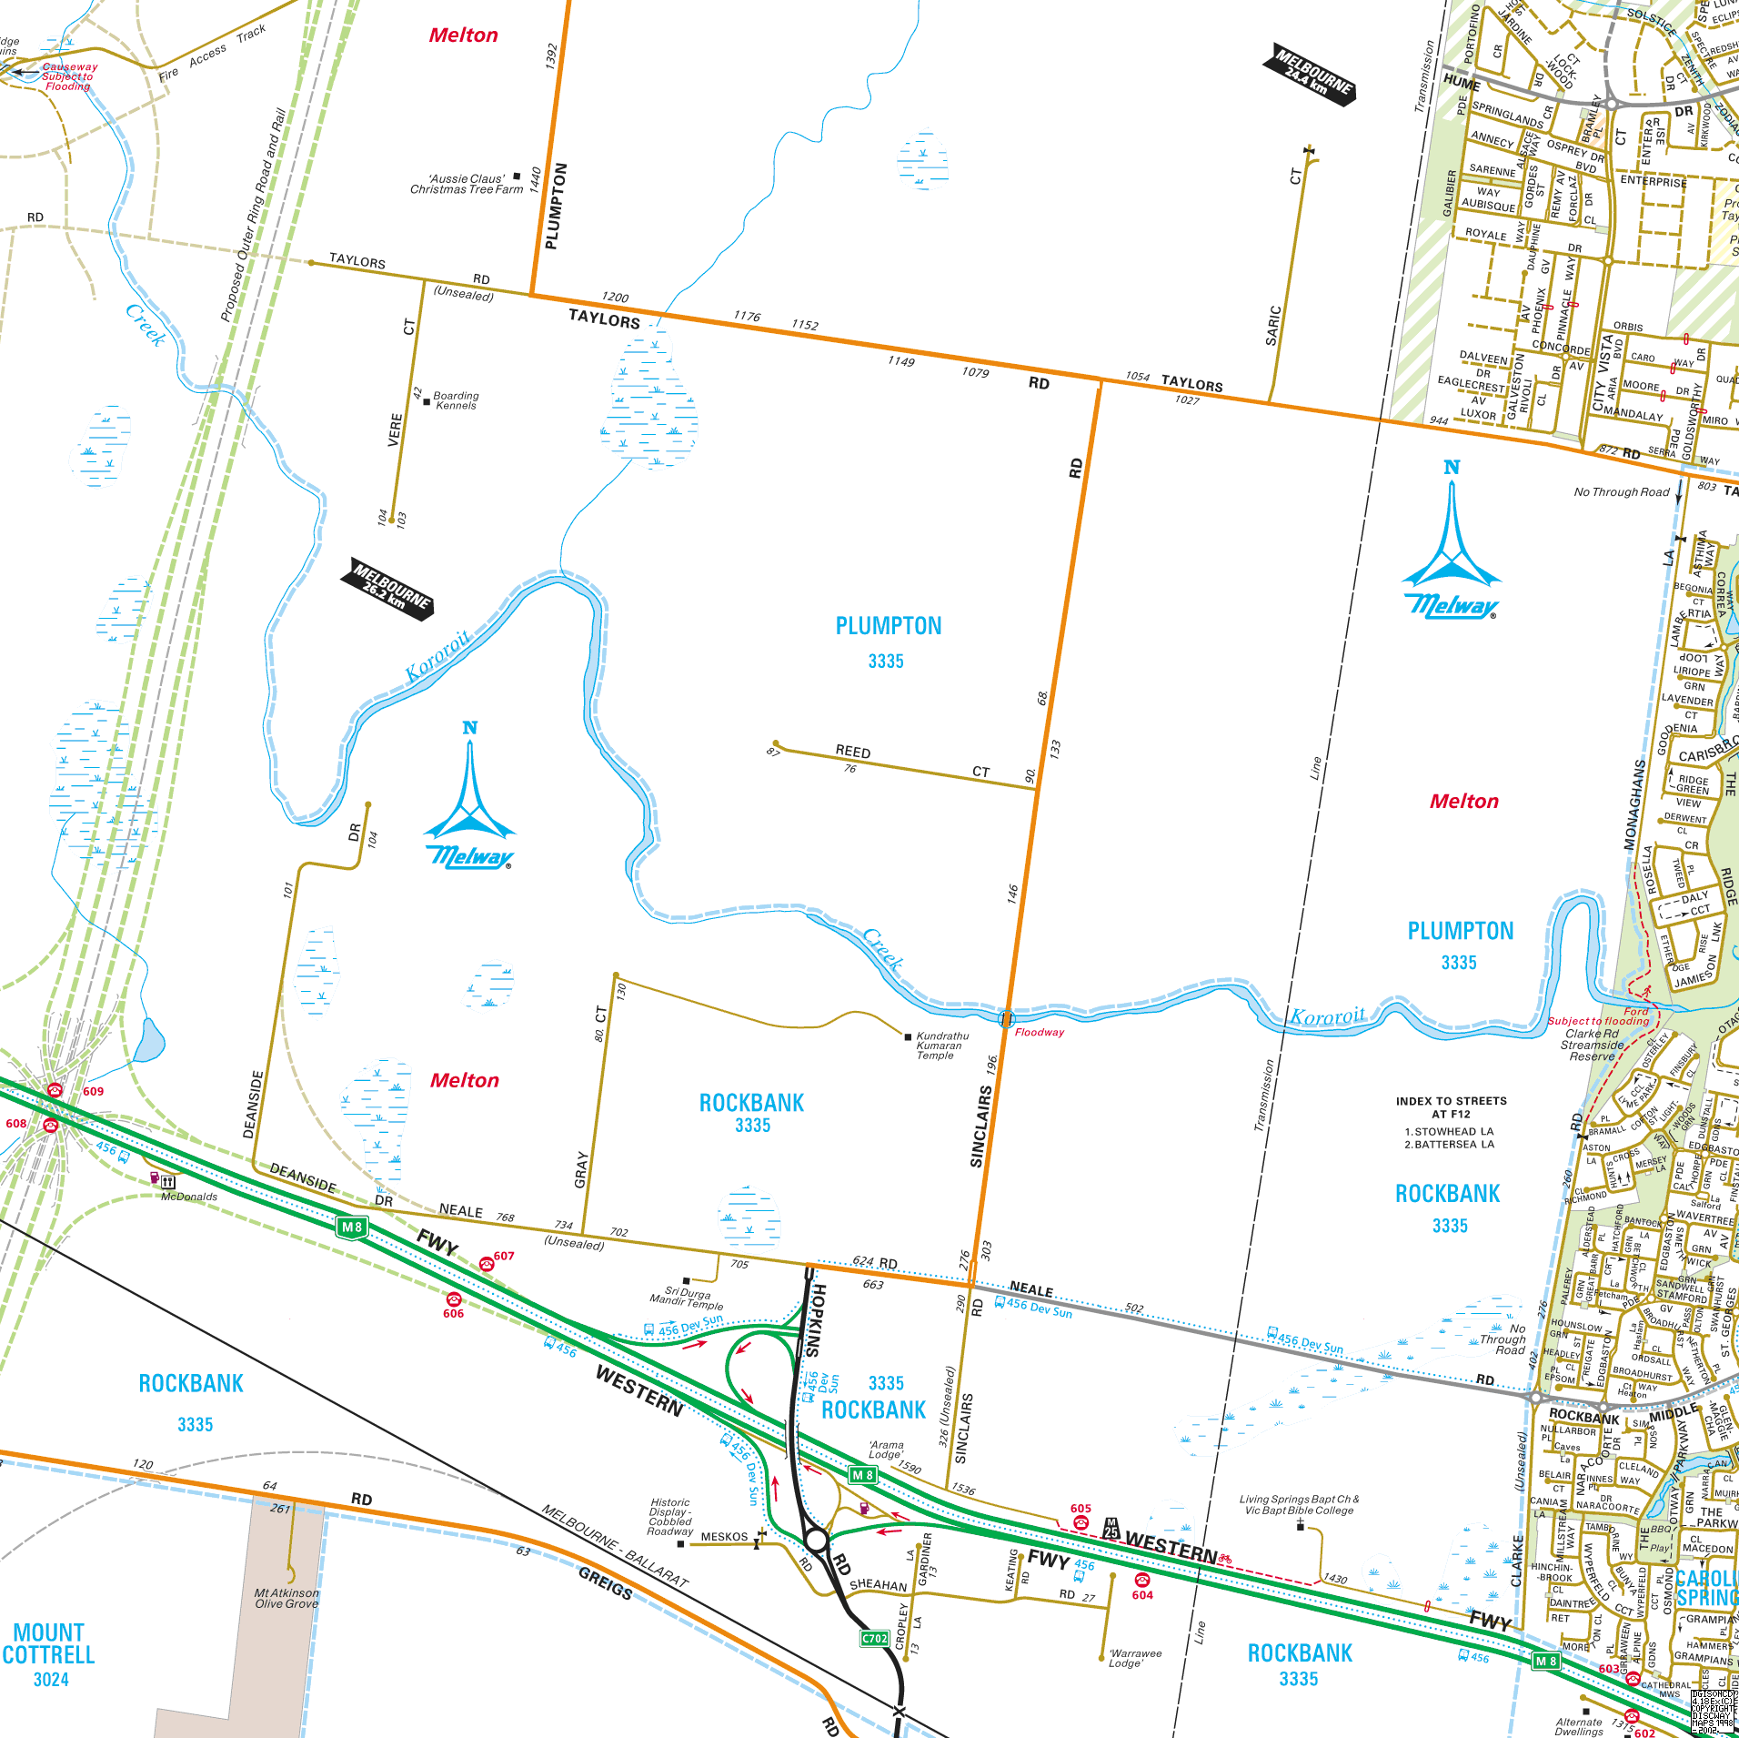

Subject Land

Kororoit PSP Area

Figure 1: Locality Plan

## Future Road Network

Plan 8 of the Kororoit PSP, shown as Figure 2, illustrates the future road network for the PSP area.

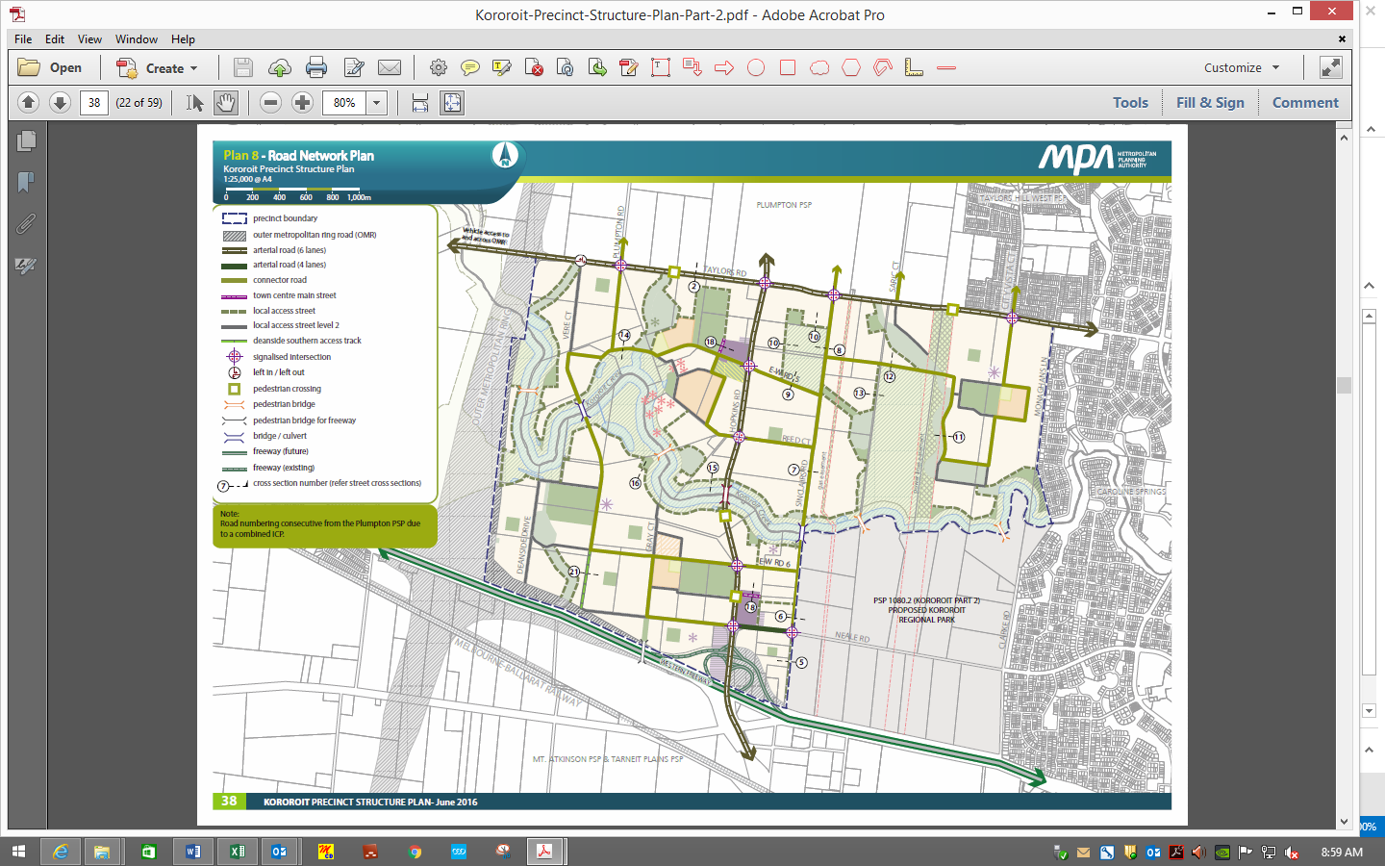

Figure 2: Kororoit PSP Plan 8 - Road Network Plan

In relation to the subject land, the following is noted.

***Taylors Road*** is designated as a six (6) lane arterial road contained within a reservation of 44 metres. Between Sinclairs Road and Saric Court, the widening of the reservation will come from the southern side (in part the subject land).

Taylors Road will provide for the primary east-west link through Kororoit and Plumpton PSP’s.

***Hopkins Road*** is a planned six (6) lane arterial road. It is aligned in a north south direction, located approximately 500 metres to the west of Sinclairs Road, connecting from the existing Hopkins Road interchange at the Western Freeway to extend across Taylors Road and through Plumpton PSP.

Hopkins Road will provide the primary north-south link for Kororoit and Plumpton PSPs.

***Sinclairs Road*** is a designated collector road, and will generally operate with a single traffic lane and parking lane in each direction. There is also provision for an off-road two-way bicycle path, nominated on the eastern side of Sinclairs Road. In the vicinity of the subject land, the PSP identifies Section 8 (shown as Figure 3) as the cross section for Sinclairs Road near to the conservation area. It shows a 27 metre reservation, inclusive of approximately seven (7) metres of widening on the eastern side of Sinclairs Road. That is, the subject land is having to provide the seven (7) metres of widening.

The cross section for Sinclairs Road, near to the subject land, is included as Figure 3.

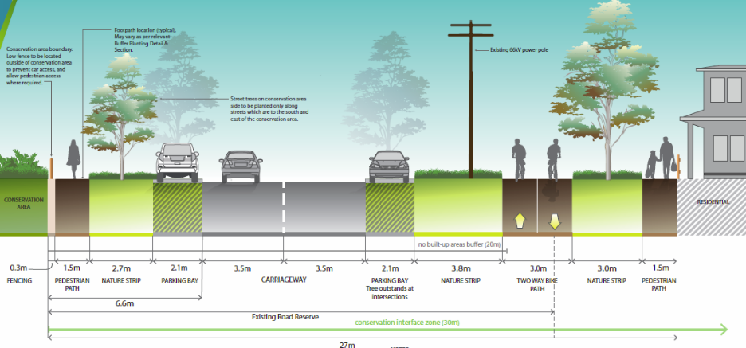

Figure 3: Sinclairs Road Cross Section

It is of note that the standard cross section for a connector road has a 25 metre reservation, with the additional width (2 metres) for Sinclairs Road seemingly required to provide separation for existing power lines and poles within the existing reservation. (It is noted that the above cross section illustrates the power lines on the east side of Sinclairs Road, whereas they exist on the western side).

I am instructed that there have been discussions between the parties about the potential removal of the above ground power lines and poles. In this scenario, presumably the proposed cross section for Sinclairs Road could revert to the standard connector road cross section (25 metre reservation).

The intersection of Sinclairs Road and Taylors Road is identified to be constructed with traffic signals.

## Bicycle Network

Plan 9 in the Kororoit PSP illustrates the public transport and bicycle network. In relation to the subject land, the plan shows a two-way off-road bicycle path running within the eastern verge of Sinclairs Road, and then some 100 metres to the east there is an off-road shared path running within the gas easement, parallel to Sinclairs Road

## Infrastructure Contribution Items

Plan 12 in the Kororoit PSP identifies the transport infrastructure that will be funded through an Infrastructure Contributions Plan (ICP). Taylors Road, Hopkins Road, and the intersection of Sinclairs Road and Taylors Road are items that will be funded.

The widening of Sinclairs Road to provide for a 27 metre reservation and the bicycle path within the gas easement are not ICP items.

# Transport Modelling

The Victorian Planning Authority engaged Jacobs to undertake transport modelling for the Plumpton and Kororoit PSPs. Jacobs prepared a report, dated June 2016, that outlines projected future traffic and public transport use within the Plumpton and Kororoit PSPs.

## 2026 Model

The 2026 Model assumes a complete road network within the Plumpton and Kororoit PSPs, however Taylors Road and Hopkins Road are only presumed to be two-lane arterials, and the Outer Metropolitan Ring Road is not constructed.

The model outputs project a two-way daily traffic volume of around 5,000 vehicles on Sinclairs Road, adjacent to the subject land. (Noting the 2026 model diagram has a volume of 4,200 vehicles but the table suggests a volume of 5,400 vehicles).

## 2046 Model

The 2046 Model assumes full build out of the PSP areas and construction of the Outer Metropolitan Ring Road. The model predicts that Sinclairs Road, adjacent to the subject land, will have a two-way daily volume of around 6,000 vehicles. (Noting the 2046 model diagram has a volume of 5,100 vehicles but the table suggests a volume of 6,900 vehicles).

# Sinclair Road Assessment

The PSP, at R48, states ‘Vehicle access to lots fronting arterial roads must be provided from a local internal loop road, rear lane or service road to the satisfaction of the responsible authority’.

Sinclairs Road is designated a connector road, and consequently it is implied that direct access to individual properties is appropriate.

I am instructed that Council does not support direct vehicle access to Sinclairs Road, until such time as a single carriageway of Hopkins Road is constructed. In this regard, the VPA are recommending the inclusion of a new guideline, stating: *“Minimise the number of new crossovers to Sinclairs Road north of Neale Road until the first carriageway for the Hopkins Road alignment is constructed between Neale Road and Taylors Road, to the satisfaction of the responsible authority.”*

## Interim (2026) and Ultimate (2046) Traffic Models

The standard VPA cross section for a connector road contemplates a daily traffic volume range of 3,000 – 7,000 vehicles.

Neither of the traffic models, interim or ultimate, project that traffic volumes on Sinclairs Road will exceed 7,000 vehicles per day, and accordingly direct individual access is appropriate. However, it is noted that both models presume that Hopkins Road is constructed.

## No Hopkins Road Connection

Sinclairs Road currently experiences a daily traffic volume of approximately 10,000 vehicles.

In the absence of a Hopkins Road connection, existing and future motorists are likely to use Sinclairs Road or Caroline Springs Boulevard as the north-south routes through the area. Caroline Springs Boulevard is an arterial road that operates as a divided carriageway with two lanes of traffic in each direction. Accordingly, it should be encouraged as the preferential north-south traffic route until such time as Hopkins Road is constructed.

That said, clearly as the PSP develops and if Hopkins Road is not constructed, then traffic volumes on Sinclairs Road will increase.

So, in my mind, the question arises as to what is a safe and acceptable level of traffic where direct access to properties is reasonable, in the context of the ultimate operation of Sinclairs Road as a connector where direct access would be expected. That is, is it acceptable to have direct access for higher than desirable traffic volumes for an interim period.

To better understand this question, I have investigated a series of roads throughout metropolitan Melbourne that operate with a traffic lane and parking lane in each direction, and that provide direct individual property access.

Examples of such roads and their respective daily traffic volumes are:

* Auburn Road, Hawthorn (near Airedale Avenue) – approximately 17,000 vehicles.
* Kooyong Road, Caulfield North (near Alma Road) – approximately 15,000 vehicles.
* Hampton Road, Hampton (near Dendy Street) – approximately 14,000 vehicles.
* Tooronga Road, Hawthorn East (near Campbell Grove) – approximately 13,000 vehicles.

A review of Crashstats for the last five (5) years of available data for these road sections does not highlight a prevalence of accidents involving motorists accessing or departing properties.

The example roads show that roads with a cross section comprising a car parking lane and traffic lane in each direction, can provide direct property access and maintain functional and safe operation up to around 15,000 vehicles per day.

In view of the above assessment, and in the context of the ultimate operation of Sinclairs Road, I am of the opinion that direct property access is acceptable for an interim period whilst there is no Hopkins Road connection across Kororoit Creek.

# Bicycle Network

In relation to the subject land, the PSP illustrates north-south parallel bicycle routes along Sinclairs Road and the gas easement. These routes are in the order of 100 metres apart, and in this regard I am of the opinion that both routes are not necessary.

The gas easement is an encumbrance that is best served to provide for the bicycle path, and minimises interaction with vehicles. To this end, I believe the two-way bicycle path designated on Sinclairs Road can be removed. This will allow the road reservation to be reduced by at least three (3) metres, whether it is the standard connector road cross section or the nominated Sinclairs Road Conservation Area cross section.

# Conclusions

Having undertaken a traffic engineering assessment of Amendment C147 to the Melton Planning Scheme relating to the , I am of the opinion that:

1. Sinclairs Road is designated as a connector road, and accordingly direct property access should be allowed.
2. In the interim, even without a Hopkins Road connection, direct property access is acceptable.
3. There is a bicycle path nominated along the gas easement, and in this context I do not think a two-way bicycle path along Sinclairs Road is necessary. Accordingly, the nominated Sinclairs Road reservation can be reduced by at least three (3) metres.

I have made all the inquiries that I believe are desirable and appropriate and there are no matters of significance which I regard as relevant, to the best of my knowledge, have been withheld from the Panel.



JASON WALSH   
DIRECTOR  
TRAFFIX GROUP   
21st November 2016

|  |
| --- |
|  |
| 1. Summary of Qualifications |

#### Name

Jason Walsh - Director, Traffix Group Pty Ltd

#### Address

Suite 8, 431 Burke Road   
GLEN IRIS   
VICTORIA 3146

#### Qualifications

My educational qualifications and membership of professional associations are as follows:-

* Bachelor of Civil Engineering, Monash University
* Bachelor of Science, Monash University
* Member, Victorian Planning & Environmental Law Association

#### Experience

I have approximately 20 years experience in Traffic Engineering including,

* 1995-2000 at Turnbull Fenner (now Traffix Group), including short term placements at the cities of Bayside and Whittlesea,
* 2000-2011 at Grogan Richards Pty Ltd (now Cardno),
* 2011-present at Traffix Group.

#### Areas of Expertise

* Car parking and Traffic.
* Traffic advice and assessment of land uses and development proposals to planning authorities, government agencies, corporations and developers (including major residential, retail, food and drink, commercial, industrial, institutional and mixed use projects).
* Preparation and presentation of evidence before VCAT and Panels.

#### Expertise to Prepare this Assessment

My experience and expertise over the past 20 years, including involvement with varied forms of developments, qualifies me to comment on the traffic implications of the proposed development.

#### Instructions

I was instructed Best Hooper Pty Ltd on behalf of Villa World Developments Pty Ltd to undertake a traffic engineering assessment of Amendment C147 to the Melton Planning Scheme relating to the , and in particular the operation of Sinclairs Road.

#### Facts, Matters and Assumptions Relied Upon

* Amendment C147 to the Melton Planning Scheme documentation.
* Kororoit PSP.
* Plumpton PSP.
* Jacobs Modelling Report for Kororoit and Plumpton PSPs.
* Traffic counts of Sinclairs Road (November 2016).

#### Documents Taken into Account

See above.

#### Identity of Persons Undertaking Work

Jason Walsh as per the evidence statement.

James Cossins (Traffic Engineer, Traffix Group) assisted with preparation of the evidence report.

#### Summary of Opinions

See Conclusions section of the evidence statement.

|  |
| --- |
|  |