Sunshine nec PUblic engagement outcomes report summary

context

Plan Melbourne identifies the Sunshine as an “emerging” National Employment Cluster, a place that will make a major contribution to Australia’s economy.

The Sunshine NEC has excellent transport connections; a range of thriving businesses; important regional institutions, such as the Sunshine Hospital and Victoria University campuses; well-developed service centres and a diverse local population. Sunshine has the potential to become a major provider of teaching, healthcare services, medical research, education, transport and logistics, business and retail services for Melbourne’s west.

Overall, the VPA forecasts that the number of jobs in the Sunshine NEC could grow from around 18,200 (in 2011) to 46,000 by 2051. This is an increase of just over 700 jobs per year, over the next 40 years.

To encourage Sunshine’s development and growth, the VPA is creating a framework plan for the Sunshine NEC, which will guide future land uses in the area and spur investment.

The Sunshine NEC Framework Plan is a collaborative project being led by the Victorian Planning Authority (VPA) in collaboration with City of Brimbank and other key state government agencies and stakeholders.

Purpose
Phase 1 of public engagement for the Sunshine National Employment Cluster (NEC) Framework Plan has been completed. In the first phase, Brimbank City Council and the VPA sought to test preliminary ideas that will be used to help formulate future land use, development and infrastructure planning for the Sunshine NEC.
This report summarises the activities undertaken, the feedback and how the input will be used in shaping the content and directions for the project.
Feedback was gathered using several methods including via surveys, written submissions, focus groups and stakeholder conversations.
Generally, the VPA’s draft Vision, Principles & Key Ideas for the future of the Cluster align with those raised by submitters from the Cluster’s residential, worker and business communities.

Engagement Program and Activities
Table 2 – Public Engagement Participation Table

Date | Public Engagement Activity | Number of Participants
16 June – 26 July 2016 | Sunshine National Employment Cluster - Survey | 61
17 June 2016 | Launch event | 60
20 June 2016 | Presentation to the Sunshine Health, Wellbeing and Education Precinct Management Board | 20
20 June 2016 | Presentation to the Solomon Heights Land Owners Group | 10
20 June 2016 | Presentation to the St Albans Traders Association | 15
22 June 2016 | Presentation to the Sunshine Partnership Group | 15
18 July 2016 | Sunshine National Employment Cluster - Business Seminar | 40
21 July 2016 | Sunshine National Employment Cluster - Focus Group 1 | 11
26 July 2016 | Sunshine National Employment Cluster - Focus Group 2 | 15

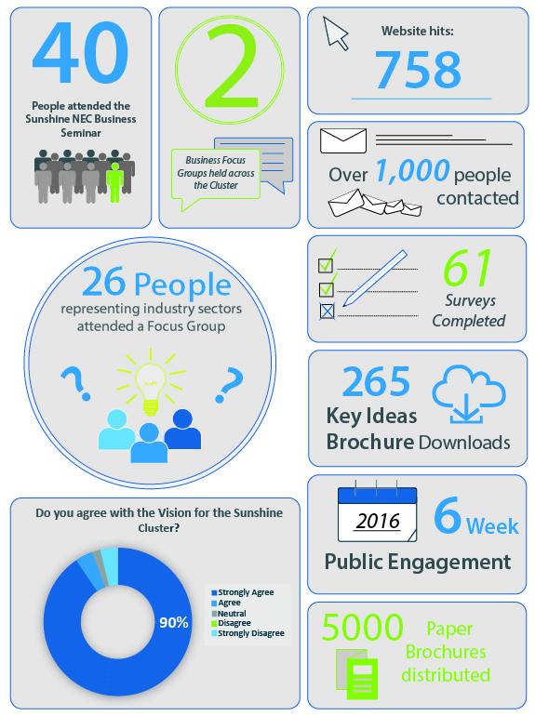

summary of feedback

economic initiatives

- Increase the amount of shared office spaces in the area to encourage growth in professional services
- Provide more flexible workspaces to allow for a variety of business models
- Manage transition to a new business demographic: large industry moving out and smaller commercial businesses moving in
- Ensure National Broadband Network (NBN) services in the precinct are rolled out in an effective and timely manner
- Provide employment opportunities for local residents
- Encourage professional industries to lease office space in the area
- Enact a fast-track planning permit process for new businesses
- Develop a chamber of commerce for Brimbank
- Provide prospects for international students such as accommodation and part-time jobs
- Attract quality restaurants, stores and family outdoor areas
- Attract a major sports team to the area
- Encourage a variety of uses within historical sites, such as an arts precinct within the John Darling Flour Mill
- Create new public facilities such as a library or a data centre
- Utilise local advocacy groups such as ‘Lead West’
- Provide job opportunities for professional ‘white collar’ services
- Invest additional resources into local schools
- Increase the amount of private facilities (e.g. private health & private schools) available to residents

public realm

- Ensure all new development has a consistent appearance to ensure the precinct can achieve a distinctive look
- Aim to create a more environmentally sustainable cluster
- Provide more landscaping and canopy trees
- Develop a green economy i.e. farmers markets
- All new development should be constructed without affecting native vegetation and the wider environment
- Increase the amount of colour in the area
- Reduce the amount of concrete, particularly car parking areas
- Improve integration of industrial and residential interfaces
- Make appropriate use of underutilised public land i.e the construction of bicycle paths beneath power easements
- Provide infrastructure to support the Cluster’s ageing population
- Ensure there is consistent rubbish collection so streets are well maintained and clean
- Improve safety in public areas to encourage a greater sense of walkability in the area
- Public spaces to be well lit to encourage night time activities within town centres
- Create public spaces that encourage reflection and education for community members

TRANSPORT

- Improve bicycle connections to make Sunshine more bike-friendly
- Extend the existing railway to Caroline Springs
- Provide cross-town bus routes to the Sunshine centre
- Develop more direct, efficient and timely bus routes
- Develop a shuttle bus express style services to key destinations such as train stations and university campuses
- Invest in roads to resolve bottlenecks
- Provide bus and bike lanes within the road network to enable public transport to increase effectiveness
- Setup a local public transport committee to provide design solutions to improve the bus network
- Follow Transport Orientated Design (TOD) principles and encourage growth adjacent to public transport hubs
- Upgrade and maintain existing road infrastructure to ensure the appearance of the area is enhanced
- Improve the road network to reduce the impact of freight and courier vehicles on traffic
- Improve the pedestrian experience to encourage walking
- Move away from car based transport
- Redirect traffic to ensure heavy vehicles do not travel through Sunshine.
HOUSING
- Explore opportunities to improve building design to match the existing character of the area
- Ensure increased housing density does not result in the area becoming a ‘concrete jungle’
- Ensure that higher density housing is located adjacent to quality open spaces and public transport
- Ensure new development is constructed in accordance with the existing neighbourhood character
- Improve enforcement of developments that have not been constructed in accordance with regulations
- Industrial sites should be recycled for diverse housing
- Remove badly maintained businesses in favour of residential dwellings
- Require development to follow Environmentally Sustainable Design principles
- Encourage modular homes to be more easily accessible
- Encourage ongoing community engagement for developments within the area.

NEXT STEPS

