la trobe nec PUblic engagement outcomes report summary

context
Melbourne’s population is set to increase to 8 million people by 2051. To accommodate this growth, an additional 1.7 million dwellings and 1.7 million new jobs will need to be created. Growth of this scale requires long-term planning and management to sustain residents’ quality of life and Melbourne's status as one of the most liveable cities in the world. The VPA's role is facilitating required land supply and identifying opportunities to increase housing, employment and investment within the state. La Trobe has been identified as a National Employment Cluster that can accommodate a significant increase in jobs.
The La Trobe Cluster is currently a base for 40,000 jobs and 75% of these are located within four significant employment locations, including:
- La Trobe University and the adjacent research and development area (4,600 jobs)
- Northland shopping centre (4,000 jobs) and the industrial area to the south (6,100 jobs)
- Heidelberg activity centre and the Austin Health medical precinct (13,900 jobs)
- Heidelberg West industrial estate (4,800 jobs).
Each of these employment locations has different strengths, particularly as key sub-regional locations for a significant proportion of the growth in knowledge and technology-based employment. The Framework Plan will set the context for the localised and more detailed planning of the four key change areas.

Purpose
Phase 1 of public engagement for the La Trobe National Employment Cluster (LTNEC) Framework Plan has been completed. It was the first phase to test the VPA’s preliminary ideas surrounding future land use, development and infrastructure planning for the La Trobe NEC.
Feedback was obtained using several methods, including surveys, written submissions, focus groups and stakeholder conversations. The VPA's aspirations for the future of the Cluster in general align with those of local residential, worker and business communities. VPA received many suggestions and comments about how to improve the amenity of the Cluster, as well as positive reinforcement of the VPA’s proposed directions for the Cluster.
The ideas for discussion were centred on transport issues, streetscapes, employment initiatives and the role of La Trobe University within the wider precinct. Participants offered many suggestions for improving the overall amenity of the Cluster and enhancing its appeal. People cited traffic congestion, particularly along Waterdale Road, as a big problem that was impacting on the productivity of businesses, which needed to be addressed. They suggested a light rail network connecting the main employment areas of the precinct would be beneficial, as would additional cycle lanes.
Other key suggestions included better blending industrial areas with residential and retail areas, enhancing open space, improving NBN access and opening up La Trobe University to the community. A breakdown of key points raised during consultation can be found on pages 3 and 4.
Overall, feedback received to date has been positive, constructive and has provided the VPA with a strong evidence basis to inform the Framework Plan being drafted in the second half of 2016.
Engagement Program and Activities
Table 2 – Public Engagement Participation Table
Date | Public Engagement Activity | No. of Participants
2 June 2016 | Launch of Consultation at Northlink Business Awards | 200
8 June 2016 | Shape Victoria online portal launched | 1,289 hits to date
8 June to 15 July 2016 | 'Have your say' Survey | 27 responses
8 June 2016 | La Trobe National Employment Cluster Future Outlook Seminar | 70 attendees
9 June 2016 | La Trobe University Infrastructure & Estates Planning Committee | 10
15 June 2016 | Business Focus Group | 18 participants
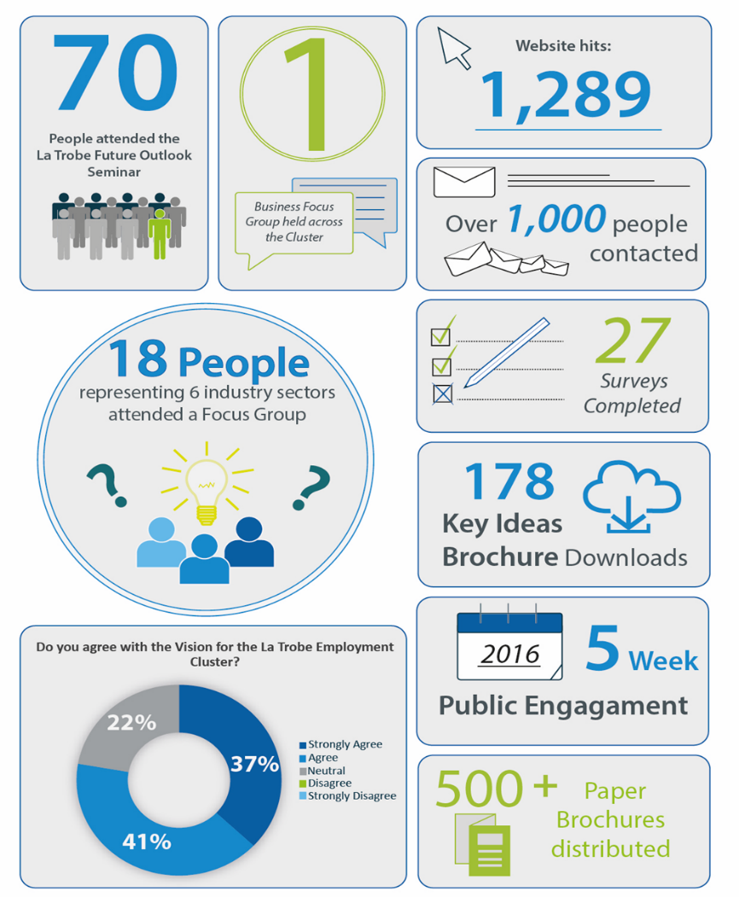

summary of feedback

Transport

- Increased quantity and safer cycle lanes are needed
- Parking and traffic congestion, particularly along Waterdale Road, is a big problem impacting on the productivity of businesses. Road projects to relieve congestion are necessary
- A light rail network is needed through the Cluster to connect the precincts (as proposed through the Northland Urban Renewal Precinct Structure Plan)
- Public transport upgrades and increased frequency is essential, including the duplication of Waterdale Road.
- The key ideas indicate that a 'turn up and go' public transport service means that services run so frequently one doesn't need to know the timetable
- Must resolve Rosanna Road East link crisis. Congestion has a flow-on affect through the whole region
- Although reducing congestion on roads is important, works generally keep up with increasing traffic demands. Providing better, efficient, frequent and reliable public transport will be a much better option
- West Preston tram needs to be extended to Reservoir station.

PUBLIC REALM

- Participants wanted existing open space to be enhanced, especially Darebin Creek
- Better pedestrian amenity is needed
- Promoting alternative housing models for sustainable living and more affordable homes is important
- Need to better blend industrial area with residential and retail uses

EMPLOYMENT INITIATIVES

- Building the profile and identity of the La Trobe NEC is needed. This will help leverage existing investments and contribute to further business growth opportunities
- More engagement with business is needed
- Should be more complementary medical to support Austin hospital
- Repat hospital redevelopment should introduce a new through road and it needs a new image
- NBN access is poor for business, needs to be improved
- Need a framework for business and education to work together to increase employment
- Local businesses should be supported by linking them with education providers and providing grants would help businesses to grow

LA TROBE UNIVERSITY

- La Trobe University is keen to formally pursue a proposed tram route through the university grounds, re-routing the existing Tram Route 86 that goes to Bundoora
- La Trobe University does not have links externally and being inwards facing makes the Cluster connectivity less effective
- Open La Trobe University to the community
- Promote University events to wider community

Next Steps
The preparation of the La Trobe National Employment Cluster Framework Plan is proposed to progress from the current stage ‘Public Engagement Phase 1’ to formulating the draft plan for further engagement in 2017 as outlined in the process to date. The key steps in the process are outlined below in Figure 11.

Figure 11 – Process and Next Steps

