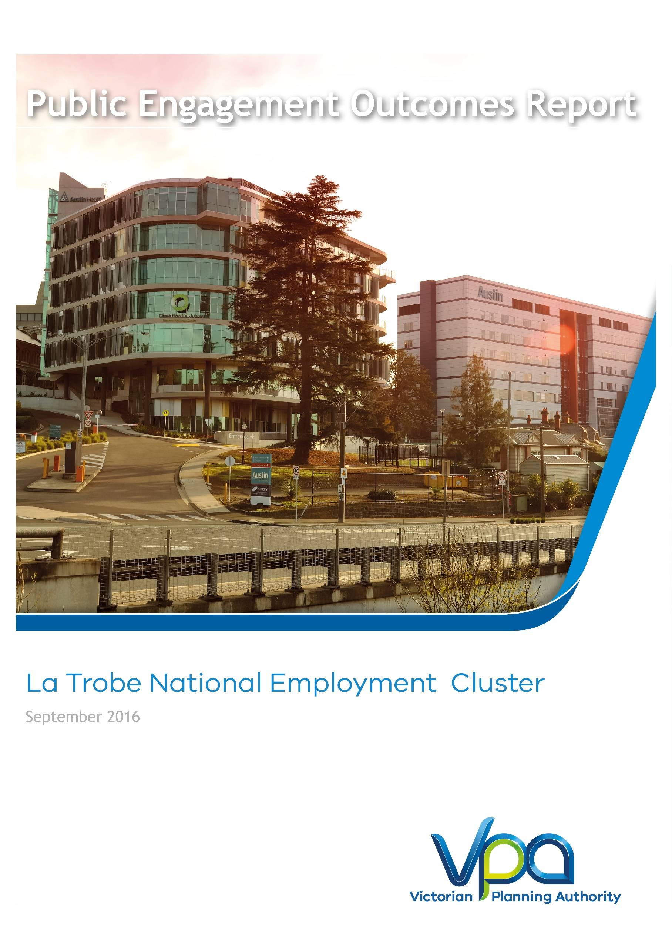

CONTENTS
1 Executive Summary 1
2 Introduction 3
2.1 Purpose 3
2.2 Report Structure 3
3 Project overview: Planning for the La Trobe Employment Cluster 4
3.1 Context 4
3.2 Plan Melbourne 2014 5
3.3 La Trobe National Employment Cluster Framework Plan 5
4 Engagement Approach 7
4.1 Phase 1 Engagement: Vision, Principles & Key Ideas 7
4.2 Phase 2 Engagement: draft Framework plan 7
4.3 Summary of Results 7
5 Engagement Program and Activities 9
5.1 Shape Victoria 9
5.2 Notifications and Advertising 10
5.3 NorthLink Northern Business Achievement awards 10
5.4 La Trobe National Employment Cluster Seminar 10
5.5 Business Focus Groups 12
5.6 La Trobe University Infrastructure & Estates Planning Committee 13
5.7 Surveys 13
5.8 Ongoing stakeholder engagement 14
5.9 Culturally & Linguistically Diverse Communities 14
6 Feedback & Outcomes 15
6.1 What we Learnt 15
6.2 Vision 16
6.3 Principles & Key Ideas 17
6.4 How the feedback will be used in the Framework Plan 21
6.5 Written submissions 22
7 Process and Next Steps 23

Figures
Figure 1 - Summary of Public Engagement Activities 2
Figure 2 – Metropolitan Context Plan 4
Figure 3 – Survey Participants Relationship to the Cluster 13
Figure 4 – Participant Comments about the La Trobe NEC 15
Figure 5 – Vision Survey Results 16
Figure 6 – Survey results: Importance of La Trobe NEC Vision Key Elements 17
Figure 7 – Survey Results: Principle 1 17
Figure 8 – Survey Results: Principle 2 19
Figure 9 – Survey Results: Principle 3 20
Figure 10 – Survey Results: Principle 4 21
Figure 11 – Process and Next Steps 23

Tables

Table 1 - Public Engagement Participation Table 9

Executive Summary
Phase 1 of public engagement for the La Trobe National Employment Cluster (LTNEC) Framework Plan has been completed. It is the first phase to test preliminary ideas and help formulate the future land use, development and infrastructure planning for the La Trobe NEC. This report summarises consultation activities undertaken, the feedback received and how this input will be used to help shape the project. The VPA sought to gather new ideas and suggestions to help plan for the Cluster.
Feedback was obtained using several methods, including surveys, written submissions, focus groups and stakeholder conversations. The VPA's aspirations for the future of the Cluster in general align with members of the local residential, worker and business communities. VPA received many suggestions and comments, as well as positive reinforcement, of the directions proposed for the Cluster.
As will be further explained in Section 4, there did not seem to be any great deviation of opinion regarding the key ideas that were distributed for comment.
Overall, feedback received to date has been positive, constructive and has provided the VPA with a strong evidence basis from which to proceed with the drafting of the Framework Plan in the second half of 2016.

Figure 1 - Summary of Public Engagement Activities
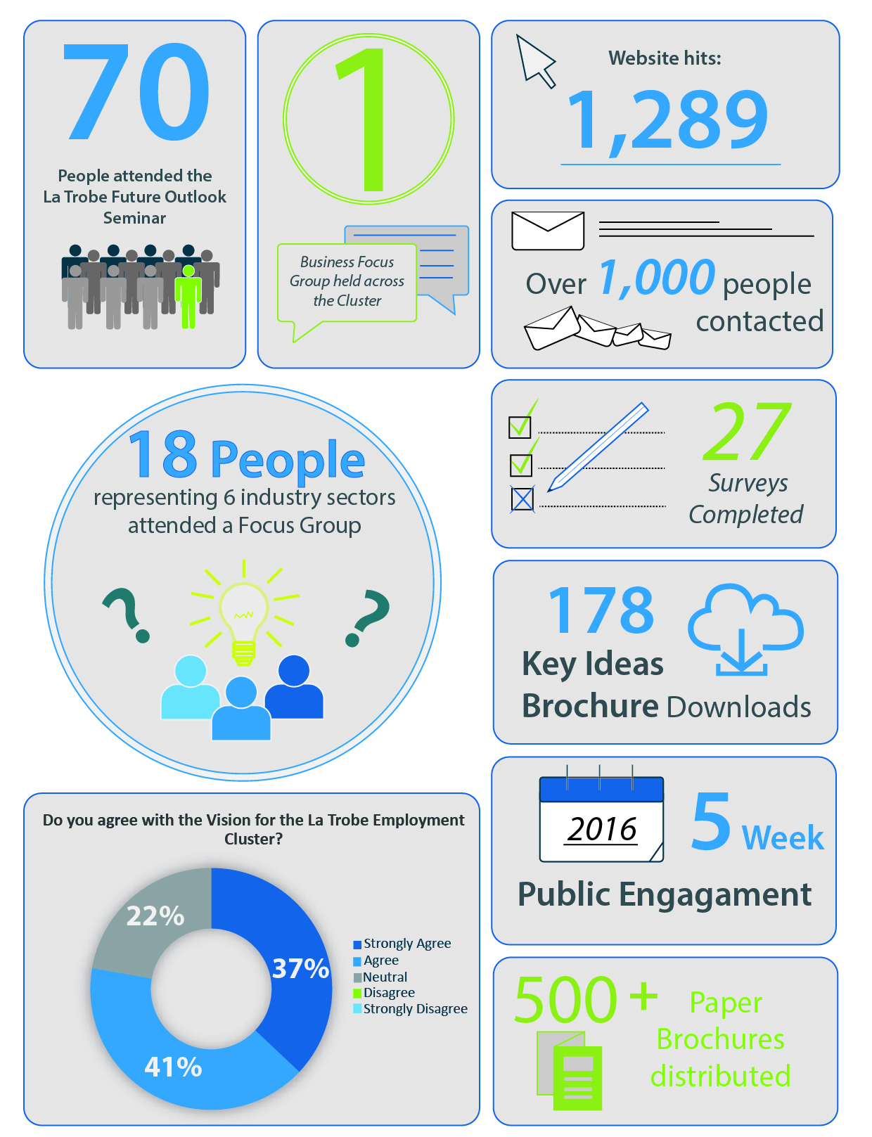

Introduction

Purpose
This Public Engagement Outcomes Report summarises the feedback received from public engagement on the draft Vision, Principles & Key Ideas for the La Trobe NEC Framework Plan.
This is the first phase of public engagement to be undertaken to help develop the future land use and infrastructure planning for the La Trobe NEC. This report summarises the activities undertaken, the feedback received and how the input will be used in shaping the content and directions for the draft Framework Plan.
Finally, you may notice our organisation is now known as the Victorian Planning Authority (VPA). The VPA has succeeded the Metropolitan Planning Authority (MPA) and continues to progress projects in key precincts such as the La Trobe Employment Cluster. For more information, see: http://www.premier.vic.gov.au/planning-for-smart-growth-across-victoria/

Report Structure
This report is broken into four sections, as follows:
Section 3: Project Overview. Provides an overview of the context in which the public engagement has taken place, including the main policy drivers and why a plan is required.
Section 4: Engagement Activities. Provides an overview of the engagement program and activities for the project.
Section 5: Feedback & Outcomes. Summarises stakeholder feedback received on the draft Vision, Principles and Key Ideas for the La Trobe NEC Framework Plan.
Section 6: Next Steps. Addresses how the feedback and input will be carried forward.

Project overview: Planning for the La Trobe Employment Cluster

Context
The La Trobe National Employment Cluster (LTNEC) Framework Plan is a collaborative project being led by the Victorian Planning Authority (VPA) in collaboration with City of Darebin, City of Banyule and the La Trobe University and Austin Health. Other state government stakeholders have also been involved. The Framework Plan aims to meet the objectives set within Plan Melbourne Refresh, the State’s metropolitan planning strategy.
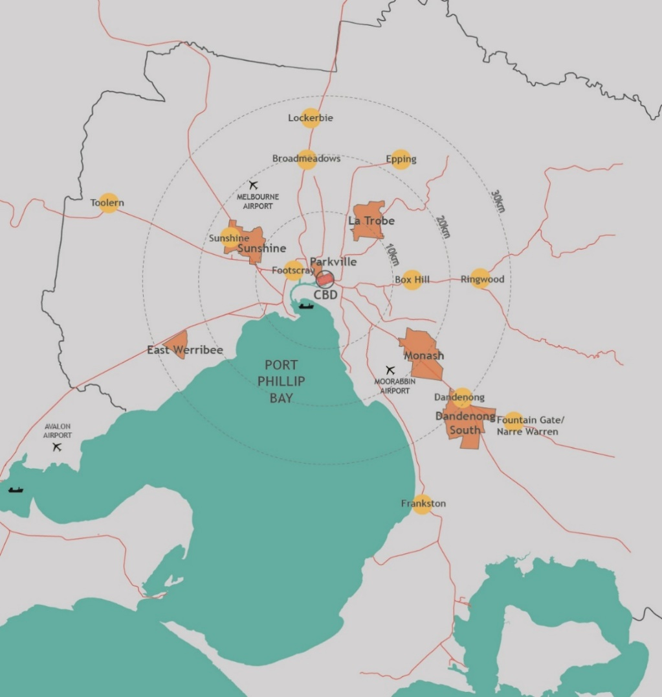
By 2051 Melbourne’s population is set to increase by 3.5 million, to be a city of around 8 million people. To accommodate this growth, an additional 1.7 million dwellings and 1.7 million new jobs will need to be created. Growth of this scale requires long-term planning and management to sustain residents’ quality of life and Melbourne's status as one of the most liveable cities in the world. The VPA's role is facilitating the required land supply and identifying opportunities to increase housing, employment and investment within the state.
Figure 2 – Metropolitan Context Plan

Plan Melbourne 2014
Plan Melbourne is a 35-year plan for integrated land use, infrastructure and transport investment in metropolitan Melbourne. It focuses on delivering the required housing, jobs and services needed to support Melbourne’s projected growth while maintaining our quality of life for the future.
Six National Employment Clusters (NECs), have been identified as areas that either have established or emerging potential to provide a foundation for sustainable employment and housing densities associated with good transport connections.
La Trobe is one of Melbourne’s emerging NECs. With 25,700 jobs, it has a unique concentration of employment supporting a mix of health, education, research, retail and commercial operators. Located in Melbourne’s northern subregion, north-east of the CBD, La Trobe NEC takes in the areas of Bundoora, Preston, Heidelberg West and Heidelberg. It is serviced by two rail lines (Hurstbridge and South Morang lines), a tram line, local bus services and an intricate network of arterial roads. Due to its location and transport services, the La Trobe NEC has potential to continue to grow as a magnet for investment, jobs, services, businesses and housing for the future.

La Trobe National Employment Cluster Framework Plan
The La Trobe Cluster is already an excellent place to work and live, with a significant number and range of jobs and a natural environment that provides plenty of opportunity to create an attractive and highly accessible mixed-use community.
Melbourne’s north is evolving from a manufacturing region towards a knowledge economy region, in which high‐tech manufacturing has been retained and research hubs are being developed. Manufacturing currently is and will continue to be a major industry in the area and a significant source of employment.
As Melbourne grows, the city will need more jobs will be needed to support economic growth. The La Trobe Cluster will play a key role in contributing to this job growth.
However, the types of businesses and jobs located in the La Trobe Cluster are changing. For example, there has been a decline in the number of traditional industrial jobs in the area. This is largely due to the decline of manufacturing in Australia, and the opportunity for businesses to find cheaper and more accessible industrial sites in other parts of Melbourne.
The La Trobe Cluster currently contains 40,000 jobs and 75% of these are located within four significant employment locations, including:
- La Trobe University and the adjacent research and development area (4,600 jobs)
- Northland shopping centre (4,000 jobs) and the industrial area to the south (6,100 jobs)
- Heidelberg activity centre and the Austin Health medical precinct (13,900 jobs)
- Heidelberg West industrial estate (4,800 jobs)
Each of these employment locations has different strengths, particularly as key sub-regional locations for a significant proportion of the growth in knowledge and technology based employment:
- La Trobe University has an expanding education and research role, including a growing student and research population, and the recently completed AgriBio Centre;
- Education jobs at La Trobe University can be expected to increase significantly as a result of the threefold increase in student numbers planned in the University’s Master Plan;
- Associated research and development jobs will increase as the proposed Research and Development Park to the south east of the University intensifies over time;
- The University’s plans for a health hub on Plenty Road as an extension to the existing University Medical Centre, will result in an increase in health related jobs;
- The proposed extension of the existing Polaris town centre to the south of Main Drive into the La Trobe University campus will provide additional retail employment opportunities;
- The Heidelberg precinct has a significant presence of health services focussed on the Austin Hospital, training and research institutions such as the Melbourne Brain Centre. Significant urban renewal opportunities are also based around Heidelberg station and along Burgundy Street;
- The Northland shopping centre is the largest shopping centre in the north of Melbourne and has the potential to catalyse significant urban renewal to create a new commercial hub serving the sub-region;
- Heidelberg West industrial estate provides local manufacturing and service industries, with the potential to include a greater proportion of knowledge based employment over time;
- The Heidelberg West industrial estate is likely to undergo some level of change over time. This needs to be investigated further, but could potentially result in significant employment intensification and diversification from manufacturing, construction and wholesale to a range of small to medium sized businesses (e.g. offices, office/warehouses and research and development); and
- Businesses in this precinct can support the La Trobe University research area on agriculture and food science technologies. In order to enable this change to occur, future planning of the area would need to enable improvements to the public realm, a diversification of retail and entertainment opportunities for local workers and improved public transport throughout the area. Some residential development may need to be incorporated in order to improve the vitality and activity within the area, particularly outside of business hours.
The Framework Plan will set the context for the localised and more detailed planning of the four key change areas.

Engagement Approach
The VPA has devised a two-phase approach to public engagement for the La Trobe NEC Framework Plan.

Phase 1 Engagement: Vision, Principles & Key Ideas
The objectives of Phase 1 were to:
- Seek feedback on the vision and principles for the Framework Plan;
- Test the key ideas for delivery of the vision and principles, including opportunities for new ideas and suggestions;
- Build understanding of the opportunities for development and investment;
- Build momentum for positive change in the education, health and employment areas; and
- Offer an opportunity to contribute to and influence the direction of the draft Framework Plan for the La Trobe NEC.
The feedback gathered from Phase 1 will help develop the Framework Plan further and highlights elements requiring more work.

Phase 2 Engagement: draft Framework plan
The objectives of Phase 2 public engagement will be to:
- Seek comments from stakeholders and the public on the draft La Trobe National Employment Cluster Framework Plan and invite submissions
- Exhibit planning scheme amendments to support the implementation of the La Trobe National Employment Cluster Framework Plan.

Summary of Results
Feedback received from the La Trobe NEC Phase 1: Vision, Principles and Key Ideas public engagement (from surveys, submissions, focus groups and stakeholder conversations) has identified that the VPA's aspirations for the future of the Cluster in general align with that of members of its residential, worker and business communities.
Many positive suggestions and comments were received and these have assisted to refine and improve the key ideas and proposed outcomes. There is general agreement to what has been proposed in the directions and key ideas for the La Trobe NEC.
Overall, feedback received for Phase 1: Vision, Principles & Key Ideas, has been positive and constructive and has provided the VPA with a strong evidence basis from which to proceed with the drafting of the Framework Plan in the second half of 2016.
Key points from the consultation are summarised on the next page and more detail is provided in Section 6 of this report.
The VPA received the following comments from respondents:
- La Trobe University is keen to formally pursue a proposed tram route through the university grounds, re-routing the existing Tram Route 86 that goes to Bundoora;
- Broadband connection is a significant issue for businesses in the industrial precincts, with the current service being of poor quality and speed;
- Increased quantity and safer cycle lanes are needed;
- More bike paths are needed;
- Parking and traffic congestion, particularly along Waterdale Road, is a big problem impacting on the productivity of businesses. Road projects to relieve congestion are necessary;
- La Trobe University does not have links externally and being inwards facing makes the Cluster connectivity less effective;
- Participants wanted existing open space to be enhanced, especially Darebin Creek;
- A light rail network is needed through the Cluster to connect the precincts (as proposed through the Northland Urban Renewal Precinct Structure Plan);
- Building the profile and identity of the La Trobe NEC is needed. This will help leverage existing investments and contribute to further business growth opportunities;
- Public transport upgrades and increased frequency is essential;
- Better pedestrian amenity is needed;
- Local businesses should be supported by linking them with education providers and providing grants would help businesses to grow; and
- Promoting alternative housing models for sustainable living and more affordable homes is important

Engagement Program and Activities
Table 1 - Public Engagement Participation Table
Date | Public Engagement Activity | No. of Participants
2 June 2016 | Launch of Consultation at Northlink Business Awards | 200
8 June 2016 | Shape Victoria online portal launched | 1,289 hits to date
8 June to 15 July 2016 | 'Have your say' Survey | 27 responses
8 June 2016 | La Trobe National Employment Cluster Future Outlook Seminar | 70 attendees
9 June 2016 | La Trobe University Infrastructure & Estates Planning Committee | 10
15 June 2016 | Business Focus Group | 18 participants

Shape Victoria
Shape Victoria is the online communication and engagement platform used by the VPA for engagement on the La Trobe NEC. It also provides information and resources about the Cluster, including maps, event information, project updates and background reports.
The webpage went live on the 8 June, 2016, which signalled the beginning of the 5-week public engagement process (8 June – 15 July 2016). During the public engagement period the project page within Shape Victoria received 1,289 hits. The webpage allows users to engage with a range of material that will inform and provide details of what is proposed for the La Trobe Cluster.
Shape Victoria included:
- Information Brochure, Maps and Presentations on the La Trobe NEC
- Upcoming event information
- Background documents and reports
- Latest news from the La Trobe NIEC
- ‘Have your say!’ survey
- Project timeline
- An extensive list of FAQ’s
- Useful links to external resources such as other State and Local Government websites
- Key contact information
- Updates about activities completed

Over the 5-week public engagement period:
- 178 people downloaded the Key Ideas Brochure
- 88 people downloaded the presentations from the Future Outlook Seminar

Notifications and Advertising
Upon starting consultation, the VPA worked with The Department of Economic Development, Jobs, Transport and Resources (DEDJTR) to identify businesses in and near to the precinct to receive email communications. Approximately 1000 businesses and interested parties were invited to participate in the public engagement activities. Three emails were issued during the course of the feedback period to promote the events, the survey and the website.
Furthermore, a letterbox drop of businesses within the Heidelberg West and Northland industrial areas was conducted.

NorthLink Northern Business Achievement awards
Northlink held the Northern Business Achievement Awards on 2 June. Here, the VPA gave a presentation detailing the main features of the La Trobe Cluster and promoted the two engagements events.
This was the first opportunity the VPA had to present and discuss the La Trobe NEC ideas with the business community. A range of brochures, maps, surveys and upcoming event information were made available on the day for attendees. Attendees were able to discuss the project one-on-one with officers before and after the formalities of the event.

La Trobe National Employment Cluster Seminar
On 8 June from 5:00PM to 7:00pm the VPA, in conjunction with the Department of Economics (DEDJTR), held the La Trobe Future Outlook Seminar at the La Trobe University.
The aim of the event was to bring together business owners, investors, key institutions and members of the general public interested in the future aspirations for employment growth and investment opportunities in the La Trobe NEC.
The event featured the following guest panel members:
- Peter Seamer, CEO, Planning Authority
- Dr. Philip Moors, Deputy Chancellor and Chair Infrastructure and Estates Planning Committee, La Trobe University
- Steve Booth, Director Economic Project Engagement, Metropolitan Development Victoria, Department of Economic Development, Jobs Transport and Resources
- Cr Craig Langdon, Mayor of Banyule
- Cr Tim Laurence, Councillor of City of Darebin
- Mario Turcarelli, Managing Director, Dolphin Products.
Approximately 70 guests attended the night from a cross section of business and research sectors, along with representatives from the VPA, City of Darebin, City of Banyule, Austin Health, La Trobe University and state government Departments of Economic Development (DEDJTR) and Department of Health and Human Services.
VPA staff were on hand to discuss the key idea with attendees one-on-one and were supported by displays and information brochures.
The seminar included the VPA introducing the La Trobe NEC key ideas for future planning and development to the audience, followed by speakers discussing the issues and opportunities regarding research, innovation and business activities in the Cluster.
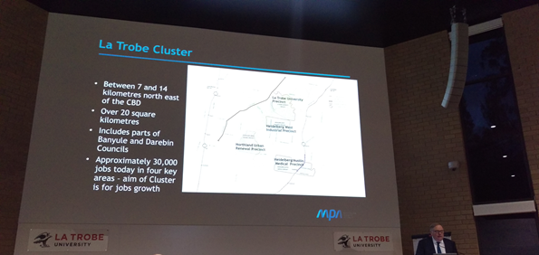
General stakeholder feedback on the night was positive, with many hearing about the Cluster and the vision for the first time.

Business Focus Groups
Following the Outlook Seminar, the VPA undertook a Business Focus Group, held on 15 June, 2016 at La Trobe University. The aim was to gain feedback and ideas on the La Trobe NEC proposed Vision, Principles & Key Ideas for the draft Framework Plan. Eighteen people attended across the three sessions, representing six different industry sectors operating in the area. The VPA, with the aid of local government representatives, facilitated the small, interactive forum discussions at the event, with all feedback formally recorded by the VPA for the purposes of this report. Key topics for discussion were structured around growing employment, transport network, walking and cycling connections, open space and community services within the Cluster.
Feedback at the focus group can be summarised as follows:
- Need to better blend industrial area with residential and retail uses;
- More engagement with business is needed;
- Should be more complementary medical to support Austin hospital;
- Repat hospital redevelopment should introduce a new through road and it needs a new image;
- Open La Trobe University to the community;
- Promote University events wider;
- NBN access is poor for business;
- Need a framework for business and education to work together to increase employment;
- Better transport connections needed, roads are congested;
- Duplication of Waterdale Road; and
- Maximise proximity to Darebin Creek.

Results from the exit survey highlighted that 100% of participants said they learnt something new during the focus group and would consider attending another event like this in the future.
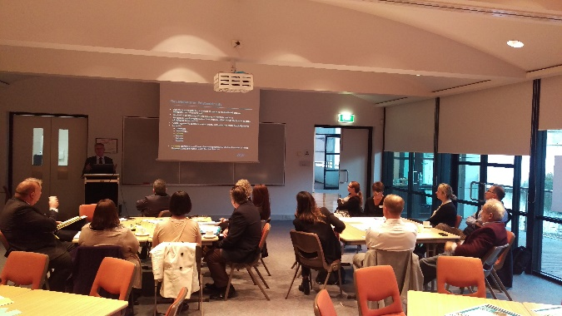
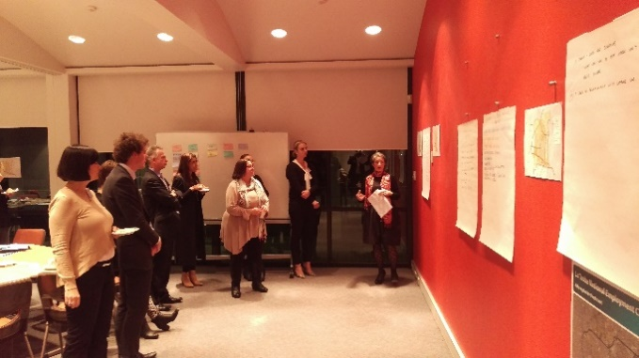

La Trobe University Infrastructure & Estates Planning Committee
The VPA provided a presentation to the University’s Infrastructure and Estates Planning Committee on the key directions and ideas for the future development of the La Trobe Cluster. The committee were supportive of the ideas put forward and stressed the importance of the University’s proposal to have a tram through the La Trobe University grounds (including the sports precinct) and would like to have further dialogue with government on the issue. The tram corridor is nominated on the La Trobe University Masterplan.

Surveys
The ‘Have your say!’ survey was the primary form for giving feedback adopted by stakeholders during the process and was available online and in hard copy. The survey was designed to give stakeholders the opportunity to provide feedback in a quick, simple, but meaningful fashion to aid the development of the draft Framework Plan.
There were a total of 27 survey respondents from industry, workers, students, residents and visitors within the La Trobe NEC. The majority of responses were from people who live, work or own a business in the Cluster as noted in Figure 3 below.
Figure 3 – Survey Participants Relationship to the Cluster

Ongoing stakeholder engagement
The VPA will continue to work collaboratively with stakeholders on developing the ideas for the Framework plan, and a range of key strategic sites and projects within the La Trobe NEC.
Ongoing facilitation and involvement in projects relating to key precincts, such as the Heidelberg West and Northland Urban Renewal Precincts, are vital pieces of the puzzle in the successful transformation of the Cluster. The VPA’s aim is that these precincts achieve optimal integration with the wider context of the area and work towards meeting the proposed Vision, Principles and Key Ideas of the future Framework Plan. It is anticipated that involvement with key precincts and projects in the Cluster will continue as the project progresses.

Culturally & Linguistically Diverse Communities
Translation services were made available in the ten identified primary languages of the area. All information provided to the public for the La Trobe NEC draft Framework Plan were made digitally and graphically accessible for screen readers and the colour blind, and in downloadable in various formats (both PDF & Word DOC).
There were no requests for translation services made during the public engagement period, however 158 stakeholders took advantage of downloading the brochure in an alternative format.

Feedback & Outcomes

What we Learnt
Participation in the 5 week engagement period in the ‘Have your say!’ survey, focus groups, written submissions and general discussions with stakeholders has helped the VPA to develop a better understanding of issues with many participants offering up ideas for what should be done to achieve the La Trobe NEC Vision.

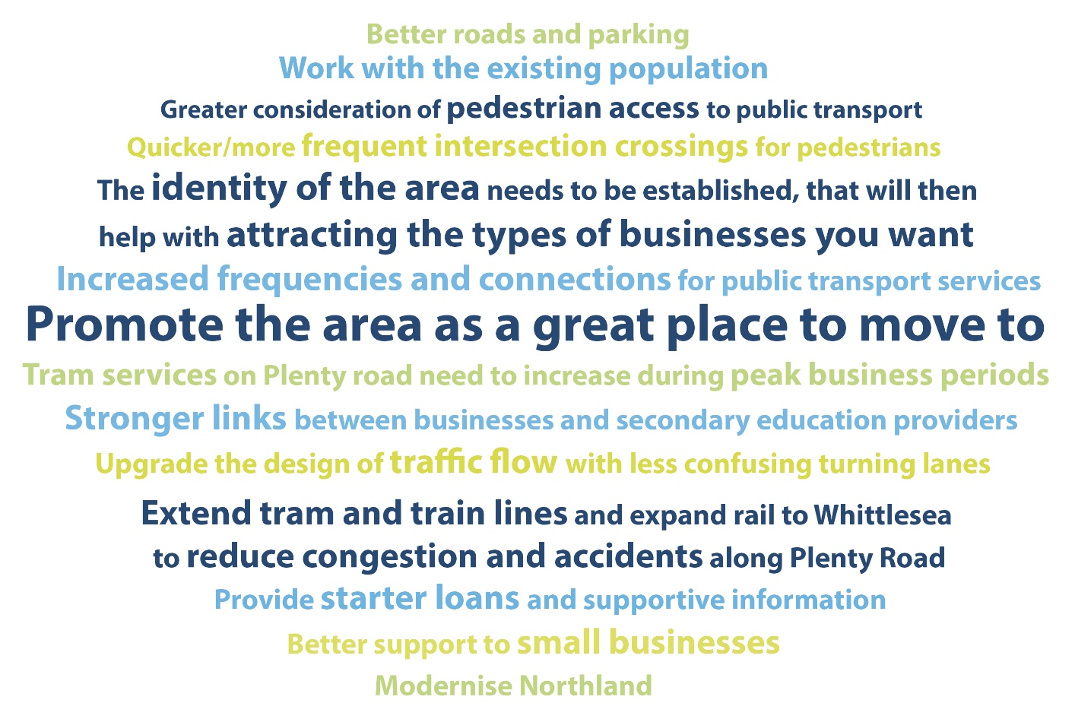
Figure 4 – Participant Comments about the La Trobe NEC

Vision
The Cluster will evolve as an attractive area of diverse businesses, world-class institutions and services in the north-eastern region that generates strong economic productivity and social investment. Four key areas in the Cluster will be accessible within a 20-minute commute of residential neighbourhoods within and around the Cluster.

Figure 5 – Vision Survey Results

The survey results show that there is clear support by the respondents for the proposed Vision for the La Trobe NEC (refer Figure 5).
A range of feedback comments were received including the following:
- Happy with the strategy, however wish to see existing recreational areas turned into affordable housing for downsizing in the future;
- Better Transport links not only within the cluster, but between clusters is essential for this plan to work. Simply adding more bus routes may not be sufficient unless serious traffic issues are addressed;
- Vision for 20 minute commute needs to be clearer;
- Tram networks should be extended;
- The area needs improved services;
- Vision also needs to be communicated with businesses further north; and
- The high level plan is very ambitious, but there appears to be a degree of disconnect between the VPA, Banyule and Darebin Councils.

Figure 6 – Survey results: Importance of La Trobe NEC Vision Key Elements

Principles & Key Ideas

Principle 1 – improve connections to & within the La Trobe Cluster.
Figure 7 – Survey Results: Principle 1

A range of feedback comments were received including the following:
- The key ideas indicate that a 'turn up and go' public transport service means that services run so frequently one doesn't need to know the timetable;
- Undertaking road projects to reduce congestion and improving cycling and pedestrian connections would complement each other. Very important for the development of the Northern corridor to have these improvements;
- Must resolve Rosanna Road East link crisis. Congestion has a follow on affect through the whole region;
- Although reducing congestion on roads is important, works generally keep up with increasing traffic demands. Providing better, efficient, frequent and reliable public transport will be a much better option; and
- West Preston tram needs to be extended to Reservoir station.

Principle 2 – Help business grow & thrive within the La Trobe Cluster

Figure 8 – Survey Results: Principle 2

A range of feedback comments were received including the following:
- Any business investment strategy needs to include actions to encourage businesses to establish in newly developed networked centres; and
- Places must be attractive to attract better development i.e. putting big car parks in the front of buildings or shopping centres is an eye sore and greatly detracts from their appeal to customers. Although car parks are important, positioning them out of sight from the main public realm improves their appeal.

Principle 3 –Provide homes close to jobs within the La Trobe Cluster.

Figure 9 – Survey Results: Principle 3

No further comments were received on this Principle.

Principle 4 –Provide facilities, open space, cycle & pedestrian links wihtin the La Trobe Cluster. .

Figure 10 – Survey Results: Principle 4

A range of feedback comments were received including the following:
- Never underestimate the importance of street appeal to encourage pedestrian access; and
- Need new schools, not expand existing - increase variety of schools? Maybe a private or an independent school.

How the feedback will be used in the Framework Plan
Feedback received from the Phase 1 Public Engagement process will be used to inform and test the proposed Vision, Principles and Key Ideas for the draft La Trobe NEC Framework Plan. Feedback received during the 5 week public engagement process will form the basis to further develop the future directions and actions within the Framework Plan.

Written submissions
Two written submissions were received and the issues raised can be summarised as follows:
- A light rail corridor through the Northland Urban Renewal Precinct is needed to assist future high-density employment and residential growth;
- Investigate for the North-East Link as a direct orbital link from the Metropolitan Ring Road at Greensborough to Eastlink at Ringwood;
- In the short-term explore a SmartBus service to Macleod Railway Station ahead of future public transport upgrades;
- Investigate grade separation for the Hurstbridge railway line at the Ruthven level crossing;
- Invest in master planning at Heidelberg Railway Station for better modal interchange at Mount/Yarra Streets and access to the Austin/Mercy Hospitals Complex above Studley Road;
- Investigate grade separation for the Hurstbridge railway line at the Ruthven level crossing at Macleod;
- Invest in master planning at Heidelberg Railway Station to explore public spaces and floor space growth for commercial, medical and allied industries;
- Identify and plan for Heidelberg West’s residential area as the key location for housing change between Northland, La Trobe University and the Heidelberg Activity Centre;
- New cycling and pedestrian bridge over the Yarra River at Warringal Parklands;
- Promote alternative housing models for sustainable living and more affordable homes, such as the innovative Murundaka Cohousing at Bamfield Road in Heidelberg Heights;
- Support the Olympia Housing initiative, including additional project phases;
- Refresh the Heidelberg Activity Centre Structure Plan for priority places where housing and employment growth is most preferred and closest to public transport;
- Recognise aboriginal cultural heritage and Darebin Creek as the Cluster’s environmental and waterway spine;
- Support improved sporting facilities in the Heidelberg area;
- Support redevelopment for the Olympic Village Learning Hub in Heidelberg West;
- Recognise changing needs for community facilities for a dynamic community profile and changing population; and
- Encourage government to work with schools for community access to outdoor play spaces.

Process and Next Steps
The preparation of the La Trobe National Employment Cluster Framework Plan is proposed to progress from the current stage ‘Public Engagement Phase 1’ to formulating the draft plan for further engagement in 2017 as outlined in the process to date. The key steps in the process are outlined below in Figure 11.

Figure 11 – Process and Next Steps

